Global Navigation Satellite System
Name
Affilitiation
Date

GLONASS
GLONASS is a satellite navigation system activated by the Aerospace Protection Forces of Russia. GLONASS is an option to the global positioning system of the United States (GPS) and is to date the only functional alternative with a worldwide reporting and similar accuracy. The satellites of GLONASS are in medium spherical orbit at 19100-kilo meter in height with an inclination of 64.8º and a time period of 11 hrs and 15 mins. These orbits make GLONASS especially suitable for use at high latitudes (either north or south), where signals from satellites of GPS are received with greater difficulty given the lower inclination of their orbits (55 degrees above the equator).
The Glonass acronyms come from Global'naya Navigatsionnaya Sputnikovaya Sistema, a few words translated from Russian come to mean something like Global Navigation Satellite System. So, this system is nothing more than the Russian GPS counterpart. A GNSS positioning service is an infrastructure that provides data to the user so that it can determine its position with the best possible accuracy depending on the application for which it is required. The position can be determined in real time.
The GLONASS constellation is distributed in 3 orbital planes, having 8 satellites uniformly spread out in each plane. To achieve worldwide coverage, 24 satellites are required. Like GPS, a GLONASS receiver must receive time signals from at least four satellites to fix its position; of these, three will be used to regulate the location of the user and the fourth to synchronize the receiver's clocks with the other three spacecraft. (Roosbeek, 2001).
History of GLONASS Development
In 1976, the development of GLONASS started in the Soviet Union. The first GLONASS satellite was launched on October 12, 1982, four and a half years after the launch of the first GPS satellite. From there, the GLONASS satellite fleet increased steadily until reaching more than two dozen vehicles in orbit in 1995. However, Russia's economic problems and the relatively short lifetime of the satellites caused the operating satellite fleet to be rapidly reduced over the next five years.
The United States Global Positioning System has become the most popular navigation tool in the world with its network of 24 satellites, it covers the entire land surface and allows us to locate ourselves on the map through the telephone, clock and other devices that use its technology. It is also used, of course, for military purposes. It all began during the Cold War, in the mid-1960s, when the limitations of the radio navigation system "OMEGA" drove the need to create a more precise method. And the North American nation began to develop, little by little, a constellation of satellites destined for this purpose. The first was put into orbit in 1978.
The predecessor government and Russian Federation of the Soviet Union wanted to have their own navigation system because the Soviet Union did not want to be left behind, the European Union would imitate its steps with Galileo and China with BeiDou - and went to work in the development of its own localization technology. He called it GLONASS, Russia's Global Navigation Satellite System, now administered by the Russian Federation through its space agency. Taking into account that the Asian country was the first to place an artificial satellite in space - Sputnik, in 1957 - nothing seemed to presage that its American rival would win the race
During the first decade of 2000, the renovation of the system was a priority for the Vladimir Putin government, the reason why great amounts of money have been invested to him. GNSS is a very costly program of the Russian Federal Space Agency. By 2010, GLONASS had extended hundred percent coverage of the Russian territory and in the month of October 2011, the whole orbital collection of twenty-four satellites was reestablished, allowing full coverage in the whole World (Dabove, 2014).
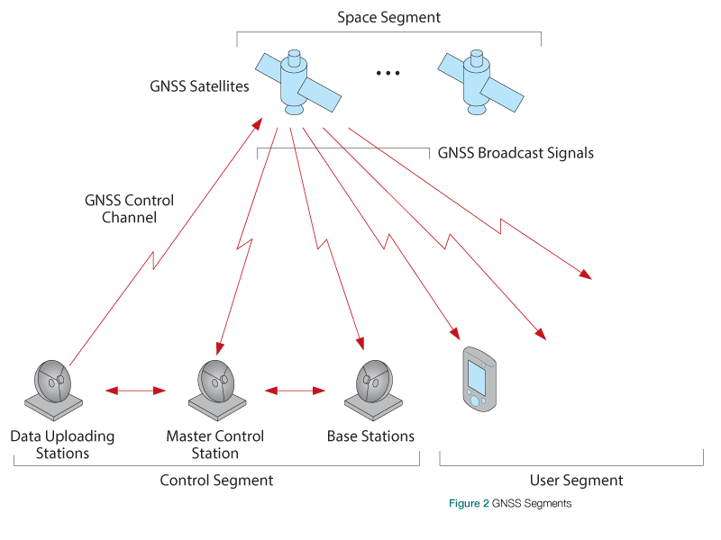
Figure 1 Global Navigation Satellite System
Signals
The Global Navigation System transmits signals using the system called FDMA (Frequency Division Multiple Access) based on the transmission of the same code with different frequencies typical of each satellite. Unlike GPS and Galileo, in which each satellite is identified through a different PRN (Pseudo Random Noise) code transmitted on the same carrier frequency, GLONASS satellites transmit the same PRN code on different carrier frequencies. That is, each satellite is assigned a different frequency in what is known as multi-channelization by frequency division or FDMA for its acronym in English. The signals are transmitted in two bands: L1 and L2. The carrier frequencies for each satellite are given by:
L1 band: f1 = (1.602 + 9k / 16) GHz
L2 band: f2 = (1.246 + 7k / 16) GHz
where k = 0, 1, 2, ..., 23 and it denotes the number of satellite.
As in the case of GPS, the carrier frequency L1 is moderated with a C/A code with a chip speed of 0.511 MHz, and with a P (Accuracy) code with a speed of 5.11 MHz. L2 frequencies are only modulated with a P-code. In the same way as GPS, GLONASS satellites transmit a navigation message at a speed of 50 bps. In this navigation message, the time of each satellite and its position at the moment of transmitting in what are the ephemeris and the almanac are coded. Because GLONASS requires wider bands of radio spectrum than GPS, there has been pressure by groups of radioastronomers to limit their spectrum. This resulted at the end of 1990, Russia committed to having its satellites transmit the same frequency when they were on opposite sides of the earth. This "antipodal" strategy ensures that GLONASS receivers do not conflict with signals on the same frequency while reducing the bandwidth required for their operation. These codes make GLONASS interoperable with GPS receivers in the US and other countries. GLONASS is also working on new codes and signals for its new Satellites.
Like GPS, to date, different versions of the GLONASS system have been developed. The GLONASS version launched in 1982, and it is the oldest version. The GLONASS M was found in 2003 and it contains a 2nd civil code. GLONASS K was started in 2011 and it adds 3rd civil frequency. The GLONASS K2 is planned to be launched from 2018. The GLONASS KM version is planned to be launched from 2025. GLONASS K satellites use the CDMA multi-channelization technique in the L3 band, which is more compatible with the GPS system. The GLONASS K2 satellites will transmit in both FDMA and CDMA in the L1 and L2 bands and the CDMA signals.
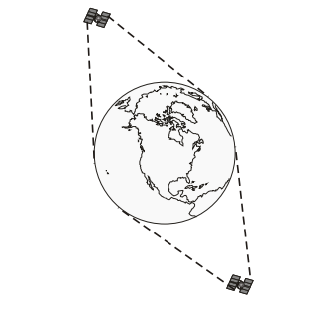
Future GLONASS satellites will transmit signals using the same CDMA technique as GPS, making receiver hardware easier thanks to better compatibility with GPS signals, the first satellite that experiments with this approach on the third GLONASS frequency, was sent into orbit last February 26th This satellite belongs to the new GLONASS-K generation, which guarantees a lifetime of ten years equal to GPS satellites. Currently, work is underway to change the GLONASS operating frequencies to avoid interference from terminals of mobile satellite systems operating in the 1610.1625 MHz band and interference with the band 1612 MHz, in which astronomical radio equipment operates.
Figure 2 GLONASS Antipodal Satellites
The reason why the performance of the GLONASS is lower than that of the GPS is due to several factors, among which are the accurateness of the atomic clocks on board, the number of satellites in the constellation and the fact that the supervision and control of the land segment are limited to the territory of Russia.
Accuracy
According to the Russian System of Differential and Control Correction, as of 2010, the accuracy of GLONASS system data for longitude and latitude was on average 2.8 m. Comparatively, the similar accuracies of GPS time and navigation definitions were on average 1.8 m. At high latitudes (south or north), an accuracy of GLONASS is well than an accuracy of Global Positioning System because of the orbital location of the satellites.
​ GPS is partially required as the primary constellation using GLONASS to enhance the robustness of the position solution. Some receivers are capable of the usage of signals for GPS and GLONASS satellites, which provide better coverage in urban canyons and a shorter acquisition time by having access to more satellites simultaneously. The receivers that receive both GLONASS and GPS signals must be able to work with the idiosyncrasies of each system: retrieve the signals from different formats: CDMA for GPS, FDMA for GLONASS; correct their clocks from the signals of both systems and convert coordinates between the reference systems used by each system: WGS84 for GPS and PZ-90.02 for GLONASS. The precision of these systems ranges on average in 1m. Interestingly, there are already many smartphones that contain receivers for GPS and GLONASS. This fact is very little known, but, for example, the iPhone 5 and 6 have the capacity to receive signals from both systems (Xie, 2014).

Space Segment
The space segment, consisting of navigation satellites, is a collection of sources of radio navigation signals that transmit a significant amount of overhead information simultaneously. The GLONASS system has a set of 31 satellites in orbit, placed at an altitude of 19,000 km and that began to be placed in orbit in 1982. This system began to be functional in 1996, although given the bad economic situation it was not until 2007 that there were enough operational satellites to serve all of Russia (Popielarczyk, 2011).
Currently, with 24 operational satellites (of the 31 mentioned above there are some that are not), the GLONASS system not only focuses on Russia but can offer its service to everyone without a problem. The satellites use PRN code. In addition, Russia is working on improving this technology little by little and it is planned that the satellites used will be progressively updated to a new model, the GLONASS-K.
Ground Segment
The ground segment of GLONASS is located in the premises of Soviet Union, with the exception of one location in the city Brasilia of Brazil. The center of ground segment is located in Moscow, Russia. While, the monitoring stations and telemetry are located in Ternopol, St. Petersburg, Komsomolsk-Na-Amure, and Eniseisk.
A master control station of ground segment operated by ROSCOSMOS is COSMODROME, the command-measuring complex, and the control center. The COSMODROME ensures the satellites' departure to the required orbits during the initial deployment of the navigation system, as well as periodic replenishment of satellites as they fail or produce a resource. The main objects of the COSMODROME are the technical position and the launch complex. The technical position ensures the reception, storage, and assembly of launch vehicles and satellites, their testing, refueling, and docking. Among the tasks of the launching complex are: delivery of a carrier with a navigation satellite to the launch pad, installation on the launch system, preflight tests, vehicle refueling, guidance, and launch (Dvorkin, 2013).
User Segment
The user segment includes consumer equipment. It is intended for receiving signals from navigation satellites, measuring navigation parameters and processing measurements. To solve navigational problems, a special built-in computer is provided in the consumer's equipment. Some technical hardware changes were conducted to alter GPS receivers and antennas to accommodate the signals of GLONASS. The variety of existing consumer equipment provides the needs of terrestrial, marine, aviation and space (within near-space) consumers (Juang, 2009).
The user segment includes all radio receivers for determining the geographical coordinates of the current location of the receiver antenna, based on the time delays in the arrival of radio signals emitted by NAVSTAR satellites (the established name is "GPS receivers").
On the possibility of receiving GPS signals, the receivers are divided into code ones - capable of receiving and processing only the CA code at the frequency L1; phase single-frequency - capable of receiving and processing, in addition to the CA code, the phase of the carrier frequency L1; two or multifrequency receivers capable of receiving and processing L2 / L2C carrier phases and a new L5 frequency, respectively, as well as multi-system (GNSS receivers) capable of receiving and processing signals from other satellite navigation systems (currently, the GLONASS system).
In addition to receiving signals from the NAVSTAR system, it may be possible in GPS receivers to receive signals from various differential correction systems that improve positioning accuracy. In the field of application GPS receivers are usually divided into household or navigation (so-called GPS navigators - automobile, tourist, sports), the autonomous positioning accuracy of which does not exceed 3-5 m and professional.
Professional GPS receivers, in turn, can be divided into receivers for cartography and GIS, geodetic systems and special (GPS modules).
GPS receivers for cartography and GIS work usually autonomously, but using various differential correction systems that increase the accuracy of positioning to a sub-meter or a decimeter. Geodetic GPS systems consist of a minimum of two receivers: a basic one, installed at a point with known coordinates, and a rover used to determine the coordinates of the points sought. After joint processing of the data of the rover and the base receiver, a sub-centimeter positioning accuracy can be obtained.
Review of GLONASS Website
The three elements of GLONASS website that provided me with good information are checking the performance of GLONASS, Project Design & System Research, and Program and GLONASS Development Strategy. I did not about these elements before. It provided me with a bundle of information about GLONASS.
Conclusion
So now we know. There is an alternative satellite navigation system to GPS and we are probably using it without realizing it. This system is the GLONASS and its use improves our estimation of positioning and complements the GPS. In the future, we will have other systems such as the GALILEO of the European Union and the BeiDou of China with which we will surely develop applications not imagined until now.

References
Dabove, P., & Manzino, A. (2014). GPS & GLONASS Mass-Market Receivers: Positioning Performances and Peculiarities. Sensors, 14(12), 22159-22179. http://dx.doi.org/10.3390/s141222159
Dvorkin, V., & Karutin, S. (2013). Optimization of the global network of tracking stations to provide GLONASS users with precision navigation and timing service. Gyroscope And Navigation, 4(4), 181-187. http://dx.doi.org/10.1134/s2075108713040056
Juang, J. (2009). Analysis of global navigation satellite system position deviation under spoofing. IET Radar, Sonar & Navigation, 3(1), 1. http://dx.doi.org/10.1049/iet-rsn:20070153
Performance Analysis of Global Navigation Satellite System Signal Acquisition Aided by Different Grade Inertial Navigation System under Highly Dynamic Conditions. (2017). Sensors, 17(12), 980. http://dx.doi.org/10.3390/s17050980
Popielarczyk, D. (2011). Application of Global Navigation Satellite System and Hydroacoustic Techniques to Safety of Inland Water Navigation. Archives Of Transport, 23(2). http://dx.doi.org/10.2478/v10174-011-0013-x
Xie, F., Liu, J., Hang, Y., & Li, R. (2014). Adaptive robust ultra-tightly coupled global navigation satellite system/inertial navigation system based on global positioning system/BeiDou vector tracking loops. IET Radar, Sonar & Navigation, 8(7), 815-827. http://dx.doi.org/10.1049/iet-rsn.2013.0294

Roosbeek, F., Defraigne, P., & Bruyninx, C. (2001). Time Transfer Experiments Using GLONASS P-code Measurements from RINEX Files. GPS Solutions, 5(2), 51-62. http://dx.doi.org/10.1007/pl00012886

