Five Years Budget Plan
Nora Kessler
Capella University
MSN-NHS 6008 Health Care Economics and Decision Making
April 3, 2018

Requirment: Create a budget for relevant expected cost and earnings over the first five years of a proposed economic initiative and identify assumptions on which the budget is based.
Year 1
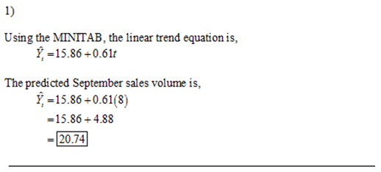

Year 2
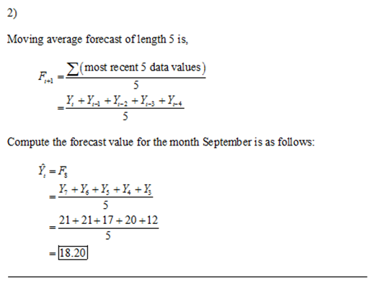

Year 3
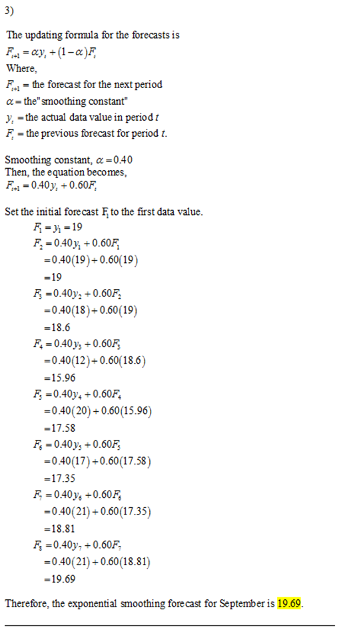
Year 4
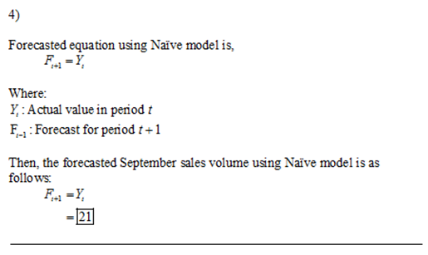

Year 5
