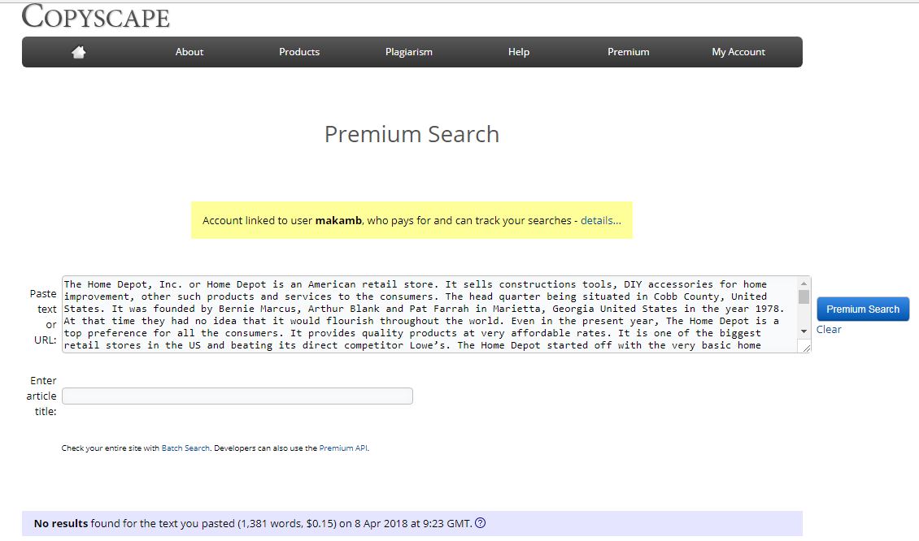
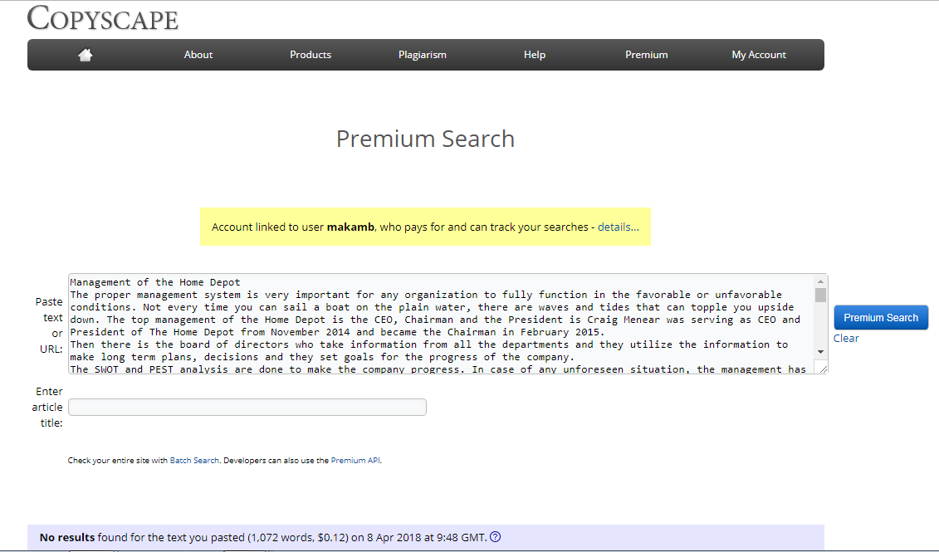

The Home Depot
Research paper
Name
Affiliation

Contents

Contents 2
The Home Depot 3
Accounting Analysis of the Home Depot 4
Finance of the Home Depot 5
Economics of the Home Depot 6
Applied Decision Methods in the Home Depot 7
Legal Issues of the Home Depot 8
Management info System of the Home Depot 9
Management of the Home Depot 10
Marketing Strategy of the Home Depot 11
Conclusion: 13
References 14

The Home Depot
The Home Depot, Inc. or Home Depot is an American retail store. It sells constructions tools, DIY accessories for home improvement, other such products and services to the consumers. The head quarter being situated in Cobb County, United States. It was founded by Bernie Marcus, Arthur Blank and Pat Farrah in Marietta, Georgia United States in the year 1978. At that time they had no idea that it would flourish throughout the world. Even in the present year, The Home Depot is a top preference for all the consumers. It provides quality products at very affordable rates. It is one of the biggest retail stores in the US and beating its direct competitor Lowe’s. The Home Depot started off with the very basic home retailing products and eventually landing into big projects (Hacker, 2006). The company did not flourish over years, and had to struggle a lot to penetrate the market and to beat its competitors.
The interesting fact is that the two owners of the Home Depot were fired from the executive jobs on the same day in the year 1978. They were working in a home maintenance firm. There, they decided to make it a fruitful departure and it was where they set the first stone of the Home Depot. Presently, they have more than 2200 stores in North America only followed by China, Mexico, Canada to mention a few. It has over 400,000 employees. The CEO of the Home Depot is Craig A. Menear.
The competitive edge is their best quality in the lowest possible rates. They have gained customer loyalty over the period of time and have millions of the loyal customers. People order both online and in stores and they always have the best experience. Their return and exchange policies are customer friendly. They have made huge stores worldwide providing almost all the necessities of house hold including plumber tools, gardening tools, paints, flooring, lumber, hardware and many more. For them Home Depot is a platform where people find anything and everything related to homes and construction under a single roof.

Accounting Analysis of the Home Depot
Accounting is basically done through financial statements. It is a process of analyzing the financial status of a company. It is done to see if the company is making profit, reaching the breakeven point or is going in loss. Then, according to these analyses, the boards of directors make the economic decisions for the company. This analysis is basically an indication of the direction that where the company is going and where is it supposed to go. The Home Depot has always focused on the reduced prices, with the growth of the company, there has been a remarkable reduction in the prices if the merchandise (Simpson, 2009).
The financial analysis of The Home Depot for the fiscal year 2017 and the fiscal year 2016 has been stated as:
Fiscal Year 2017
The Home Depot sales grew to 6.7%, making earnings of $100.9 billion. The average sales growth was 6.8% of the entire company whereas; the sale growth in the US itself was 6.9%. An improvement in the sales was observed in the US, Canada and Mexico stores which bought the net earnings to $6.8 billion in the sales as compared to the last year sales. The rapid increase was observed in the online sales as 6.7% of the total sales were done through the online system. The Home Store was very lucky to have gained 45% of the total US i.e. in the year 2017; the 45% of US sales were done by the Home Depot.

Fiscal Year 2016
In the fiscal year 2016, the sales grew to $6.1 billion making earnings of $94.6 billion. This was 6.9% more as compared to the fiscal year 2015. This was the highest earnings ever in the history of The Home Depot. The store sales increase was 5.6% for the company, 6.2% in the US local currency and the rest was generated from the stores in Canada and Mexico. The net earnings in the fiscal year 2016 were $80 billion. As, a result the ROIC return on the invested capital grew 330 and 3.14%. As, it has been observed that the fiscal year 2016 was the golden year as the company earned the highest amount in the company’s history.

Finance of the Home Depot
Finance refers to the money for the business. It is either the fixed capital or the working capital required for the maintenance of the capital and for carrying out a company’s day to day chores.
They are either
- Owner’s funds
- Loan on Long term, Medium term or Short term basis.
- The Equity Share.
The Home Depot Company also has many shareholders like any other multinational company. As mentioned in the financial statement of the company that it had made a lot of profit in the year 2016 so the shareholders got more dividend. In the fiscal year 2016, the net earnings were $80 billion so the earning per share was 18.1 that made $6.45. In this year the company returned $10 billion to the shareholders and the share repurchases were also considered. In the fiscal year 2017, the company made a net profit of $6.8 billion. The earnings per share were $7.29.
As, compared to the last five years where the Home Depot was making considerable progress, but in the last couple of years the progress is commendable. The shares per average increased along with the shareholders and the share repurchases. By analyzing the above mentioned details, for the shareholders, investing in the Home Depot will not be a bad idea.

Economics of the Home Depot
Economics is the study of the scarce resources, which have alternative or many other uses. People are a limited resource but their desires are unlimited. The thinking like what and how can be categorized under this subject. The Home Depot started off with only three stores and now is the fourth largest retailers in the US having a store in the 50 states of only the US, including Mexico, Canada and so many more countries.
The store started off the basic mom-and-pop store, where there was only limited merchandise available. Even at that point, they gave their customers the best customer service so to penetrate the market and to earn customer loyalty. They gave fewer prices for more goods and still they have the same policy. Slowly and gradually they started working with the professional contractors and provided them quality goods and this was where the business was about to enter its boom. They observed that the home maintenance products required moving from shop to shop and it was a hassle, so they addressed this issue by making their company a complete warehouse where the consumers could find almost everything under a single roof.
In the 2006, the company finally progressed to introducing the home furnishing retails. Now, the online orders were starting to initiate as well as the people were demanding custom made goods. The growth of the Home Depot is in contrast to the Wal-Mart sales, which reported a heavy drop in the online sales even in the Christmas holidays (Venugopal, 2018). This was a kick start in the enormous earning of the company. Now, the company was novice in the furnishing field, so they hired professional trainers to train their staff in this field. This lead to a very good profit and the company established The Home Depot Foundation in 2002, where billions of dollars are sent as charity.
After considering the progress of the company, the company decided to excel in their product range and introduced the furnishing department. In order to meet the consumer requirements, they had to hire trainees to train them in this field. It was thus the utilization of the available resources in order gain more profit and to increase their line of products. According to macroeconomics, the rise in the consumer demands lead to more sales which meant that the economy was rising and they can consider increasing their product range. According to microeconomics, by introducing a furnishing range, they started getting more customers and demands rose also the online ordering system was initiated.

Applied Decision Methods in the Home Depot
In this category we have to make certain decisions before investing our large capital in any business. Now, there are many ways by which we can do so. The profit loss statement or the financial statement of a company plays a vital role in taking such decisions. Even the founders of the Home Depot did not decide to open any other business but a one similar form where they had been removed as they had their expertise in that field. Keeping in view the financial statement of the fiscal year 2017, rise in the earnings the company decided to invest more in the stores and the supply chain. Similarly, in the year 2016, the visible profit compelled the company to make an investment in the MRO of the company. These were not part of the long term decision making but these decisions were made as per the company’s profits.
In the year 2006, when the Home depot introduced the furnishing range, it did not invest must much unless there was a positive consumer feedback. After the increasing demand the company had to hire trainees, made other arrangements like increasing spaces, increasing stores and increasing the inventory. So, the company excelled without facing any loses. In order to save the company from avoidable loses; the applied decision making must be very accurate. Here, in this case a small idea was launched and then it expanded with the consumer response. So, it is always a good idea to make practical analysis on a small scale before jumping into huge investments.

Legal Issues of the Home Depot
We cannot overlook a company’s legal department. The legal formalities include the merger of the company, employments, securities, store management, real estate, store operations, management, employment, liquidation, bankrupts and how a company should act under such conditions, individual properties and so many other issues including the political factors affecting the company. They are considered by the legal consultants of the company. At times, the contract is liquefied or the contractor is not fulfilling the terms and conditions and involvement of law is needed. The legal consultant of the company takes care of such matters.
In the case of The Home Depot, a very competent legal consultant is hired. Her name is Teresa Wynn Roseborough. She is responsible for the functioning of the company stores spread worldwide. Her responsibilities include the merger of the company, employments, securities, store management, real estate, store operations, management, employment, liquidation, bankrupts and how a company should act under such conditions, individual properties and so many other issues including the political factors affecting the company and the launch of the new products or the product line.
The legal consultant is very important as the board of directors and the board cannot make any decision without the approval of the legal consultant. The Altman Z score shows that the Home Depot has always scored more than 3 since it was made and is very unlikely to get bankrupt. There are many other assumptions that the legal consultant does, like buying a place to make store for the company would not have been possible without a legal consultant. The Home Store has its own personal legal consultant rather than hiring a new one each time and that doesn’t prove favorable as these people have a lot of confidential knowledge about the company. Even the competitors in case of the Home Depot is Lowe’s and in creating a competitive edge the role of the legal advisor cannot be ignore.

Management info System of the Home Depot
The process of handling the invoices, inventory control, customer traffic control, transactions, goods coming versus earnings, profits and so much more is the responsibility of the management information system of the MIS. In managing a single store it gets very tricky and at times the company might lose some accuracy. The Home Depot had to face this issue. Since the number of stores was huge they had to come up with contingency plans. The KM World awarded the Home depot the August Best Practice Award in the year 1999 for an amazing achievement in production and efficiency.
They had put up 17 microfilm cameras, had to see bills, packaging slips. Freight charges and with the increasing times it was becoming unmanageable. The IS manager of the Home Depot Adam Klein said before the advent of the digital media when every single document was done manually, including every minor to major details. Every year the company was growing from 21% to 235 and the department was dug up in papers and it got absolutely unmanageable. It was where we decided that now the company needs digital management system. (Bolita, August 1999). Also, there is responsibility on the company to handle the customers in the best possible ways.
The Home Depot is serving several responsibilities as,
- Serving the customers in the best possible way
- Taking care of the staff
- Doing ethically right things
- Giving maximum shareholder value
- Entrepreneurial Spirit
- Building strong relationship
It was all compiled under this system, the bigger the company gets, the more complicated the calculations and the MIS gets and for this purpose proper data basis are created so as to make the work quicker and accurate.

Management of the Home Depot
The proper management system is very important for any organization to fully function in the favorable or unfavorable conditions. Not every time you can sail a boat on the plain water, there are waves and tides that can topple you upside down. The top management of the Home Depot is the CEO, Chairman and the President is Craig Menear was serving as CEO and President of The Home Depot from November 2014 and became the Chairman in February 2015.
Then there is the board of directors who take information from all the departments and they utilize the information to make long term plans, decisions and they set goals for the progress of the company.
The SWOT and PEST analysis are done to make the company progress. In case of any unforeseen situation, the management has to come up with the contingency plans.
In 2017, since the Home Depot was progressing so the board of directors increased the value of the shares to 55% and thus decided to make two new stores in Mexico and one in Canada. The management of the Home depot had to come up with the following plans for the stores.
- Efficiency of the Company
Most efficient use of available space for the new product lines, the land used for the stores and where to establish their stores.
- Financial Decisions
The estimated project cost, estimated loses credits, debit, inventory and its depreciation costs.
- The Time and Productivity Ratios
Various customer orders and customizations requires know how of the work and the time required to accomplish it.
- The Preconfigured Storage Designs and Ideas
When there is lack of space but they had to fit in all their merchandise, they had to consider alternate designs for storage space and the ambiance should be welcoming for the customers.
Since the Home Depot had a proficient management, it is progressing by leaps and bounds. An exemplary attitude was also set by the founders which had continued over the passage of time and by keeping their values alive the Home Depot is on the way to progress with every passing year. Their mode of operation is the same old as it was forty years back that they sell quality products in the cheapest price possible but the quality has never suffered.

Marketing Strategy of the Home Depot
Just making a store is not sufficient; we need to introduce it to the public. We need to convince them that why they should buy our products? Also, we need to target our audience. Before launching any products we need to do some test marketing. The Home Depot followed certain marketing strategies to compete their competitors and to earn more customer loyalty.
As it was previously mentioned that the two founders of the Home Depot, Bernie Marcus, and Arthur Blank were fired on the same day from the home maintenance firm from the executive post, so, we can easily infer that it was a well-established firm when they both had just set up the first stone of the Home Depot. There was a big competition awaiting them and apparently it seemed impossible to penetrate the market. But most surprisingly, they not only penetrated but have also given a tough competition to their opponents.
Fiscal year 2017 is the fifth dream successive year of the Home Depot (Dhamdhere, 2016).
- Improved and more stores
- Best quality supply Chain and flawless inventory management
- Competent Decision making skills
- Online Selling
- 24/7 Customer Support
- The Orange Door
- Improved and more stores
The Home Depot has always invested in making more stores but has never sacrificed the quality of the merchandise. It has always emphasized on the concept of one step shop that the consumers should get everything under one roof.
The people have appreciated this concept a lot as the contractors also come and pick up huge stock from a single store and thus save a lot of their time.
- Best quality supply Chain and flawless inventory management
The supply chain is available in the most affordable rates with the highest quality guaranteed. They keep an eye on the consumer feedback and keep their product customer friendly.
- Competent Decision making skills
The management is absolutely chosen and sorted out and there is no corruption and thus the company is making best decisions and thus is flourishing. It is always a pleasure to view the financial reports of the company as there is always good news of the progress.
- Online Selling
The online sales are generating a lot of profit. The Home depot has its own mobile app designed so that it is more convenient for the customers to connect with them.
The Home Depot is going to start the advertising on Pinterest platform where the customers will view the products and order the online. Now, the home depot is investing in digital stores.
- 24/7 Customer Support
The Home Depot specially focuses on the customer support and only for their convenience they have arranged a 24 hours a day and 7 days a week customer support so that none of the customers has to wait or think of any other option for purchasing.
- The Orange Door
  - The Orange Door has been made a charity organization where the Home Depot takes care of the people all over the world. They have a slogan that we bleed orange so as to inculcate the spirit of unity starting from the upper management to the lowest management. Unity is the key factor.

Conclusion:
The year 2017 was also not bad as the online sales grew rapidly and the store is going to invest. The Company says that they will invest around $11 billion or more in the next 3 years in the stores and in the supply chain so as to meet the company’s demand. In the year 2016, $50 billion were invested in the MRO of the company i.e. Maintenance Repair and Operations.
The Home depot also has its own data base where all the stores are managed by a single but a fully comprehensive system. No matter how many stores they open and in how many countries, the MIS will be properly handled and thus the company will keep on progressing. Therefore, it can be concluded that the company is earning a handsome income and the store is a complete success. A good marketing strategy plays a great role to introduce you to your target market.

References
Bolita, D. (August 1999). Home depot builds information effeciency . KM world , Volume 8, issue 8
Dhamdhere, P. (Sep 29, 2016 ). 6 Strategies Behind the Home Depot’s Marketing Domination.
Hacker, J. J. (2006). Evaluation of niche markets for small scale forest products companies. USDA Forest Service and WestCentral Wisconsin Regional Planning.
Simpson, J. W. (march 2009 (revised december 2009)). Relational Investors and Home Depot (A).
Venugopal, A. (February 20, 2018). Home Depot's earnings powered by strong U.S. housing market

