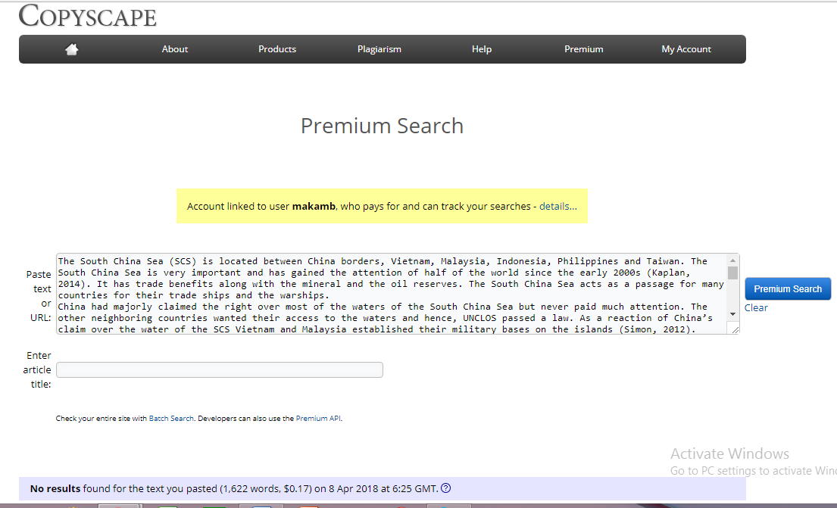

Competition in the South China Sea

Name

Affiliation
Contents

Introduction 3
Background of the South China Sea 3
Proposed Solution 5
Conclusion 6
References 8

Competition in the South China Sea

Introduction
The South China Sea (SCS) is located between China borders, Vietnam, Malaysia, Indonesia, Philippines and Taiwan. The South China Sea is very important and has gained the attention of half of the world since the early 2000s (Kaplan, 2014). It has trade benefits along with the mineral and the oil reserves. The South China Sea acts as a passage for many countries for their trade ships and the warships.
China had majorly claimed the right over most of the waters of the South China Sea but never paid much attention. The other neighboring countries wanted their access to the waters and hence, UNCLOS passed a law. As a reaction of China’s claim over the water of the SCS Vietnam and Malaysia established their military bases on the islands (Simon, 2012). China also gave them tough competitions within a short time but the US interfered in the matter and started assisting the opponents of China heavily.
In my point of view, China should agree with the UNCLOS decision. Also, if China remains adamant, it might trigger war between the countries and as we can see that the US is going to give a tough competition to China and the losses would be beyond repair for all the countries. So, in order to amicably handle the conditions China should kneel down.

Background of the South China Sea
South China Sea issue had been a burning issue since 1990 -2008 and could have led to worst situations, but now the claimant states also consider the fact that by doing so they can upset their terms with the neighboring countries and their trade relations may get affected. So, they want to handle this very delicately. The issue of claiming their rights on the South China Sea is very intricate and should be resolved. The South China Sea is very rich in natural res0urces including oil reserves of around 11 billion barrel, natural gas reserves estimated at about 190 Trillion Cubic feet, and can generate a business of almost about $7 trillion per annum. Moreover, the South China Sea also serves as the shortest route between Pacific Ocean and the Indian Ocean allowing an estimated global maritime trade of around 30%.
These factors are very appealing for any country to claim its right over the sea. Here are given the claims by all the major players in the issue of South China Sea.
China’s Claim:
2000 to 4000 years back, Xia and Han Dynasty records show that the SCS was under the rule of China. In 1947 China demarcated a boundary agreement called the Nine Dash Line which claimed a major part of the sea. As a reaction to this UNCLOS- United Nations Conventions on the Law of the sea passed a law that the water near the boundaries of any country would be under their jurisdiction. The claim of the South China Sea is not based on law but mostly on their own municipal laws on concession (Loja, 2018).
Vietnam’s Claim:
It claims that they had been ruling the Spratley and the Paracel islands since the 17th century. So they have a legal right over the sea.
Philippines’ Claim:
It wants to dominate the Spratley Islands as they are very close to its boundaries and the Scarborough Islands.
Malaysia’s Claim:
It wants the water near its boundaries and also a share in the Spratley Islands.

Brunei’s Claim:
Since Brunei is the farthest of all the countries, it just wants the South China Sea near its boundaries. All the claimants of the South China Sea were involved in making island so as to claim more authority over the Spartley Islands (Davenport, 2018).
Vietnam, Taiwan and Philippines had been investing in the islands since decades and had stationed military forces there. China realized this threat after so many years and within 18 months had made more artificial islands than any of these countries had made in decades and set up its military basis. This diverted the world attention where Malaysia contacted the Permanent Court of Arbitration (PCA) in 2013 and claimed that China is disobeying the parameters set by UNCLOS. In 2016, PCA gave a decision against China. China declared that decision as null and void.
Currently, China has not given a positive response on the decision whereas; the other countries have responded very positively over it. On the other hand, the US is very unhappy about China’s activities. It uses aircrafts and naval vessels for freedom of navigation missions close to China’s Bases. It also provides military and technological support to the opponent countries in order to support them against China.

Proposed Solution
The UNCLOS agreement was very practical all the countries but for China it is not a good idea. According to the Nine Dash Rule China claims to be all in all ruler of the sea and all the benefits would go to China. But if we consider the other decision, China’s share would be divided among the neighboring countries. The claimants should bring up their maritime claims to the law so as to make fruitful decisions (Beckman, 2014).
According to Urchick (2018) there are four factors that will have a major impact on South China Sea in the coming two to three years;
Trump policy in East Asia
Behavior of CCP
Foreign policy of Vietnam
The trends of ASEAN as a collective security organization
The South China Sea is a very rich sea. It has enormous minerals and can be very profitable to the respective country. If we consider the present situation, China might get involved in the war with its opponent countries i.e. Vietnam, Taiwan and Philippines. China has claimed it sovereignty over the lands and the waters of the South China Sea since the ancient times ad sixty years after the China Republic was made. China had peacefully exploring the waters and the land (Li, 2017). These countries are being aided by the United States and China is also very strong country. If they come in a war scenario, it would be a loss of many countries. So, the best way to resolve the issue is by distributing the goodness among all the countries and using the South China Sea mutually with a little more responsibility.
Even if the war takes place, only the victorious country will claim the right over the South China Sea. So it is a do or die situation but currently it is avoidable. Every time initiating a war is never a good idea, for China had never paid much attention on the South China Sea before, so it won’t matter a lot of the neighbors get their share. Recently, China has made artificial islands over the reefs and has expected to claim more authority of power whereas; the countries near those islands are claiming rights over those islands (HO, 2015).
The claims of China were contradicted by Vietnam which claimed to have ruled since 17th century. But presently, it is completely a different scenario and countries should make a mutual decision that is in the favor of all rather than fighting over it and destroying the present resources to get more resources and again it is an assumption but no one knows if actually the sea has so many resources or not. The decision is quite fair that each country can claim the right over the water near their boundaries. By doing so, the trade ships and warships from the Asia and Europe can easily travel and hence the world can claim benefits of the trade.
The World War I and World War II were fought but the world did not see the World war III as it has more disadvantages then the advantages. The issues can be resolved on a table then why to drag a war scenario? But China does not agree to this and wants the entire sea that covers the nine dash lines. Although the US is not directly involved but it is keeping a close eye on the territory of the South China Sea, China must tread through very carefully in order to regain its lost territory (To, 2003).

Conclusion
The South China Sea was under China’s rule unless the world realized its worth. Now, it is an open treat for all the countries that share its water with their boundaries. The UNCLOS agreement said that the countries that share their boundaries with the South China Sea can exercise their right over it till a particular area. The law of the sea was based on two factors first was the sovereignty of the country that how much water body touches its boundaries and secondly, the cannon shot rule that how far their cannons could shoot (Snyder, 2004).
China is not agreeing over it and the US and China is becoming rivals over this issue. In my opinion, the world wide decisions should be made considering the major cause and benefit of all. If China has to withdraw its share keeping a major cause in mind, it shouldn’t remain a dispute anymore. Together we can make this world a happy place to live. Permanent Court of Arbitration in 2016 gave the most important judgment including the ocean navigation rules for other countries and the maintenance of the marine environment (Schoenbaum, October 1, 2016). The peace of the South China Sea is of great significance to China, Southeast Asian countries, and the third-party countries of the Pacific including the United States. However, the current development trend will lead to losses for all parties. Under the current situation, the focus should not be on resolving territorial disputes. Diplomats of all countries must work hard to ease the situation and mobilize all parties to take confidence in establishing measures to ensure peace and stability.

References
Beckman, C. G. (2014). International Journal of Marine and Coastal Law . New Journal Article on South China Sea Disputes , Vol. 29, Issue 2, pp. 193 – 243.
DAVENPORT, T. (2018). Island-Building in the South China Sea: Legality and Limits. Asian Journal of International Law , 76-90.
HO, W. W.-C. (2015). Meritime Safety and Security Law Journal . South China Sea .
Kaplan, R. D. (2014). Asia's cauldron: The South China Sea and the end of a stable Pacific. Random House.
Li, G. (2017 - Issue 1). The origins of the South China Sea issue. The journal of Modern Chinese History , Volume 11.
Loja, M. H. (2018). A Critical Legal Approach to the South China Sea Territorial Dispute. Brill Online books and Journals .
Schoenbaum, T. J. (2016). The South China Sea Arbitration Decision and a Plan for Peaceful Resolution of the Disputes. Journal of Maritime Law & Commerce , vol. 47, No. 4, Pp. 451-77.
Simon, S. W. (2012). Conflict and diplomacy in the South China Sea. Asian Survey, 52(6), 995-1018.
Snyder, C. ( 2004). Maritime Security in the South China Sea. The journal of Conflict Studies , Vol 24, No 1.
To, L. L. (2003 ). Security Dialogue. China, the USA and the South China Sea Conflicts , Vol. 54(2): 201–215 .

