Name
Professor
Course
Date
Being an Introvert is a Good Thing
By Crystal Robello
Topic
A social issue was discussed by a 17-year-old, twelfth-grade girl Crystal Robello. She brought to light a topic that most of us are very reluctant to discuss and motivated the people by her own first-hand experiences and tried to convince that being an introvert is not something to be embarrassed by. The main point if her speech was that great people were also introvert but this mature did not come in their way of being successful. She herself was playing soccer in her school since she was 9.
Appearance
The discussion was made using the first-hand experience. The girl who claimed to be an introvert was talking confidently in front of so many people was very encouraging. She was very clear in her ideas. The intonation, the clauses she took further captured the attention of the audience. The body movement reflected her self-appraisal and that she was not shy being like that. Her simple yet a subtle dress was adding to her confidence level.
Her speech was very effective and it spells bounded the audience to sit back and to listen to her point of view. The speech that made the audience believe her was when she told her own personal experiences and taking them towards the great men of our society. Since many people have this nature, so it was a help and a motivation for them. The best part was that when she emphasized that we should appreciate ourselves and that we should not change our inborn habits just because of the people around us.
Authority
You cannot convince an audience until you have examples to prove the authority of your topic to your audience. Simple phrases like great minds think aloud and that many leaders like Abraham Lincoln and Gandhi were introvert yet very successful leaders. Her consideration of the point that being shy should not mean that you are less competent than others. She gave example if Emma Watson and Albert Einstein that these people are prominent examples in the society, yet they were introvert. Their habit of being introvert did not hinder their way to success. So we need to be proud of it rather feeling ashamed. If we cannot start a conversation about making many friends this doesn’t mean that we are different people. Her speech ended with the words that if we see any introvert sitting alone, we should bot he unhappy about it as they are up to something great.
Credibility
Crystal Robelle opened her conversation with the most relatable issue that such introvert people couldn’t think of a topic to discuss with her friends. Although people keep nagging them for being quiet they cannot help it. They like to be alone but such people who make up 50% of American population want to stay alone in their homes but they are not lonely. They are deep thinkers and they have great ideas.
An introvert person has a different point of view than extrovert and her emphasis was that one should be very proud of it. They can be good leaders and they can also be good followers. She consoled the people that it is good to have your own point of view and if you are not sharing them with others, this is okay and you should be happy about it rather than start changing yourself.

Work Cited
https://youtu.be/zKSXOSQEcoo
https://youtu.be/sfjN15zsPyQ
https://youtu.be/0oAJsPFH2wk

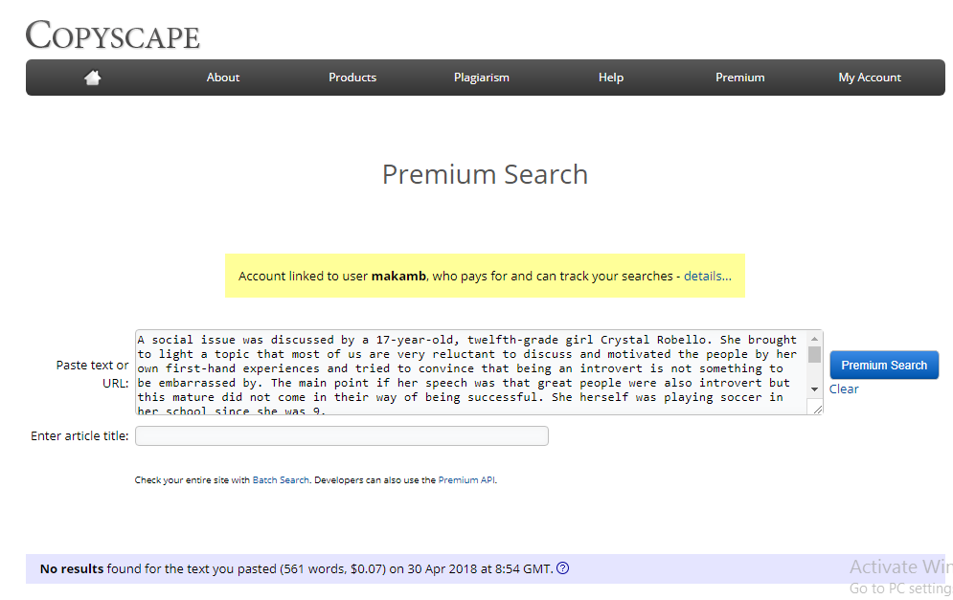
Plagiarism Report

