Lab Report

Name

Date

Lab Report

Abstract:

From the Bernoulli's theorem when a fluid that is incompressible, ideal fluid is flowing steadily along a flow tube, the velocity of the flow increases, while the static pressure of the fluid will decrease; therefore conversely, the flow velocity will decreases and the static pressure of the fluid increases. However, the sum of the static pressure and the dynamic pressure of the fluid is always called the total pressure. The Bernoulli theorem is the basis for the takeoff principle of an airplane. This experiment implements Bernoulli’s theory and gathers readings. The method and results are recorded and presented to make sure that things are recorded.

Introduction:
The Bernoulli equation is an equation that expresses the mechanical energy conservation of a moving the fluid is obtained by taking the integration of the equation of motion along the streamline when the ideal positive pressure fluid is stationary under the action of the force. Due to the famous Swiss the name D. Bernoulli was named in 1738.
p + ρgz + (1/2) * ρv ^ 2 = C
p, ρ, v = pressure, density and velocity of the fluid;
z = vertical height;
g = gravity.
The above equations represent the pressure energy p, gravity potential energy ρgz and kinetic energy (1/2)*ρv ^2 of the fluid per unit volume, respectively. During the movement along the streamline, the sum remains the same, that is, the total energy is conserved. However, the total energy between the streamlines (ie, the constant value in the above equation) may be different.
For gas, the gravity can be ignored and the equation is simplified to p+(1). /2)*ρv ^2=constant (p0), the terms are called static pressure, When it is reduced to zero, the pressure will reach the maximum (theorem should be equal to the total pressure). The wing of the aircraft generates the lifting force, which means that the speed of the lower airfoil is low and the pressure is strong. The airfoil speed is high and the pressure is small, so the force is upward. According to the equation, the total pressure and static pressure of the fluid can be measured to obtain the speed, which becomes the principle of the pitot tube velocity measurement. In the non-rotating flow, the rotation-free condition can also be used. The Euler equations give the same result but the meanings are different.
At this time, the constants are same in the whole flow field, that indicates fluids on the flow lines have the same total energy, and the equation is applicable to any two points of the full flow field. In viscous flow, the viscous friction consumes mechanical energy to generate heat, and the mechanical energy is not conserved. When the Bernoulli equation is promoted, the mechanical energy loss term should be added. The
figure is the aerodynamic experiment to verify the Bernoulli equation.
Procedure:
The experiment started with leveling the apparatus for experiment on the hydraulic bench. After level, we connected the apparatus bay to the bench flow supply. After a successfully connection was created, it was positioned to outflow above the volumetric tank. Then it needed to have the air Purged from the pressure tapping points in the manometer. To do so, closed the bench control and rig flow valves controlled opening of the air bleed screw and the adjacent air valve. Then opened the bench valve and allowed to flow the air through the manometers that purged all the air from vales. Then pulled some air to manometers again till half the length of manometer. Once it was done, pulled the total head probe (Pitot tube) out of the test section. While doing this, we were careful not to bend it completely out of the apparatus.
Then tried to Increase the flow rate that could results in obtaining the maximum difference among readings first manometer and monometer corresponding to throat area. Closed the single valve at the bottom of the volumetric tank. Record the time required to collect 15 Liters of water. Record the reading of manometers A-F in the orange, and 1-6 & 8 in the yellow. While the probe was working properly, we recorded the reading of the manometer and connected to it by traversing the probe along the duct starting at the first pressure tabbing, with 1cm increments, the objective here is trace the decrease in the total pressure along the Venturi. Repeated the above procedure for two additional flow rates, medium, and low.
Results:
Run1: Low flow rate
Volume(m^3) | 0.006 | Time (s) | 18.53 |  | Flow rate(m^3/s) | 0.0003238
Tap# | Prussure Head (m) | Area (m^2) | Velocity(m/s) | Velocity head (m) | Theoretical Pressure(m) | Total Head Experimental (m) | Pobe(if used)*12 (m) | Error%
1 | 0.405 | 0.000616 | 0.525860 | 0.014094 | 0.405000 | 0.419094 | 0.419094 | 0%
2 | 0.37 | 0.000346 | 0.934862 | 0.044545 | 0.374550 | 0.414545 | 0.419094 | 1%
3 | 0.1 | 0.000154 | 2.103439 | 0.225507 | 0.193587 | 0.325507 | 0.419094 | 22%
4 | 0.247 | 0.000222 | 1.460721 | 0.108752 | 0.310343 | 0.355752 | 0.419094 | 15%
5 | 0.305 | 0.000302 | 1.073183 | 0.058701 | 0.360393 | 0.363701 | 0.419094 | 13%
6 | 0.334 | 0.000394 | 0.821656 | 0.034410 | 0.384685 | 0.368410 | 0.419094 | 12%
8 | 0.36 | 0.000616 | 0.525860 | 0.014094 | 0.405000 | 0.374094 | 0.419094 | 11%
Table 1: Title Of The Table
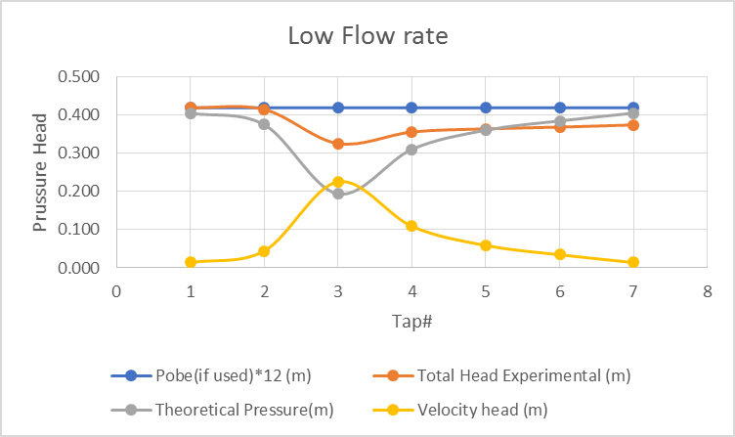
Table 1: Title Of The Table

Run1: Medium Flow Rate
Volume(m^3) | 0.006 |  | Time(s) | 17.88 |  | Flow rate(m^3/s) | 0.00033557
Tap# | Prussure Head(m) | Area(m^2) | Velocity(m/s) | Velocity Head(m) | Theoretical Pressure(m) | Total Head Experimental(m) | Theoretical (m) | Erorr%
1 | 0.43 | 0.000616 | 0.544977 | 0.015138 | 0.430000 | 0.445138 | 0.445138 | 0%
2 | 0.39 | 0.000346 | 0.968847 | 0.047842 | 0.397295 | 0.437842 | 0.445138 | 2%
3 | 0.06 | 0.000154 | 2.179906 | 0.242201 | 0.202936 | 0.302201 | 0.445138 | 32%
4 | 0.24 | 0.000222 | 1.513824 | 0.116802 | 0.328335 | 0.356802 | 0.445138 | 20%
5 | 0.311 | 0.000302 | 1.112197 | 0.063047 | 0.382091 | 0.374047 | 0.445138 | 16%
6 | 0.345 | 0.000394 | 0.851526 | 0.036957 | 0.408181 | 0.381957 | 0.445138 | 14%
8 | 0.377 | 0.000616 | 0.544977 | 0.015138 | 0.430000 | 0.392138 | 0.445138 | 12%
Table 1: Title Of The Table

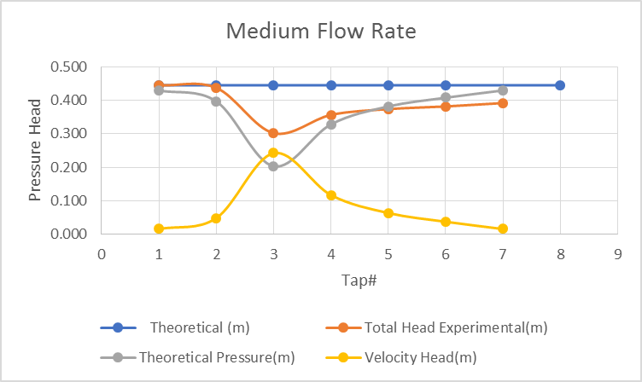
Table 1: Title Of The Table

Run3:High Flow Rate
Volume(m^3) | 0.006 |  | Time(s) | 17.51 |  | Flow rate(m^3/s) | 0.000342661
Tap# | Prussure Head(m) | Area(m^2) | Velocity(m/s) | Velocity Head(m) | Theoretical(m) | Total Head Experimental(m) | Pobe(if)used*12(m) | Erorr%
1 | 0.47 | 0.000616 | 0.556492 | 0.015784 | 0.470000 | 0.485784 | 0.485784 | 0%
2 | 0.415 | 0.000346 | 0.989320 | 0.049885 | 0.435899 | 0.464885 | 0.485784 | 4%
3 | 0.02 | 0.000154 | 2.225969 | 0.252545 | 0.233239 | 0.272545 | 0.485784 | 44%
4 | 0.23 | 0.000222 | 1.545812 | 0.121791 | 0.363993 | 0.351791 | 0.485784 | 28%
5 | 0.318 | 0.000302 | 1.135699 | 0.065740 | 0.420044 | 0.383740 | 0.485784 | 21%
6 | 0.36 | 0.000394 | 0.869519 | 0.038535 | 0.447249 | 0.398535 | 0.485784 | 18%
8 | 0.4 | 0.000616 | 0.556492 | 0.015784 | 0.470000 | 0.415784 | 0.485784 | 14%
Table 1: Title Of The Table

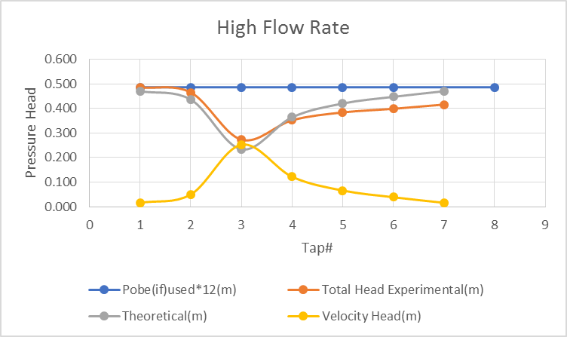
Table 1: Title Of The Table
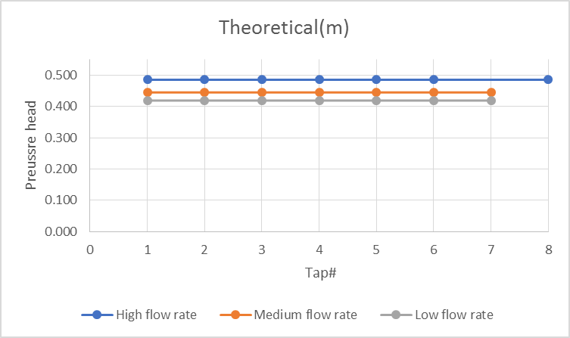
Table 1: Title Of The Table

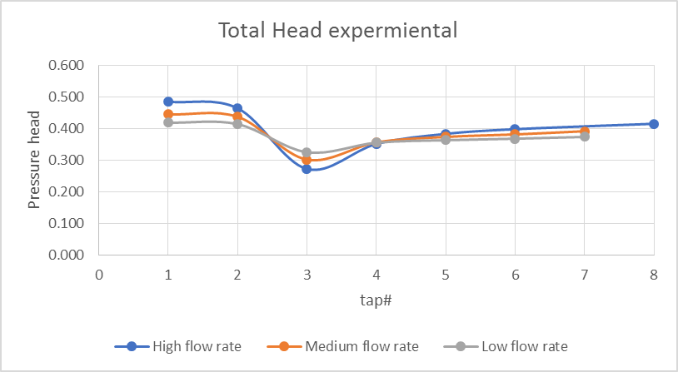
Table 1: Title Of The Table

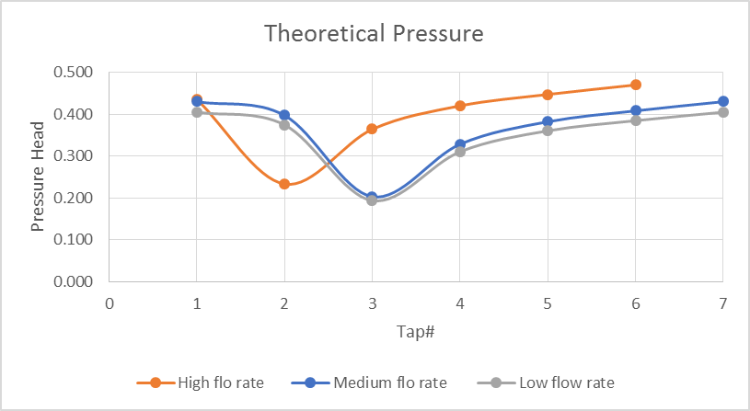
Table 1: Title Of The Table
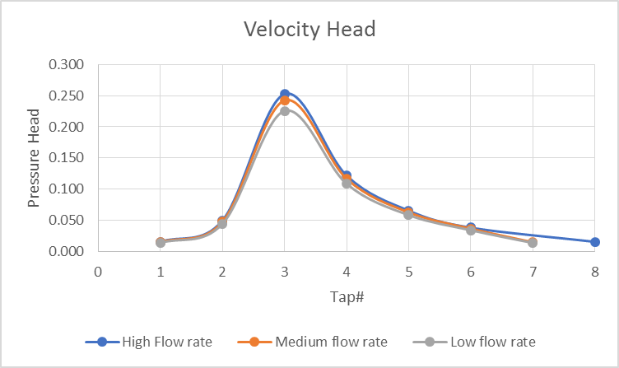
Table 1: Title Of The Table
Conclusion:
Bernoulli deduced the Bernoulli equation from the behavior of observing liquids, but his equations can only be applied to incompressible fluids, and fluids that are compressible but have very slow flow rates (maybe up to 1/3 of the speed of sound) . Using basic physical principles, similar equations can be developed to apply to compressible fluids. Here are a few similar to the law of hard work that can be applied to equations in different fields. Their derivation uses only the basic laws of physics such as Newton's second law and the first law of thermodynamics. The experiment proved the equation with data provided.

