Statistics
Name
Affiliation

Statistics
Exercise 27
SPSS was used to analyze the data given in the textbook (Table 27-4)
Q1.
Answer.
The mean age of the sample data is 56.5 years. Mean is calculated by adding up all the values and then dividing the sum obtained by total number of values.
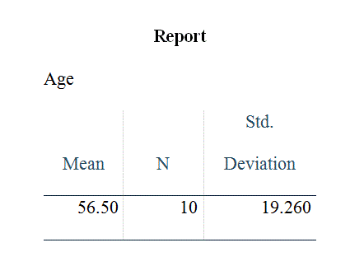
Q2.
Answer.
SPSS analysis shows that 20% (2 out of the total 10) patients never used tobacco.

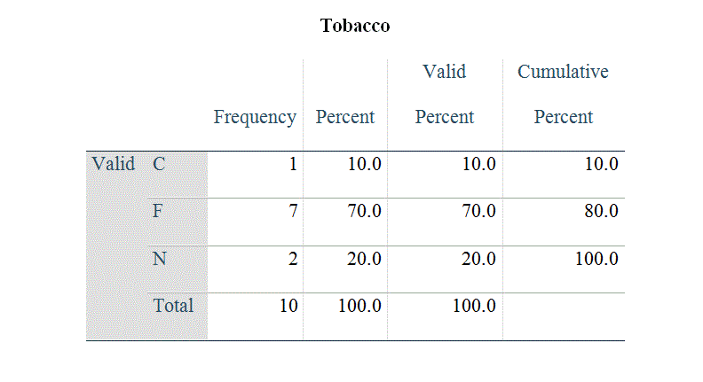
Q3.
Answer.
Through SPSS analysis, standard deviation of the age is calculated to be 19.260
Q4.
Answer.
In the given case, a subject having abnormally low or high age from the mean sample would have been tagged as an outlier. Outliers basically skew the data and causes difficulties in interpreting the results. To check out the outliers in a given population, interquartile range of the distribution can be calculated and any age lying outside the interquartile range by 1.5 times would be the outlier. None of the patients’ age is 1.5 times outside the interquartile range, therefore there are no outliers in the ages of given population.
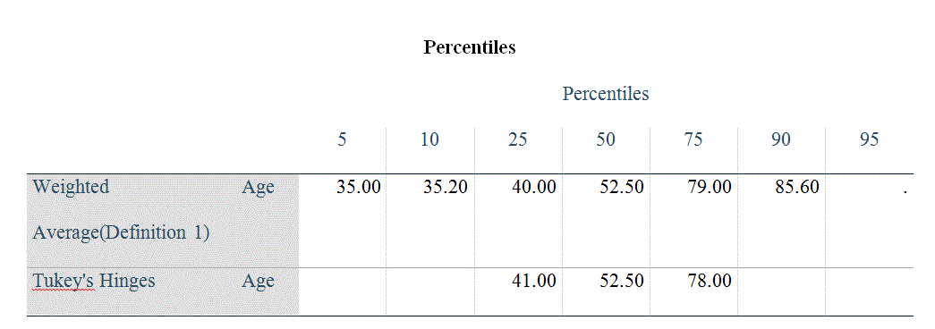
Q5.
Answer.
The range of the age values as calculated through SPSS is 51. Range of a given value is calculated by subtracting the lowest value from the highest value. In the given case, lowest age value is 35 and highest is 86.
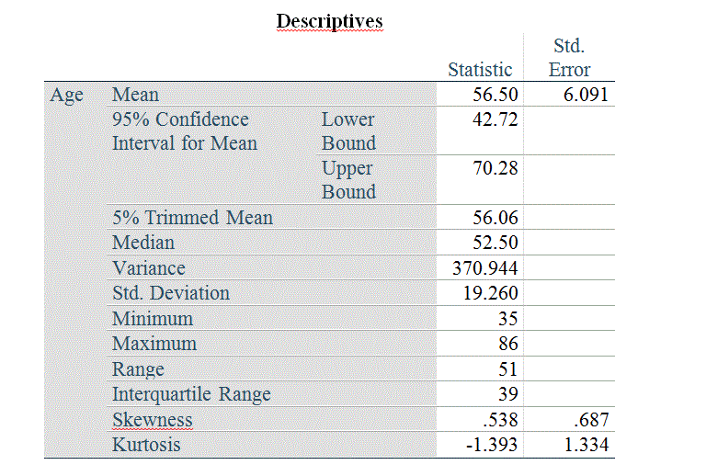

Q6.
Answer
SPSS analysis shows that 30% (3 out of the total 10) patients were taking Infliximab.
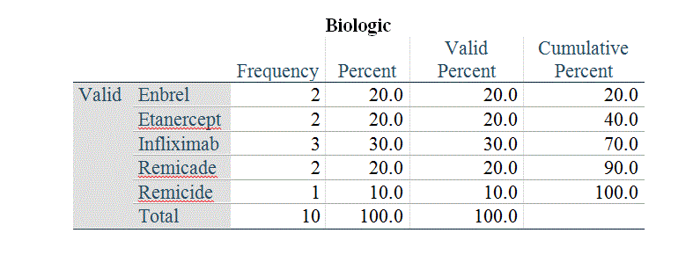
Q7.
Answer.
SPSS analysis shows that 50% (5 out of total 10) patients had Rheumatoid Arthritis as their diagnosis
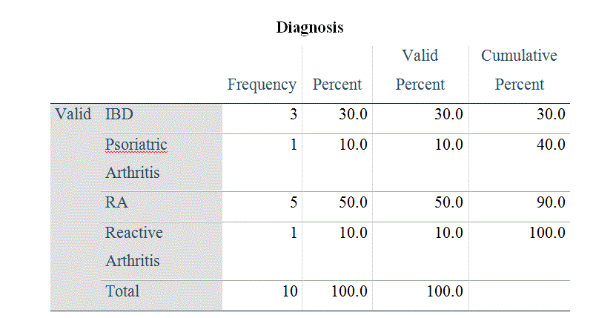
Q8.
Answer.
As per analysis of the given data through SPSS, 30% (3 out of total 10) patients had irritable bowel syndrome as their primary diagnosis.

Q9.
Answer.
The descriptive statistics for age performed through SPSS shows that 95% confidence interval (CI) for age is 70.28 for upper bound and 42.72 for lower bound.
Q10.
Answer.
The statistics performed through SPSS for Diagnosis shows that 10% (1 out of total 10) patients had psoriatic arthritis as their primary disease.
Exercise 6
Q1.
Answer.
According to the Table 1, background characteristics and use of medication for patients with stable chronic obstructive lung disease classified in patients with moderate and severe airflow limitation, on page 61 of the textbook, frequency of the COPD patients in the severe airflow limitation group who are employed in the Eckerblad et. al. (2014) study is 7 and the percentage of the same is 14%.
Q2.
Answer.
As per the text under “relevant study results” on page 60 of the textbook, the retired percentage of the total sample is 61% and 15% of the total sample is on sick leave.
Q3.
Answer.
Total sample size of the study, according to the text under “relevant study results” on page 60, was 91 patients. The frequency of the total sample still employed, as shown in the table 1 on page 61 of the textbook, was 14out of which 7 were from moderate group and 7 were from severe group. The percentage of the total sample still employed was 15% (14 divided by 91 and multiplied by 100).
Q4.
Answer.
The total percentage of the sample with smoking history is 97% [(88/91)*100]. The smoking history for studying participants is clinically important because smoking is a major known cause of COPD (Chronic Obstructive Pulmonary Disease). The individuals/patients with a smoking history and are still smoking have higher worsening symptoms or exacerbation of the systems during the study.
Q5.
Answer.
Pack years of smoking is used as a standard way for quantifying the pack of cigarettes that someone has smoked during her or his lifetime. Smoking 1 cigarette pack per day for a whole year is equivalent to 1 pack year. Therefore, if someone smokes a half pack of the cigarettes per day for 6 years, that would be 3 pack years. When it comes to severe and moderate airflow limitation groups, there is no difference between them regarding pack years. The p value present next to the means values helps in determining this. IN present case, p value is 0.177 which is greater than 5% level of significance.
Q6.
Answer.
The four most common psychological symptoms reported by this sample of patients with COPD were feeling sad (22%), feeling irritable (28%), worrying (33%), and difficulty sleeping (52%). Further, there were no significant differences noted in the occurrence of psychological symptoms between the patients with moderate and severe airflow limitations.
Q7.
Answer.
The frequency and percentage of the total sample using short-acting β ₂ –agonists was 45 (13 for moderate airflow limitation group and 32 for severe airflow limitation group) and 49% respectively.

Frequency
Moderate airflow limitation group = 13
Severe airflow limitation group = 32
Total 45
Percentage
(45/91) * 100 = 49%
Q8.
Answer.
Yes, there is a significant difference between the severe and moderate airflow limitation groups regarding the use of β ₂ –agonists. The p value for the comparison two frequencies in this study suggests that the severe airflow limitations group has significantly higher number of people who reported use of a short-acting β 2 –agonist.
Q9.
Answer.
Yes, the percentage of COPD patients with severe and moderate airflow limitation using short-acting β 2 –agonists was according to my expectations. I expected this because patients with severe COPD have more severe airflow limitations and also more prone of having acute-exacerbations. As a result of likeliness of having more acute-exacerbations, they are more likely to have short-acting β 2 –agonists for prevention. This is also recommended by the National Guidelines Clearinghouse who provides the information from the American College of Chest Physicians on COPD.
Q10.
Answer.
Yes, these findings are ready as well as helpful for utilization in the practice because they have provided a relative frequency and percentage of symptom experience along with medication use for the patients with severe or moderate COPD. Although, there is no information provided regarding the treatment or therapy, they still serve as an informative piece regarding the probability of symptoms for those suffering with COPD.

Exercise 8
Q1.
Answer.
Mean of any data is the average of the total. In the present case, mean of the given data is 576 that is calculated by adding all the given values and then dividing the sum by the total number of values.
Mean (X) = (563 + 593 + 606 + 520 + 563 + 610 + 577) / 7
X = 4032 / 7
X = 576
The median is the middle value of any given data when it is arranged in a particular order. The median of the given data in present case is 577, and it is calculated by arranging all the given values in ascending order and then picking the middle value (Median).
Median (X) = Middle value in the list
Median (X) = 520, 563, 563, 577, 593. 606. 610
Median (X) = 577
The mode of the number of the nursing students enrolled in this program is 563 as mode is the number that appears more in a given data.

Q2.
Answer.
As mode is the number/value that occurs more in the given data, therefore, the mode for the variable inpatient complications in Table 2 of the Winkler et al. (2014) study is “AMI post admission for patients admitted with UA”. This complication is found in 8% of the study participants.
Q3.
Answer.
No, the distribution of inpatient complications does not have a single mode. In fact, this distribution is bimodal. First mode of this distribution is “AMI post admission” having a frequency of 21 and second mode is “transfer to ICU” having a frequency of 17. Among all other complications; cardiac arrest (7), AMI extension (6), cardiogenic shock (5), and new heart failure (2), AMI post admission (21) and transfer to ICU (17) are at higher frequencies.
Q4.
Answer.
The three most common cardiovascular medical history events in this study according to Table 1 are previous acute MI (41%), history of unstable angina (45%), and history of CAD (63%). Knowing the frequency of these most commonly occurring events is clinically important because of the reason that they are not always present in the patients at risk. This is because they are not at 100% frequency. Moreover, probability of having ACS (acute coronary syndrome) increases when the above mentioned three events are present at the same time.

Q5.
Answer.
The mean and median lengths of stray (LOS) are 5.37 and 4 days respectively for the participants of this study and this is shown at the bottom of Table 2 on page 82 of the textbook.
Q6.
Answer.
The mean and median for the LOS are not similar as the mean is greater than the median. The greater mean of the sample indicates that there are more patients in sample who have less than 5.37 LOS days. However, as the number of patients in the sample having greater than 5.37 days, the absolute value of days may be greater for these patients in comparison to shifting the average above the median.
Q7.
Answer.
It is indicated by the study results in the introduction that the participants with PVCs greater than 50 per hour with a frequency of 22% experienced the most frequent arrhythmias followed by the non-sustained ventricular tachycardia that was found in 15% of the sample patients.
Q8.
Answer.
The most common arrhythmia in the question 7 is “PVCs greater than 50 per hours” is related to LOS as it is independently predicting an increase in the LOS and the results are statistically significant as value of p is less than 0.0001.

Q9.
Answer.
Study variables “final diagnosis of acute myocardial infarction” and “age greater than 65” were independently predictive of the 50 PVCs (premature ventricular contractions) per hour in this study. This indicates that patients with age 65 or more if diagnosed with acute myocardial infarction (AMI) have more chances of being presented to the hospital with 50 or more premature ventricular contractions per hour.
Q10.
Answer.
According to Table 1, white race is the mode for the given sample with a frequency and percentage of 143 people and 51% respectively. Moreover, the table also indicate that the frequency and percentage of American Indian patients was 23 and 8% only, which is too less as compared to the frequency and percentage of other races. Therefore, because of too less number of American Indians in this study, the study findings cannot be generalized to the American Indians with ACS.
Exercise 9
Q1.
Answer.
The name of measurement method used in the Roch, Dubois, and Clarke (2014) study was “the Caring Nurse-Patient Interaction Short Scale (CNPISS)” that is a quantitative measure. This method has a 5 point scale that ranges from almost always to almost never. High scores in this method indicate that performing caring practices has higher frequency.

Q2.
Answer.
The data collected with the scale (CNPISS) that is identified in the question 1 were an interval measure. A series of numbers can be used to rank the data with same distance among each number. Meaningful information is provided by the distance on the scale.
Q3.
Answer.
Comforting care, relational care, and clinical care were the subscales included in the CNPISS while measuring perceptions of RNs’ Caring Practices. These subscales proved their relevance by finding the differences among the mean values that were reported for the scales. Ability to measure different nursing care aspects add to the importance of these subscales. There are probabilities that nurses may have a strong feeling about one care form like clinical care and may have a relatively less strong feeling towards their relational care with the patients.
Q4.
Answer.
Relational care was the subscale for which the lowest mean was recorded indicating lower interest of nurses in performing relational care practices with their patients.
Q5.
Answer.
The dispersion results for relational care subscale of the caring practices in Table 2 range between 1.00 and 5.00, and have a SD of 1.01 and mean of 2.90. These results indicate that the score were in the range of 1 to 5 and maj0or part of the scores was around 2.90 +/- 1.01.

Q6.
Answer.
Lowest dispersion or variation of scores was observed for clinical care because there was there was lowest difference amongst low and high values that ranged between 2.44 and 5.0 will smallest standard deviation (SD). This shows that there is a direct relationship between SD and sample distribution as when the SD value is smaller the sample distribution is narrower around the mean.
Q7.
Answer.
Comfort care subscale of the Caring Practices had the highest mean with 4.08. These results indicate that in a standard distribution, almost half of the sample size would be around the mean value that is 4.08.
Q8.
Answer
The comparison of overall rating for organizational climate with the overall rating of caring practices shows that they had means of 3.13 and 3.62 respectively with a standard deviation of 0.56 and 0.66 respectively. Further the range of overall rating for organizational climate was 1.75 to 4.67 while overall rating of caring practices had a range of 1.95 to 5.0. The scale used for organizational climate measured the negative or positive perception of the nurses about the organization whereas the frequency of caring practices was measured by the caring practices scale. As both the scales measured different outcomes, a direct comparison is not possible although caring practices had a higher mean value than organizational climate. As per these results, the perceptions made by the nurses were slightly positive and they averaged above the middle score of 2.5 for both overall rating for organizational climate and overall rating for caring practices.
Q9.
Answer
The response rate of 45% in this study is a limitation of the study and not strength because it is indicating the bias involved into the sample population. Moreover, this gives the hints of biasness, in favor or against the organization, which is there in the people who submitted the surveys, or possibly they had their own perceptions regarding care.
Q10.
Answer.
According to the conclusion that researchers made, nurses were performing caring practices regularly as evident from the statement that Roch et. al. (2014) made concluding that “mean scores were either slightly above or well above the 2.5 midpoint of a 5-point scale.” It was also concluded by the researchers that rational care elements had less frequency while they were carried out in comparison to the other care aspects. My practice can be affected by these results as the information from these conclusions can be used for the identification of weaknesses or strengths in a patient care.

