Questions to be graded exercise 10 & 26
Name
Affiliation

Questions to be graded exercise 10 & 26
Exercise 10
Q1.
Answer.
In the Oh et al., (2014) study, the demographic variables that were measured at nominal level were Non-smoker, Non-drinker, Regular exercise, and History of fracture. Moreover, bone mineral density was also measured and nominally categorized as osteoporosis, osteopenia, and normal. Any data that is not a number or is in the form of a list or name is known as nominal data.
Q2.
Answer
In order to explain the body mass index (BMI) in this study, the statistics calculated were weight and height in kilograms and centimeters. These statistics were calculated according the formula of body mass index, which is;
BMI = Weight (kg) / Height (m²)
Height in the study was first calculated in centimeters and was then converted into meters to fit the BMI formula. Therefore, the calculated statistics were appropriately used in the study without causing any differences between the BMI of controlled and intervention groups.
Q3.
Answer.
The mean BMI score for control group were calculated to be 23.38 with standard deviation (SD) of 3.32, and the mean BMI score for intervention group was calculated to be 24.17 with a standard deviation of 2.5. Moreover, the standard deviation of both groups shows that the two means were significantly overlapping with no significant difference being showed by the t score of chi squared score at significance level of less than 5% (0.05). These calculations show that the distributions of scores for BMI for both control and intervention groups in the study were similar.
Q4.
Answer.
The statement “there were no significant differences between the intervention and control groups” given on page 98 of the textbook with reference to table 2 of the study, indicates that there was no significant difference in BMI between both groups.
Q5.
Answer.
The frequency and percentage of the sample that smoked is zero based on the sample size of N = 41 as Table 2 show that 21 out of 21 participants of the intervention group and 20 out of 20 participants in the control group were non-smokers. So the frequency of non-smokers was 41 and percentage was 100%. Moreover, data presented in table 2 also shows that frequency and percentage of non-drinkers was 40 and 98% respectively.
Calculations
Frequency of participants who smoked = 0
Percentage of participants who smoked = 0
Frequency of non-Smoking participants = 21 + 20 = 41
Percentage of Non-Smoking Participants = (41/41)*100 = 100%
Frequency of Non-drinkers = 20 + 20 = 40
Percentage of Non-drinkers = (40/41)*100 = 97.56 * 100 = 98%

Q6.
Answer.
Dual Energy X-ray Absorptiometry (DEXA), also known as Bone Densitometry or Bone Density Scanning method was used for measuring the bone mineral density (BMD) in the study. Along being simple, noninvasive, and quick, this method is a high-quality standard method to measure BMD in medicine. According to a statement in Oh et. al., (2014), these scans have an error rate of less than 1%.
Q7.
Answer.
In order to determine the differences between control and intervention groups for the lumber and femur neck BMS, the mean of the BMD score was calculated. The t-statistics of the difference of the means that was calculated for determining the significance of the difference shows no significance among the differences.
Q8.
Answer.
At the beginning of the study, both control and intervention groups are homogeneous that is indicated by the statement that “there were no significant differences in the baseline characteristics of the intervention and control groups”. Random selection method was used to select the participants for each group and no significant differences are shown by both the groups in baseline characteristics. It is important to have homogeneous groups for testing TLM as heterogeneous baseline characteristics of a group can lead to have a role in BMD instead of TLM.

Q9.
Answer.
Interpretation of the trial results along with statistical power can be impacted by low adherence level. Low adherence from the patients to a particular program can yield underpowered results and reducing the contrast between studies. Due to this the results of the study can be inconclusive or poor. Therefore the statement “the adherence rate to the TLM program was 99.6%”in Oh et. al., (2014) indicates that the results of the study are reliable.
Q10.
Answer.
The information about BMI, wright, height, and age along with some measures of lifestyle are provided but there are chances that the sample of this study is not adequately described. There are certain characteristics like race that would have helped in improving the findings of this study if used for baseline characteristics. Moreover, lack of information about the function of intervention and control group also indicates that the sample for this study was not adequately described.

Exercise 26
Q1.
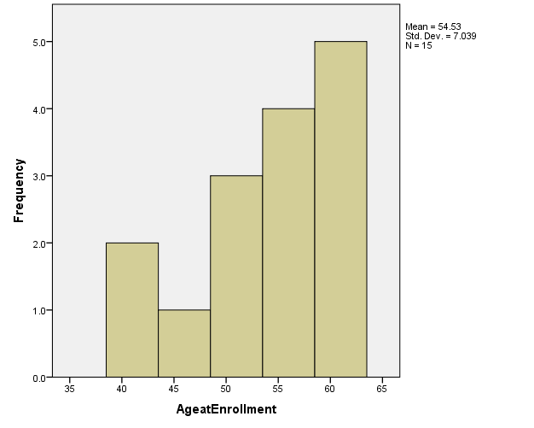
Answer.
SPSS was used to plot the frequency distribution for “Age at Enrollment”
Q2.
Answer.
The frequency distribution for age at enrollment in Question 1 is positively skewed as it has most of the data shifted towards right with most of the data points or distribution on the right side of the graph. Positive skewness in the frequency distribution for age at enrollments indicates that maximum students in the study had an older age at enrollment. If the graph had more data points or distribution on the left side of the graph, than there would have been a negative skew in the frequency distribution.
Q3.
Answer.
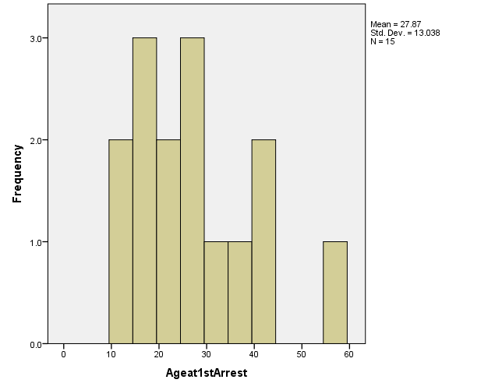
While comparing the original study with n = 20 and the study with smaller dataset of n = 15, we come to know that the study with smaller dataset has less skewed data. The frequency distribution graph of age at 1st arrest for smaller dataset of n = 20 shows more normal distribution as compared to the original skewness statistic. More over the smaller dataset also has lower kurtosis and skewness values as compared to the original study. During interpretation values closer to zero are better irrespective of skewness of the data. For the smaller dataset of n=20, the Shapiro-Wilk test shows a p value of 0.211, which is greater than 0.05 and hence the smaller dataset is well within the distribution.

Descriptive Statistics
 | N | Mean | Std. Deviation | Skewness |  | Kurtosis
 | Statistic | Statistic | Statistic | Statistic | Std. Error | Statistic | Std. Error
AgeatEnrollment | 15 | 54.53 | 7.039 | -.622 | .580 | -.600 | 1.121
Ageat1stArrest | 15 | 27.87 | 13.038 | .990 | .580 | .746 | 1.121
YearsofEducation | 15 | 12.53 | .990 | .658 | .580 | -.936 | 1.121
NumberTimesFired | 15 | .93 | 1.223 | .955 | .580 | -.717 | 1.121
Valid N (listwise) | 15

Tests of Normality
 | Kolmogorov-Smirnovª |  |  | Shapiro-Wilk
 | Statistic | df | Sig. | Statistic | df | Sig.
AgeatEnrollment | .183 | 15 | .192 | .927 | 15 | .248
Ageat1stArrest | .138 | 15 | .200* | .923 | 15 | .211
NumberTimesFired | .311 | 15 | .000 | .737 | 15 | .001
YearsofEducation | .372 | 15 | .000 | .753 | 15 | .001
*. This is a lower bound of the true significance.
a. Lilliefors Significance Correction

Q4.
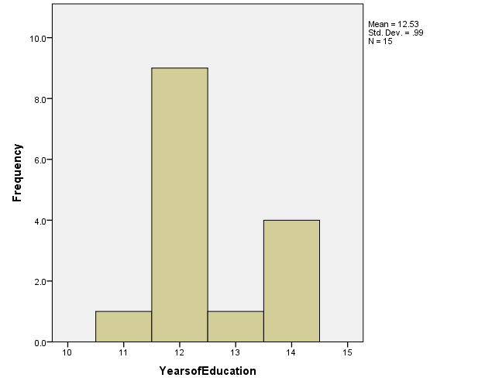
Answer.

Q5.
Answer.
The kurtosis of the distribution in question 4 is leptokurtic because there are higher peaks indicating that results are clustered around the mean indicating a higher kurtosis. Because of this, standard deviation comes out to be smaller than platykurtic or mesokurtic distributions.
Q6.
Answer.
According to the data table given below, the skewness statistics for age of enrollment is -0.62. The negative sign with the skewness statistics value indicates that major part of the tail of data will be distributed at the left of the mean that is also evident in the frequency distribution graph for age at enrollment.
Descriptive Statistics
 | N | Mean | Std. Deviation | Skewness |  | Kurtosis
 | Statistic | Statistic | Statistic | Statistic | Std. Error | Statistic | Std. Error
AgeatEnrollment | 15 | 54.53 | 7.039 | -.622 | .580 | -.600 | 1.121
Valid N (listwise) | 15

Q7.
Answer.
According to the table given below, the kurtosis statistics for years of education is -0.936. The negative sign with the kurtosis statistics value for years of education indicates that the distribution has light tails and the data is mostly concentrated around the mean. This value has a magnitude of almost 1 but it is a little less than 1, which indicates that kurtosis has a moderately high value.
Descriptives
 |  |  | Statistic | Std. Error
YearsofEducation | Mean |  | 12.53 | .256
YearsofEducation | 95% Confidence Interval for Mean | Lower Bound | 11.98
YearsofEducation | 95% Confidence Interval for Mean | Upper Bound | 13.08
YearsofEducation | 5% Trimmed Mean |  | 12.54
YearsofEducation | Median |  | 12.00
YearsofEducation | Variance |  | .981
YearsofEducation | Std. Deviation |  | .990
YearsofEducation | Minimum |  | 11
YearsofEducation | Maximum |  | 14
YearsofEducation | Range |  | 3
YearsofEducation | Interquartile Range |  | 2
YearsofEducation | Skewness |  | .658 | .580
YearsofEducation | Kurtosis |  | -.936 | 1.121
Q8.
Answer.
As shown in the table given below, the Shapiro-Wilk statistic for number of times fired from job is 0.001, which indicates that the distribution for number of times fired from is not standard. The Shapiro-Wilk statistic is basically used for testing deviation from a standard deviation and it can be used to identify the normality of a distribution if the p value is less than 0.05.
Tests of Normality
 | Kolmogorov-Smirnovª |  |  | Shapiro-Wilk
 | Statistic | df | Sig. | Statistic | df | Sig.
AgeatEnrollment | .183 | 15 | .192 | .927 | 15 | .248
Ageat1stArrest | .138 | 15 | .200* | .923 | 15 | .211
NumberTimesFired | .311 | 15 | .000 | .737 | 15 | .001
YearsofEducation | .372 | 15 | .000 | .753 | 15 | .001
*. This is a lower bound of the true significance.
a. Lilliefors Significance Correction

Q9.
Answer.
The Kolmogorov-Smirnov statistic is inappropriate to report for these example data because it is used for the data that are larger in siz3, usually greater than 2000, as compared to the given example.
Q10.
Answer.
Having low skewness and significant Shapiro-Wilk statistics at p < 0.05 is a common thing to happen. Skewness just describes the deviation of graph tails from the mean and in case that the skewness is low; both tails will be nearly equal in their deviation from the mean. At the same time, a significant Shapiro-Wilk value explains the overall distribution shape, which means that, no particular distribution type is followed by the data or data may be non-parametric.

