Challenge
Interaction Plot
Name
Affiliation

Interaction Plot
Example Used
Studying impact of study time and sleep time during an exam on exam performance
 |  | Study Time
Sleep Time |  | 1hr | 2hrs | 3hrs | 4hrs | 5hrs | 6hrs | Average
Sleep Time | 4hrs | 46 | 50 | 52 | 54 | 57 | 60 | 53.16666667
Sleep Time | 5hrs | 48 | 54 | 58 | 64 | 70 | 80 | 62.33333333
Sleep Time | 6hrs | 50 | 55 | 60 | 65 | 75 | 92 | 66.16666667
Average |  | 48 | 53 | 56.6667 | 61 | 67.3333 | 77.3333
Variables
Independent
Sleep Time
Study Time
Dependent
Exam Performance
Interaction Plot
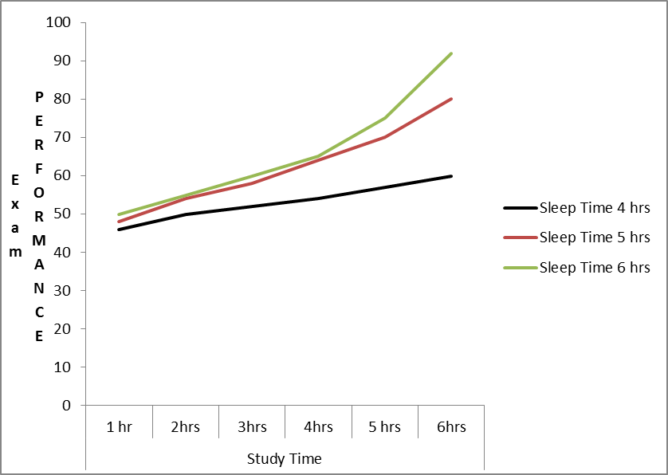
Before plotting an interaction plot, it is important to know some basics like which factor to plot on which axis. The independent variable having more levels is always plotted on horizontal axis, the abscissa that is simply known as x-axis. The dependent variable is plotted on “y-axis”

Explanation of the Interaction Plot
In the interaction plot, variable “Study Time” is presented on “X-Axis” and “Exam Performance” of “Y-Axis” whereas variable “Sleep hours” is represented by curved lines.
The interaction plot illustrates a significant difference in exam performance due to a change in study time hours and sleep time hours indicating existence of a positive interaction between the dependent and independent variables. When sleep time is 1 hours and study time is 4 hours, exam performance is at the lowest and when study time is 6 hours and sleep time is also 6 hours, exam performance is at the highest mark. It appears from the interaction plot that as the study time increase, exam performance gets better for all levels of sleep time however the effect is greater when sleep time increases to 6 hours.
If we calculate the average exam performances across all three levels of sleep time, exam performance, on the average appears better following a 6 hours’ sleep time with an average of 66.16 followed by 5 hours sleep time. Lowest average among the three levels of sleep time for 4 hours indicates lowest performance. The average exam performances for 6 levels of study time are 48, 53, 56.6667, 61, 67.3333, and 77.3333 respectively. The difference between the 3 levels of sleep time is the “sleep time main effect” whereas the difference in exam performance as a function of study time is the “study time main effect”. The much better study time effect for 6 hours group as compared to the 1 hour group is the “sleep time by study hours” interaction
If we simple look at the 6 hours study time level we see better exam performance with the increase in study time hours. This is “study time simple effect” for 6 hours sleep time group. There is a comparatively smaller study time simple effect for 1 hour group. Similarly, if we look only at the 6 hour study time, the exam performance gets better with increase in the sleep time hours. This is the “sleep time simple effect” for 6 hours study time group. The sleep time simple effect for 1 hour study time group is marginal.

Reference
Slutsky, D. J. (2014). The effective use of graphs. Journal of wrist surgery, 3(02), 067-068. https://www.ncbi.nlm.nih.gov/pmc/articles/PMC4078179/

