Questions to be graded
Exercise 18 and Exercise 33
Name
Affiliation

Exercise 18
Q1.
Answer.
The group degrees of freedom (df) is calculated by using the formula “df = k - 1”, where “k” is the number of groups in the study. The formula used to calculate error degrees of freedom is “error df = N – K”, where “N” is the number of participants and “k” is the number of groups. These formulas are given in chapter 18 under the heading “statistical technique in review”, on page 180 of the textbook. In the Mayland et al. (2014) study, the number of participants is 255 and number of groups is 3. So using the df formula, group df is 2 whereas error df is 252.
Group df
df = k – 1
df = 3 – 1
df = 2
Error df
Error df = N – k
Error df = 255 – 3
Error df = 252
Q2.
Answer.
According to the Table 3 on page 183 of the textbook, the F and P value for spiritual need – patients are 38.1 and <0.0001 respectively. As the alpha (α) in this study is 0.05, any results having a probability p ≤ 0.05 is considered as statistically significant, therefore the probability value of p = <0.0001 indicates that it is statistically significant.
These results mean that a statistical significant difference exists among the group that is compared to other groups in terms of spiritual need – patient.
Q3.
Answer.
As given in the Table 2 of on page 182 0f the textbook, the post-hoc result for facilities for the hospital with LCP vs. the hospital without LCP is p = 0.85, which is above the alpha level of significance α = 0.05 and therefore the means for this comparison are not significantly different. Since it is must for all the hospital facilities to have a standard of care meaning that all facilities must be analogous and therefore, in my opinion this is an expected fining.
Q4.
Answer.
The assumptions for using ANOVA include normal distribution of the sample, mutual exclusiveness of the groups, equal variance of the groups, independent observations, and dependent variable must be in a ratio or interval.
Q5.
Answer.
The variable syndrome management has the result F = 10.6, p < 0.0001 on the Table 3. These values indicate that there is one group that is significantly different from the other two groups. From this it could be inferred that one of the groups had either significantly better or worse symptom management at the end of life.
Q6.
Answer.
Maryland et al. (2014) only used ANOVA for analysis and t-tests were not applied. Since multiple groups were compared in the study, therefor not using t-tests was an appropriate decision by Maryland et al. (2014). Using t-tests would have been inappropriate because we can compare only two means with t-tests. This suggests that the researcher would have needed multiple t-tests to get results and reach to a conclusion that on the other hand would have raised the probability of Type-1 error.
Q7.
Answer.
Tuckey’s HSD was performed as the post hoc analysis in the given study. Tuckey’s HSD is less conservative as compared to the Scheffe test. Although Scheffe test is helpful in preventing Type-1 error, it may have a negative impact on detection of true difference by hiding the detection.
Q8.
Answer.
The null hypothesis of care for three study groups is “care would be equally quantified across all three groups under study”. The F and p values of F = 35.9 and p ≤ 0.0001 suggests that the null hypothesis should be rejected as the p value is less than the alpha (α) value.
Q9.
Answer.
The post hoc results for care indicate that Hospice is significantly higher with regards to care as compared to the hospital without LCP and hospital with LCP. The comparison between hospital with LCP and hospital without LCP suggests that care was significantly higher for hospital with LCP as compare to the hospital without LCP.
Q10.
Answer.
From the study findings that are presented in the Tables 2 and 3 indicates that communications, the ward environment, facilities, and care has the significantly higher results all through the end of life care. On the other hand, symptom management or control has no difference while comparing hospice to hospitals with LCP, however differences are significant when hospice is compared to the hospitals without LCP protocol. From these results it is evident that hospice has higher applicability and suitability as compared to the hospitals for handling the patients who are at last stages of their life.

Exercise 33
Q1.
Answer.
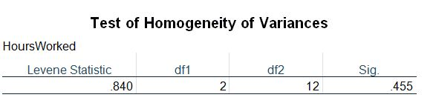
The test of homogeneity of variance performed using SPSS indicates that the data meets the criteria for homogeneity of variance as the p value is greater than α = 0.05. Greater p value means that there is no significant difference among the variances of three groups.
Q2.
Answer.
The frequency distribution of the dependent variable, post treatment hours worked indicates that the shape of the distribution is unimodal. 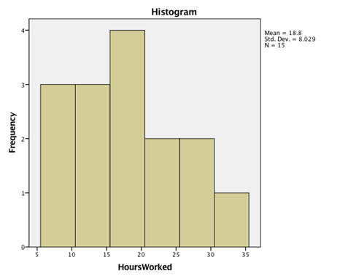
The result of the Shapiro-Wilk test of normality for the dependent variable is 0.934.

Tests of Normality
 | Kolmogorov-Smirnovª |  |  | Shapiro-Wilk
 | Statistic | df | Sig. | Statistic | df | Sig.
HoursWorked | .206 | 15 | .085 | .934 | 15 | .314
a. Lilliefors Significance Correction

Q3.
Answer.
The means for three groups, Supported, TAU Observational, and TAU Randomized are 14.60, 15.20, and 26.60 respectively.
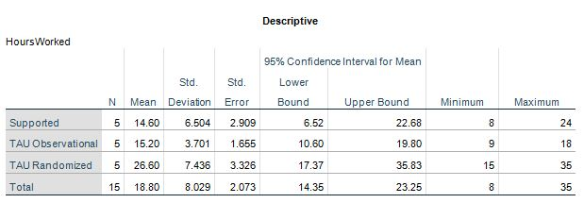
Q4.
Answer.
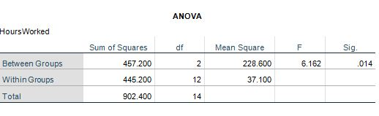
The given set of data has a F value = 6.162, group df = 2, and error df = 12
Q5.
Answer.
As indicated in the ANOVA table, F value for the given set of data is 6.162 with a p value of 0.014. This clearly shows that p value is less that α = 0.05 hence the F value is significant at given level of significance, i. e., 0.05.
Q6.
Answer.
The exact likelihood of obtaining an F value at least as extreme as or as close to the one that was actually observed, assuming that null hypothesis is true, is 6.162 with a p value =1.4% or 0.014.
Q7.
Answer.
The TAU Randomized group worked the most weekly job hours post-treatment with a mean job hours of 26.60. Moreover, the results of the Tuckey HSD test gives a p value of 0.023 for the pair of group 1 and group 3, and 0.030 for the pair of group 2 and group 3 indicating that both are significant at 0.05 level of significance. This helps in concluding that TAU Randomized group worked the most weekly job hours post-treatment.
Q8.
Answer.
All the three groups were found significantly different when ANOVA test was performed on the number of hours worked post treatment and F and Values were 6.162 and 0.014 respectively. The Tuckey’s HSD test for post hoc comparison indicated that TAU randomized group worked significantly the most hours as compared to the other two groups; supported and TAU observational. The mean hours worked for TAU randomized group was 26.60, for Supportive group was 14.6, and for TAU observational it was 15.2 hours. Both the supportive and TAU observational groups had no significant differences with respect to hours worked.
However, there were no significant differences between the Supported and TAU Observational group.
Q9.
Answer.
There is no difference in my final interpretation when comparing the results of the LSD post hoc test and TUCKEY HSD test because both tests show same significant values indicating that TAU randomized group has significantly higher mean work hours as compared to the supportive and TAU observational groups. The p values for LSD test and Tuckey HSD test are 0.009 and 0.023 respectively indicating a significant difference among the groups.
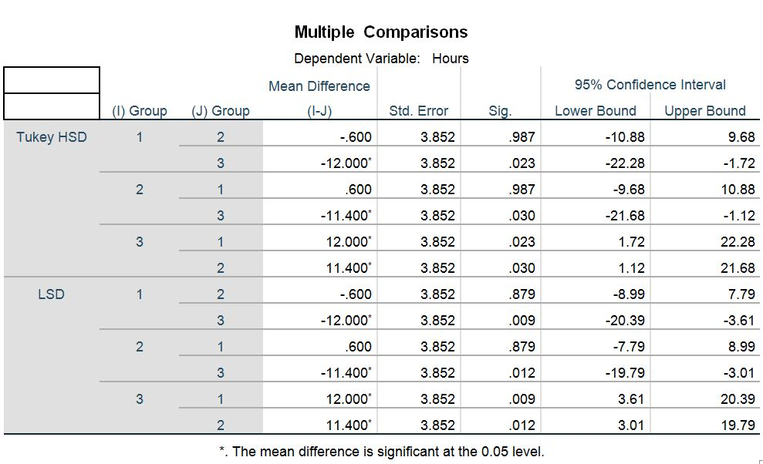
Q10.
Answer.
When there are more than two groups, it is appropriate to use ANOVA as it is used for comparing data among two or more than two groups to determine the differences. In the scenario when the researcher decides to combine the two groups, a t-test could be used as the appropriate statistics as a t-test is used for comparing the means of two nominal groups having a rational or interval data. However using a t-test increase the risks of type-1 error, therefor ANOVA is more appropriate as it reduces the risk of type-1 error.

