Methods of Inquiry
Name
Affiliation
Date

Methods of Inquiry

Quantitative Methods of Inquiry
Quantitative methods of inquiry are those methods that are used to get the numeric, statistical or mathematical data of some research. This data is very precise and can be collected through questionnaires, survey sheets, polling or even by using the previous statistical data and deriving the fresh data based on the previous trends. The computational skills are required in this technique and they present a clear view of the future of an organization (Quinlan, 2018).

Pros & Cons of using Quantitative Methods
The quantitative methods have some advantages that compel the author to use this method. The basic advantage is that it provides a platform for a vast study and that it involves more data and the result is quite generalized. Since the summarized form of data is provided so the results are reliable. Moreover, it is very quick and cost-effective, as the already available data is to be processed. It gives us a clear picture of the future and the businesses use quantitative data to make future decisions (Allwood, 2012). While the cons are that a comparatively smaller sample size is to be tested.
The results give us a glimpse of the future, but they are not 100% correct. The data of the previous terms are used to make a guess about the future and the businesses cannot fully rely on this method regarding their business transactions (Allwood, 2012). Nowadays, before taking any decisions regarding the business and the investment, the managers would look at the quantitative analysis of the company and on their basis, they predict the future and make decisions accordingly. According to Miles, Hubeman, & Saldana (2014) the qualitative data is very general as compared to the quantitative data which is very precise and accurate.

Popular Methods of Quantitative Research Methodology
There are a few popular methods for quantitative research. In any organization, the experimental design is being created. The Quantities methods of data collection are divided into four parts; descriptive, correlational, quasi-control experiment, and experimentation (Kateraas, & Madelius, 2015). Quantitative research methods use multivariate statistical analyses of numeric data to generate results which are responsive to the defined research question, which is divided into four types. The Descriptive Design; where no hypothesis is created, and the researcher would create the hypothesis after the collection of the data. Usually, such a reading is done when one is searching about the variable is the nature.
A Correlational Design is referred to the design in which the variable is measured in the form of statistical data (Marczyk, DeMatteo, & Festinger, 2017). The variables are usually measured by observation. A Quasi-Experimental Design is often known as the Casual-Comparative. It makes a cost-effective relationship between two variables. The researcher would not limit the variable to a single group, nor does he play with the independent variable. He would only compare the results of the groups that were not depending on the variable.
So, it is kind of an open measurement design, lastly, the Experimental Designs that are also called the experimentation (Brannen, 2017). This design uses the scientifically proven methods to determine the cause and the effect and their relationship in a group of variables. The researchers would make a point that all the variables must be kept constant except the one which is being used to find the measurement. After that, the effects of the dependent and the independent variables are collected and compared, and their relationship is derived.

Primary and the Secondary Data Collection
Primary data is the data that is in the raw form. It is collected directly by the researchers who are performing the experiments and the readings are according to the experiment performed. This data comes from the first-hand experience of the researcher. While, the secondary data collection is the data design which is already available from the previous researches. These are collected from the research purposes and one does not have to perform the experiments to get the secondary data (Le Tran, Seymour, Riecken, & Abbas). The common sources are the census data, the information collected in any office, organizational data etc.

Advantages and Disadvantages of Primary and the Secondary Data Collection
The primary data is the first-hand information and it gives us the fresh readings. The researcher has full control over the experiment. Wile, the disadvantages are that it is very expensive and at times one must outsource other people to help in the experiment. The secondary data is time and cost effective (Johnston, 2017). It is in the form of company reports or the diary. These sources are authentic as they have been used previously. While the disadvantages are that the secondary data is collected by the third party and at times there can be a difference while carrying out the experiment. Both the sources are made a way to collect the data. The secondary data also has a lot of relevant information saved and the primary and the secondary data would make a lot of great research study.

Conclusion
Quantitative methods are used to statistical data of any research. The data gathered is further used for analysis. The basic advantage of using this method is that it provides a platform for a vast study and that it involves more data and the result is quite generalized. Quantitative research methods are divided into four important types which include descriptive, quasi-control, correlational, and experimental design. These are all the different methods to conduct the researches and to collect the data. One can use one or more than one according to the types of research that he is going to do.
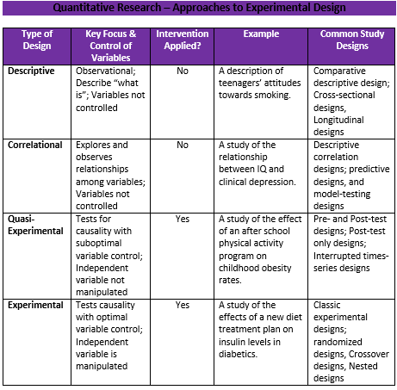
Figure 1: Quantitative Researches
Sources: https://cirt.gcu.edu/research/developmentresources/research_ready/quantresearch/approaches

.

References
Allwood, C. M. (2012). The distinction between qualitative and quantitative research methods is problematic. Quality & Quantity. 46(5), 1417-1429.
Brannen, J. (2017). Mixing methods: Qualitative and quantitative research. Routledge.
Johnston, M. P. (2017). Secondary data analysis: A method of which the time has come. Qualitative and Quantitative Methods in Libraries, 3(3), 619-626.
Kateraas, E. D., & Medelius, P. J. (2015). U.S. Patent No. 8,936,552. Washington, DC: U.S. Patent and Trademark Office.
Le Tran, M. A., Seymour, J., Riecken, T., & Abbas, R. (2017). Data Collection 1: Observations and Document Analysis: Who's looking?. In Qualitative Research and Intercultural Understanding (pp. 38-47). Routledge.
Miles, M. B., Huberman, A. M., & Saldana, J. (2014). Qualitative data analysis. Sage.
Quinlan, C. B. (2018). Business research methods. South Western Cengage.
Marczyk, G., DeMatteo, D., & Festinger, D. (2017). Essentials of research design and methodology. John Wiley.

