- Calculate the mean, median, and mode for “Age”.
Mean, Median, and Mode:
The mean is the average of all numbers and is sometimes called the arithmetic mean. To calculate mean, add together all the numbers in a set and then divide the sum by the total count of numbers.
In the data center, means and medians are often tracked over time to spot trends, which inform capacity planning or power cost predictions. The statistical median is the middle number in a sequence of numbers. To find the median, organize each number in order by size; the number in the middle is the median. The mode is the number that occurs most often within a set of numbers. (Sekaran & Bougie 2016)
Statistics
Age
N | Valid | 10
N | Missing | 0
Mean |  | 38.5
Median |  | 41.0
Mode |  | 44.0
Calculated mean is given in the above table, it can be observed that mean value of age is 38.5 which is indicating that the average age from given data of age is 38.5. median age is 41 and mode from given age group is 44 which is indicating there are more people with having age 44 years.
- Calculate measure of dispersion for “Age”:
Measures of Dispersion is a measure of dispersion is a statistic that tells you how dispersed, or spread out, data values are. One simple measure of dispersion is the range, which is the difference between the greatest and least data values. (Agresti & Finlay 1997) As measure of dispersion in statistics are variance, standard deviation and interquartile range.
 |  | Statistic
 | Variance | 111.833
 | Std. Deviation | 10.57513
 | Interquartile Range | 17.25

In the above table the value of standard deviation (10.57) can be observed which is showing the deviation from the mean age which is 38.5 years.
- Calculate Skewness and Kurtosis for “Income” (with SPSS). Is this variable skewed? If, so, what kind of skew?
Skewness, and Kurtosis
It is the degree of distortion from the symmetrical bell curve or the normal distribution. It measures the lack of symmetry in data distribution. It differentiates extreme values in one versus the other tail. A symmetrical distribution will have a skewness of 0.
Positive Skewness means when the tail on the right side of the distribution is longer or fatter. The mean and median will be greater than the mode. Negative Skewness is when the tail of the left side of the distribution is longer or fatter than the tail on the right side. The mean and median will be less than the mode. (Hoel & Jesson 1977)
Kurtosis is all about the tails of the distribution — not the peakedness or flatness. It is used to describe the extreme values in one versus the other tail. It is actually the measure of outliers present in the distribution.
Descriptive Statistics
 | N | Minimum | Maximum | Skewness |  | Kurtosis
 | Statistic | Statistic | Statistic | Statistic | Std. Error | Statistic | Std. Error
Income | 10 | 25000.00 | 120000.00 | 1.167 | .687 | -.117 | 1.334
Valid N | 10
In the above table “Yes” it is highly skewed because skewness is greater than 1. And it is negatively skewed because as we know that Negative Skewness is when the tail of the left side of the distribution is longer or fatter than the tail on the right side.
Descriptive
 |  | Statistic | Std. Error
 | Skewness | 1.167 | .687
 | Kurtosis | -.117 | 1.334

As in the Bar graph it can be observed the data of income in negatively skewed because tail of the left side distribution is longer than the right side distribution.
- Prepare a frequency distribution for the data of “number of past jobs.” Plot it (bar chart).
Bar Chart:
A bar chart is a graph with rectangular bars. The graph usually compares different categories. Although the graphs can be plotted vertically (bars standing up) or horizontally (bars laying flat from left to right), the most usual type of bar graph is vertical. The horizontal (x) axis represents the categories; The vertical (y) axis represents a value for those categories. In the graph below, the values are percentages. (Johnson & Bhattacharyya, 1992)
Number of past jobs
 |  | Frequency | Percent | Valid Percent | Cumulative Percent
Valid | 1.00 | 2 | 20.0 | 20.0 | 20.0
Valid | 2.00 | 4 | 40.0 | 40.0 | 60.0
Valid | 3.00 | 2 | 20.0 | 20.0 | 80.0
Valid | 4.00 | 2 | 20.0 | 20.0 | 100.0
Valid | Total | 10 | 100.0 | 100.0
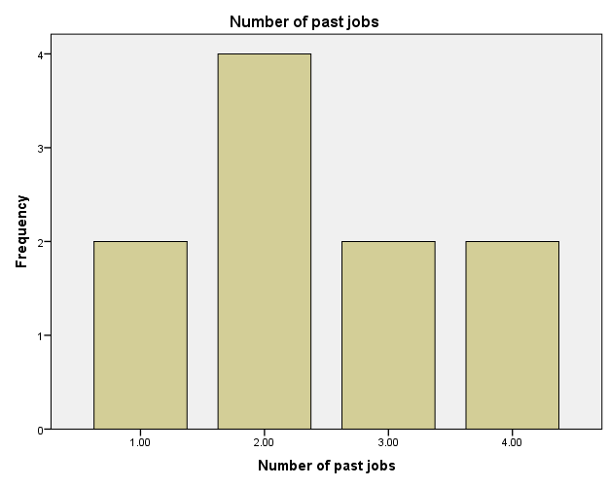
In the above table frequency distribution of no. of past jobs is shown which is indicating that 1, 3, 4 are in frequency. Only 2 is having frequency of 4 which means that individual with age 24, 29, 38, and 44 had done 2 jobs in the past. And remaining individuals are with 1, 3, or 4 past jobs.
- Given the provided income distribution (and assuming normality), what would be the z-score for someone who earns $40,000/year? $100,000/year?
In order to calculate Z-scores first we need to measure mean and standard deviation as given below:
Descriptive Statistics
 | N | Mean | Std. Deviation | Skewness |  | Kurtosis
 | Statistic | Statistic | Statistic | Statistic | Std. Error | Statistic | Std. Error
Income | 10 | 59020.0000 | 35403.13232 | 1.167 | .687 | -.117 | 1.334
Valid N (listwise) | 10

Now Z-score for $40,000/year is:
Z-score = ($40,000 – 59020.00)/35403.13 = -0.537
And it shows that $40,000 is 0.537 times standard deviation below from mean income.
Now Z-score for $100,000 is:
Z-score = ($100,000-59020.00)/35303.13 = 1.16
And it shows that $100,000 is 1.16 standard deviation time more than mean income.

References
Sekaran, U., & Bougie, R. (2016). Research methods for business: A skill building approach. John Wiley & Sons.
Hoel, P., & Jessen, R. C. (1977). Basic statistics for business and economics (No. 519.5 H6715b Ed. 1). John Wiley & Sons.
Agresti, A. & Finlay, B. (1997). Statistical Methods for the Social Sciences, 3th Edition. Prentice Hall, 1997.
Johnson, R.A. & Bhattacharyya, G.K. (1992). Statistics: Principles and Methods, 2nd Edition. Wiley, 1992.

