- Generate a histogram for the longevity variable.
A: To generate a histogram by using SPSS, simply click on graphs, select legacy dialog, further select histogram (type of chart) and select the variable on you want to generate, check on a normal curve and select ok. The output window shows you the results given below;
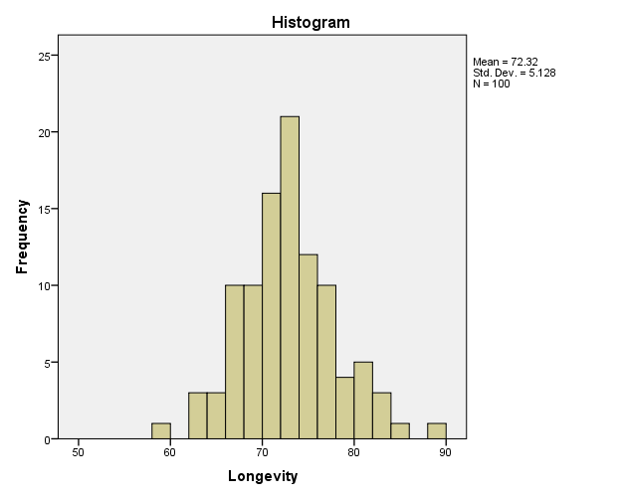
The above graph indicates the longevity of persons, which indicates the average age of 72.2 out of 100. That most of the respondents rely under this age.

- Generate an appropriate graph to examine the distribution of smokers in the sample. Interpret the results.
A: Researcher selected a pie chart an appropriate for this and analyze via SPSS.
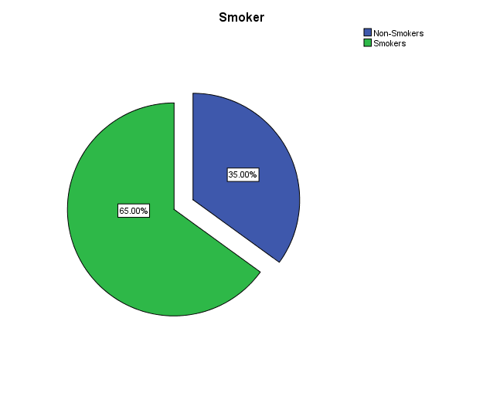
Interpretation
The above graph indicates the ratio of smokers lies under the sample, which indicates that 35% of the sample were non-smoker while majority 65% were smokers. Means they are more prompt towards smoking.

- Generate two new variables: average parents’ lifespan, and average grandparents’ lifespan.
- Average parents lifespan = (father+mother)/2
- Grandparents lifespan = (Gfather+Gmother)/2

- Generate a chart (pick an appropriate one) to examine whether a person’s longevity relates to the average life span of their parents. Repeat this for their grandparents.

From above graph, it can be assessed that persons’ longevity related to average life span of their parents as both are almost going same direction.

Even from diagram, we have same results shows relationship between persons’ longevity and to their grandparent’s average life span.

- Looking at the graphs can you infer which association is stronger? Explain.
By looking at both graphs, it can be seen that there is more strong association between persons’ longevity and average parent’s life span because both lines have very minor deviation to each other as compare to average life span of grandparents. As the above histogram also indicates the average age of sample. So it further revealed the minor difference but not an appropriate for parents and grandparents life span.

References
IBM Corp. Released 2013. IBM SPSS Statistics for Macintosh, Version 22.0. Armonk, NY: IBM Corp.

