Case Module 4
Name
Affiliation
Date

Table of Contents
Defined Variables in SPSS 3
Corrected Scales of variables 3
Descriptive Statistics 4
Scatter Plot 7
Distorted and Non-Distorted Graph 7
Role of variables as independent, dependent, mediator and moderator 9
Mediation Analysis 10
Moderator variable 10
References 11

Defined Variables in SPSS
The variable view in SPSS defined the variables in three types of measurement scales; nominal, ordinal and scale. Nominal scale is used to enter data of qualitative nature such as gender (male and female), city name, yes and no answers. Ordinal data is used to enter data which has some order like grades of students, data measured on Likert scale suggested by Likert (1932) which takes the data on 5 or 7 point scale measuring strongly agree to strongly disagree, or categorizing education (Harpe, 2015). The scale measurement is used for quantitative data which might be interval or ratio scale data.

Variables in the Datasets and their Levels of Measurement
The variables in the current data set are employees’ id, income, age, years of education, number of hours worked per week, number of children, age of employees when first child was born, years of working in current job. Their levels of measurements are scale, scale, scale, nominal, scale, nominal, scale and scale respectively.

Corrected Scales of variables
The measurement column in the SPSS variable’s view is not specified correctly as the employee’s id is not a scale variable but a nominal variable as the id has no physical measurement but is just the numbers assigned to employees. Similarly, years of education are not a scale variable but an ordinal variable as it contains ordering (low education ranks low and high education ranks high). Number of children in a family is not a nominal variable but it is discrete variable as number of children is counts and in SPSS, it can be categorized as scale variable.
Role should be set as for income it is dependent, age is independent, years of education is mediator, number of hours work per week is independent or moderator, number of children is independent, age when first child was born is independent and years in current job should be set as moderator variable.

Descriptive Statistics
As age, education, number of workers worked per week, number of children, age when first child was born and years in current job are scale variables, we could use mean, median, mode for measuring central tendencies and standard deviation to measure dispersion in the data and skewness for normality checking as described by Zar (1999). For ordinal data which is years of education in our data, median and mode are preferred. Table 1 describes that mean income of employees is $41356.7; median indicates that 50% of the employees have income less than $32499 and 50% of the employees have more than $32499 of annual income, the value of mode indicates that most of the employees are earning $45000 of annual income, the standard deviation os $34214.19. The coefficient of skewness is 2.24 which indicate that there is positive skewness in the income distribution of employees. Similarly, the value of mode for age 42 indicates that most of the employees have 42 years of age. For years of education, median and mode are calculated as it is considered as ordinal data. Median 14 indicates that 50% of the employees have less than 14 years of education and 50% have more than 14 years of education and value of mode 12 indicates that most of the employees have 12 years of education. Mean, median and mode for the number of hours worked per week is almost same showing that on the average, most of the workers worked for 40 hours per week. Similarly, years in current job has mode of 5 which means that most of the employees are working from 5 years in the current job. Age and number of hour’s worker per year are showing normality as the value of coefficient of skewness is about zero. All other variables are showing the sign of positive skewness.

Table 1: Descriptive Statistics
 | Mean | Median | Mode | Standard deviation | Skewness
Income | 41356.7 | 32499.48 | 45000.24 | 34214.19 | 2.249714
Age | 44.79878 | 45 | 42 | 11.768 | 0.231767
Education |  | 14 | 12
No. of hours worker/week | 42.0561 | 40 | 40 | 0.085384 | 0.071487
No. of children | 2.315854 | 2 | 2 | 1.183522 | 1.252291
Age when first child was born | 24.3561 | 23 | 21 | 5.801143 | 1.069012
Years in current job | 8.208537 | 8 | 5 | 8.492426 | 1.578166

Table 2: Frequency Analysis for Ordinal Data
Years of Education | Frequency | Percent
0 | 1 | 0.12
2 | 4 | 0.49
7 | 1 | 0.12
8 | 7 | 0.85
9 | 11 | 1.34
10 | 29 | 3.54
11 | 27 | 3.29
12 | 235 | 28.66
13 | 90 | 10.98
14 | 133 | 16.22
15 | 43 | 5.24
16 | 138 | 16.83
17 | 32 | 3.90
18 | 36 | 4.39
19 | 12 | 1.46
20 | 21 | 2.56
Total | 820 | 100

Scatter Plot
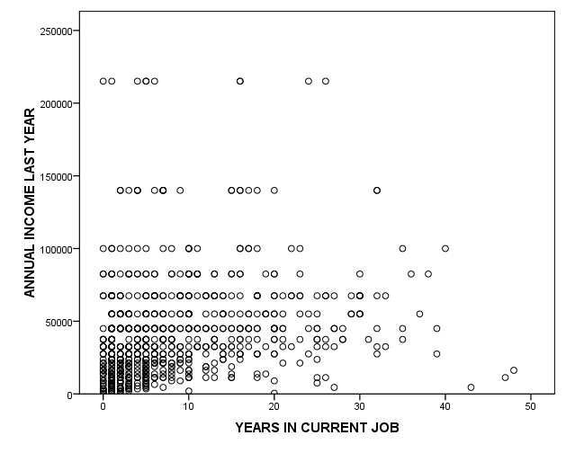
Figure 1: Scatter Plot

The above graph shows the scatter points between years of employees working in current job and annual income of those employees. The graph shows weak association between the two points as the points are much scattered and no clear positive association could be observed from the graph.

Distorted and Non-Distorted Graph
Distorted graphs could create interpretation and presentation problems which might be due to extreme scale ratios, scale breaking, unrelate scaling, wrong manipulation of the second dimension etc., (Bryan, 1995). So, to explain distorted and non-distorted graphs, hours of work per week is selected and the figure 2 shows the distorted graphs where scaling for y-axis (frequency) is not appropriate showing a maximum scaling up to 800 whereas the highest bar of histogram is about 300 employees. So, the graph is not presenting what it is supposed to measure. Figure 3 represent the non-distorted graph of the same variable where both axes are in accurate scaling.

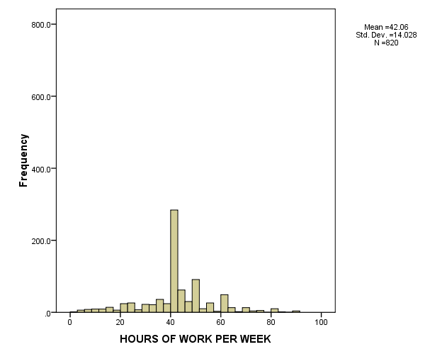
Figure 2: Distorted Graps

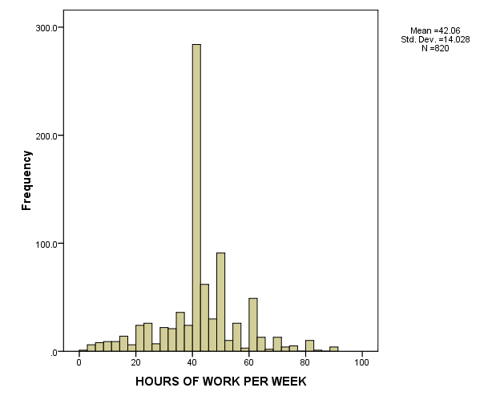
Figure 3

Role of variables as independent, dependent, mediator and moderator
In co-relational or experimental studies, mediator variable performs the role of intervening variable (Ghosh, & Jacobson, 2016), i.e., this variable makes a link between dependent and independent variable. In such type of studies, independent variable is not directly affecting dependent variable rather independent variable influences mediator variable and then mediator variable influences dependent variable. Thus, it creates a chain of relationship that characterizes the effect between dependent and independent variable (Namazi and Namazi, 2016).
A moderator variable (might be quantitative or qualitative) is a variable that affects or strengthen the relationship between dependent and independent variable. It also can change the direction of the relationship and acts as a second independent variable in the model (Baron and Kenny, 1986).

Mediation Analysis
Job satisfaction Annual Income years of Education

Moderator variable
Job satisfaction Annual Income years of Education
Years in Current job
Years in current Job

In the above model, we consider four variables as
- Job satisfaction= Dependent variable
- Years of Education= Independent variable
- Annual Income= Mediator variable (Intervening variable)
- Years in current job= Moderator variable
As first sight, relationship between job satisfaction and years of education doesn’t seem appropriate but if we intervene another independent variable annual income of the last year which is getting affected by years of education of the employees and ultimately affecting job satisfaction of employees is playing a role of moderating variable in the model high education of a person affects the income level and high income level ultimately increase the job satisfaction among employees. For moderator variable, years in current job are selected as how many years you will spend in the current job will ultimately strengthen the relationship between job satisfaction, income and years of education of the employees.

References
Baron, R. M., & Kenny, D. A. (1986). The moderator–mediator variable distinction in social psychological research: Conceptual, strategic, and statistical considerations. Journal of personality and social psychology, 51(6), 1173.
Bryan, J. (1995). Seven types of distortion: A taxonomy of manipulative techniques used in charts and graphs. Journal of technical writing and communication, 25(2), 127-179.
Ghosh, R., & Jacobson, S. (2016). Contending claims to causality: a critical review of mediation research in HRD. European Journal of Training and Development, 40(8/9), 595-614.
Harpe, S. E. (2015). How to analyze Likert and other rating scale data. Currents in Pharmacy Teaching and Learning, 7(6), 836-850.
Howell, J. P., Dorfman, P. W., & Kerr, S. (1986). Moderator variables in leadership research. Academy of management review, 11(1), 88-102.
Namazi, M., & Namazi, N. R. (2016). Conceptual analysis of moderator and mediator variables in business research. Procedia Economics and Finance, 36, 540-554.
Zar, J. H. (1999). Biostatistical analysis. Pearson Education India.

