- Introduction
  - What is Cyberterrorism?
Cyber terrorism is a "criminal act perpetrated on pcs leading to violence, death or destruction and terrorization with the aim to force governments into changing their policies" Berinato (2002). According to Denning,' the convergence of terrorism and cyber space is cyber terrorism. It is usually understood to mean illegal aggressions and threats against computers, networks and data stored on them to bully or force the government or its people to advance political or social goals. Denning (2000).
Cyber terrorism is a severe crime which often causes great alarm. Cyber-terrorism is a convergence of cyberspace virtual world and terrorist bullying techniques. However, the prospective threat posed by cyber terrorism has been exaggerated in the past and creates confusion about the actual nature of this threat. The danger is highly serious and alarming. Research indicates that the ability of today's terrorists to anonymize and inflict massive damage is appealing for cyber terrorism (Weimann, 2004). In many terrorist groups, cyber terrorism also has a press attraction. Although cyber terrorism can be exaggerated, legislation and enforcement actions to tackle and prosecute criminals for planning and organizing a terrorist assault are still needed (Prasad, 2012).
1.2 How cyberterrorism affects the economy?
Modern economies rely strongly on survival information systems based on information technology (IT). Increased confidence in ISs leads to enhanced risk and vulnerabilities. Security in the IT world has therefore become a major problem (Sonnenreich et al., 2006). Investing optimally in information systems security can bring comparative strategic benefits (LeVeque, 2006) via confidence and a favorable picture perceived by partners, clients, and providers. Confidence can hardly be duplicated among rivals. Optimal investment means avoiding inadequate investment.
Information systems are susceptible, and terrorists can use data systems ' vulnerabilities to attack their opponents (Embar, 2002; Jormakka & Molsa, 2005). The word cyberterrorism has been provided a fresh meaning. Parks and Duggan (2001) have described cyber terror as an expansion of traditional terrorism and a fresh strategy to attack cyberspace by terrorists. Cyber terrorists will train or recruit their own recruits to combine physical and cyber-attacks. Mueller also emphasized that the government alone cannot fight the cyber threat (Nakashima, 2010). The potential for terrorist attack should be known to organizations that make up the critical infrastructure of a domestic economy (Nickolov, 2005).
Examples
2019:
- Chinese State-funded hackers stole private data and data about IT identification of some of the Airbus staff in Europe.

- The United States Democratic National Committee disclosed that in the weeks following the mid-term elections, Russian hackers were targeted, and the Center for Strategic and International Studies were discovered to be targeting hackers in connection with Russian intelligence.

- Reuters reports that the UAE was found to work in helping to hack the nation to militants, diplomats and foreign public officials in the telephones of former U.S. intelligence staff.
2018:
• Marriott International recognize that its Starwood system has been hacked— allegedly by Chinese hackers — and up to 500 million guests ' private information has been robbed.
Other large attacks and incidents that some considered to be acts of cyberterrorism, include:
• In December 2016, the outcome of remote intrusion in the Ukrainian 3 regional energy distribution businesses was the consequence of 225 000 clients. The attacks were believed to come from Russia by the cyberterrorists. Cyber criminals have flooded telephone lines and used malware to attack and ruin hard drive information.
• The German parliament was assaulted by cyber criminals in 2015, and this caused extensive disturbance. The hackers infected 20,000 German-led computers, supported employees and government workers, stole delicate information and then claimed several million dollars to clean up the harm.
1.3 Statement of the Problem
Although the global recession has been expanding, and safety has enhanced as well as international repression, cybercrime has grown by two numbers each year over the last century. The Internet is an evolving border with the emergence of fresh criminal threats. Law enforcement and other professional criminals struggle in this ever changing criminal arena.
1.4 Significance
As the Internet becomes more prominent in people's life, it is essential to know how the Internet impacts every aspect of how we live, operate and play. There are very few individuals today whose lives are not influenced by the technology of the Internet era either beneficially or harmfully. In the area of schooling, company, leisure and social interactions, the capacity to share and exchange data instantly offered unprecedented and unparalleled advantages (Wang & Huang 2011). On the adverse hand, the commission of offenses has increased, including pornography proliferation, hatred crimes, cyber stalking, and internet fraud. This research is important because cyber terrorism attacks need a strategy.
Literature Review
The following terrorist literature review shows that some terrorists are extremely trained. Rees et al. (2002) found, for example, that terrorist organizations from the Middle East, from university students, professionals and young female workers, have come from a wide range of populations since the end of the 1990s. Additional study has shown that many terrorists have a history of the upper class (Hassan, 2001; Pedahzur et al., 2003; Sageman, 2004). However, Krueger and Maleckova (2003) discovered that terrorism promotion was more prevalent among workers than workers and more prevalent among secondary educated workers than among analphabets.
Sageman (2004) discovered that at least some education was provided to 71 percent of Muslim participants who alleged terrorists, with 43 percent professionals. It is therefore sensible to believe that many terrorists are extremely trained and knowledgeable on the computer. Because there is a pool of learned prospective terrorists, terrorist organizations can finance, hire, and train such people in computer safety science.
Bryan (2004) has summed up several prospective cyber-terror threats. A cyber terrorist might be able to:
- Electrical electricity assault; manufacturing of gas and petroleum; transport and storage; water supply; banking and finance.
- Access the plant and change its drug formulas for the death of a drug manufacturer.
- Access records of hospital and alter blood kinds for patients.
- To report the data stolen to others (e.g. movement of troops).
- Manipulating perception, views and socioeconomic and political direction.
- Facilitate robbery of identity.
Those that influence the infrastructure or business systems of the country are the more hazardous cyber terrorism attacks. Cyber terrorism, although it may not have the same impact as a physical explosion, can lead to large-scale financial losses. Customers could purchase products from other on-line vendors if cyber terrorists shut down the Amazon.com website. In this situation, only Amazon.com would lose sale, but this event would benefit other internet vendors.
But if the intrusion resulted in the development of false trades, particularly for important financial institutions, such as national / federal banks, a panic among enterprises could be created that would, in turn, adversely affect the domestic economy. Cyber terrorism needs fewer individuals and fewer inputs compared to other terrorism methods.
Cyber terrorism does not need the physical presence of cyber terrorists. By using proxy servers and IP-change techniques, cyberterrorists can remote assaults and keep anonymous to conceal their true addresses. Since cyber terrorists can readily conceal their identity, public officials find it hard to trace and catch them.
Cyber terrorists use the simplest strategy to attack by sending infected viruses e-mails. It could be in the interest of cyber terrorists if the virus is newer or unknown and cannot be identified by antivirus software. A cyber-terrorist-led computer worm can burrow through a network, hide and either steal data or interfere with the operation of the computer systems.
Theoretical Framework
  - Game theoretical model IS Security
Schechter and Smith (2003) created a game theory model to measure the company's appeal for theaters and to determine the correct amount of safety needed for packaging devices. Under different attack circumstances, their study has disclosed that a business would profit considerably by enhancing the likelihood of detection and/or the likelihood of the assault and the likelihood of hacker beliefs.

2.2. Deterrence function in IS Security
The theory of deterrence was commonly used for studying the actions of criminalists and anti-socialists in the economic and criminological areas (Becker, 1968; Pearson & Weiner, 1985). In criminal theory, dissuasive conduct differs with the expectation of penalty consisting of the suspected likelihood of being caught and the amount of penalty. In the area of cyber terrorism it is based on domestic and global legal frameworks, cooperation on data sharing between countries and the capacity of States to recognize the offenders that the anticipated penalty to cyber terrorism will be imposed (Hua & Bapna, 2012).
- Methodology
The study consisted of a comprehensive examination of accessible studies in the last three years with a view to latest literature. As technology changes quickly, present research to the emerging field of cybercrime must be concentrated. This is why the study papers released in 2011 were given unique attention.
Results
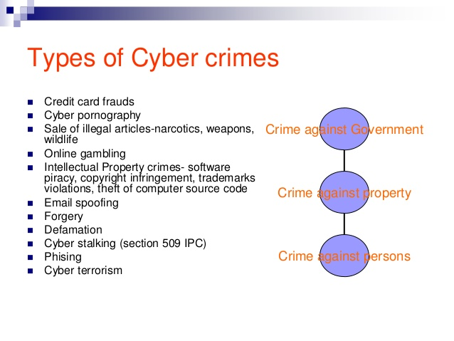

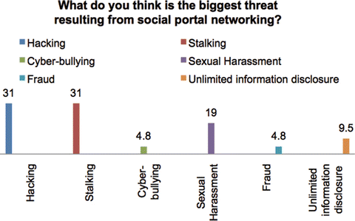
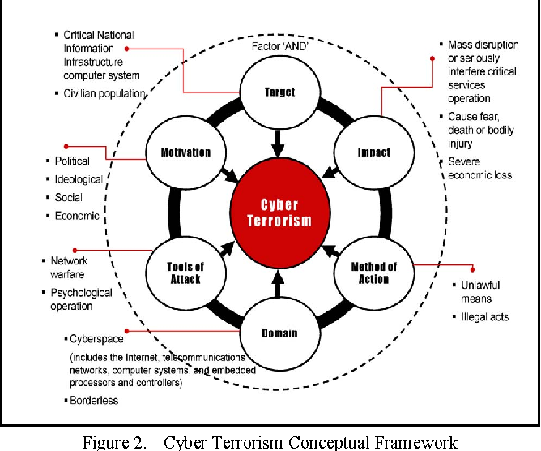

5. Discussion
It is remarkable that a big number of our cyberspace is constructed without any safety considerations, and companies may not fully understand the hazards associated with the techniques they use. Thus the implementation of safety as an essential part of growth in software and hardware is a precious technique of growth of protection against cyber terrorist threats before they can be implemented. Although our state has many disruptions for cyber attackers, criminals often remember the chance of being caught, it could be said that this does not concern terrorist and terrorist organizations. Thus when debating cyber-terrorism avoidance techniques in comparison to cybercrime, the approaches should be viewed differently from the attacker's point of view. The terrorists often have no laws to follow and do not deal with identity implications before or during an assault. The conclusion that it is essential to define attackers in the quickest possible time is preliminary recognition, defense and intervention. Intrusion detection has been one of the most active study fields in the last 20 years in cyber terrorism. To recognize assaults in order to implement the correct mitigation technique, secure obstacles both within our systems and physically are needed. Many of these methods include encryption, as earlier mentioned. One of the oldest techniques of intrusion detection could be viewed as passwords. As these techniques are used more commonly, there are more vulnerabilities. It is remarkable that to create an attack mitigation, fresh intrusion detection systems must be constantly developed in order to be as efficient as possible during an assault.
In addition, cyberattack reactions can be enhanced by concentrating more attention on information preservation during an assault. As many safety experts worldwide have discussed, information violations often are not lately backed up, so it is important to always have up-to-date systems or databases. A key aspect of incident management is to limit the number of damages created by a cyberattack. This is the main step in the recovery, response and future protection of a cyber terrorism law.
Conclusion and suggestions
The significance that cyber terrorism is an imminent threat must always be seen as one of the biggest findings conveyed in this study. In our society terrorists hide until an attack is carried out. This represents room both physically and digitally when we talk about terrorism. Every terrorist has particular motivations to be transmitted by damage. In search of future assaults, like the future threats to industrial control systems, this should always be regarded. It is essential to use this exposure to counter-terrorism techniques. It is vital to understand where cyber terrorism can happen and to develop a proactive reaction to future threats. We learned that whilst cyber attacking may be carried out at any moment or location, it is crucial in all jurisdictions to develop techniques for identifying and tracing terrorists. This can include surveillance, enhancement of cybercrime legislation or the development of technology to detect system intrusions. Implementing' Fire driller' processes, efficient monitoring of system safety, and mitigation and attack reaction are suggested in order that a cyber terrorist attack can be prevented, as this is obviously developing further.
- While the prevention of cyber terror is one of the biggest issues of our government, it has obviously evolved further. For industrial control systems, this is particularly emphasized.
- Understanding the importance of developing and improving ID technology with a special emphasis on preliminary recognition of cyber-threatening intelligence. Possible methods include data mining and machine learning to forecast possible assaults, which could be taken or extended.
- Providing increased schooling to private and public sector organizations developing technologies which can be threatened by cyber terrorism. Those who develop fresh systems should guarantee that safety is the focus of their development, to reduce the number of vulnerabilities.

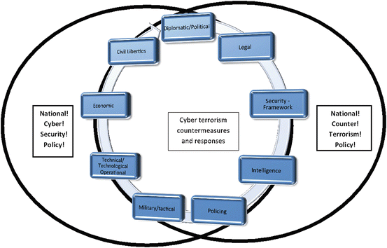

References
Becker, G. S. (1968). Crime and punishment: An economic approach. In The economic dimensions of crime (pp. 13-68). Palgrave Macmillan, London.
Berinato, S. (2002). The truth about cyberterrorism. CIO Magazine, 15.
Bryan Foltz, C. (2004). Cyberterrorism, computer crime, and reality. Information Management & Computer Security, 12(2), 154-166.
Denning, D. E. (2000). Cyberterrorism: Testimony before the special oversight panel on terrorism committee on armed services US House of Representatives. Focus on Terrorism, 9.
Embar-Seddon, A. (2002). Cyberterrorism: Are we under siege? American Behavioral Scientist, 45(6), 1033-1043.
Hassan, N. (2001). An Arsenal of Believers, The New Yorker. November, 19, 36-41.
Hua, J., & Bapna, S. (2013). The economic impact of cyber terrorism. The Journal of Strategic Information Systems, 22(2), 175-186.
Jormakka, J., & Mölsä, J. V. (2005). Modelling information warfare as a game. Journal of information warfare, 4(2), 12-25.
Krueger, A. B., & Maleckova, J. (2002). Education, poverty, political violence and terrorism: Is there a causal connection? (No. w9074). National Bureau of Economic Research.
LeVeque, V. (2006). Information security: A strategic approach. Wiley.
Nakashima, E. (2010). FBI director warns of ‘rapidly expanding ‘cyberterrorism threat. Washington Post March, 4.
Nickolov, E. (2006). Critical information infrastructure protection: analysis, evaluation and expectations. INFORMATION AND SECURITY, 17, 105.
Pearson, F. S., & Weiner, N. A. (1985). Toward an Intergration of Criminological Theories. J. Crim. L. & Criminology, 76, 116.
Pedahzur, A., Perliger, A., & Weinberg, L. (2003). Altruism and fatalism: The characteristics of Palestinian suicide terrorists. Deviant Behavior, 24(4), 405-423.
Prasad, K. (2012). Cyberterrorism: addressing the challenges for establishing an international legal framework.
Rees, M., August, M., Baghdadi, G., Hamad, J., Klein, A., MacLeod, S., & Mustafa, N. (2002). Why suicide bombing is now all the rage. Time, April, 15, 33-9.
Sageman, M. (2004). Understanding terror networks. University of Pennsylvania Press.
Schechter, S. E., & Smith, M. D. (2003, January). How much security is enough to stop a thief? In International Conference on Financial Cryptography (pp. 122-137). Springer, Berlin, Heidelberg.
Sonnenreich, W., Albanese, J., & Stout, B. (2006). Return on security investment (ROSI) -a practical quantitative model. Journal of Research and practice in Information Technology, 38(1), 45.
Wang, S. Y. K., & Huang, W. (2011). The evolutional view of the types of identity thefts and online frauds in the era of the Internet. Internet Journal of Criminology, 12.
Weimann, G. (2004). Cyberterrorism: How real is the threat? (Vol. 31, No. 20-119). United States Institute of Peace.

