Regression and Statistical Effects
Alexander Rodgers
RES601 Research Design and Fieldwork (SUM2019-1)
Dr. Ken Cromer
07/29/2019

Regression and Statistical Effects
Prepare appropriate descriptive statistics – remember, means and standard deviations (and possibly histograms) for interval variables, frequency tables for categorical and dummy variables. Are there any things of interest in these descriptive statistics?
Categorical Variables and Dummy Variables Frequency Tables
Sex
 |  | Frequency | Percent | Valid Percent | Cumulative Percent
Valid | FEMALE | 262 | 40.6 | 42.3 | 42.3
Valid | MALE | 358 | 55.5 | 57.7 | 100.0
Valid | Total | 620 | 96.1 | 100.0
Missing | System | 25 | 3.9
Total |  | 645 | 100.0

Minority
 |  | Frequency | Percent | Valid Percent | Cumulative Percent
Valid | NO | 155 | 24.0 | 25.0 | 25.0
Valid | YES | 464 | 71.9 | 75.0 | 100.0
Valid | Total | 619 | 96.0 | 100.0
Missing | System | 26 | 4.0
Total |  | 645 | 100.0

Admin_resp
 |  | Frequency | Percent | Valid Percent | Cumulative Percent
Valid | NO | 159 | 24.7 | 25.7 | 25.7
Valid | YES | 460 | 71.3 | 74.3 | 100.0
Valid | Total | 619 | 96.0 | 100.0
Missing | System | 26 | 4.0
Total |  | 645 | 100.0

Science
 |  | Frequency | Percent | Valid Percent | Cumulative Percent
Valid | NO | 171 | 26.5 | 27.6 | 27.6
Valid | YES | 448 | 69.5 | 72.4 | 100.0
Valid | Total | 619 | 96.0 | 100.0
Missing | System | 26 | 4.0
Total |  | 645 | 100.0

Degree_tier
 |  | Frequency | Percent | Valid Percent | Cumulative Percent
Valid | 0 | 480 | 74.4 | 77.4 | 77.4
Valid | 1 | 140 | 21.7 | 22.6 | 100.0
Valid | Total | 620 | 96.1 | 100.0
Missing | System | 25 | 3.9
Total |  | 645 | 100.0
All the above tables shows percentage and frequency of variables according to their categories. The above tables values can be used to check about involvement of a particular category in the research. Demographics are very important in the analysis where they are being considered as main variable. They are also useful to show the population characteristics (Berson, and Berson, 1997).
Descriptive Statistics Interval Variables
Descriptive Statistics
 | N | Minimum | Maximum | Mean | Std. Deviation
Age | 620 | 26.011 | 71.270 | 48.280 | 8.520
Years In Dept | 620 | 1.000 | 42.432 | 16.325 | 7.877
Role Ambiguity | 620 | 1.098 | 7.124 | 4.120 | 1.110
Role Conflict | 620 | 1.003 | 9.732 | 6.390 | 1.350
Task Conflict | 620 | 2.003 | 11.214 | 6.020 | 1.500
Relationship Conflict | 620 | 1.178 | 9.624 | 4.880 | 1.530
Political Perceptions | 620 | 1.897 | 6.378 | 4.250 | 0.780
Salary | 619 | 25916.000 | 212266.000 | 61955.785 | 30858.052
tch_rating | 619 | 5.583 | 10.662 | 9.739 | 0.666
Fault | 620 | -1.890 | 11.060 | 3.285 | 1.490
Blame | 611 | -3.050 | 14.790 | 5.296 | 2.280
Log_salary | 619 | 10.163 | 12.266 | 10.940 | 0.413
Log_rating | 619 | 1.720 | 2.367 | 2.273 | 0.076
Valid N (list wise) | 610

Descriptive statistics clarify different things like averages, deviations from averages (SD) maximum and minimum values of different variables. Descriptive statistics tells the summary for variables statistical figures (Oja, 1983). For example as shown in the table AGE with deviation from the average upward or downward of 852.0% whereas maximum and minimum are 71.270 and 26.011 respectively.
Histograms
Histograms used to check normality of data of variable. A proper bell shaped Histogram tells that variable is with normal data (Field ,2005). It is basically pure representation related to distribution of data. Karl Pearson was first who introduced Histogram (Wikipedia, n.d). In the following figures all Histograms shows normality in variable’s data because they are having proper bell shape except Salary and Tech Ratings which are not in proper bell shape. The data should be normalized to get streamline result. If there is no bell shape of histogram then there is problem with data. This problem can be solved by increasing sample size. The residuals are normally distributed as shown in bell shape of Histogram.
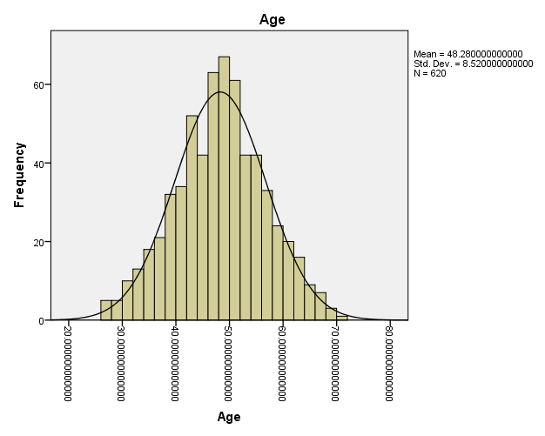

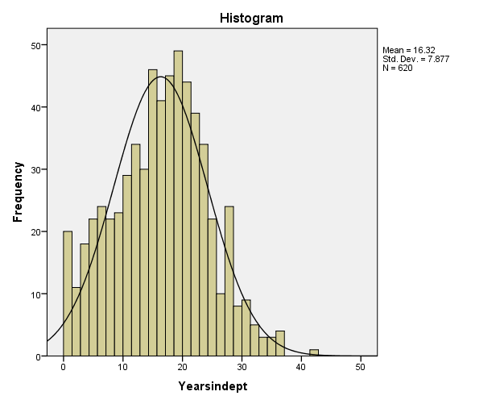

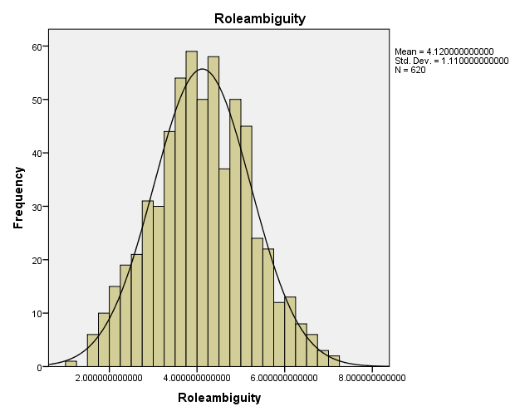

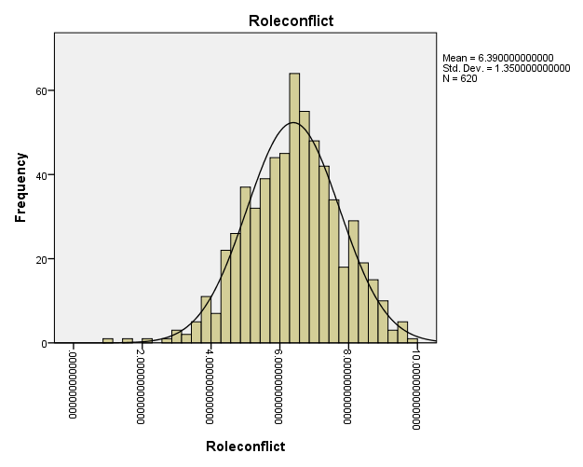

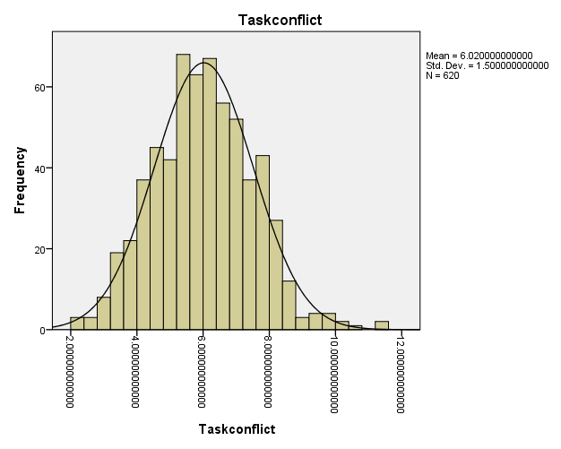

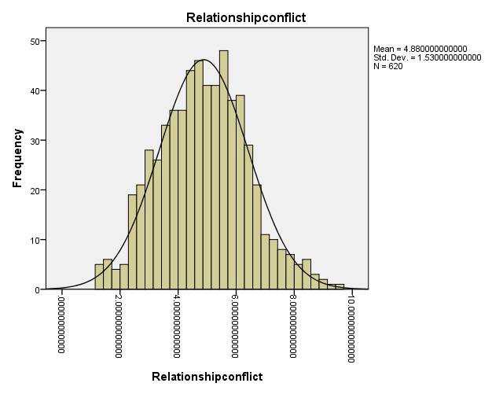

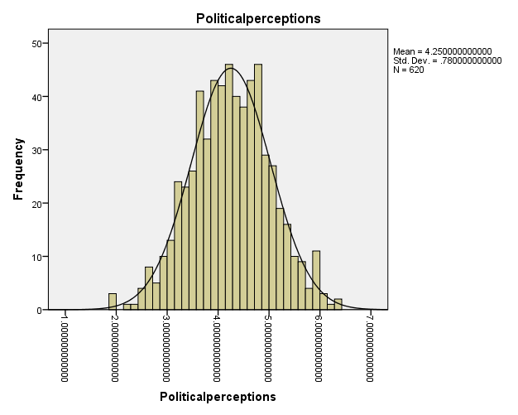

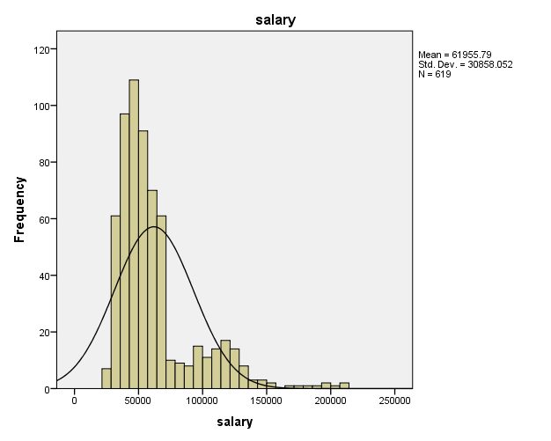

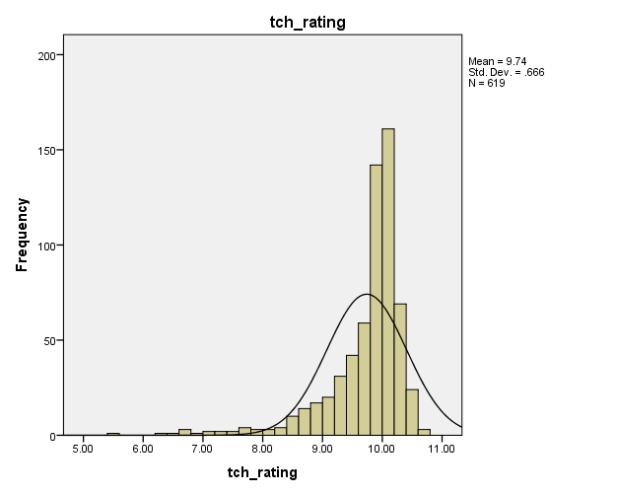

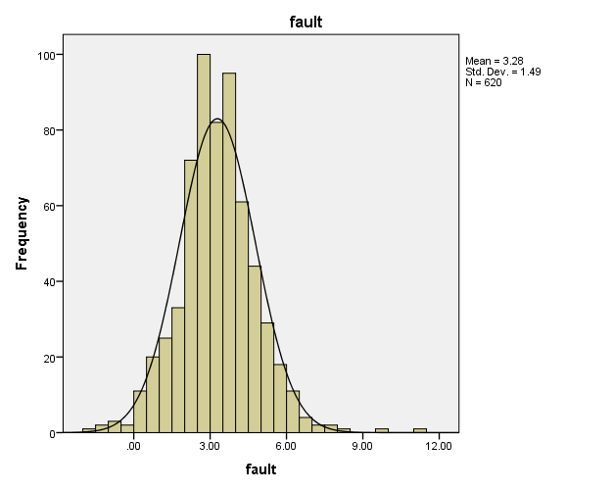

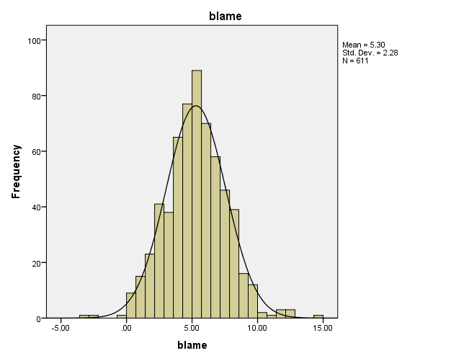
Construct three scatterplots looking at the relationships among some of the interval variables that interest you. What if anything do you discover this way?

Scatterplots
Three scatterplots of interval variables are given below using SPSS.

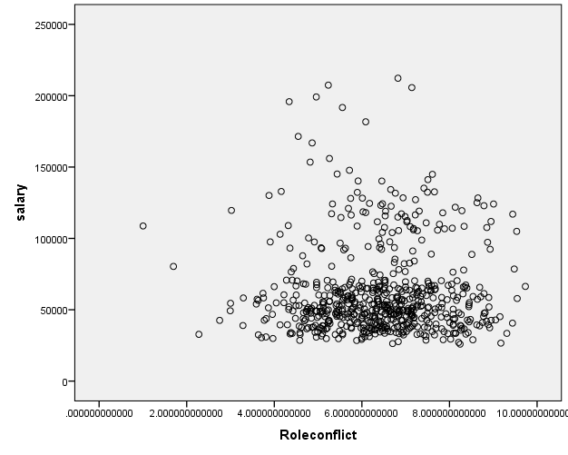

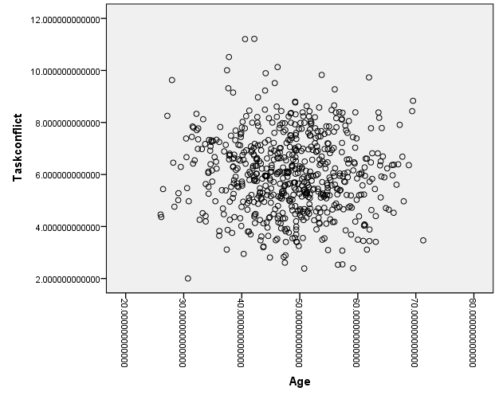

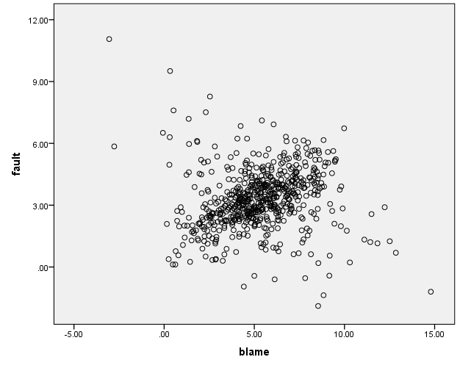
The above scatterplots diagrams shows that there is no proper relationship among the two variables used to draw each scatterplot. The scatter diagram clearly identify that there is no relationship among variable. Because if there is a relationship then this diagram will make a line shape or curve. (Field, 2005).
Set up a regression model to predict salary (DV) from teaching ratings (IV). Be sure to request appropriate residuals plots. What are your results? What do you learn from the residuals plots?
Regression Model
Salary = α + β₁ Role ambiguity + β₂ Role conflict + β₃ Relationship conflict + β₄ Political perceptions.
Model Summary
Model | R | R Square | Adjusted R Square | Std. Error of the Estimate
1 | .168ª | .028 | .022 | 30516.449
a. Predictors: (Constant), Political perceptions, Role ambiguity, Role conflict, Relationship conflict

Model summary shows value of R-square shows 2.80% variation in Salary is explained by Political Perception, Role ambiguity, Role conflict and Relationship conflict (Field, 2005). .The results shows that model used for this research are well predicted by the independent variables.
ANOVAª
Model |  | Sum of Squares | df | Mean Square | F | Sig.
1 | Regression | 16681822849.03 | 4.00 | 4170455712.26 | 4.478 | .001^{b}
1 | Residual | 571789745461.39 | 614.00 | 931253657.10
1 | Total | 588471568310.42 | 618.00
a. Dependent Variable: salary
b. Predictors: (Constant), Political perceptions, role ambiguity, role conflict, relationship conflict

The means of variables presents in a group has been analyzed with differences and different estimation procedures through ANOVA (Wikipedia, n.d). ANOVA tells about significance of regression model. Salary is quite well predicted by Political perceptions, Role ambiguity, Role conflict, Relationship conflict with F= 4.478, p=.001 (Field, 2005).

Coefficientsª
Model |  | Unstandardized Coefficients |  | Standardized Coefficients | t | Sig.
 |  | B | Std. Error | Beta | t | Sig.
1 | (Constant) | 79624.222 | 7575.833 |  | 10.510 | .000
1 | Role Ambiguity | -2978.877 | 1299.023 | -.107 | -2.293 | .022
1 | Role Conflict | 2235.671 | 1151.392 | .098 | 1.942 | .053
1 | Relationship Conflict | 2527.772 | 1055.986 | .125 | 2.394 | .017
1 | Political Perceptions | -7531.252 | 2160.124 | -.190 | -3.486 | .001
a. Dependent Variable: Salary
The total effect of Role Ambiguity on Salary is significant(β=-2978.877, t=-2.293, p=0.02). The total effect of Role Conflict on Salary is insignificant(β=2235.671, t=1.942, p=0.053). The total effect of Relationship Conflict on Salary is significant(β=2527.772, t=2.394, p=0.01). The total effect of Political Perceptions on Salary is significant(β=-7531.252, t=-1.90, p=0.00). Significant effect means the independed variables are purely playing important role in explaining the over research (Field, 2005).
Since neither salary nor teaching ratings is particularly normally distributed (i.e., both are skewed), we might do better with the log transforms of these data. Try your regression model with these transformed variables. Any better? How do you know?
Model Summary
Model | R | R Square | Adjusted R Square | Std. Error of the Estimate
1 | .244ª | .059 | .052 | .40190
a. Predictors: (Constant), log_rating, role conflict, relationship conflict, role ambiguity, political perceptions

Model summary shows value of R-square shows 5.9% variation in log_Salary is explained by log_rating, Role conflict, Relationship conflict, Role ambiguity. The results support the argument tof these variables.
ANOVAª
Model |  | Sum of Squares | df | Mean Square | F | Sig.
1 | Regression | 6.261 | 5 | 1.252 | 7.753 | .000^{b}
1 | Residual | 99.013 | 613 | .162
1 | Total | 105.274 | 618
a. Dependent Variable: log_salary
b. Predictors: (Constant), log_rating, role conflict, relationship conflict, role ambiguity, political perceptions

ANOVA tells about significance of regression model. Log_salary is quite well predicted by log_rating, role conflict, relationship conflict, role ambiguity. with F= 7.753, p=.000. The statistical values shows clearly about impact of the main variable.

Coefficientsª
Model |  | Unstandardized Coefficients |  | Standardized Coefficients | t | Sig.
 |  | B | Std. Error | Beta | t | Sig.
1 | (Constant) | 13.083 | .496 |  | 26.390 | .000
1 | Role Ambiguity | -.049 | .017 | -.133 | -2.881 | .004
1 | Role Conflict | .037 | .015 | .121 | 2.437 | .015
1 | Relationship Conflict | .036 | .014 | .135 | 2.618 | .009
1 | Political Perceptions | -.108 | .028 | -.204 | -3.791 | .000
1 | Log_rating | -.834 | .214 | -.153 | -3.900 | .000
a. Dependent Variable: Sog_salary

Total effect of all variables on log_salary is found significant because all variables have p<0.05.The p values if less than 0.05 then it will not accepted.
Now let’s try a multiple predictor model. Use salary as DV, and age, years in dept, sex, level, tch_rating, minority, admin_resp, science, degree_tier, and pub_prestige as IV’s. How good is your prediction now? What are the best predictors? Anything in the residuals?
Model Summary
Model | R | R Square | Adjusted R Square | Std. Error of the Estimate
1 | .879ª | .773 | .769 | 14821.431
a. Predictors: (Constant), pub_prestige, tch_rating, minority, sex, degree_tier, science, age, admin_resp, level, years in dept

Model summary shows value of R-square shows 7.73% variation in salary is explained by pub_prestige, tch_rating, minority, sex, degree_tier, science, age, admin_resp, level, years in dept. The good value of R Square clearly support the argument of considering it best model.
ANOVAª
Model |  | Sum of Squares | df | Mean Square | F | Sig.
1 | Regression | 454909273810.115 | 10 | 45490927381.012 | 207.083 | .000^{b}
1 | Residual | 133562294500.308 | 608 | 219674826.481
1 | Total | 588471568310.423 | 618
a. Dependent Variable: salary
b. Predictors: (Constant), pub_prestige, tch_rating, minority, sex, degree_tier, science, age, admin_resp, level, years in dept

ANOVA tells about significance of regression model. Salary is quite well predicted by pub_prestige, tch_rating, minority, sex, degree_tier, science, age, admin_resp, level, years in dept with F= 207.083, p=.000(Field, 2005)..
Coefficientsª
Model |  | Unstandardized Coefficients |  | Standardized Coefficients | t | Sig.
 |  | B | Std. Error | Beta | t | Sig.
1 | (Constant) | 55618.412 | 10063.462 |  | 5.527 | .000
1 | Age | -53.673 | 113.521 | -.015 | -.473 | .637
1 | Years In Dept | 77.973 | 139.666 | .020 | .558 | .577
1 | Sex | -1929.021 | 1236.022 | -.031 | -1.561 | .119
1 | level | 13213.781 | 838.391 | .459 | 15.761 | .000
1 | tch_rating | -7016.031 | 902.403 | -.151 | -7.775 | .000
1 | Minority | 7428.059 | 1447.509 | .104 | 5.132 | .000
1 | Admin_resp | -3864.562 | 1632.358 | -.055 | -2.367 | .018
1 | Science | -932.651 | 1412.487 | -.014 | -.660 | .509
1 | Degree_tier | 10797.654 | 1576.196 | .147 | 6.850 | .000
1 | Pub_prestige | 14475.222 | 717.333 | .533 | 20.179 | .000
a. Dependent Variable: salary
Total effect of age, years in dept, sex, and science on salary is found insignificant. While all other variable’s effect found significant on salary. Thee best predictor is because of good results(Field, 2005)..

Your prediction is good, but it’s too complicated. See if you can reduce complexity by using a stepwise procedure on the same model. What is the efficiency of prediction of your final model here? What predictors are left? Which have been excluded? Of those left, which are best? Anything in the residuals?
The results of Regression with Dependent Variable Log_Salary showed very good and satisfactory results. While other last model also shows good results. The rank of variable can reduce normality issue to get good results (Friedman, 1937). The above results are calculated using stepwise procedure. Final model shows more satisfactory results as it gives more significant values for independent variables. The more specific values found using this model. This can also be done using other skipped variables as controlled variables. Residuals also becomes better as compared to previous models.
Any overall comments on using regression techniques?
Regression model shows well predictions of dependent and independent variables. The cause and effect relationship can be found in proper way using regression analysis. Its assumptions scrutinize data at early stages. The active researchers used mostly regression analysis. This is simple linear regression while many other types of regression are also available according to nature of data. Regression also accommodates various types of missing data (Wikipedia, n.d). The best technique used to analyze the numerical data is regression analysis. This technique explains relationships of variables in quite impressive way (Inquiries Journal, n.d). There is always existence of error term in the regression model, this is because the predictor variables cannot be perfect always so there is chance of error term. The error term should be minimum (Gallo, 2015). The residuals of a regression model must be distributed normally. This is very important concept discusses by a regression model. Regression model uses Histogram to check the normal distribution of errors(Laerd Statistics, n.d). So regression technique is a good technique to analyze data as well as relationship among variables.
References
Berson, D.W. and Berson, D.L., 1997. The importance of demographics in economic analysis: the unusual suspects. Business Economics, pp.12-16.
Gallo, A., 2015. A refresher on regression analysis. Harvard Business Review, 4.
Oja, H., 1983. Descriptive statistics for multivariate distributions. Statistics & Probability Letters, 1(6), pp.327-332.
Field, A., Discovering Statistics Using SPSS (Introducing Statistical Methods S.), 2005.
Friedman, M., 1937. The use of ranks to avoid the assumption of normality implicit in the analysis of variance. Journal of the american statistical association, 32(200), pp.675-701.
Regression Analyssi. In Wikipedia (n.d). Retrieved from https://en.wikipedia.org/wiki/Regressi on_analysis
Histogram. In Wikipedia (n.d) Retrieved from https://en.wikipedia.org/wiki/Histogram
ANOVA. In Wikipedia (n.d) Retrieved from https://en.wikipedia.org/wiki/Analysis_of_variance
How to Use Regression. Retrieved from http://www.inquiriesjournal.com/blog/posts/309/how-to-use-regression-effectively/
Linear Regression Using SPSS.(n.d).Retrieved from https://statistics.laerd.com/spss-tutorials/linear-regression-using-spss-statistics.php

