Personality
Alexander Rodgers
MGT699 Special Topics in Management (WIN2020-1)
Dr. Thomas Matula
0/28/2019

Personality
The Big Five Personality was developed in the early 1990s. Since its development, it has been used by business professionals and researches because it is an effective model (Borghuis, et al., 2017). The Big Five Personality test has been applied two times in this assigned task. I have applied the Big Five Personality test on me as well as the cousin of my friend who does not know much about me, to fill out this test. The five-point Likert scale has been used to vary from strongly agree to disagree strongly. The result of the first survey has provided in-depth information on my personality on five traits, including (i) openness, (ii) conscientiousness, (iii) extraversion, (iv) agreeableness, (v) neuroticism. My percentile for openness is 25%, conscientiousness 84%, extroversion 34%, agreeableness 98%, and neuroticism 79% (See Appendix A). I have perceived more favorably by the other participant in the second survey. The result of the second survey indicated that my percentile for openness is 88%, conscientiousness 93%, extroversion 95%, agreeableness 89%, and neuroticism 05% (See Appendix B).
Openness means that sense of curiosity about the other things and the world (Lovik, Verbeke & Molenberghs, 2017). In the first survey, my score on openness is quite low, which reflected that I prefer to keep things in the same way. I do not like changes in my life as well as I am traditional in my thinking. A low openness score reflects that I prefer to keep the concepts straightforwardly, but the others think that I am down-to-earth and grounded. The second survey has shown comparatively high on openness that reflected that I am original, curious, sophisticated, and creative. The variation in scores is due to impression management or self-presentation that is the process that helps people to control the ways people perceive them.
Conscientiousness reflects a detail-oriented and precise nature. In the first survey, I have scored high in this dimension that reflects that I prefer to keep things in order. I am always prepared for the assigned tasks at the school or workplace. I am goal-driven and persistent. I prefer to follow the regular schedule and keep track of the details. I work hard to attain my goals. The other people have seen me as a fair and reliable person because of this trait. I can micromanage various tasks and situations, and I am cautious and hard to please. In the second survey, I have obtained the same result on the conscientiousness that reflects that others also assume that I am hardworking, detail-oriented, and persistent.
Extraversion explores the energy that can be drawn from social interactions. In the first survey, I have scored low in this domain that reflects the hidden part of my personality. I take it hard to make small talk in public places. I avoid large groups and remain reserved. It does mean I cannot interact with people, but I like to spend time alone or with a small group of closed ones. I am a private person in terms of sharing details of my life. The results of the second survey are quite different, which reflected that I am highly extroverted. Basically, I am an introvert, but I never allow others to judge me and always pretend to be extrovert. I have the ability that I can leave that impression on the others that I want to do so. This quality has been reflected in this survey that presented me with an introvert, but when another person has evaluated me, he rated me on high extroversion.
Agreeableness reflects the smooth running and flow of things. In the first survey, I have scored high on this dimension that shows the critical aspect of my personality. I am always ready to help out other people. I have a caring nature, and I am honest in my dealing. I give quality time to the people around me and always think positive about others. I am cooperative and helpful. The results of the second survey are similar to the first survey that reflected that I am sympathetic, good-natured, courteous, and forgiving.
Neuroticism is the tendency to have unsettling feelings and thoughts. The result of the first survey indicated a high percentile on this domain that reflects I am insecure and vulnerable, easily stressed, struggle with complicated situations, and have mood swings. When things get wrong, I always blame myself and get frustrated by myself easily, especially when committing a mistake. In the second survey, the results are dissimilar, and I have attained a high score. Another participant thinks that I am a calm, secure, hardy, and relaxed natured person. The low score in the second survey does not mean that I am not confident; instead, it reflects that I tend to be more resilient.
Goffman gave the theory of impression management in 1959, which is one of the well-known theories in the domain of identity preferences. The theory reflected that the identify presentations are constructed and prepared through backstage (Leary, 2019). Another theorist Jones in the 1960s, has also explored that impression management can be used to control the impression of personal characteristics (Bolino, Long & Turnley, 2016). Impression management is primarily a fundamental interpersonal process that revolves around the concept of self. Impression management is the primary reason behind the existing gaps between the two surveys on the different dimensions of the personality. It is the technique that is used to control the way of thinking of others about the person himself. The public images are developed by using the technique of impression management because it helps people to attain the desired goals. I have also left such impressions on the others because I assume these impressions are valuable. The discrepancy has existed because I primarily have a varied personality, but the perceived personality of others is different.
McCrae and John (1992) reflected the theoretical basis to assume the existence of five main personality dimensions. The Five-Factor model is the systematic organization of personality traits. The two historical paths to the Five-Factor Model are the Lexical approach and the personality dimensions. The lexical approach was originated from the studies of natural language trait terms. Already existing scales including Hogan Personality Inventory, California Psychological Inventory, Multidimensional Personality Questionnaire, Adjective Check List, MMPI, and Interpersonal Adjective Scales are empirically related to each of the dimensions of Five-Factor Model. There are few empirical demonstrations of the correspondence between personality traits ad lexical factors.
In short, the Big Five Personality Test is a reliable tool that is implemented twice to accomplish this task. The variation in the scores is due to the theoretical basis of impression management.

Reference
Bolino, M., Long, D., & Turnley, W. (2016). Impression management in organizations: Critical questions, answers, and areas for future research. Annual Review of Organizational Psychology and Organizational Behavior, 377-406.
Borghuis, J., Denissen, J. J., Oberski, D., Sijtsma, K., Meeus, W. H., Branje, S., & Bleidorn, W. (2017). Big Five personality stability, change, and development across adolescence and early adulthood. Journal of Personality and Social Psychology, 641-650.
Leary, M. R. (2019). Self-presentation: Impression management and interpersonal behavior. Routledge.
Lovik, A., Verbeke, G., & Molenberghs, G. (2017). Evaluation of a very short test to measure the big five personality factors on a Flemish sample. Journal of Psychological & Educational Research.
McCrae, R. R. , & John, O. P. (1992). An introduction to the five factor model and its application. Journal of Personality, 60, 175-215. DOI: 10.1111/j.1467-6494.1992.tb00970.

Appendix A
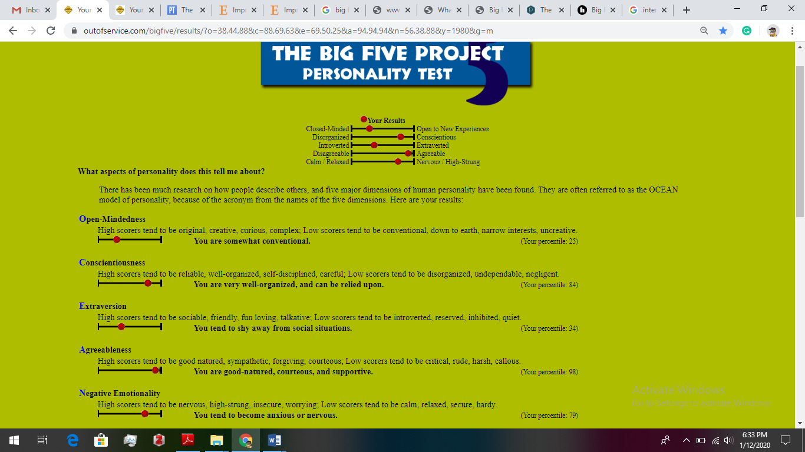
Source: https://www.outofservice.com/bigfive/results/?o=38,44,88&c=88,69,63&e=69,50,25&a=94,94,94&n=56,38,88&y=1980&g=m
Appendix B
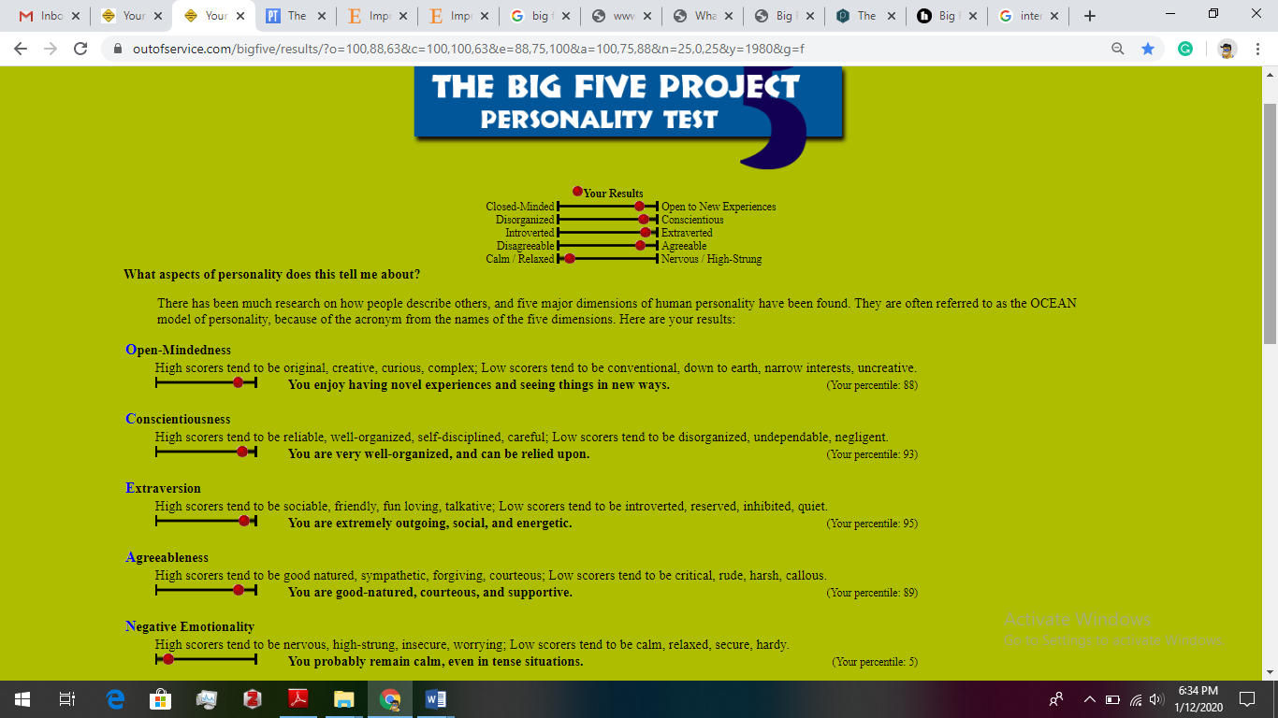
Source: https://www.outofservice.com/bigfive/results/?o=100,88,63&c=100,100,63&e=88,75,100&a=100,75,88&n=25,0,25&y=1980&g=f

