[SLP 4]
[Student’s Name]
[Institutional Affiliation]

Trident University International MGT699 Module 4 – Analytic Tool

Identification and Assessment of Meta-Analysis Stages and Practices
(based on Figure 1, p. 307, Kirca & Yaprak, 2010)
 | Practice | (Riketta, 2008) | (Harrison, Newman, & Roth, 2006)
- Formulate problem | Identify and read relevant theoretical and empirical articles | Empirical evidence and theoretical backgrounds have been explored to select relevant study articles. | Literature and theories have been explored to select relevant study articles.
 | Identify important, common variables, study, and measurement characteristics to assess | The important variables discussed in the study are job attitudes and job performance. The casual relationship has been identified for these study variables | The major variables of the study are contextual performance, turnover, absenteeism, lateness, and focal task performance
 | Identify contradictory findings | The contradictory findings reflected that does job attitude maximize performance. Which ways have been used to increase the association between job attitudes and performance? Various empirical studies on performance and job attitudes have not provided enough information due to the cross-sectional study design. | Job attitudes and job performance as the two enduring and central constructs within the organizational level research. The strength of this relationship is the debate so the elementary question remains unanswered that reflects the importance of job attitudes that predict and understand job performance in the work role directed behaviors.
 | Decide on meta-analysis objectives | The objective of meta-analysis is to provide the most controlled and up to date information about the meta-analytic tests of a causal association between job attitudes and job performance. | The objectives of the meta-analysis are given here:  - To study the negative impact of contextual performance on the turnover  - To study the negative impact of contextual performance on the absenteeism  - To study the negative impact of contextual performance on the lateness  - To study the negative impact of contextual performance on the focal task performance
 | Develop a preliminary theoretical framework | The preliminary theoretical framework has reflected that the job attitudes reflect performance, as well as performance, shows the job attitudes. | Theoretical models have been developed in the research that reflects the relationship between the attitudinal factors and behavioral criteria.  - The attitude engagement model has been used for connecting the overall job attitude and individual effectiveness.
- Collect Data | Conduct key-word database searches | All the published and unpublished studies that met the criteria have included here. Electronic databases such as ABI/Inform has been used to cover the published and unpublished dissertations. Business Source Premier has been used to cover the published articles. PsycINFO has been used to cover the published chapters, articles, unpublished dissertations, and books. Web of Science has been used for the former Social Sciences Citation Index that covered the published articles. | Electronic and manual articles have been explored through databases. Quantitative and qualitative reviews, bibliographies, and conference proceedings have been used in the study.  - PsycINFO, ABI/Inform databases, and ERIC have been used to explore the articles.
 | Search references for key studies | - Ashforth & Saks (1996)  - Bateman & Organ (1983)  - Bechtold et al. (1981)  - Bond & Bunce (2003)  - Borrill et al. (2003)  - Crampon et al. (1978)  - Donaldson et al. (2000)  - Griffin (1991)  - Maier & Rosnstiel (2006) | The reference key studies have been searched through using terms “citizenship behavior”, “pro-social behavior”, “contextual performance”, and “extra-role behavior”.
 | Manually search-relevant publications | All the studies were searched through using databases. | Manually searched articles are identified through abstracts through references to sick leave use, absenteeism, turnover, attendance, quitting, lateness, tardiness, promptness, performance, etc.
 | Solicit studies from key researchers | All the studies are approached easily | All the studies are approached easily
 | Post requests for articles and working papers on academic list-serves | The authors who failed to report the complete correlation matrix were contacted to get the missing correlations of the study | Requests were not posted for the published articles and working articles, instead, all the papers were already approachable that has been used in the study.
 | Develop elimination criteria | The elimination criteria are given here:  - Participants other than employees of the organization  - The studies do not examine job satisfaction and organizational commitment  - The study does not have the panel design  - Data has been analyzed at the group level  - Zero-order correlation for the job attitude and performance were not available for the two measurement waves | The elimination criteria are given here:  - Studies that were not selected through contextual performance meta-analysis that used employed adults. This procedure was similar to the existing meta-analysis that has represented the attitude-behavior matrix.
 | Screen studies according to elimination criteria | Total of 16 studies have been screened after the elimination criteria | A total of 49 studies have been screened after the elimination criteria.
 | Decide whether data is sufficient to proceed with meta-analysis | The data was sufficient for proceeding the meta-analysis | The data was sufficient for proceeding the meta-analysis
- Evaluate Data | Identify common metrics across studies (e.g. correlation coefficient) | The meta-analytic regression analysis has been conducted on the 16 studies that repeatedly measured job performance and job attitude. | The meta-analytic regression analysis has been conducted on the 5 turnover studies, 5 lateness studies, 8 absenteeism studies, and 24 focal performance studies.
 | Identify key substantial and methodological study characteristics | The well-planned methodology has been used in the meta-analytic study | The well-planned methodology has been used in the meta-analytic study
 | Prepare coding form and manual | All the studies were coded into two categories based on the nature of the performance that studies measure. | All the studies were coded based on the variables that study measure.
 | Code each study | Each study has been coded with the meantime lag was an average of 9.2 months.  - Lag= time lag between the coded waves in the months  - A1 = job attitude at first coded wave  - A2 = job attitude at the second coded wave  - P1 = performance at first coded wave  - P2 = performance at second coded wave  Only Time 2 and Time 3 have been coded due to the intervention between Time 1 and Time 2. | The literature found 564 studies but 50 failed to report enough information. The remaining 514 studies have been coded for time sequencing. Overall 82 studies were predictive, 139 were the postdictive, and 292 were concurrent.
 | Prepare database and check for errors | Databases have been used to avoid errors | Databases have been used to avoid errors
- Analyze Data | Conduct univariate analysis of mean effect sizes | The effect sizes are small that reflected that it is crucial to communicate the outcomes of the study so that the practitioner can understand the practical significance of the study.
 | Search for moderators using bivariate analysis of effect sizes | No as such bivariate moderators of the study | Bivariate relationships have been estimated for job attitude and performance
 | Search for moderators using multivariate analysis of effect sizes | The possible moderators of the study include the autonomy in the workplace, organizational tenure, job attitude, and performance.  Justice perceptions and reward systems are additional moderators such as job attitude-performance effects. | The predictive effective sizes were more than positive effect sizes
 | Construct and analyze the meta-analytical correlation matrix to test the theory | The software MPlus 4.2 has been used that reflected that job attitude or job performance at the second coded measurement waves was regressed on job attitudes and performance. The effect was significantly week (β = .06) | Structural equation modeling has been used
- Interpret and discuss | Report univariate and bivariate findings using tables and figures | See Table 1 given at the end of the document. | See Table 2 given at the end of the document.
 | Make detailed recommendations for future research based on the findings | In the presence of weak effects in the analysis, future studies should focus on the moderations of the association between job attitudes and performance. The study findings reflected that the timing of measurement is the one moderation that effects more likely to emerge for the longer vs. shorter periods. The study should include the panel designs for broadening the databases for follow up meta-analyses on the casual association between job performance and job attitudes. | Future studies should employ the conditional probability and stage sequential analysis that was lacking in this study.

Riketta (2008) and Harrison et al. (2006) has proceeded the coding process with rigor and included all the possible researches in the data. Former has screened a total of 16 studies and the latter has included 49 studies after the elimination criteria. Riketta (2008) has coded studies based on the nature and performance of study measures while Harrison et al. have coded studies based on time sequence including 139 postdictive and 292 concurrent studies. It is recommended to the authors to improve the coding process through clear identification of common metrics across studies. They should represent substantial and methodological study characteristics so that it would be easy to understand. The coding manual should be developed that seems missing in both these studies. It is necessary to code an easy study to come up with accurate outcomes.

Table 1
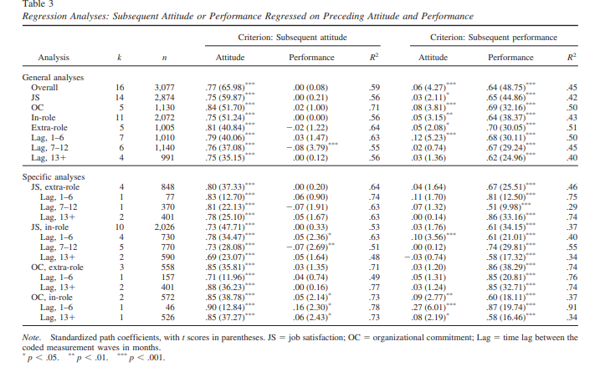

Table 2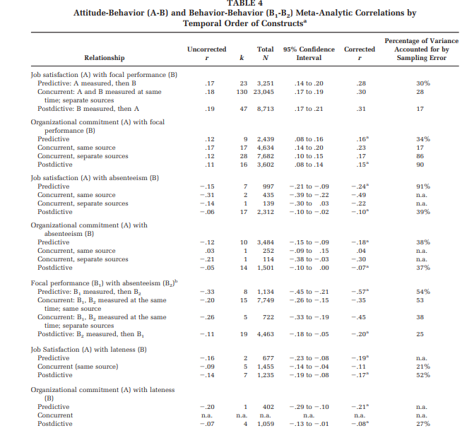

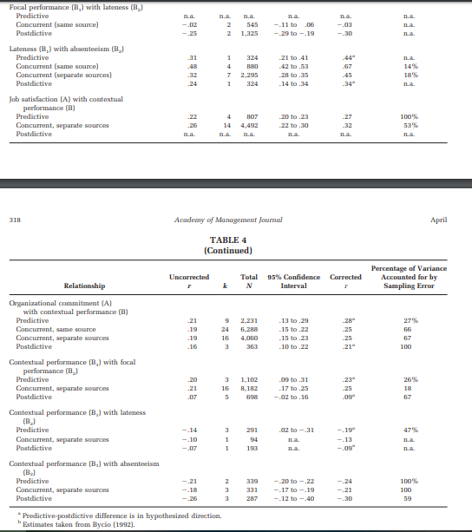

References
Harrison, D. A., Newman, D. A., & Roth, P. L. (2006). How important are job attitudes? Meta-analytic comparisons of integrative behavioral outcomes and time sequences. Academy Of Management Journal, 49(2), 305-325. doi:10.5465/AMJ.2006.20786077
Kirca, A. H., & Yaprak, A. (2010). The use of meta-analysis in international business research: Its current status and suggestions for better practice. International Business Review, 19(3), 306-314.
Riketta, M. (2008). The Causal Relation Between Job Attitudes and Performance: A Meta-Analysis of Panel Studies. Journal Of Applied Psychology, 93(2), 472-481.

