Mediation through Structural Equation Modeling
Name
University

Introduction
This paper deals with the mediation models, their interpretation, and evaluation through “structural equation modeling” (SEM). The paper mainly discusses an important study of and Bauer et al. (2006) by evaluating and interpreting the mediation model used in this study, discussing the indicators used for variables, and reflecting different fit measures used in the analysis. Furthermore, this paper also draws a structure path diagram based on the discussion and suggestions of Colquitt, Conlon, Wesson, Porter, and Ng (2001).

Indicators and LVs
The key latent variables (LVs) used in Bauer et al. (2006) are information privacy concerns (IPC), procedural justice (PJ), task-taking motivation (TTM), organizational attraction (OA), intentions towards the organization (ITO), and experience with computers (EWC). This study used “single indicator approach” by directly using items to indicate each LV. The variable of personal IPC used two items; PJ was measured through two items; EWC has five items; TTM has ten items; OA has four items; and ITO has three items. It means that the multiple indicators approach has not been used by Bauer et al. (2006) for each LV. The variables and indicators are two different concepts because variables combined, make the structural model in a study while indicators of a variable make a measurement model (Barrett, 2007; Byrne, 2001). The LV refers to the key variable that is not observed directly rather, it is inferred from observed variables (i.e. indicators). The indicator refers to the observed variable that is used to rap a concept, and is directly observed (Bollen, 2005; Williams, Vandenberg, & Edwards, 2009). The concept of LV is derived from the Latin word named as “lateo” which means “lie hidden” so, this variable is hidden and measured by other variables called “indicators” or “observed variables”.

Issues Associated with using items as Indicators of LVs
In some studies, the items are used to indicate LVs however, some issues are associated with this approach. Using items as indicators may lead to the presence of a large number of indicators in the model which can affect the effectiveness of the analysis. Three main problems associated with using this approach reduce the effectiveness of this method. Firstly, the low communality, low consistency/reliability of items, and smaller ratio of common variance to unique variance as compared to parcels reduce the effectiveness of items as indicators of LV. The second problem is associated with the communal error variance because this variance can enhance the correlations among estimates of uniqueness. The use of items as indictors of LVs may lead to twofold factor loadings during the “exploratory factor analysis” (EFA) due to measurement contagions (Barrett, 2007; Williams et al., 2009). The third problem associated with method of using items as indicators of LV is about the normality because the chances of non-normal distribution are more for items than for parcels. This problem of normality can interrupt a number of assumption of SEM procedures. Another problem of using items as indicators is about the higher covariance matrix (CVM), which reduces the chances of model fitness (Barrett, 2007; Byrne, 2001; Williams et al., 2009). Bauer et al. (2006) used scales consisting of multiple items as indicator of each LVs. For instance, the IPC has been indicated with scale of two items; PJ has been indicated with scale of two items; EWC has been indicated with scale of five items; TTM has been indicated with scale of ten items; OA has been indicated with scale of four items; and ITO has been indicated with scale of three items. Hence, the “disaggregation” has been applied in this study to indicate LVs.

Structural Path Diagram of Study 1
The figure 1 shows the structural path diagram of the first study of Bauer et al. (2006) in which the relationship between IPC, PJ, TTM, OA, and ITO have been shown along with the moderator of EWC and control variable of outcome favorability.
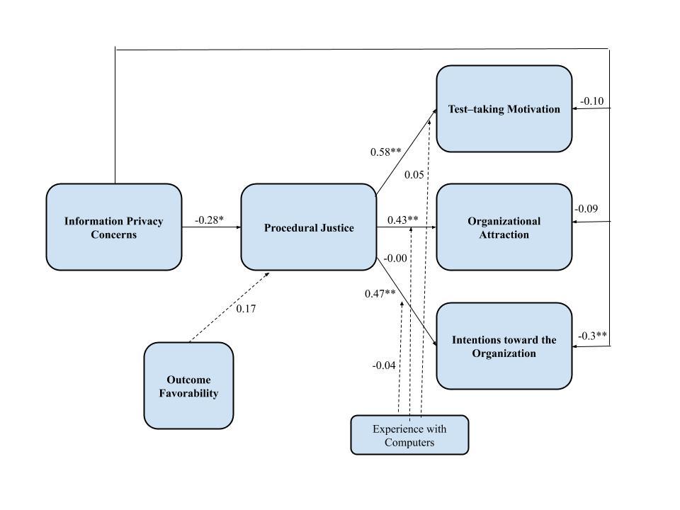
Figure 1. Structural Path Diagram of Study 1
The figure is showing that negative relationships exist between IPC and PJ, IPC and TTM, IPC and ITO, and IPC and OA. Furthermore, it is showing that positive relationships exist between PJ and ITO, PJ and OA, and PJ and TTM. The EWC negatively moderates the relationship between PJ and ITO, and between PJ and OA while it positively moderates the relationship between PJ and TTM. However, all moderation effects are insignificant. The values shown in this diagram are based on the data collected from sample students through longitudinal study. This is based on the data collected in form of responses of questions asked from students about each variable through longitudinal approach.

Fit Measures
Different fit measures that have been used in the study of Bauer et al. (2006) in study 1 and 2 include “χ2 , RMSEA, Comparative Fit Index (CFI), Adjusted Goodness-of-Fit Index (AGFI), and standardized root mean residual (SRMR)” which ultimately reflect the model fitness. The model fitness was tested for two model in both studies, one for the fully mediated model (FMM) and other for the partially mediated model (PMM). It has been found in this study that the PMM showed better fit in both studies because the fit measures of both PMM were showing better results than that of FMM. These measures reflect the variance between the expected/predicted CVM and sample CVM used in the analysis for a particular model. The CFI, RMSEA, and SRMR (>0.95, <0.08, and <0.10 respectively) reflect the favorability and goodness of model. Similarly, the AGFI >0.85 for all PMM as well as FMM in both studies of Bauer et al. (2006) is also reflecting the good fitness of models. In short, higher the similarity between the predicted CVM and sample CVM, the higher is the favorability of model estimation (Williams et al., 2009).

Path Coefficient
In Bauer et al. (2006), the value of 0.47** showed on the arrow between PJ and ITO in figure 2 shows the size of effect of PJ on ITO. It means that the PJ has a significant positive effect on ITO. This value was found based on the longitudinal data collected from students so, it is showing that students who have higher perceptions of PJ of organization showed high ITO. This value of .47** reflects that the impact of PJ on ITO is significant and positive at p-value<0.01. It actually means that one unit increase in PJ causes 47% increase in ITO and vice versa (Bauer et al., 2006).

Mediation in Study of Bauer et al. (2006)
The results of study of Bauer et al. (2006) suggested that the PMM has a better fit as compared to the FMM. The mediation in this study particularly refers to the mediating role of PJ between IPC and three applicants’ reactions i.e. OA, TTM, and ITO. It means that the increase in IPCs reduce the perceived PJ which ultimately reduces the ITO, TTM, and OA. It means that the IPCs are affecting the applicants reactions through PJ because the results proved the indirect effect of IPCs on OA, TTM, and ITO. The partial mediation (PM) in this context means that IPCs are having direct as well as indirect effects on applicants’ reactions (i.e. OA, TTM, and ITO) while full mediation (FM) in this context means that the IPCs do not have any significant direct effect on OA, TTM, and ITO rather, the whole effect is indirect and through the PJ. In the second case, the PJ fully mediates the relationship between IPCs (Bauer et al., 2006).
Bauer et al. (2006) reached the conclusion that the PMM is a better fit than FMM because the fit measures of PMM were showing better results than that of FMM. It means that the PMM with direct associations of IPC with OA, TTM, and ITO as well as indirect association of IPC with OA, TTM, and ITO through the mediator of PJ showed highly favorable fit measures. In contrast, the FMM containing only the indirect association of IPC with OA, TTM, and ITO through the mediator of PJ showed comparatively less favorable fit measures than that of PMM. Therefore, the researcher reached the respective conclusions. These results of study 2 of Bauer et al. (2006) provided the greater support than study 1 for the hypotheses of this study because these results are suggesting that applicants having lower IPCs report higher perceived PJ, TTM, OA, and ITO than applicants having higher IPCs. They further imply that applicants having positive PJ perceptions have more favorable reactions i.e. higher TTM, ITO, and OA than applicants having negative or lower perceptions of PJ. Hence, these findings prove the hypotheses of the study. The findings of this study will be value addition to the literature of PJ because they will enhance the empirical evidence about the role of perception of PJ in enhancing the reaction of applicants. They will also contribute to the practice in the field of organizational justice (OJ) because HR managers will be able to realize the importance of OJ in determining the reactions of applicants. Therefore, they can get assistance from the findings and suggestions of this study that how they can achieve positive and more favorable reactions of applicants by focusing on OJ so that perceptions of PJ can be enhanced in order to enhance TTM, OA, and ITO among applicants (Bauer et al., 2006).

New Structural Path
Hypotheses: The interpersonal justice (IJ) significantly partially mediates the relationship between authentic leadership (AL) and organizational trust (OT).

Figure 2. New Structural Path Diagram
The authentic leader always focuses on building the honest and fair relationships with his/her followers on ethical basis and valuing their efforts and input. Such a leadership brings different positive outcomes related to subordinates (Alinezhad, Abbasian, & Behrangi, 2015; Song & Seomun, 2014). The positivity, truthfulness, fairness, and openness of authentic leadership lead towards the IJ in an organization because it will bring fairness in relationships among workers as well as leaders at the workplace. When employees feel that they are treated fairly at the workplace, they are more likely to trust the organization (Emuwa, 2013; Kiersch & Byrne, 2015). It means that the fairness of relationships (i.e. IJ) at the workplace enhances the trustworthiness of the organization. Hence, it seems that the AL has the potential to enhance OT through the mediation of IJ. The study of Colquitt et al. (2001) revealed that the dimensions of OJ named as “informational justice” and “interpersonal justice” have received a little attention of researchers as compared to other dimensions of OJ. Therefore, there is need to efficiently explain the role of these dimensions of OJ in different organizational outcomes. Given the great importance of IJ and implications of Colquitt et al. (2001), it is hypothesized here IJ can act as strong mediator between AL and OT. Therefore, it is expected that the IJ will significantly mediate the association between AL and OT.

References
Alinezhad, M., Abbasian, H., & Behrangi, M. R. (2015). Investigating the Effects of Authentic Leadership of Managers on Organizational Commitment of Teachers with Organizational Justice as the Mediator Variable. Ciência e Natura, 37, 407-416.
Barrett, P. (2007). Structural equation modelling: Adjudging model fit. Personality and Individual Differences, 42(5), 815-824.
Bauer, T. N., Truxillo, D. M., Tucker, J. S., Weathers, V., Bertolino, M., Erdogan, B., & Campion, M. A. (2006). Selection in the information age: The impact of privacy concerns and computer experience on applicant reactions. Journal of Management, 32(5), 601-621.
Bollen, K. A. (2005). Structural equation models. Encyclopedia of biostatistics, 7.
Byrne, B. M. (2001). Structural equation modeling with AMOS, EQS, and LISREL: Comparative approaches to testing for the factorial validity of a measuring instrument. International journal of testing, 1(1), 55-86.
Colquitt, J. A., Conlon, D. E., Wesson, M. J., Porter, C. O., & Ng, K. Y. (2001). Justice at the millennium: a meta-analytic review of 25 years of organizational justice research. Journal of Applied Psychology, 86(3), 425.
Emuwa, A. (2013). Authentic leadership: Commitment to supervisor, follower empowerment, and procedural justice climate. Emerging Leadership Journeys, 6(1), 45-65.
Kiersch, C. E., & Byrne, Z. S. (2015). Is being authentic being fair? Multilevel examination of authentic leadership, justice, and employee outcomes. Journal of Leadership & Organizational Studies, 22(3), 292-303.
Song, B., & Seomun, G. (2014). The influential factors related to organizational citizenship behavior of nurses: With focus on authentic leadership and organizational justice. Journal of Korean Academy of Nursing Administration, 20(2), 237-246.
Williams, L. J., Vandenberg, R. J., & Edwards, J. R. (2009). 12 structural equation modeling in management research: A guide for improved analysis. Academy of Management Annals, 3(1), 543-604.

