OPERATION & INFORMATION MANAGEMENT

Bunsiness Proposal
BUSINESS PROCESS MODEL

Figure 1: Existing-Business Process Model
PROPOSED BUSINESS PROCESS MODEL

Figure 2: Proposed business structure with expansion
INDUSTRY OVERVIEW
The global pet grooming market looks glossy having projected annual growth of 4.7% between 2015- 2025. Pet accessories are also pulling on the lead, too-tipped to top £900 million by 2021-2022. Sole traders who deal in the pet industry will need more unique products to appeal to the expanding market.
Population of baby boomers, young couples, young children and elderly this industry growing day by day and due to its growth we must say it will be a continuous growth particularly for people who treat pets especially dogs, as a man’s best friend.
This industry has some inspiring incentives such as low start-up cost, flexible work hours, health benefits, potential of high earnings, and high demand for dog walking services and doing what you love like showcase your pack of dogs.

EXECUTIVE SUMMARY
Jordon King is a standard and certified dog groomer and has a small dog grooming salon. Her salon is located in a safe, neatly renovated and secured housing area. Her business venue is a hub that carries out all round services as it relates to dogs. It is a single person owned business that believe in giving dogs the right treatment they need to looks pretty & beautiful also, enable them to perform their roles as defined by her.
We have a plan to run our existing business according to proposed plan to make our business more successful and convenient for clients so that they can easily grab our products and entertain by our services. We are going to register our salon with a proper name “TopDog style Groomer®”. We are putting our plan in place to be sure that any dog in our custody is well taken care of and in the pursuit of excellence. Our objective of financial success along with uncompromising services and integrity, which is why we have decided to venture into more advanced setup by having advanced technology and more professional services. At our place, our client’s overall best interest would always come first. We will provide our services by our values and professional ethics. We are going to rent out free space area as veterinary clinic. We will ensure that we will hire professional dogs’ trainers and Vet doctors’ et al that are well experienced and passionate in imparting knowledge and skills to dogs at various learning standings.
Our overall business goal is to be amongst the top 10 dog grooming services and related business and also to become the leading dog brand in the pet industry in the United Kingdom within the 1st five years of operations.
PRODUCTS AND SERVICES
TopDog style Groomer® is going to offer range of dog grooming services and related products to maintain a dog’s physical appearance within the scope of pet industry. For instance,
TopDog style Groomer® fundamental services are following:
- Cutting & Brushing
- Clipping & Cleaning
- Bathing & Drying
- Styling

Our several additional linked services include:
- Dog Walker, trainers, behaviorists
- Residential Kennels
- Pet Photographers
- Grooming dogs in specific skills (Hunting skills, security skills, circus skills and running errands)
- Operating standard Vet clinic
Now we are going to offer more generalized range of pet related products to groom them more beautiful such as:
- Collars, leads & toys
- Pet food, Shampoos
- Dog tie & chains
- Pet cloths
- Tear stain remover
- Oral cleaning
- Odor elimination

VISION & MISSION STATEMENT

Our vision
“To create highly good & effective dog grooming services business that will become the number one choice for both individual and corporate organizations”

Our Mission
“To provide highly effective & affordable professional services and other unique & adorable products related to dog grooming to a wide range of client”
JOB ROLES & RESPONSIBILITIES

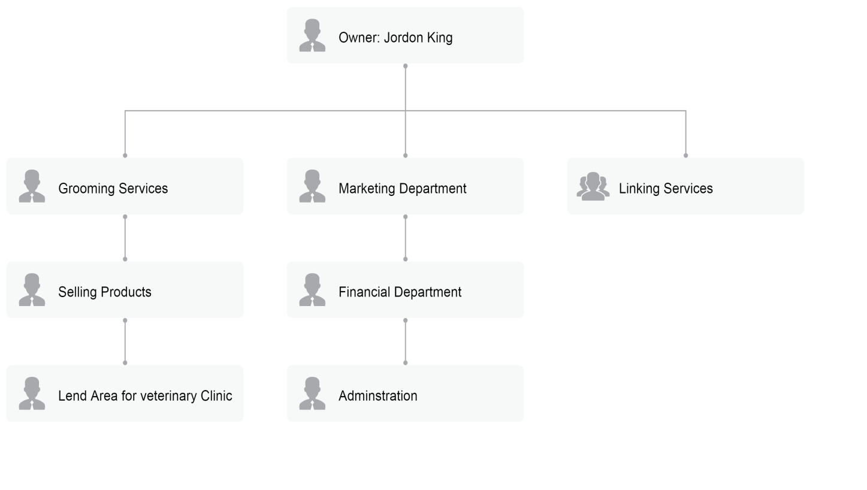
Operations Model:
The founder of TopDog style Groomer® Jordon King is the sole owner. Now we have decided to expand our business by hiring few employees for different departments such as an accountant who will handle our accounts in Finance department. Our large area that was not in a use, have been rent out for medical treatment by hiring highly qualifies Vet Doctor. We have a place to do office work in a sound & friendly environment.
We have expansion plan by offering door-to-door services so we have a van goes around to do pet in home care at customers’ driveway. We will offer mix of virtual services to sell our products online for the easiness of customer through our website. For our website, the primary function to introduce our products & services, post our contact information and allow customer to book an appointment by filling out a form in the website. Administration department will handle these appointment and will be arranged meeting with owner to whom she will give consultancy.
We have responsibility of offering a clean, comfortable living environment for their pets and while keeping the streets and outdoors area tidy by cleaning the waste disposal produced by their pets.
Transaction Model:
Our business model is a B2C (Business to customer) model. We collect payments after providing services at our workplace and online as well via cash and visa/credit card.

STARTUP COST AND CAPITALIZATION
We have started our business with a pared-down service. As our work demand increases, that’s why we are going to expand our business by offering additional products & services to increase our revenue stream. We are integrated Information system to meet future demands of our customers efficiently.
Estimated monthly fixed cost: £4,500
Estimated per unit variable cost: £0.00
Year 1sale of services: £50,000
Year 1unit of services: £1,450
Average per unit of service revenue: £38.49
We can minimal our cost by opting different choices but still cost include buying the relevant equipment, insurance and basic promotional material.

STRATEGIC ANALYSIS:
SOCIAL
ECONOMICAL
POLITICAL

ENVIRONMENTAL
LEGAL
TECHNOLOGICAL

PESTLE ANALYSIS
We adopt PESTLE Analysis for our strategic analysis to develop our business expansion plan:
Political Analysis
- Growing regional & international political crises can lead to ignorance of pet care
- Continuous changing governmental laws & crises due to political forces can pose a huge hurdle in the implementation of dog care center
- Tax policy, labor law and trade restrictions can also create hurdle
Economic Analysis
Following factors may influence on growth of business:
- Economic growth
- Interest rates
- Exchange rates
- Inflation
- Unemployment rates

Social Analysis
- Poor social security system cause negligence towards dogs care center
- Social values and certain cultural connection
Technological Analysis
- Technological incentives
- Technological changes
- Automation
Legal Analysis
- Corrupted legal system can make it difficult to acquire patent & license for salon
- Discrimination laws
- Antitrust law
- Health & safety laws
Environmental Analysis
- Climate change
- Environmental policies
- Pet & Dog care facility would not only help animals but will also contribute to the ecological chain system

PUBLICITY & ADVERTISING STRATEGY
Information & Communication Technology (ICT) intensely change the area of social & business communication. No doubt, ICT has had messive impacts on business’ operations. ICT fosters innovation in business. Innovation makes businesses run more efficiently and effectively. Innovation increase value, enhance quality and boost productivity. We have integrated IT system in our business to make more growth and we can save time by using information technology system. In our existing system, people get knowledge of our business by “Mouth of Word” but now we have adopted different advertising strategies to promote our business throughout our domestic level. Now we have been able to work with our brand and publicity consultant to help us map out advertisement &publicity that will help us to flourish in the heart of target market. We have gain almost number one choice for both individual and corporate clients. Below are the platforms we anticipate to influence on to promote and advertise our services;
- We are focused to advertise via social media such as Twitter, Instagram, Facebook, YouTube and Google etc.
- Sponsored relevant community based events
- Place advertisement on electronic media platform and on print media (community based newspaper & magazines)
- Installation of billboards
- Distribution of fliers and broachers in community
- Advertisement of our product & services on our official website
- Ensure our staff, employees, Vet doctors and van must be in business logo and wear proper brands shirts having organization logo

BUSINESS GROWTH:
SUSTAINABILITY & EXPANSION STRATEGY
The success & future of business lie in the competency & capacity of the employees, investment strategy, the number of loyal customers and its business structure. Being a dog groomer is considered as one of the easiest job so anyone can start up this entity with low cost budget (Press, 2009). So, it doesn’t stiff major competitors but somehow, face competition especially in UK. If anyone of the factor mentioned above, is missing then it will probability of difficulty an organization can face. Major goal of TopDog style Groomer® is to run business without taking heavy debt but a minimum from external sources to run its operations and utilize its own resources as well and will survive off its own cash flows. We will expect low profit margin at beginning of new set-up as dog grooming services and related products are cheaper comparatively. Profit sharing arrangement will be made available to all management staff based on performance so we can retain best hands in our business. Our company’s corporate culture & trained workforce will ensure its boom and will take our organization to greater heights.

OPEN SOURCE SOFTWARE (OSS)

Source Name | Features | Best For | Price/Rate | Free Trial
Booking koala | - Booking forms, an admin dashboard, provider dashboard,  - smart scheduling, customer dashboard, referrals,  - coupon management, themes, rating system,  - System logs, mobile apps and much more. | - For new set-ups  - Who want to save time & money | $27.00 per month | Yes
Kennel Connection | - boarding, grooming, daycare, training, pet sitting and special services  - Client and pet record-keeping  - scheduling, full point-of-sale capabilities, and employee management | - Pet Care Facilities  - Special Services | $69.00 per month,  per user | Yes
MeoGo | - Access from all computer platforms (IOS, Android, Desktop App)  - Easy & simple to focus on your grooming work while let MoeGo to streamline your business operations  - Top-notch customer service  - We believe software features won't differ different players, but software service does | - Pet Care Service Providers,  - Mobile Pet Groomers,  - Pet Groomers,  - Pet Day Care/Boarding,  - Veterinary | $39.00 per month,  Free Version available | Yes
Shake your Tail | - A simple way to schedule appointments & manage client details  - Email & SMS reminders | - Manage Clients  - Manage Pets | $4.99 per month | Yes
Time To Pet | - client portal, integrated scheduling and invoicing, online payments,  - dedicated mobile applications for both your clients and your team, GPS tracking, text messaging, and Quickbooks Integrations | - best-in-class pet sitting software and dog walking software | Team- $25/ month + $13/ month per active user  Solo - $35 per month | Yes

Open source software fuels enterprising organizations. It enables greater innovations & differentiation. It also helps companies to stand apart and encouraging healthy competition at a lower cost. As we have discussed five different alternatives regarding open source software to use best one for our day to day operations. We have found that range of software is easy & simple, offering unique features but if we look at our business structure and budget.
Booking Koala is one of the software with reasonable price. It is good for our business because we are extending with new products & services. But when we compare with the rest of software, it is not much related to our business structure. As it has free trial so we must try it before applying in our organization.
Kennel Connection is well known software. Its price is comparatively high but when it comes to security and a range of facilities, it’s not bad option (Blumberg, 2020).
MeoGo is relatively feasible software that it can be access through any computer platform from anywhere at affordable price.
Shake your tail is very simple & orthodox software. Good thing is about this software it is offering a cheaper rate than others.
Time to pet is comparatively higher at cost. We will not choose this software because it is providing range of facilities that are not linked with our business.
We will prefer to go for that software which will be cost-effective, Software that will offer agility and flexibility. It must provide solid information security and cover maintenance cost. Therefore, we are going to use Kennel Connection software that is costly little a bit as compared to others but it provide a wide range of special Services and free trial as well.
***********************

References
Blumberg, M. (2020). Startup CEO: A Field Guide to Scaling Up Your Business (Techstars). . John Wiley & Sons.
Press, E. (2009). Start Your Own Pet Business and More: Pet Sitting, Dog Walking, Training, Grooming, Food/treats, Upscale Pet Products. . Entrepreneur Press.

