COVID-19 PANDEMIC

LITERATURE REVIEW

COVID-19, initiated from a small town in China, has grown to be a pandemic victimizing millions of people around the globe. The population is striving to deal with the pandemic effectively as a strong emphasis on national lockdowns and social distancing measures have been made. The economic downturn that has arisen from the pandemic can be remedied through a number of strategies that may change the terrifying situation and eventually, the virus may be eliminated from nations. The emergence of COVID-19, and its impact on the world are therefore explained in detail.
The COVID-19 pandemic has engulfed the world in a series of unending turmoil and upheaval. The economic downturn has led to countries designing contingency plans and changing the set-up of educational institutes and companies to an entirely online-based strategy. The emergence of the COVID-19 infection and its announcement as a pandemic will be discussed below.
Sułkowski, 2020 explains how during December 2019, a new viral lung disease known as Covid-19 emerged in Wuhan, China. The virus's cause is most likely zoonotic and originated through bats. The SARS-CoV-2 virus quite likely broke through the interspecies firewall and started infecting people present within the Wuhan market. On February 8, 2020, only a few days after the start of systemic evaluations, China reported 33,738 known cases of the infection as well as 811 deaths. Upon March 11, 2020, WHO declared the Covid-19 pandemic, highlighting the public health threat posed by the outbreak of the virus.

Fritz, 2021 expresses how the COVID-19 pandemic has engulfed the world as millions of individuals have fallen prey to its infection and symptoms that tend to stay for 15 days or more. The symptoms of the coronavirus infection, can vary from moderate to severe. The highly frequent symptoms are fever, a dry cough, as well as shortness of breath. However, there are many other signs that prove that you should be checked by the doctor. Not every individual has the same signs, and the sequence in which they occur can differ. Some patients have no signs — what doctors term as "asymptomatic" cases — but they have the tendency to transmit the infection to others.

Gallagher, 2021 explains how the symptoms of the COVID-19 tend to vary from simply a continuous cough to a loss of smell or taste and a persisting fever. The normal time for signs to appear after being infected is five days, however the World Health Organization states it might go up to 14 days. The precautions that individuals have been required to take, to prevent themselves from the spread of the virus includes wearing a mask to protect themselves from catching the virus from public spaces, washing hands frequently or sanitizing them, avoiding touching their eyes, mouth and nose with unwashed hands. However, the main precaution that the population is required to take is to maintain social distancing. The contagious nature of the COVID-19 has enabled governments to execute lockdowns that prevent crowding of populations and thus, halting the spread of the infection.
However, the COVID-19 has posed a highly negative impact on the economies and the population throughout the world. The infections contain the strength to be transmitted from one individual to another, which is why social distancing needs to be ensured.
One of the main approaches that governments are expected to take in dealing with the spread of the virus includes the elimination approach. Countries seeking Covid-19 eradication outperform those attempting to contain the virus. Striving for zero-Covid yields more optimistic effects than attempting to “survive with the virus.” Therefore, it is essential to explore how this strategy impacts populations.
Countries that have eradicated Covid-19 are facing less economic downturn as compared to countries that are attempting to coexist with the virus. The mainland China as well as Taiwan could be the only two countries with neutral or net positive economic development in 2020. Having a clear “zero-Covid” target offers a powerful motivator and organizing emphasis. Suppression lacks a definite end destination, rendering countries vulnerable to swift revivals, as seen currently in Ireland. The ensuing confusion makes planning difficult, with far-reaching implications for colleges, businesses, and family life (Baker & McKee, 2021).

The number of deaths per day within the United States has eclipsed those that are present in other countries. California and Texas have experienced the greatest amount of deaths within the population. The chart below demonstrates the trends for the deaths within the United States and it can be seen how the ratio declined in between but it again rose to a maximum rapidly as 2020 ended (Murphy et al., 2021).
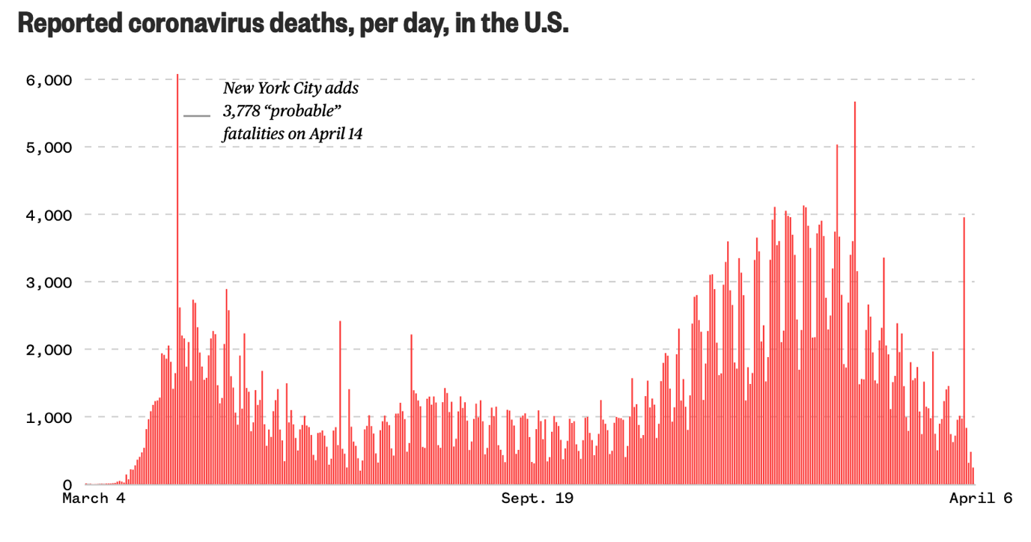 (Murphy et al., 2021)
On April 5, 2021, around 530 new coronavirus deaths as well as 76,594 new cases were identified throughout the United States. During the previous week, there were a total of 64,851 cases each day, a 20% rise as compared to the previous two weeks. Some colleges opted to conduct any or more of their courses online, and many others revived their buildings, albeit with stringent policies and protocols restricting conduct and research. As the fall semester started in August and September, college towns experienced some of the fastest per capita case rise in the nation. And by November, as the number of cases increased across the world, tens of thousands further cases emerged. The table below demonstrates the overall number of cases that arose from educational institutes throughout the United States (The New York Times, 2021).
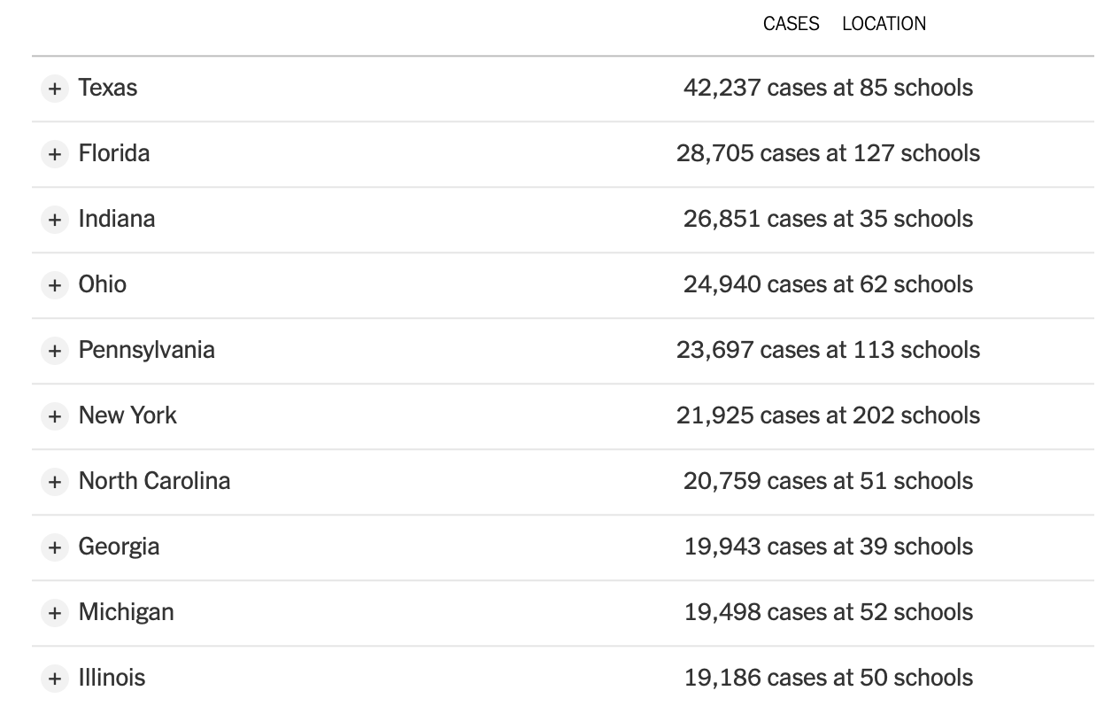
(The New York Times, 2021)
However, in order to deal with the COVID-19, It is imperative that the population follows pandemic public health preventive measures, effectively limiting epidemic spread, and the nations will enact no quarantine at all if the health sector capability is at or above threshold levels. Singapore, Hong Kong, Taiwan, and Sweden are a few examples. Social distancing within big cities, lowering the reproductive number can be pushed by changing work hours as well as conducting staggering.
Various strategies such as social distancing, changing of work hours and inculcation od staggering has been implemented throughout the world. It is essential to study their impact on the countries and the masses that are present within them.
Such modifications inevitably reduce the strain on public transit during peak hours as well as alleviate crowding throughout lunch breaks. Also, offices and classes, for example, can run in shifts, and weekends can be utilized to run processes smoothly. No quarantine is needed if the health system's capability is sufficient and the amount of hospital or ICU beds is at or above threshold limit. Unless the number of ICU beds is less than the limit, quarantining the population would only encourage the country to delay the transmission of infections and allow the curve to be flattened (Gershon et al., 2020).

Debata et al. (2020) explains how the COVID-19 pandemic has created significant damage to the global economy, causing productivity and demand to be reduced. Developing nations, including India, are vulnerable to certain economic shocks and are expected to see a decline in economic development. As a result, the Indian economy had entered a slow period after the introduction of demonetization as well as the goods and services tax (GST), and also the state was looking at ways to get the economy growing. Tourist industry, healthcare, aircraft, textile, agriculture, manufacturing, gems/jewelry, as well as start-ups, all of which significantly contribute to the economy and job creation, have recorded losses in billions throughout the pandemic.
The COVID-19 epidemic has also started to change how economic actors conduct throughout societies, starting with lifestyle as well as social development and extending to economic practices of individuals and businesses. The outbreak's impact can be felt at both the micro and macro stages. Several major multinational firms, for instance, have now partially stopped development in China as well as other nations, and air and sea transportation networks to and from China and some other economies have been blocked, culminating in a partially or completely border ‘locked down’ (Barua, 2020).

Conclusion
However, to deal with the economic impact of COVID-19, A variety of policy responses are needed, both within the short term and in the years ahead. In the near term, central banks as well as treasuries must ensure that damaged economies remain operational while the virus epidemic progresses. Governments play an important part in times of economic and monetary tension. Although central banks will respond by lowering interest rates, this shock is more than just a market management problem; it is a multidimensional crisis that will necessitate monetary, fiscal, as well as public health approaches (McKibbin & Fernando, 2020). The pandemic has strongly impacted the health career plans that were initially planned for. It has brought life to a sudden halt and there is a requirement to completely alter the normal way of life and shift towards a “new normal”. However, the alteration is now being made speedily and people are coming to terms with the changes that are necessary to allocate health and safety for the masses. To execute this research, it is imperative that the economic impact of COVID-19 is studied in detail and all the factors that are involved in this process be separated and analyzed singularly.

References
Baker, M., & McKee, M. (2021). All countries should pursue a Covid-19 elimination strategy: here are 16 reasons why | Michael Baker and Martin McKee. the Guardian. Retrieved 6 April 2021, from https://www.theguardian.com/world/commentisfree/2021/jan/28/all-countries-should-pursue-a-covid-19-elimination-strategy-here-are-16-reasons-why.
Barua, S. (2020). Understanding Coronanomics: The economic implications of the coronavirus (COVID-19) pandemic.
Debata, B., Patnaik, P., & Mishra, A. COVID-19 pandemic! It's impact on people, economy, and environment.
Fritz, A. (2021). The covid-19 symptoms to watch out for. The Washington Post. Retrieved 6 April 2021, from https://www.washingtonpost.com/health/2020/12/02/covid-symptoms/.
Gallagher, J. (2021). Covid symptoms: What are they and how do I protect myself?. BBC News. Retrieved 6 April 2021, from https://www.bbc.com/news/health-51048366.
Gershon, D., Lipton, A., & Levine, H. (2020). Managing Covid-19 Pandemic without Destructing the Economy.
McKibbin, W., & Fernando, R. (2020). The economic impact of COVID-19. Economics in the Time of COVID-19, 45.
Murphy, J., Wu, J., Chiwaya, N., & Muccari, R. (2021). Graphic: Coronavirus deaths in the U.S., per day. NBC News. Retrieved 6 April 2021, from https://www.nbcnews.com/health/health-news/coronavirus-deaths-united-states-each-day-2020-n1177936.
Sułkowski, Ł. (2020). Covid-19 Pandemic; Recession, Virtual Revolution Leading to De-globalization?. Journal of Intercultural Management, 12(1), 1-11.
The New York Times. (2021). Coronavirus in the U.S.: Latest Map and Case Count. Nytimes.com. Retrieved 6 April 2021, from https://www.nytimes.com/interactive/2020/us/coronavirus-us-cases.html.

