Case 3
Measurement Model
Measurement model or outer model enables the researcher to assess how efficiently the observed variables merge to recognize fundamental hypothesized construct. Measurement models are tested through confirmatory factor analysis and latent variables are defined by hypothesized factors. In measurement model, latent variables rely on the measures chosen by the researcher. The accuracy of latent variable depends on the extent that the measures defining it are strongly correlated to one another. Such as the weak correlation between the one measure with other two measures of the same construct, resultantly, that construct will be defined poorly (Weston, Rebecca & Gore, Paul.,2006). A measurement model is referred to as multivariate regression where indicators are known as endogenous or exogenous latent variables. In reflective measurement model, correlation among the same domain items is usual (Edward and Bagozzi, 2000). Comparably, a set of indicators based on linear combination form the construct in a formative measurement model. Therefore, change in indicators follows variety in the inactive variable (Borsboom et al. 2003).
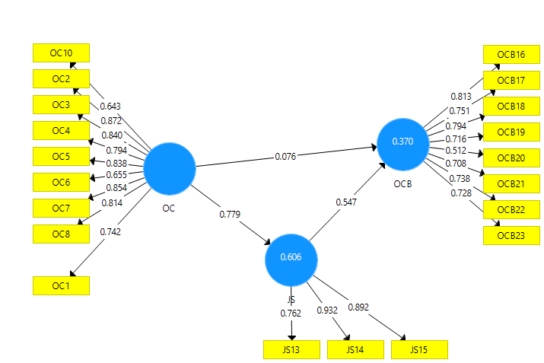
Figure 1. Path Coefficients
PLS Algorithm
Wold (1982) developed the PLS path modelling model and Henseler et Al., (2009) defined PLS algorithm as the series of regressions corresponding of weight vectors. Fixed points equations are satisfied by the convergence of weight vectors (Dijkstra, 2010). In the above figure, the path model constructed with the research question shows that all the paths of the model are significant. Organizational citizenship behaviour, organizational commitment and job satisfaction have path coefficients 0.547, 0.076 and 0.981 and 0.779, respectively. All the three values are significant indicating a meaningful relationship between OC, JS, and OCB. These values indicate the variation caused in dependent variable (54.7% in OC, 7.6% in OCB and 77.9% in job satisfaction) is significant.
Table 1
VariablesDescriptive and Confirmatory Factor Analysis
 | Descriptive Statistics |  | Confirmatory Factor Analysis
 | Mean | SD | Outer Loading | t-value | p-value
JS13 | 5.010 | 0.927 | 0.762 | 7.840 | 0.000
JS14 | 5.253 | 0.783 | 0.932 | 54.903 | 0.000
JS15 | 5.394 | 0.708 | 0.892 | 19.823 | 0.000
OC10 | 5.626 | 0.733 | 0.643 | 3.948 | 0.000
OC2 | 5.172 | 0.922 | 0.872 | 22.173 | 0.000
OC3 | 5.010 | 0.959 | 0.840 | 21.746 | 0.000
OC4 | 5.232 | 1.013 | 0.794 | 12.797 | 0.000
OC5 | 5.561 | 0.779 | 0.838 | 11.934 | 0.000
OC6 | 5.223 | 0.835 | 0.655 | 3.882 | 0.000
OC7 | 5.262 | 0.819 | 0.854 | 18.616 | 0.000
OC8 | 4.707 | 1.130 | 0.814 | 25.193 | 0.000
OCB16 | 5.007 | 0.745 | 0.813 | 21.712 | 0.000
OCB17 | 4.959 | 0.875 | 0.751 | 15.489 | 0.000
OCB18 | 4.977 | 0.829 | 0.794 | 10.931 | 0.000
OCB19 | 4.948 | 0.744 | 0.716 | 12.511 | 0.000
OCB20 | 5.400 | 0.609 | 0.512 | 5.844 | 0.000
OCB21 | 4.748 | 0.976 | 0.708 | 7.316 | 0.000
OCB22 | 4.690 | 0.974 | 0.738 | 7.941 | 0.000
OCB23 | 4.538 | 1.326 | 0.728 | 14.109 | 0.000
﻿OC1 | 5.283 | 0.711 | 0.742 | 8.901 | 0.000

  - Descriptive Analysis
In the above table, variables are taken with descriptive statistics and confirmatory factor analysis. Organizational behaviour (OB) is independent variable, organizational citizenship behaviour (OCB) is dependent variable and Job satisfaction (JS) plays a mediating tole between this DV and IV. JS has 5 number of questions from which question no 11 & 12 had been deleted due to having lower factor loading. The remaining 3 items range from 5.010 to 5.394 with SD from 0.927 to 0.708 indicating data is not dispersed and are close to the mean value. The mean value of OC ranges from 5.283 to 5.626 with SD ranges from 0.711 to 1.130. The mean value of OCB ranges from 5.007 to 4.538 with SD from 0.745 to 1.326 that shows slight neutrality of the responses.
  - Confirmatory Factor Analysis
The second header of Table 1 displays Confirmatory factor loadings with outer loadings. Constructs having loadings of 0.5 and greater are considered strong variables whereas loadings below 0.5 are considered weak. Weak loadings should be removed from the table. Two items JS11 and JS12 from the variable of job satisfaction have been removed due to lower outer loading. Moreover, one item OC9 from the variable organizational behaviour is removed for the same reason. Resultantly,all the construct’s factor loadings meet the criteria of being equal to or greater than 0.5.
T statistics identifies the discrepancy between the means of two groups. It is used to test hypothesis. The higher the t statistics the greater is the corroboration in favor of alternative hypothesis. All the items surpassed threshold value of t-stats which 1.96 at 5% confidence interval. P value < 0.05 is considered sognificant. P value 0.00 means the variable is quite significant. Since all items in the table have a p value=0.000 indicate significance of variables.
Table 2
Convergent Validity
  - Cronbach Alpha
The reliability of constructs’ internal consistency is ensured by Cronbach’s alpha .The ideal range of CA is to between 0.7 to 1. All the constructs shown above in the table falls in the ideal range which reflects consistency and reliability of data.
  - Spearman Rank Correlation
Spearman rank correlation rho A (next to Cronbach’s alpha’s column) shows the strength of connection between two factors. All the constructs have values more than 0.8 which indicates a strong association between the variables.
  - Composite Reliability
The reliability and validity are shown in the above table. Results are satisfactory when constructs have composite reliability greater than 0.7. In the above table all the constructs have CR greater than 0.7 which is good indicator and posit the reliability of the scale.
  - Average Variance Extract
AVE is performed to determine the degree of correlation between two constructs. The minimum threshold value for AVE is 0.5, since AVE values for JS, OC and OCB all are above 0.5, which indicates the data support convergent validity.
Table 3
Fornell-Larcker Criterion (Discriminant Validity)
Fornell-Larcker Criterion
Discriminant validity measures whether the constructs are correlated or not. It ensures the existence of a strong relationship between a construct with its own indicators (Carmines and Zeller, 1979). In discriminant validity relationship between latent variables is analyzed. When AVE loadings are more than 0.5 discriminant validity results are acceptable.
Table 4
HTMT Ratio (Discriminant Validity)
Heterotrait-Monotrait Ratio, HTMT
HTMT ratio is another method to check discriminant validity. In HTMT values less than 1 means positive discriminant validity. In the above table all the constructs have values less than 1 which means the validity is proved.
References
Borsboom, D., Mellenbergh, G. J., & van Heerden, J. (2003). The theoretical status of latent variables. Psychological Review, 110(2), 203–219
Carmines, E. G., & Zeller, R. (1979). Reliability and Validity Assessment. Sage publication, Inc.
Dijkstra, T. K. (2010). Latent Variables and Indices: Herman Wold’s Basic Design and Partial Least Squares, in Handbook of Partial Least Squares: Concepts, Methods and Applications (Springer Handbooks of Computational Statistics Series, vol. II), V. Esposito Vinzi, W. W. Chin, J. Henseler and H. Wang (eds.), Springer: Heidelberg, Dordrecht, London, New York, pp. 23-46.
Edwards, J.R. and R.P. Bagozzi (2000). "On the nature and direction of relationships between constructs and measures," Psychological Methods, 5:2, pp. 155–174
Henseler, J., Ringle, C. M., and Sinkovics, R. R. (2009). The Use of Partial Least Squares Path Modeling in International Marketing, in Advances in International Marketing, R. R. Sinkovics and P. N. Ghauri (eds.), Emerald: Bingley, pp. 277-320.
Weston, Rebecca & Gore, Paul. (2006). A Brief Guide to Structural Equation Modeling. The Counseling Psychologist. 34. 719-751. 10.1177/0011000006286345.
Wold, H. (1982). Soft Modeling: The Basic Design and Some Extensions, in Systems Under Indirect Observations: Part II, K. G. Jöreskog and H. Wold (eds.), North-Holland: Amsterdam, pp. 1-54.

