Case 4
Structural Equation Modelling
The structural model contains the association among latent variables that must be derived from theoretical consideration. Independent latent variables are mentioned as exogenous variable and the dependent variables are referred to as endogenous variables (Weston, Rebecca & Gore, Paul, 2006). An error term is always associated with endogenous latent variables. Error term is limited to zero in PLS-SEM because treating with formative method (Diamantopoulos, 2011). Hence, display of error term in omitted in a path model of PLS. In case of exogenous latent construct draw on reflective model, no error term is attached to this construct (Sarstedt et Al., 2017). Equations in structural model particularize the hypothesized association among the latent variables. This relationship can be defined as covariance, direct effects or indirect (mediate) effects. Covariance is corresponding to correlation in a way they defined as non-directional relationship among LVs. Path coefficients represent the strength of relationship between latent variables and Coefficients are the outcomes regression for each endogenous latent variables on their straight predecessor (Sarstedt, Marko & Ringle, Christian & Hair, Joe, 2017).
Hypothesis Testing
Bootstrapping method tests the results of PLS-SEM statistical significance like various path coefficients. PLS-SEM assumes that data is not normally distributed, it is a non-parametric process which is used to assess the consequence of path coefficients (Efron and Tibshirani, 1997; Davison and Hinkley, 1997). Bootstrap gives the t statistic and p values which indicates the whether the relation between constructs is significant or not. Mooney and Duval (1993) and Wood (2005) calls bootstrap a transparent method, which is easy to use for researchers. Figure 1 illustrates PLS-SEM Bootstrap.

Table 1
R-square
 | R-Squ. | Adjusted R-Squ.
OCB | 0.370 | 0.357
JS | 0.606 | 0.602

The r-square table tells us about the overall strength of the model such as variability caused by the predictors in endogenous variable. The value of R-square is .370 that means approximately 37% variation of endogenous variable OCB due to exogenous variable OC, which is weak, however, the relationship becomes moderate with 60.6% variation occurred between DV & IV due to the inclusion of mediator JS.
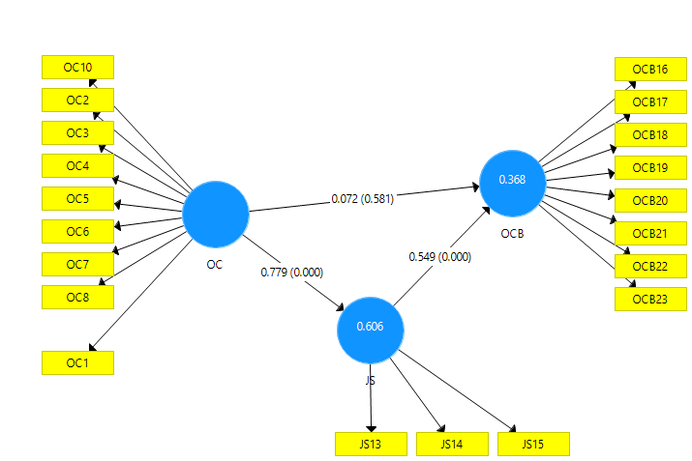
Table 2
Path Coefficients
 | Original Sample (O) | t-value | p-value | f-square | Conclusion
JS -> OCB | 0.549 | 4.476 | 0.000 | 0.187 | Accepted
OC -> JS | 0.779 | 9.753 | 0.000 | 1.539 | Accepted
OC -> OCB | 0.072 | 0.551 | 0.581 | 0.004 | Rejected

Path coefficients of all hypotheses is shown in the above table. Path coefficient explains the variation caused by predictors in dependent variable. Results from bootstrap will prompt whether to accept the alternate hypothesis or reject it. The p-value <0.05 with t-value >1.96 indicates relation significance at 95% confidence interval. Additionally, f-square value >0.02 is considered significant. In the following table, the only smaller t-value is OC to OCB with p-value >.05 that shows insignificant relation between these variables. Although, JS is significantly related to both endogenous and exogenous variables. Hence, H1 is rejected due to no significant relation between OC and OCB and H2 is accepted because the findings suggest that Organizational commitment has indirect effect on organizational citizenship behaviour through the mediation of job satisfaction.
Mediation Analysis
The mediation impact can be progressed between the product in such a way that independent variable and a mediator and a way like mediator and dependent variable can be statistically significant (Simon, 2015). Therefore, mediation analysis is conducted for evaluating causal relationship through involving third illustrative mediator variable between dependent and independent variable (Hair et Al., 2016). bootstrapping approach is suitable for conducting mediation analysis because this technique does not suppose statistics something division and can equality be applied to small sample size (Hair et al., 2016). Before conducting mediation analysis in PLS-SEM, it is essential to ensure the significant association between exogenous and endogenous variable without involving any mediator yet (Zhao, Lynch & Chen, 2010).
Table 3
Specific Indirect Effects
 | Original Sample (O) | t-value | p-value
OC -> JS -> OCB | 0.427 | 3.592 | 0.000

JS positively and significantly mediates the relation of OC and OCB. It has a p-value 0.000 and t-value 3.592 which meets the significance criteria.
References
Davison, A. C., & Hinkley, D. V. (1997). Bootstrap methods and their application (No. 1). Cambridge university press.
Diamantopoulos, A. (2011). Incorporating formative measures into covariance-based structural equation models. MIS Quarterly, 35(2), 335–358.
Efron, B., & Tibshirani, R. (1997). Improvements on cross-validation: the 632+ bootstrap method. Journal of the American Statistical Association, 92(438), 548-560.
Hair Jr, J. F., Sarstedt, M., Matthews, L. M., & Ringle, C. M. (2016). Identifying and treating unobserved heterogeneity with FIMIX-PLS: part I–method. European Business Review.
Mooney, C. F., Mooney, C. L., Mooney, C. Z., Duval, R. D., & Duvall, R. (1993). Bootstrapping: A nonparametric approach to statistical inference (No. 95). sage.
Sarstedt, Marko & Ringle, Christian & Hair, Joe. (2017). Partial Least Squares Structural Equation Modeling. 10.1007/978-3-319-05542-8_15-1.
Simons, T., Leroy, H., Collewaert, V., & Masschelein, S. (2015). How leader alignment of words and deeds affects followers: A meta-analysis of behavioral integrity research. Journal of Business Ethics, 132(4), 831-844.
Weston, Rebecca & Gore, Paul. (2006). A Brief Guide to Structural Equation Modeling. The Counseling Psychologist. 34. 719-751. 10.1177/0011000006286345.
Wood, M. (2005). Bootstrapped confidence intervals as an approach to statistical inference. Organizational Research Methods, 8(4), 454-470.
Zhao, X., Lynch Jr, J. G., & Chen, Q. (2010). Reconsidering Baron and Kenny: Myths and truths about mediation analysis. Journal of consumer research, 37(2), 197-206.

