Discussion 6
The concepts I have learnt in this course help me a lot to develop methodology chapter in my dissertation. The corresponding concepts in writing methodology become clear throughout the activities of modules. Before proceeding in research, the first essential things to consider for the researcher is sample size. Many scholars have contributed to the estimation of sample size. Some traditional concepts in calculating sample size are 50 per variable observations coma 5 to 10 per parameter observations, minimum hundred and so on. No such rule of thumb is situationally applicable.
Sample size requirement is dependent on numerous factors like model size variables distribution missing data amount coma variable’s reliability and strength of variables relationship. Although 200 samples are recommended for PLS-SEM to get significant statistics and 300 samples are significant for covariance-based SEM (Panditharathna, 2020). I have learned well use of multidimensional scale that allowed me to discover the themes and dimensions to elaborate like and unlike distance between underlying data set. This is statistical technique is helpful in developing research design that enabled the researcher to visualize the data in perceptual manner.
Steps of Data Analysis using SEM

Source: Dragan, Dejan & Topolšek, Darja. (2014)
All Significant Steps in SEM Modelling
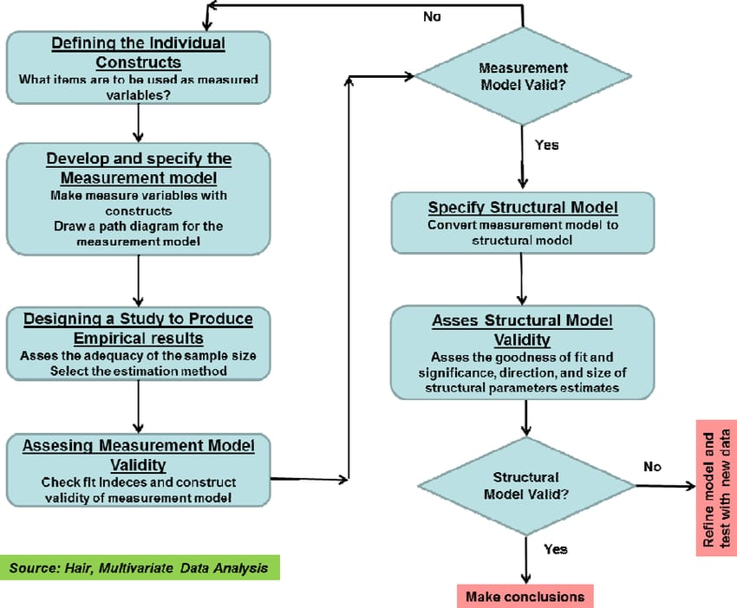
Source: Dragan, Dejan & Topolšek, Darja. (2014)
SEM is more powerful statistical technique than regression analysis that is utilized in measuring in analyzing the association of latent and observed variables. SEM is unique in a sense as it investigates linear associations among variables, meanwhile, explain the measurement error (Beran & Violato, 2010). Confirmatory factor analysis is necessary to confirm the factors structure of observed variables set. It helps the researcher to verify the existence of correlation among latent constructs and underline observed variables through testing hypothesis. Algorithm and Bootstrap are two techniques of SmartPLS to deal with measurement and structural modeling.
Two types of models are included in SEM that is measurement model and structural model. Measurement model focused on measuring the composite for latent variables, however, hypothetical dependence can be we tested by structural model (Kline, 2010). The comparison between measurement and structural model can be measured directly because of having different components. Measurement model includes observed endogenous factors however the structural model consists of latent unobserved and endogenous factors. All these concepts are clear to me after completing these modules. I have now better understanding related to using SEM technique for writing methodology chapter of my dissertation.
References
Beran, T.N., Violato, C. (2010). Structural equation modeling in medical research: a primer. BMC Res Notes 3, 267. https://doi.org/10.1186/1756-0500-3-267
Dragan, Dejan & Topolšek, Darja. (2014). Introduction to Structural Equation Modeling: Review, Methodology and Practical Applications.
Kline RB (2010). Principles and practice of structural equation modeling. Guilford Press, New York
Panditharathna, Roshan. (2020). Re: How to determine sample size in quantitative research. Retrieved from: https://www.researchgate.net/post/How_to_determine_sample_size_in_quantitative_research/5e4a8eed0f95f177412350ac/citation/download

