Productivity In A Service Economy
Productivity in a Service Economy" is a topic that examines how efficiency and output can be improved in industries that provide services rather than tangible goods. It often involves optimizing processes, utilizing technology, enhancing employee skills, and focusing on customer satisfaction to increase productivity and competitiveness in service-based sectors such as healthcare, finance, hospitality, and professional services (Yapp, 2022).
Accommodation and Food Service Industry
During the COVID-19 pandemic, the Accommodation and Food Service Industry faced unprecedented challenges. With travel restrictions and social distancing measures in place, many establishments experienced a sharp decline in patronage, leading to significant job losses and operational disruptions (Sood, 2021). To survive, businesses adapted by enhancing their takeout and delivery services, implementing stringent health protocols, and reimagining customer experiences to cater to a more health-conscious public (ILO, 2020). Despite the hardships, the industry's resilience was evident as it began to show signs of recovery, reflecting the essential nature of hospitality and the human desire for connection and convenience.
Table 1: Productivity of Accommodation and Service Industry
Accommodation and Food Service Industry

 | Employment (thousands) | 33,447
Percent change:  2021-2022 | Labor productivity | -1.50
Percent change:  2021-2022 | Unit labor costs | 52.20
Percent change:  2021-2022 | Output | 24.90
Percent change:  2021-2022 | Hours worked | 26.50
Percent change:  2021-2022 | Labor compensation | 80.30
Source: U.S. Bureau of Labor Statistics

The above table reflects the economic indicators for the Accommodation and Food Service Industry during a period that was likely affected by the COVID-19 pandemic. Here's an interpretation of the table in that context:
- Employment (thousands): The industry employed 33,447,000 people. During the pandemic, this sector saw significant job losses due to lockdowns and reduced travel, but the figure suggests a recovery or stabilization in employment levels.
- Labor Productivity (-1.50%): This decrease indicates that, on average, each worker produced less per hour compared to the previous year. The pandemic introduced challenges such as health protocols that may have reduced efficiency.
- Unit Labor Costs (+52.20%): The substantial increase suggests that the cost of labor per unit of output rose sharply. This could be due to increased wages to retain staff during uncertain times or additional costs for health and safety measures.
- Output (+24.90%): The increase in output is a positive sign, indicating that the industry has been able to grow despite the pandemic, possibly due to adaptations like increased takeout and delivery services.
- Hours Worked (+26.50%): The increase in hours worked could reflect longer hours for existing staff due to social distancing measures requiring more time for the same tasks, or it could indicate rehiring of staff as restrictions eased.
- Labor Compensation (+80.30%): This substantial rise could be a result of hazard pay, augmented benefits, or higher wages provided during the pandemic to account for the elevated risk and to lure workers in a heated labor market.
On the whole, the table indicates that the Accommodation and Food Service Industry has been forced to deal with a greater amount of expenses, while at the same time experiencing higher productivity losses during the pandemic (Hutton et al., 2022). Nevertheless, the sector’s performance seems to be suffering as resilience has been observed in growth of output and compensation but also in efforts to adapt and recover. The pandemic hit this sector hard, with a number of businesses having to shift to new operating models that usually entail smaller capacities and greater emphasis on health and safety.
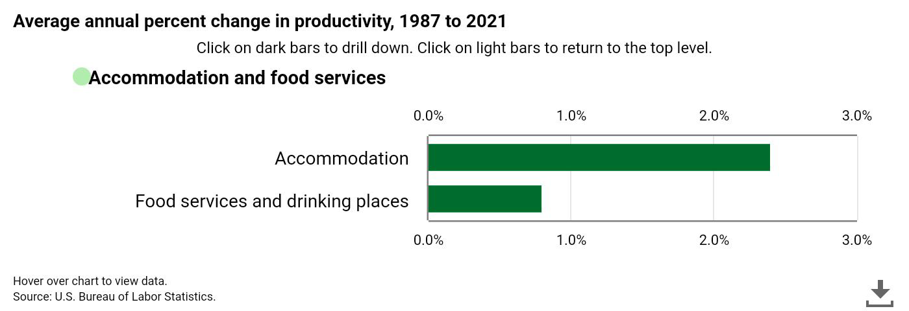
There have been great changes of the productivity in the Accommodation and Food Service Industry during these years under the influence of different economic factors and industry-specific trends. Here is an overview:
1-Year Change in Productivity:
In the very last year, the industry experienced productivity inconstancy. For instance full service restaurant had a -2.1% change in 2022 after a huge change of 20.5% in 2021. The volatility can be associated with recuperation from the pandemic, which sees business adapting to new operation models as well as customer behaviors (Gumber & Sullivan, 2022).
Average Annual Percentage Change in Productivity: Average Annual Percentage Change in Productivity:
In the long run, the average annual percentage change in productivity is indicative of the overall efficiency improvement of the industry. The Accommodation sector, such as hotels and related facilities as a whole, has been going in the right direction, reflecting successful adjustment to market needs and technological changes (BLS, 2022).
Industry-Specific Application for a Productivity Trend: Industry-Specific Application for a Productivity Trend:
One of the significant industry-specific applications, which has affected productivity trends, is the implementation of digital transformation. Providers have used AI, IoT and cloud computing technologies to improve experiences among the customers and the operations. In addition, this digital move has brought about operational transparency and efficiency and resulted in industry productivity at large (Chin et al., 2023).
The Rise Of Productivity As A Service In The Coworking Model (2021):
Thrall of productivity as a service in the coworking model is the name of the drift of the coworking spaces developing further from physical work spaces to some arrangements which are aimed at the productivity improvement for their members. This can be in the form of tools and equipment access, networking functions, mentorship programs, education workshops, and service support including administrative assistance and IT support. With these value-added services, the coworking spaces seek to draw and keep members by providing a complete solution, which provides not only a place to work but also collaboration, innovation, and personal and professional development. This model is consistent with the demands of the current workforce who need an environment that delivers more than a desk and Wi-Fi, but a supporting structure enabling them to be productive and successful (Kane, 2021).
Conclusion
Overall, in terms of productivity, the Accommodation and Food Service Industry had a mixed performance. The accommodation sector showed a positive increase largely due to technological innovations and better service delivery, whereas the food services sector performed dismally with a reduced growth in labour productivity. Specifically, drinking places suffered a negative trend, which calls for some changes in the drinking places subsector to improve its efficiency and profit-making. Industry is cautiously optimistic, as it tries to make use of good trends against some negative ones(Hofmeister et al., 2023).
The technological innovations were major factors in productivity increases. Hotels and other accommodation operators introduced contactless check-ins, digital room keys, and smart room amenities to minimize human interaction and comply with health protocols. Such policies did not only create safety but also rationalized operations, minimally making staff redundant and enhancing the efficiency (Goldstein, 2021). In addition, the pandemic spurred increased acceptance of remote working hence creating a phenomenon that saw people reserve hotel rooms which they used as remote offices. In fact, the “work from hotel” model became a kind of alternative business for the hotel sector and it sometimes was the only source of keeping occupancy rates when the traditional tourism were not coming in large volumes (Japutra & Situmorang, 2022).
Meanwhile, the growth of the use of a room during the pandemic was not homogeneous over the sector. For example, occupancy rates of luxury hotels were hit much more than economy hotels (Krishnan et al., 2020). This means that while the accommodation sector may have been helped by increased room usage in some segments, the general positive productivity trend is related more to the hotel industry’s ability to change and develop in response to the challenges brought by the pandemic.

References:
Yapp, C. (2022). Productivity in a service economy. https://www.longfinance.net/news/pamphleteers/productivity-service-economy/
ILO. (2020). COVID-19 & accommodation and food service activities Prevention and …. https://www.ilo.org/wcmsp5/groups/public/---dgreports/---dcomm/documents/publication/wcms_754201.pdf.
Sood, S. (2021). Impact of COVID-19 on food services and drinking places, first quarter of 2021. https://www150.statcan.gc.ca/n1/pub/45-28-0001/2021001/article/00010-eng.htm.
Hutton, G., Irvine, S., & Foley, N. (2022). Hospitality industry and Covid-19 – House of Commons Library. https://commonslibrary.parliament.uk/research-briefings/cbp-9111/.
Gumber, C. & Sullivan, B. (2022). How Food Service, Transportation Workers Fared Before Pandemic - Census.gov. https://www.census.gov/library/stories/2022/07/how-food-service-transportation-workers-fared-before-pandemic.html.
BLS. (2022). U.S. Bureau of Labor Statistics, Labor Productivity for Accommodation and Food Services: Full-Service Restaurants (NAICS 722511) in the United States [IPUTN722511L001000000], retrieved from FRED, Federal Reserve Bank of St. Louis; https://fred.stlouisfed.org/series/IPUTN722511L001000000, March 14, 2024.
Chin, H., Marasini, D.P. & Lee, D. (2023). Digital transformation trends in service industries. Serv Bus 17, 11–36. https://doi.org/10.1007/s11628-022-00516-6
Hofmeister, J., Kanbach, D.K. & Hogreve, J. (2023). Service productivity: a systematic review of a dispersed research area. Manag Rev Q. https://doi.org/10.1007/s11301-023-00333-9
Krishnan, V., Mann, R., Seitzman, N., & Wittkamp, N. (2020, June 10). Hospitality and COVID-19: How long until ‘no vacancy’ for US hotels? McKinsey & Company. https://www.mckinsey.com/industries/travel-logistics-and-infrastructure/our-insights/hospitality-and-covid-19-how-long-until-no-vacancy-for-us-hotels
Japutra, A., & Situmorang, R. (2022). The hotel industry was hit hardest during the pandemic. We should learn from their experiences to devise future strategies. The Conversation. https://theconversation.com/the-hotel-industry-was-hit-hardest-during-the-pandemic-we-should-learn-from-their-experiences-to-devise-future-strategies-185446
Goldstein, J. (2021). Impacts of the pandemic on US productivity growth. https://www.atlanticcouncil.org/commentary/blog-post/impacts-of-the-pandemic-on-us-productivity-growth/.
Harper, J. (2021, March 3). An Employer’s Guide to At-Will Employment: Definition, Exceptions & More. The HR Digest. https://www.thehrdigest.com/an-employers-guide-to-at-will-employment-definition-exceptions-more/
Kane, K. (2021, October 13). The rise of productivity as a service in the coworking model. Forbes. https://www-forbes-com.cdn.ampproject.org/v/s/www.forbes.com/sites/forbesbizcouncil/2021/10/13/the-rise-of-productivity-as-a-service-in-the-coworking-model/amp/?amp_gsa=1&_js_v=a9&usqp=mq331AQIUAKwASCAAgM%3D#amp_tf=From%20%251%24s&aoh=17103134377889&referrer=https%3A%2F%2Fwww.google.com&share=https%3A%2F%2Fwww.forbes.com%2Fsites%2Fforbesbizcouncil%2F2021%2F10%2F13%2Fthe-rise-of-productivity-as-a-service-in-the-coworking-model%2F

Appendix
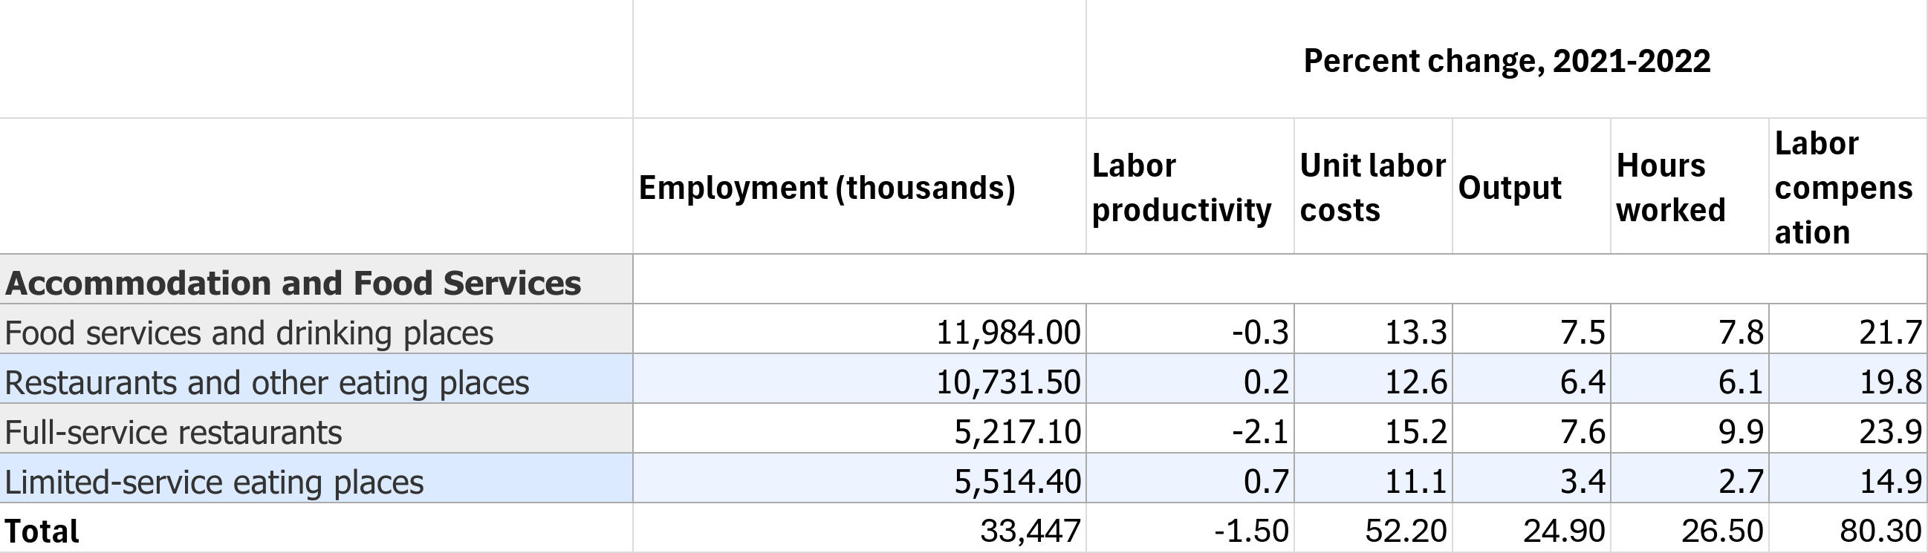
Table 2: Productivity of Accommodation and Food Service Industry

