What country would you choose? Explain why.
Considering my career in the foreign country, I would opt for Japan as compared to the U.S. This decision is solely based on the economic parameters. According to the World data report (2024), currently, Japan aces the race of unemployment, inflation, cost of living and corruption index. Although the average wage in the U.S is higher than Japan; however, the cost of living and uncontrolled inflation in the U.S is evidently quite higher which justifies Japan as a comparatively more suitable country for an individual with family, where my preference would always be a reduced cost of living where Japan aces.
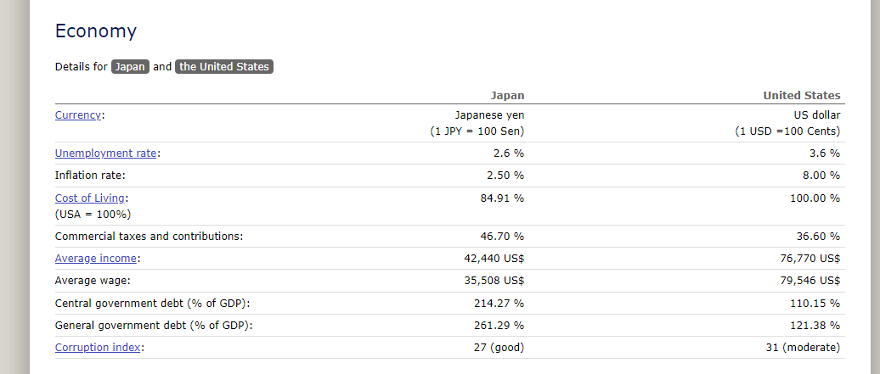
b. What are the advantages and disadvantages to you for selecting that particular country over another?
The biggest advantage of selecting Japan is the higher minimum wage rate as compared to the U.S and less cost of living (World Data Report, 2024) which will help me save more and take care of my family with a younger kid. Besides, according to the visit world report (2024), Japan offers life, medical and work insurance along with retirement fund, 2 to 3 bonuses annually and transportation expenses which will certainly improve the quality of life for me over there. In addition, the country has several globally recognized businesses in the IT sector triggering a challenging and progressive professional working environment (Shibata et al., 2022) which will enable me to polish my existing skills and get more certification.
However, attaining job with higher lingual proficiency of Japanese may be a challenge for me which is a mandatory requirement to attain work visa. Besides, they are workaholic people (Akutsu et al., 2022), therefore balancing work life may also be another considerable challenge for me. Likewise, Japan has a higher tax rate of 46% whereas for the U.S it is 36% (World data report, 2024), so it would be another challenging aspect for me.
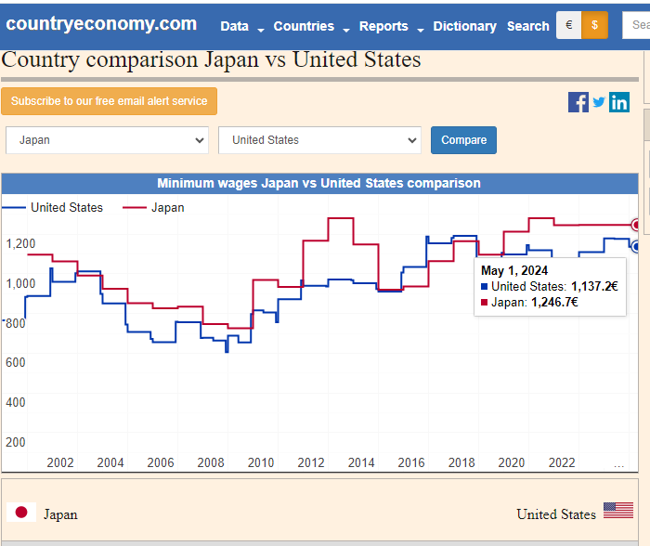
Two multinational companies, compare and contrast as per the job criteria
Fujitsu and IBM are two IT companies that are my priority where the former is based in Japan and later is based in the U.S. Considering my learning-oriented attitude, I prefer to work in an inclusive, progressive, collaborative, and engaging working environment where the company provokes a culture of adaptability, diversity, agility, innovation, and work life balance. Considering my familial responsibilities with a younger kid, I prefer to take out some time for my family and friends where work life balance is one of the most critical factors that I cannot settle at. Besides, good word of mouth about the companies and active indulgence of businesses in corporate social responsibility initiatives is another preferred job criterion for me where I want to associate myself with an ethically upscaled and socially responsible business.
In addition, competitive salary package, job security and career development trajectory are the third keynote preferences, where both the selected companies ace both locally and internationally.
Reasons for selecting the companies and their respective industrial standing:
For Fujitsu, the value system of company resonates with my value preferences encompassing trust, empathy, and aspiration as keynote considerations (Fujitsu, 2024). Besides, the company is actively involved in CSR practices as a payback to the society ensuring to realize the socio-economic and environmental impact of all the activities that the company is indulged in (Fujitsu, 2024). According to Indeed Survey (2024), Fujitsu has managed to score 3.6 based on the ratings of employees and related stakeholders about the company’s culture, work life balance and compensation and benefits, whereas job security has been identified as a notable concern of employees.
On the contrary, IBM, apart from being recognized as one of the global leaders in the IT industry, the company is ranked 3.9 offering comparatively more benefits, compensation packages, cultural inclusiveness, job security and career advancement opportunities. Likewise, the Glassdoor reviews report (2024) also identified that both companies offer balanced work life opportunities whilst promoting a culturally diverse and inclusive working environment where flexible working hours enable the employees to work and manage their family time and other commitments respectively. For me, I would still choose to work in Fujitsu Japan because of evident socio-economic patterns discussed previously. The most compelling reason for selecting Fujitsu and IBM as my career advancement companies is that both companies earned their place in Fortune Global 500 where IBM is ranked at the 118th place and Fujitsu is ranked at 356th level.
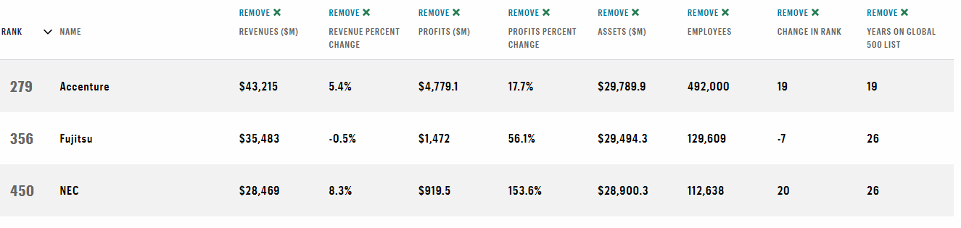
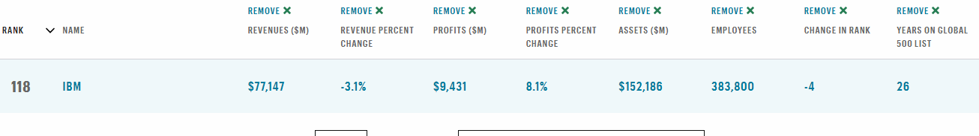
Industry outlook in the next 5 to 10 years
IT consulting industry in both the U.S. and Japan is projected to have a progressive trend in the next few years, where fast paced technology-driven attitude of people and businesses with an explicit focus on AI and IoT solutions adds value to the industry, bolstering fierce competition among the businesses. In the U.S, the industry has recorded a valuation of $710 billion with a 2.9% increase from 2019 to 2024 encapsulating more than 497k businesses. This expansion trajectory is projected to reach 5.82% in the next 7-10 years (Statista, 2024). Likewise, for Japan, the IT consultancy industry is projected to have a CAGR of 8.6% in the next 7-10 years reaching $941 billion (Sperical Insights Report, 2024).
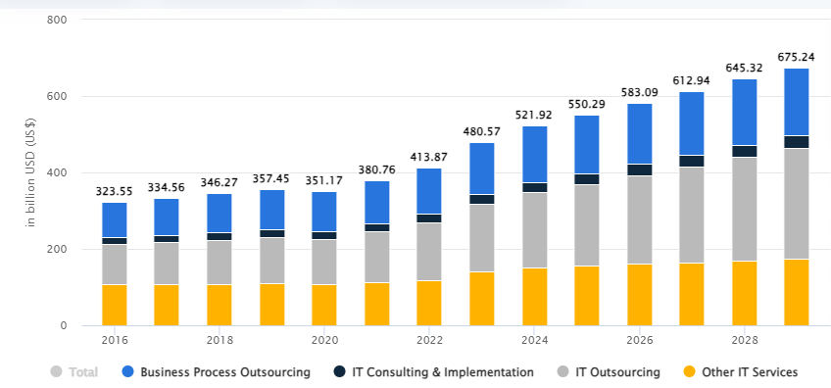
For the U.S.
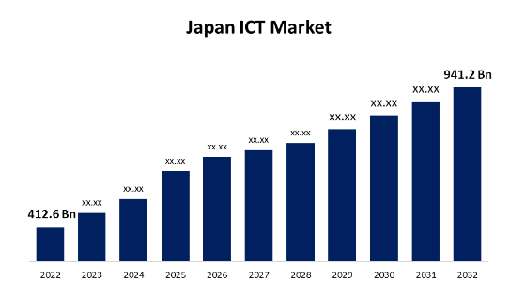
Latest ethical issues and lawsuits
Fujitsu’s post office lawsuit has attained attention in the latest years where the false accusation imposed on hundreds of the post masters for stealing the accounts has turned out to be a result of the incorrect information in the computer software named Horizon. The false accusation due to the faulty software has ruined the reputation of many posts master’s resulting in their imprisonment and financial ruins. The horizon system is still used by the post office in UK; however, there are talks about the ethical obligations for Fujitsu to compensate those affected by their inaccurate software functionalities (BBC, 2024).
Likewise, IBM employees in Brazil have also proceeded with the lawsuits against IBM for it classifying them as tech workers stating that the company’s registration in Brazil as a sales company hinders the employees to attain benefits that they are obliged to get as tech workers. The situation has got worse after the latest advertisement by the company about it employing people from Minas Gerais state for the remote position leaving no choice for the potential workers, but to join hands with a string of unions in the state and hence proceed with another legal action against the company.
Environmental contribution
IBM has actively been indulging in environmentally friendly activities for three decades. Recently, the company has set a target for 2025 to reduce carbon emissions by 65%. Besides that, the company plans to shrink its water withdrawal tendency and usage with a specific focus on water-stressed regions. The company is equally focused on adopting sustainable procurement practices in relation to their paper and wood-based packaging materials along with creating 50 pollinator gardens as an epitome o company’s interest in biodiversity (IBM, 2024). Fujitsu is equally committed towards adopting environmentally friendly practices with a focus on eradicating the carbon emissions from its operations by 2050 as an ultimate vision to decarbonization. The company is also adept to implementing cutting-edge technological solutions promoting digital transformation (Fujitsu, 2024).
Current Jobs
Currently, the company has multiple jobs in the domain of HR at entry level which include HR technical analyst, HR infrastructure officer, Labor relations Manager and employee relationship manager. All these jobs align with my future career goals and objectives. Likewise, in Japan, Fujitsu offers early career beginning internships leading to full time jobs in the field of HR which is my priority.
Fujitsu provides visa sponsorship assistance along with giving 20 days annual leaves in addition to the national holidays in Japan. In the U.S. IBM does the same along with helping the employee in obtaining employment based green card; however, the decision to processing visa for the employee depends on the job requirements which may vary in each case.

References
Akutsu, S., Katsumura, F. and Yamamoto, S., 2022. The antecedents and consequences of workaholism: findings from the modern Japanese labor market. Frontiers in Psychology, 13, p.812821.
BBC., 2024. Post Office scandal explained: What the Horizon saga is all about. Retrieved from https://www.bbc.com/news/business-56718036
Fujitsu., 2024. About us. Retrieved from https://www.fujitsu.com/global/about/csr/#:~:text=Fujitsu%20will%20work%20to%20achieve,through%20technologies%20supporting%20digital%20transformation.
IBIS world., 2024. IT Consulting in the US - Market Size, Industry Analysis, Trends and Forecasts (2024-2029). Retrieved from https://www.ibisworld.com/united-states/market-research-reports/it-consulting-industry/#IndustryStatisticsAndTrends
IBM lawsuits., 2024. Why IBM employees in Brazil are suing to be classified as tech workers. Retrieved from https://restofworld.org/2024/ibm-lawsuit-brazil/
IBM., 2024. Sustainability. Retrieved from https://www.ibm.com/history/sustainability#:~:text=IBM%20has%20vowed%20to%20reduce,by%202023%20to%20encourage%20biodiversity.
Fortune., 2024. Fortune 500. Retrieved from https://fortune.com/ranking/fortune500/2020/
Shibata, S., 2022. Digitalization or flexibilization? The changing role of technology in the political economy of Japan. Review of International Political Economy, 29(5), pp.1549-1576.
Spherical Insights Report, 2024. Japan ICT market. Retrieved from https://www.sphericalinsights.com/reports/japan-ict-market
Statista,.2024. IT Services – United States. Retrieved from https://www.statista.com/outlook/tmo/it-services/united-states#key-players
World data report., 2024. Country Comparison. Retrieved from https://www.worlddata.info/country-comparison.php?country1=JPN&country2=USA

