BUS530 Case 1

Your Name
Trident University International
BUS530 Managerial Economics
Due Date

BUS530 Case 1
Tea and Coffee Commodity Analysis: Supply, Demand, and Market Trends
As per the studies which tends to analysed that the commodity price fluctuations offer a unique window into the dynamic interplay of global economic forces and this analysis examines the 6-month price trends of Tea, Mombasa and Coffee, Arabica, both categorized under non-energy agricultural beverages (Tan., 2024). One of the major objectives of this case is to assess the economic factors driving these changes using real-world data and apply fundamental supply and demand theory for market interpretation (Jolliffe., 2025).
6-Month Commodity Analysis
However, on the basis of primary commodity which was selected is Tea, Mombasa and over five recent quarters, the average prices per kilogram were: $2.19 (Q1 2024), $2.21 (Q2 2024), $2.16 (Q3 2024), $2.17 (Q4 2024), and $2.24 (Q1 2025). Based on the Tea, it experienced slight price instability, with modest declines in Q3 and Q4 followed by a mild uptick in Q1 2025 and these fluctuations reflect supply-side sensitivities in East Africa, where climatic variability can affect harvest output. It tends to be analysed on the demand side, global tea consumption remains stable but lacks robust growth due to competition from substitute beverages like coffee and health-based consumer preferences shifting to herbal options (Deci & Ryan, 2021). In accordance with the minor rise in Q1 2025 likely corresponds with regional supply tightening or increased demand due to colder seasonal consumption patterns.

Figure 1: Tea, Mombasa analysis

Figure 2: Coffee, Arabica analysis
As per the above graphs which show that the Coffee, Arabica was selected as the comparative commodity and its average prices per kilogram were: $4.56 (Q1 2024), $5.28 (Q2 2024), $5.85 (Q3 2024), $6.80 (Q4 2024), and $8.59 (Q1 2025). However, on the basis of that this represents a significant upward trend in price over the same timeframe. According to the Coffee’s steady increase suggests both growing consumer demand and supply constraints in key exporting countries such as Brazil and Colombia. It also tends to analysed that the weather-related disruptions, crop diseases like leaf rust, and increased global consumption have combined to elevate prices. Based on the specialty coffee market's expansion contributes to long-term demand growth (Ray et al., 2021).
Commodity Comparison
Based on the chart comparing quarter-over-quarter percentage changes illustrates a stark contrast between the two commodities and while tea's changes remain mostly within ±3%, coffee's quarterly growth exceeds 10%, peaking at over 26% in Q1 2025. According to this divergence underscores how market dynamics differ even within the same commodity category.
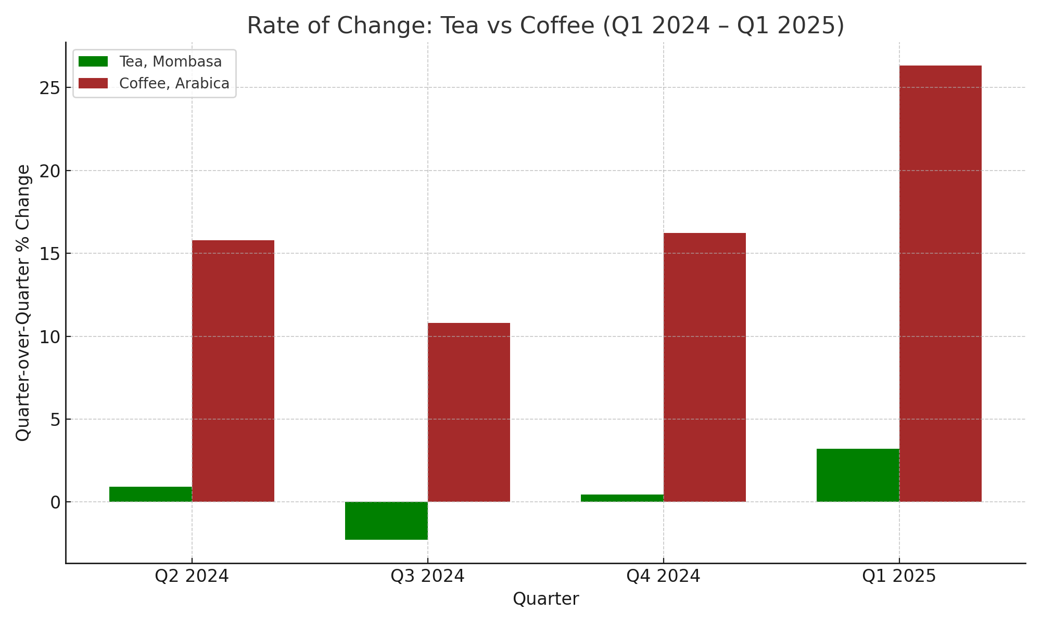
Figure 3: Rate of change comparison analysis
Commodity Index
In accordance with the commodity Index for beverages provides broader context. However, on the basis of index values from Q1 2024 to Q1 2025 were: 140.4, 187.3, 176.7, 201.1, and 232.3. These figures indicate a rising trend in beverage commodity prices overall and the index rose nearly 65% over five quarters and this suggests that factors influencing the prices of tea and coffee are consistent with industry-wide dynamics—such as increased global demand, higher transport and labor costs, and climate impacts on agricultural production (Herzberg, 2022).

Figure 4: Index value analysis
Overall Analysis
It is evident from the above studies that the price changes in raw commodities influence the demand for their finished products. Based on the case of tea, stable pricing may encourage consumer loyalty, but the limited price rise means producers may struggle with margin compression if input costs rise. Nevertheless, it also tends to be comprised of consumers which may switch to complementary beverages, such as juice or herbal infusions, depending on pricing and health trends. One of the major examples consist of coffee, the steep price increase may reduce demand elasticity, causing some consumers to seek substitutes like energy drinks or cheaper instant brands. So, on the basis of that in turn, this creates pricing pressure on retailers who must balance affordability with profitability (Ray et al., 2021).
Based on the substitute goods—such as cocoa or herbal drinks for tea, and soda or energy drinks for coffee—play a critical role in shaping consumer behavior. In accordance with the complementary goods like milk and sugar may also see fluctuating demand depending on tea and coffee price levels. It tends to analysed that the sellers respond by adjusting packaging sizes, marketing strategies, and inventory planning. So, on the basis of that the premium coffee sellers might double down on branding to justify prices, while tea producers may invest in diversification to retain consumers.

Conclusion
According to the above analysis, which tends to conclude that the tea and coffee commodity trends show both convergence and divergence in response to global supply and demand forces. As per the study, Tea’s stable pricing reflects market maturity and stable supply, while coffee's surging prices signal growing demand pressures and constrained supply. In accordance with the broader beverage index confirms these trends. It is important to understand that these dynamics allow producers, marketers, and consumers to make informed decisions in an increasingly volatile global marketplace.
References
Deci, E. L., & Ryan, R. M. (2021). Intrinsic motivation and self-determination in human behavior. Springer Science & Business Media.
Herzberg, F. (2022). Motivational factors and economic behavior. Economic Review Press.
Ray, S., Thomas, L., & Wang, Y. (2021). Global commodity markets and trade dynamics. International Economic Journal.
Tan, H.H.G., 2024. Spilling the ‘tea’on Tea: A Commodity Chain Analysis into Sri Lankan Tea. LSE Journal of Geography and Environment, 2(1).
Jolliffe, L., 2025. Coffee and tea tourism. In Encyclopedia of Tourism (pp. 169-170). Cham: Springer Nature Switzerland.

