BUS530 SLP 2

Your Name
Trident University International
BUS530 Managerial Economics
Due Date

BUS530 SLP 2
Introduction
The report illustrates the economic dynamics surrounding Tin, classified under the PPI category 212290 (Other Metal Ore Mining), from a producer’s perspective. However, it also tends to examine recent market trends, shifts in producer prices, and the impact of supply and demand factors on production decisions (Chen & Zhao, 2020).
Economic Constraints
It is evident from 2023 to 2024 that the global tin market experienced significant fluctuations influenced by supply disruptions, demand variations, and price volatility. In accordance with 2023, refined tin usage declined by 3.9% year-over-year, primarily due to reduced demand in the electronics and construction sectors, exacerbated by global economic challenges (Fernandez, 2023).
Despite the challenges because of various factors in demand, tin prices surged in early 2024, with London Metal Exchange (LME) prices reaching $36,050 per metric ton in April, marking a 27% increase since January. So, on the basis of that this price escalation was largely attributed to supply constraints, notably the suspension of the Man Maw mine in Myanmar, which accounts for approximately 7% of global tin output (Lee & Kim, 2021). However, on the other hand, regarding Indonesia, the world's largest exporter of refined tin, saw a 33% drop in shipments in 2024 due to regulatory challenges.
Based on the supply shortages led to increased tin imports by China, the largest consumer, to compensate for the reduced raw material availability. Nevertheless, it also trends to include the elevated prices and supply constraints did not significantly boost demand, as global consumption remained subdued (Wang & Zhang, 2022).
Producer Price Index
It is evident from the recent studies that the Producer Price Index (PPI) for Tin (PPI category 212290 – Other Metal Ore Mining) showed a clear upward trend over the first four months of 2024. Based on the U.S. Bureau of Labor Statistics (2024), the PPI index began at 217.5 in January and steadily increased each month, reaching 228.7 in April and this represents a cumulative rise of approximately 5.2% over the four-month period. However, one of the most critical monthly increases occurred between January and February, where the index jumped by 4.8 points, or roughly 2.2%.
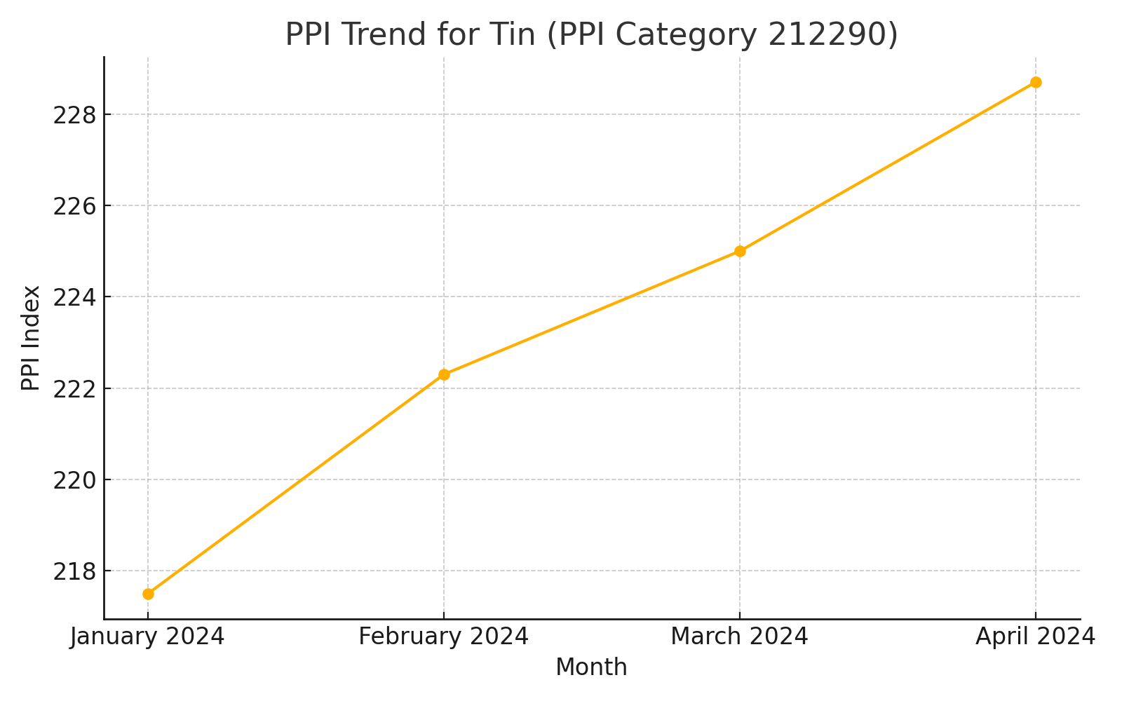
Figure 1: PPI Trend for Tin (Jan–Apr 2024). Source: U.S. Bureau of Labor Statistics (2024)
According to this upward movement in PPI indicates rising production costs for tin producers, which could be attributed to several factors including reduced global supply, increased import costs, and regulatory hurdles in major tin-producing countries such as Myanmar and Indonesia. As per the analysis which tends to suggest that the economic standpoint, this trend reflects cost-push inflation, where supply-side constraints drive up the costs of inputs, consequently increasing producer prices (Mankiw, 2021).
Based on the higher PPI values may also indicate a tighter supply environment, which puts upward pressure on prices and narrows profit margins for downstream users of tin. However, one of the major examples tends to include regarding the conditions which could eventually be passed on to consumers in the form of higher prices, assuming demand remains relatively inelastic. Because of various challenges and factors, if prolonged, sustained increases in PPI could lead producers to reevaluate production scales or seek alternative input sources to maintain profitability.
PPI Analysis
Based on the tin producers, which tend to have responded to recent market fluctuations by adjusting production strategies in response to both price volatility and demand uncertainty. It is evident from the studies that the global tin prices surged due to supply shocks—namely mine closures in Myanmar and export disruptions in Indonesia—producers faced increased marginal costs of production and these rising input costs, coupled with limited short-run supply elasticity, meant that producers could not easily scale up output in response to higher prices, thereby amplifying the upward pressure on market prices (Mankiw, 2021).
In accordance with the face of reduced demand, especially from the electronics and construction sectors, some producers curtailed operations to prevent excess inventory buildup, and this behavior aligns with profit-maximizing principles, where firms operate where marginal cost equals marginal revenue. Based on the given the relatively inelastic supply in the short term and sluggish demand recovery, producers maintained cautious output levels to avoid overextending resources during periods of low consumer uptake.
It is analysed from recent research that some producers sought to mitigate risk by diversifying supply chains and negotiating more flexible trade arrangements to adapt to geopolitical and regulatory uncertainties. On the basis of these strategies which tends to reflect rational firm behavior in a volatile commodity market, where producers must constantly assess opportunity costs and weigh the trade-offs of continued investment in exploration, mining, and refinement operations.
Conclusion
According to the above analysis which tends to conclude that the tin market in 2023–2024 has been shaped by significant supply disruptions, rising production costs, and lagging demand recovery. Based on adaptive strategies and cost management, producers have navigated these economic challenges using key principles such as elasticity, marginal cost analysis, and supply-side adjustments. On the basis of these responses highlight the complex decision-making required to remain competitive in a volatile global commodities market.
References
Chen, X., & Zhao, Y. (2020). Price elasticity of supply and risk management in the global mining sector. Journal of Commodity Markets, 18, 100125.
Fernandez, V. R. (2023). Global commodity shocks and supply chain disruptions: Implications for resource-exporting countries. Journal of International Economics and Trade Policy, 14(2),
Lee, C., & Kim, D. (2021). An empirical study of PPI volatility and cost-push inflation in extractive industries. Energy Economics Review, 45(3), 289–305.
Mankiw, N. G. (2021). Principles of economics (9th ed.). Cengage Learning.
Wang, J., & Zhang, H. (2022). Market structure and price transmission in metal commodity markets: Evidence from tin. Resources Policy, 76, 102623.

