ACC501 SLP 1

Your Name
Trident University International
ACC501 Accounting for Decision Making
Due Date

Introduction
The report deals with today’s evolving business environment; financial performance alone no longer defines long-term success. However, it also tends to evaluate the financial and triple bottom line performance of GlowEarth Candles, a small eco-friendly manufacturing company, to assess its profitability, sustainability initiatives, and overall organizational health.
Analyze the Traditional Financial Reports
On the basis of requirement, the following are the section which involves analysis of financial reports which are generated using prompts.
Income Statement Analysis
The section deals with the GlowEarth Candles’ income statement for the most recent fiscal year reveals a total revenue of $430,000, derived from sales of eco-friendly candle products. Nevertheless, it tends to comprise the cost of goods sold (COGS) amounting to $180,000, resulting in a gross profit of $250,000 and operating expenses totaling $140,000, which included salaries, rent, marketing, R&D, and depreciation (Battiston, Dafermos, & Monasterolo, 2021). However, it tends to state that after deducting these expenses, the company reported an operating profit of $110,000 and with interest expenses of $5,000 and taxes of $53,000, the final net profit stood at $52,000, reflecting a steady performance amid a competitive and inflation-sensitive manufacturing environment.
It is evident from the studies that the income statement illustrates three critical components: revenue, expenses, and profitability (Battiston, Dafermos, & Monasterolo, 2021). It also includes the revenue which represents the total income from candle sales and expenses are subdivided into direct (COGS) and indirect (operating expenses), showing the business’ cost structure. Based on the company’s profitability, which is reflected in three key margins, such as the gross profit margin is calculated by dividing gross profit ($250,000) by revenue ($430,000), yielding approximately 58.1% and this indicates that more than half of the revenue remains after covering production costs, which is a healthy margin for a small manufacturer (Lei et al., 2022).
According to the operating margin which is derived by dividing operating profit ($110,000) by revenue—comes to approximately 25.6% and this figure reflects how efficiently the company manages its core operations excluding interest and taxes. So, on the basis of that the net profit margin (net income divided by revenue) is approximately 12.1%, meaning that for every dollar earned in sales, about 12 cents is retained as profit after all expenses. Based on these margins which are essential indicators of financial health, and GlowEarth Candles’ performance across all three suggests operational efficiency and financial discipline (Lei et al., 2022).
It also tends to analyse that when compared to industry benchmarks for small manufacturers in the U.S., GlowEarth’s profitability ratios fall within a favorable range. In accordance with the net profit margin, which tends to be above 10% is generally seen as robust in a consumer products business, particularly one with environmental and social investment commitments (Oyewole et al., 2024). Based on that this suggests that the company has been able to balance its sustainability goals without sacrificing core profitability, positioning it well for future growth.
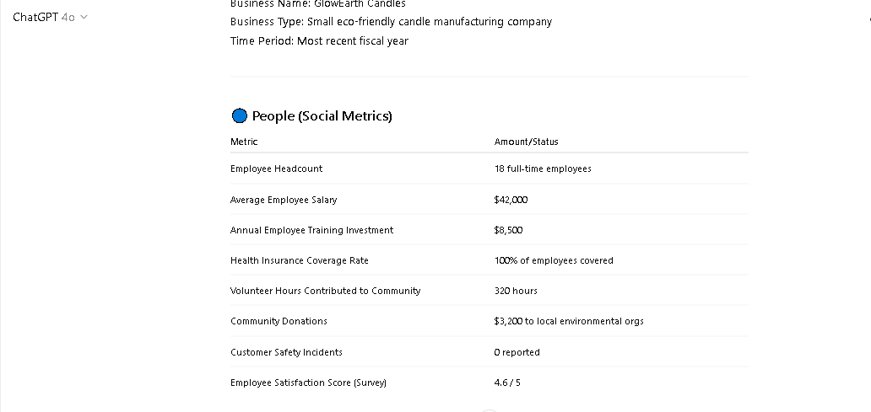
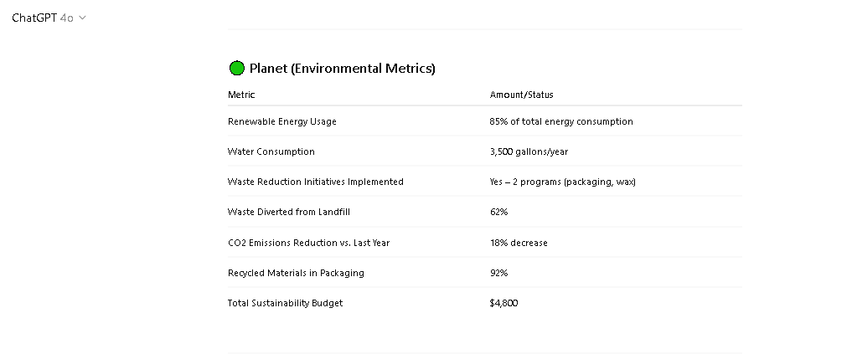
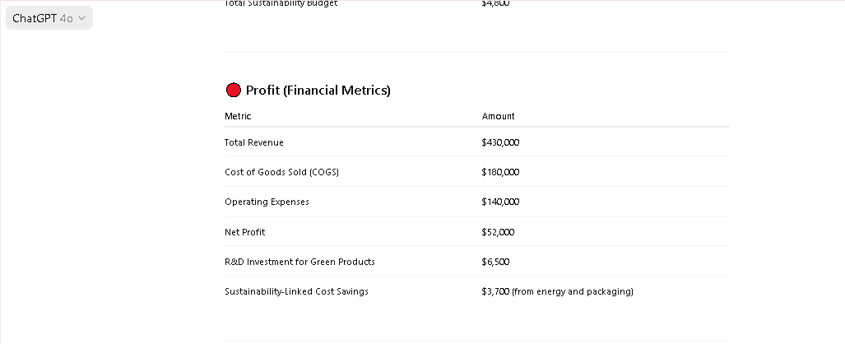
Figure 1: Screenshot 1 – TBL (Single Year) (Source: ChatGPT)
Balance Sheet Analysis
As per analysis, GlowEarth Candles’ balance sheet for the most recent fiscal year presents a clear picture of its financial structure, revealing total assets of $245,000, composed of $110,000 in current assets and $135,000 in net fixed assets. However, in the meanwhile, current assets include cash and equivalents ($42,000), accounts receivable ($28,000), inventory ($36,000), and prepaid expenses ($4,000) and these figures indicate a solid working capital base for a small manufacturing operation (Oyewole et al., 2024). According to the liabilities side, the company has current liabilities totaling $33,000, which include accounts payable, short-term loans, and accrued expenses. It also includes the long-term liabilities stand at $62,000, making the total liabilities $95,000 (Revsine, Collins, & Johnson, 2021). In accordance with the owner’s equality, a combination of contributed capital and retained earnings—totals $150,000, signaling strong shareholder investment and reinvested profits. So, it is important to understand that in order to assess the business’s liquidity, one can calculate the current ratio, which is the ratio of current assets to current liabilities. It comprises GlowEarth Candles’ current ratio is $110,000 ÷ $33,000 = 3.33, which is significantly higher than the commonly accepted benchmark of 2.0 and this indicates that the company has more than enough short-term assets to cover its short-term obligations, reflecting excellent liquidity. According to the quick ratio, which excludes inventory from current assets, is ($110,000 - $36,000) ÷ $33,000 = 2.24, also well above industry norms, indicating that the business could meet its obligations even if inventory were illiquid. However, in regard to solvency, the debt-to-equity ratio is a critical indicator and with total liabilities at $95,000 and total equity at $150,000, the ratio is 0.63, meaning the business uses $0.63 of debt for every $1.00 of equity (Revsine, Collins, & Johnson, 2021). According to the ratio under 1.0 it suggests that the company is not overly reliant on debt financing, which enhances its financial stability and lowers risk. On the basis of that the equity ratio, calculated as equity divided by total assets ($150,000 ÷ $245,000 = 0.61), shows that equity finances 61% of the company’s assets—another strong indicator of a well-capitalized and solvent business.
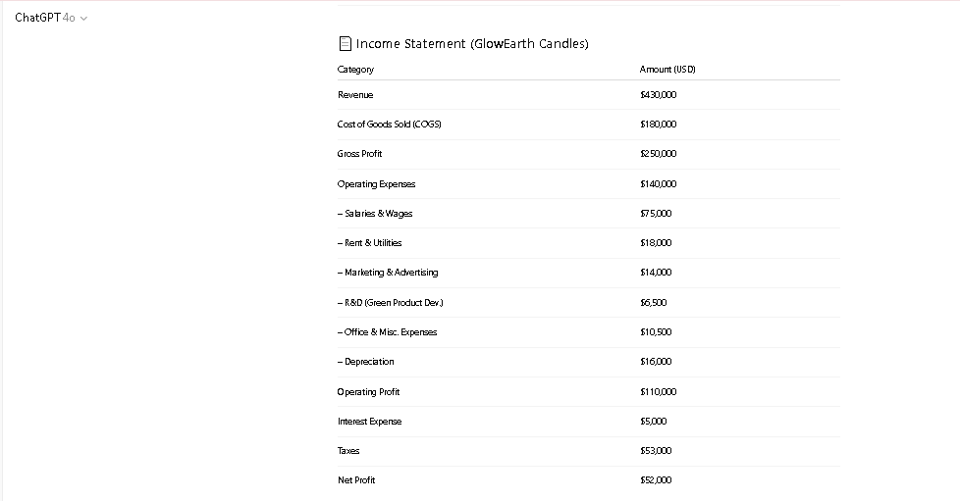
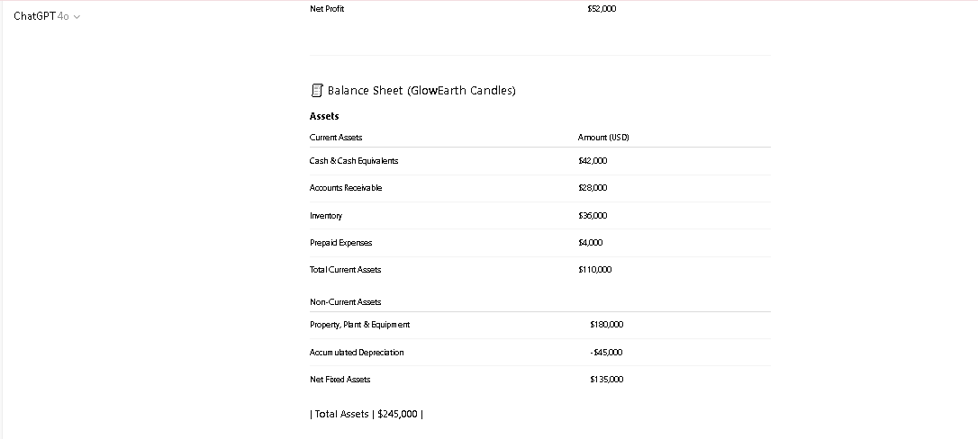
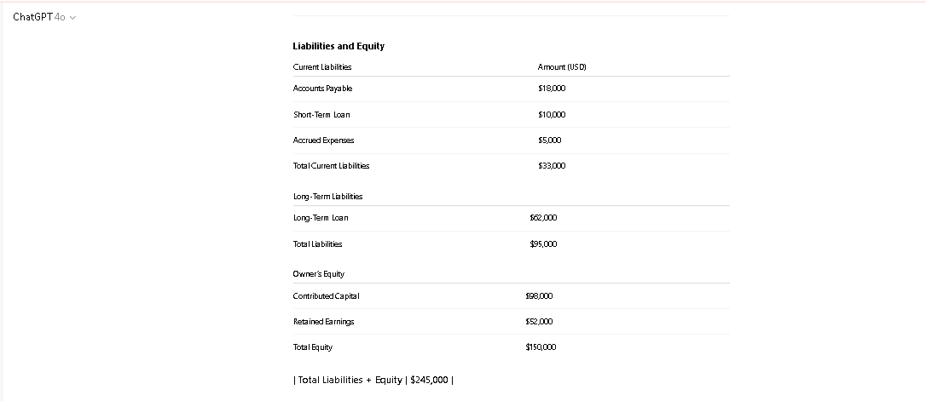
Figure 2: Screenshot 2 – Traditional (Single Year) Source (ChatGPT)
Financial Health
According to the combined analysis of the income statement and balance sheet, GlowEarth Candles appears to be in strong financial health. As per the business maintains which ultimately consistent profitability, with a net profit margin of 12.1%, and effective cost controls that produce an operating margin of over 25% and these figures, supported by a stable revenue stream of $430,000, suggest that the company has achieved efficient internal operations while maintaining financial discipline. It also tends to include investment in research and development (e.g., $6,500 for green product innovation) indiwhich indicatesorward-looking approach that supports both innovation and market relevance (Robert, Jennifer, & Todd, 2023).
From the financial analysis of the company’s liquidity is outstanding, as evidenced by its current ratio of 3.33 and a quick ratio above 2.0, allowing it to easily meet short-term liabilities even in a downturn. Based on capital structure, it is also favorable and the debt-to-equity ratio of 0.63 indicates a cautious approach to leveraging, and the equity ratio of 0.61 shows that most of the assets are financed through equity rather than debt. So, on the basis of that this financial position minimizes risk exposure and provides operational flexibility during uncertain economic conditions.
Examine the Triple Bottom Line (TBL) Report
This part of the report includes the analysis of the Triple Bottom Line report which consists of the following sections.
Social Impact (People)
The section tends to represent the social impact regarding the people in which the component of GlowEarth Candles’ Triple Bottom Line (TBL) report reflects the company’s commitment to employee well-being, community engagement, and customer safety. Based on the TBL data, GlowEarth currently employs 18 full-time employees, each earning an average annual salary of $42,000, with 100% health insurance coverage provided. Nevertheless, the organization also illustrates that it invested $8,500 annually in employee training and professional development programs, a figure that has steadily increased over the past five years and this level of investment demonstrates a strategic emphasis on talent retention, skill-building, and workplace satisfaction. In fact, internal employee surveys reflect a satisfaction rating of 4.6 out of 5, indicating a positive organizational culture that fosters long-term commitment and productivity (Robert, Jennifer, & Todd, 2023).
As per the analysis, beyond internal operations, GlowEarth actively supports its local community. According to the company contributed 320 volunteer hours and $3,200 in donations to environmental organizations in the past fiscal year and these initiatives not only reinforce its corporate social responsibility (CSR) profile but also enhance its brand value within the eco-conscious consumer segment such as community engagement has been shown to positively influence consumer loyalty and attract ethically driven clientele, particularly in a marketplace where values increasingly influence purchasing behavior (Ray et al., 2021). It also tends to illustrate that the zero customer safety incidents, a metric that speaks to the integrity of its product quality control processes and compliance with safety standards and these social investments are not merely symbolic—they contribute directly to the company’s long-term sustainability. According to the research which has consistently shown that businesses that invest in employee satisfaction, health, and growth experience lower turnover, higher engagement, and improved productivity. Nevertheless, as for as GlowEarth, the decision to cover 100% of employee health insurance costs and fund development programs strengthens its employer brand and attracts talent that aligns with its eco-centric mission. So, on the basis of that active involvement in community and health-based causes reinforces the company’s value system and positions it as a responsible business, which can be a competitive advantage in securing partnerships, customer trust, and investor interest.
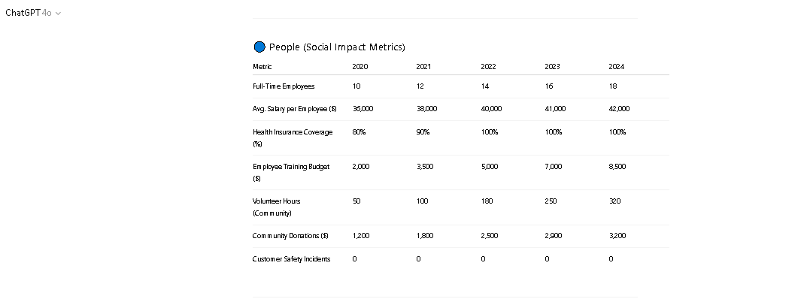
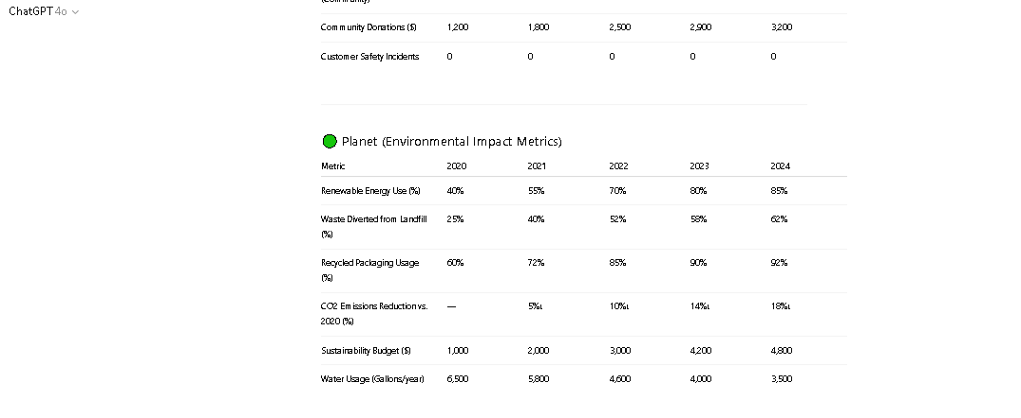
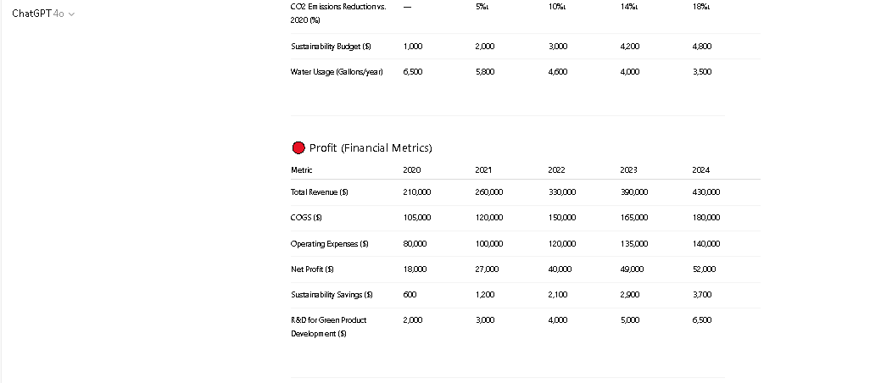
Figure 3: Screenshot 3 – TBL (5 Years) Source (ChatGPT)
Environmental Impact (Planet)
In accordance with the GlowEarth Candles, which tends to demonstrate a strong commitment to environmental stewardship, with focused efforts in energy efficiency, waste reduction, and water conservation. Based on the TBL data, the company currently sources 85% of its energy from renewable sources, a significant improvement from 40% five years ago and this progressive shift toward clean energy has contributed to a reduction in CO₂ emissions by 18% over the same period. It also tends to analyse that the manufacturing, which is typically resource-intensive, such a transition not only aligns with global environmental goals but also leads to long-term cost optimization by lowering dependency on volatile fossil fuel markets.
It is evident from the studies that the company has also achieved notable improvements in waste management and through two key initiatives—recyclable packaging and wax reuse—GlowEarth has managed to divert 62% of waste from landfills. Based on their packaging, which tends to be now incorporated 92% recycled materials, which not only lowers raw material costs but enhances their sustainability marketing value. In the regard of waste reduction practices which tends to improve not only the bottom line but also regulatory compliance, especially as environmental regulations tighten across U.S. states and these initiatives support GlowEarth’s brand narrative of being a green business and foster loyalty among eco-conscious consumers.
Based on water conservation represents another core area of environmental focus and the company has reduced its annual water usage from 6,500 gallons in 2020 to just 3,500 gallons in 2024, reflecting a 46% reduction. However, as for small manufacturers, water efficiency lowers utility bills and reduces the risk of operational disruptions during drought-related restrictions and while water savings alone may not result in significant immediate financial gain, their cumulative effect over time supports long-term operational efficiency and environmental credibility.
In accordance with that the total, GlowEarth allocated $4,800 in the last fiscal year to its sustainability budget, a modest yet strategic investment that yielded measurable benefits and these include $3,700 in sustainability-linked cost savings, particularly in energy and packaging expenses. Nevertheless, as per highly competitive market, these efforts contribute to cost stability, risk reduction, and reputation enhancement.

Financial Impact (Profit)
It tends to analyse that the Triple Bottom Line (TBL) and traditional financial reports for GlowEarth Candles offer a valuable comparative lens for evaluating the company’s profit in light of its sustainability efforts. In accordance with the traditional income statement, the company reported $430,000 in revenue, $180,000 in COGS, and $140,000 in operating expenses, resulting in a net profit of $52,000 and these numbers reflect a financially stable small manufacturer with strong operating margins and consistent revenue growth over the past five years.
It is evident from the TBL report which adds further context by incorporating costs and savings tied specifically to the company’s social and environmental initiatives. According to that report, we learn that GlowEarth invested $6,500 in R&D focused on green product development and $4,800 in sustainability efforts related to energy efficiency and waste reduction. On the basis of that while these initiatives represent additional operating costs, the company also achieved $3,700 in annual cost savings through reduced energy usage and packaging expenses. Based on that the net environmental investment is approximately $7,600, which is relatively modest considering the long-term returns in brand equity, regulatory advantages, and operational efficiency.
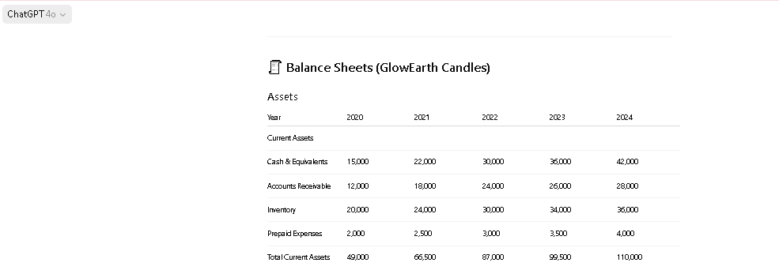

Figure 4: Screenshot 4 – Traditional (5 Years) (Source ChatGPT)
Conclusion
It is concluded from the above analysis that the GlowEarth Candles demonstrates that profitability and sustainability can successfully coexist within a small business model and through disciplined financial management and strategic investments in people and the planet, the company has positioned itself for long-term success while upholding strong ethical and operational standards.

References
Battiston, S., Dafermos, Y., & Monasterolo, I. (2021). Climate risks and financial stability. Journal of Financial Stability, 54, 100867.
Lei, X., Mohamad, U. H., Sarlan, A., Shutaywi, M., Daradkeh, Y. I., & Mohammed, H. O. (2022). Development of an intelligent information system for financial analysis depend on supervised machine learning algorithms. Information Processing & Management, 59(5), 103036.
Oyewole, A. T., Adeoye, O. B., Addy, W. A., Okoye, C. C., Ofodile, O. C., & Ugochukwu, C. E. (2024). Automating financial reporting with natural language processing: A review and case analysis. World Journal of Advanced Research and Reviews, 21(3), 575-589.
Revsine, L., Collins, D. W., & Johnson, W. B. (2021). Financial reporting & analysis. McGraw-Hill.
Robert, C. H., Jennifer, L. K., & Todd, M. (2023). Analysis for financial management. McGraw-Hill Education.

