ACC501 Case 2

Your Name
Trident University International
ACC501 Accounting for Decision Making
Due Date

Introduction
The report deals with the cost analysis in a small sports-themed clothing manufacturing business, focusing on volume discounts, product discontinuation, and make-or-buy decisions such as integrating accounting data with strategic considerations. It also tends to evaluate how pricing strategies, operational choices, and product portfolio adjustments influence profitability and long-term competitiveness (Brunner et al., 2025). Based on the study which tends to apply variable costing methods to assess contribution margins, guide decision-making, and mitigate financial and operational risks (Silva, França & Neto, 2024).

Defining the Concepts
It is evident from the different studies that the large-quantity price reductions—such as volume or bulk discounts—are a form of second-degree price discrimination, where firms offer declining per-unit prices as purchase quantity increases, encouraging customers to self-select into higher-volume tiers. Based on this approach which helps businesses capture more consumer surplus and maximize revenue, particularly when buyers’ marginal utility diminishes with each additional unit. One of the major examples tends to contain offering price breaks on larger clothing orders allows the sports-themed apparel manufacturer to increase sales volume while fully utilizing production capacity (Brunner et al., 2025). As per the accounting perspective, the strategy lowers variable cost per unit through economies of scale and enhances contribution margin—provided that the discounted price still exceeds the variable cost and contributes to fixed cost coverage (Silva, França & Neto, 2024). However, it also comprises certain advantages which are to improve inventory turnover and reduced holding costs when large orders are processed efficiently and on the basis of that there are potential pitfalls: excessive discounts can erode profit margins, devalue the brand, and trigger competitive responses (Silva, França & Neto, 2024). On the other hand, in this regard, if not offered transparently to all qualified buyers, volume discounts could raise legal concerns—especially under U.S. law, such as the Robinson–Patman Act, which prohibits discriminatory pricing practices that favor some buyers over others. Despite the various factors, second-degree price discrimination through large-quantity discounts can strategically enhance profitability and operational efficiency, it must be implemented carefully, ensuring discounts still safeguard contribution margin and comply with pricing regulations (Brunner et al., 2025).
In accordance with the discontinuing a product in a small sports-themed clothing business can reshape the landscape across operations, finance, and customer relations. As per the supply chain standpoint, removing a product may disrupt vendor relationships, reduce economies of scale, and require renegotiation of supplier contracts or material commitments. It is important to understand that financially, discontinuation entails immediate lost sales and contribution margin, possible inventory write-offs, and potential restructuring expenses; managers must weigh these against cost savings in avoidable fixed costs (Senanayake et al., 2025). It also tends to analysed that CFOs must also incorporate these shifts into long-term financial planning, as supply chain instability can significantly affect profitability and forecasting accuracy. So, on the basis of that strategically, discontinuation enables resource reallocation to more profitable items—which may improve overall margins—but risks alienating loyal customers, especially if the discontinued item held sentimental or aesthetic value (Senanayake et al., 2025). It is important to understand that in order to mitigate this, businesses might adopt phased withdrawal strategies, introduce replacement or substitute items, or communicate proactively with customers to preserve loyalty such as by coordinating across disciplines—operations, finance, and marketing—the firm can carefully manage the trade-offs of product discontinuation, ensuring the move enhances long-term profitability without damaging supplier networks or customer goodwill (Brunner et al., 2025).
It tends to be based on make-or-buy decisions which requires a firm to determine whether to produce goods in-house or outsource them—a core strategic decision impacting cost structure, quality control, and operational flexibility (Senanayake et al., 2025). As per the accounting standpoint, the analysis entails comparing relevant costs: internal manufacturing includes direct materials, direct labor, variable and avoidable fixed overheads, while outsourcing entails purchase price, shipping, storage, and potential contract costs. According to certain businesses which also consider capacity utilization, core competencies, and long-term strategic positioning—outsourcing may reduce costs and simplify operations but could compromise quality control, lead times, and supply chain resilience (Senanayake et al., 2025). However, one of the major and recent literature reaffirms classic transaction cost theory, emphasizing governance, asset specificity, and vertical integration as key drivers in make-or-buy choices. As per the operation, outsourcing can streamline production cycles and improve quoting speed, boosting revenue potential in agile environments (Brunner et al., 2025).

Product Table
Product | Selling Price | Variable Cost | Contribution Margin (CM) | CM Ratio
Team Jerseys | $50 | $28 | $22 | 44%
Athletic Hoodies | $65 | $34 | $31 | 48%
Training Shorts | $30 | $19 | $11 | 37%
Sports Caps | $20 | $14 | $6 | 30%
As per the accounting perspective, Athletic Hoodies and Team Jerseys yield the highest CM per unit and CM ratios, making them critical profit drivers. Based on these products which not only cover their own variable costs but also contribute significantly toward fixed operating expenses such as factory rent, supervisory salaries, and equipment depreciation (Husemann, Kirste & Stumpf, 2024). According to the training Shorts, while having a lower CM ratio, benefit from higher sales volume, making them a steady contributor to total CM. Sports Caps have the lowest CM ratio and dollar margin, indicating limited profitability and greater vulnerability to material cost increase discourtesies (Pekkari et al., 2024).
In the regard of contribution margin analysis which ultimately helps management prioritize resources toward high-margin products, consider pricing adjustments for low-margin items, and make informed decisions on potential discontinuation or redesign. As per strategically, maintaining a balanced mix—where low-margin items like caps serve as entry products that complement high-margin core offerings—supports both short-term profitability and long-term market positioning (Senanayake et al., 2025).

Special Pricing Order
Scenario | Units | Price/Unit | Variable Cost/Unit | Incremental Revenue | Incremental Variable Costs | Incremental CM | Notes/Decision
Base Case – Idle Capacity | 500 | $55 | $34 | $27,500 | $17,000 | $10,500 | Accept – adds $10,500 toward fixed costs & profit
Limited Capacity – 200 Units Regular Sales Lost | 500 | $55 | $34 | $27,500 | $17,000 | $4,300 | Accept – smaller benefit due to $6,200 lost CM
Setup Cost of $1,000 | 500 | $55 | $34 | $27,500 | $17,000 | $9,500 | Accept – after setup cost still profitable
Break-Even Price (Idle Capacity) | — | $34 | $34 | — | — | $0 | Covers only variable costs, no profit
Break-Even Price (With $1,000 Setup) | — | $36 | $34 | — | — | $0 | Covers variable + setup cost, no profit
Break-Even Price (With 200 Units Lost Sales) | — | $46.40 | $34 | — | — | $0 | Covers variable + lost CM, no profit

According to the regional retailer offers a one-time order for 500 Athletic Hoodies at a special price of $55/unit. In accordance with the product’s regular price is $65, variable cost is $34/unit, and there is sufficient idle capacity to fulfill the order without displacing regular sales. No additional fixed costs are required (Husemann, Kirste & Stumpf, 2024).
Incremental analysis (base case: idle capacity, no extra fixed costs)
- Incremental revenue = 500 × $55 = $27,500
- Incremental variable costs = 500 × $34 = $17,000
- Incremental contribution margin (CM) = $27,500 − $17,000 = $10,500
Decision (base case) = Accept.
So, on the basis of that the order price covers variable costs and adds $10,500 toward fixed costs and profit.
It also tends to fulfill the special order displaces 200 units of regular sales.
CM per regular unit = $65 − $34 = $31
Lost CM from displacement = 200 × $31 = $6,200
Net CM from accepting = $10,500 − $6,200 = $4,300 → Still accept, but benefit is smaller.
One-time setup cost = $1,000 fixed.
- Net CM = $10,500 − $1,000 = $9,500 → Accept.
Break-even special price = $34 (equals variable cost).
- $1,000 setup over 500 units: $34 + ($1,000/500) = $36.
- 200 units displaced (opportunity cost): $34 + (200×$31)/500 = $34 + $12.40 = $46.40.
- Both displacement and $1,000 setup = $48.40.
Risks & qualitative factors (brief)
- Price signaling
It tends to consist of a large discount may anchor future price expectations.
- Channel conflict
It tends to be existing customers may request similar pricing.
- Brand positioning
It tends to ensure the offer is clearly “one-time / special terms” to avoid erosion of list price integrity.
Negotiation options that can be more advantageous
- Bundle to lift CM
Keep $55 for 500 hoodies if the retailer also buys 100 Team Jerseys at regular price.
  - Added CM from jerseys = 100 × ($65 − $34) = $3,100 → Total deal CM becomes $13,600 (base case $10,500 + $3,100).
- Tiered volume pricing
Offer $55 up to 500 units and $54 for ≥700 units (if capacity allows).
At 700 units @ $54: CM = 700 × ($54 − $34) = $14,000 (vs. $10,500 at 500 units).
However, the results tend to ensure the extra 200 units don’t crowd out higher-margin regular sales.
- Cost-down variant = hoodie (fewer colorways/prints) that reduces variable cost by $2 to $32/unit at the same $55 price.
  - New CM per unit = $55 − $32 = $23 → CM on 500 units = $11,500 (an extra $1,000 vs. base case).
- Off-peak scheduling
It tends to commit to produce during low-utilization weeks and keep the $55 price, avoid crowd-out risk, and may negotiate a modest deposit to cover any custom materials.

Product Discontinuation
Item | Amount ($) | Notes
Annual Sales Revenue | 80,000 | 4,000 units × $20 each
Annual Variable Costs | 56,000 | 4,000 units × $14 each
Annual Contribution Margin (CM) | 24,000 | Sales − Variable Costs
Avoidable Fixed Costs Saved if Stopped | 12,000 | Costs eliminated if product is discontinued
Lost Contribution Margin | (24,000) | CM lost if discontinued
Net Effect on Profit | (12,000) | Savings − Lost CM
Accounting Decision | — | Keep product — discontinuation reduces profit

Current contribution margin:
- Sales revenue = 4,000 × $20 = $80,000
- Variable costs = 4,000 × $14 = $56,000
- Contribution margin (CM) = $80,000 − $56,000 = $24,000
Net benefit/loss if discontinued
- Lost CM = $24,000
- Avoidable fixed cost savings = $12,000
- Net effect on profit = Savings − Lost CM = $12,000 − $24,000 = −$12,000
Decision
So, on the basis of that discontinuing the product would reduce overall profit by $12,000, since the lost CM exceeds avoidable fixed cost savings and from an accounting perspective, the product should not be discontinued unless strategic factors outweigh the short-term financial loss (Pekkari et al., 2024).
Consumer Perspective and Mitigation Strategies
As per the consumer standpoint, discontinuing Sports Caps could negatively affect brand loyalty and customer satisfaction, especially if caps serve as affordable entry-level products or carry team branding that strengthens community ties. Based on the regular customers who buy caps may reduce purchases of higher-margin items if their preferred accessory is no longer available (Husemann, Kirste & Stumpf, 2024).
However, it is important to understand that in order to mitigate these effects, the business could offer a cap with improved features or designs, potentially at a higher CM, to retain customers while improving profitability (Husemann, Kirste & Stumpf, 2024). However, it also includes the before discontinuation, run limited-time promotions bundling caps with jerseys or hoodies to clear inventory and upsold customers (Pekkari et al., 2024).

Make-or-Buy Decision
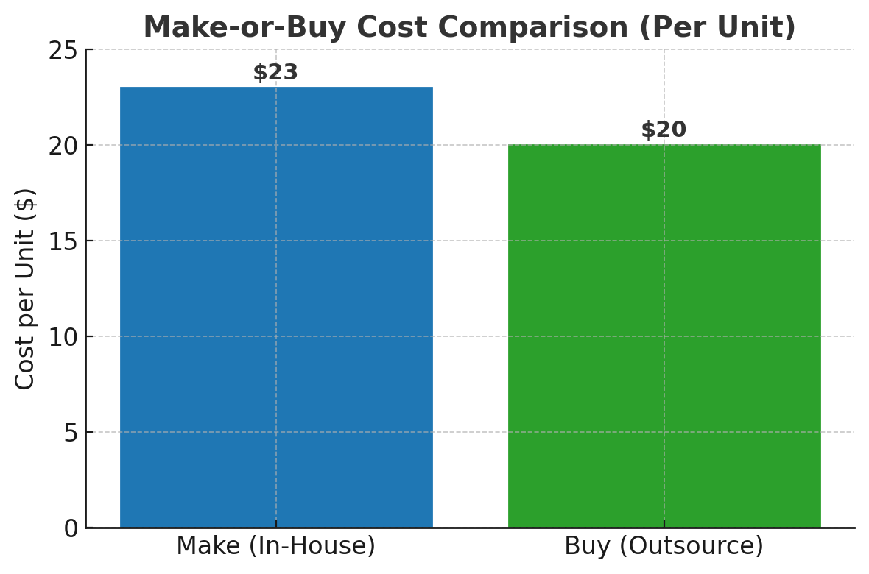

Relevant in-house production cost (per unit)
- Direct Materials = $9
- Direct Labor = $7
- Variable Overhead = $3
- Avoidable Fixed Overhead = $4
- Total relevant cost to make = $23 per unit
Relevant cost to buy (per unit)
- Purchase Price = $18
- Remaining Fixed Overhead (unavoidable) = $2
- Total relevant cost to buy = $20 per unit
Decision impact (per unit)
- Savings if outsourced = $23 − $20 = $3 per unit
Annual impact (assuming 10,000 units)
- Annual savings = $3 × 10,000 = $30,000
Accounting Decision
As per the outsourcing saves $3 per unit, or $30,000 annually, making it financially advantageous in the short term, assuming supplier reliability and product quality are not compromised.
As per the quality perspective, outsourcing introduces risks such as inconsistent workmanship, material substitutions, and slower response to design changes. So, it is important to maintain brand reputation in sports apparel requires consistent fabric durability, stitching standards, and colorfastness (Husemann, Kirste & Stumpf, 2024). However, it is also essential to understand that in order to mitigate these risks, the business should document material types, stitching density, and finish details in supplier contracts. However, it also includes the use of third-party quality control services to test random batches before dispatch (Pekkari et al., 2024).
Conclusion
According to the above analysis which concludes that the cost analysis across pricing strategies, product discontinuation, and make-or-buy decisions demonstrates how accounting data informs strategic business choices such as quantitative calculations with qualitative considerations such as customer impact and quality control, the business can balance profitability with long-term brand value. So, on the basis of that, adopting a data-driven yet customer-focused approach ensures sustainable growth and competitive advantage in the marketplace.

References
Brunner, B., Aegerter, A. M., Johnston, V., Volken, T., Deforth, M., Sjøgaard, G., Elfering, A., Melloh, M., Barbero, M., Cornwall, J., Da Cruz Pereira, Y., Distler, O., Dratva, J., Dressel, H., Egli, T., Ernst, M. J., Etzer-Hofer, I., Falla, D., Gisler, M., . . . NEXpro Collaboration Group. (2025). Cost-utility and cost–benefit analysis of a multi-component intervention (NEXpro) for neck-related symptoms in swiss office workers. BMC Public Health, 25(1), 160-13. https://doi.org/10.1186/s12889-024-21103-6
Husemann, M., Kirste, A., & Stumpf, E. (2024). Analysis of cost-efficient urban air mobility systems: Optimization of operational and configurational fleet decisions. European Journal of Operational Research, 317(3), 678-695. https://doi.org/10.1016/j.ejor.2023.04.040
Pekkari, C., Lund, B., Davidson, T., Naimi-Akbar, A., Marcusson, A., & Weiner, C. K. (2024). Cost analysis of orthognathic surgery: Outpatient care versus inpatient care. International Journal of Oral and Maxillofacial Surgery, 53(10), 829-835. https://doi.org/10.1016/j.ijom.2024.02.005
Senanayake, S., Lieo, S. W. X., Latib, A. B., Kularatna, S., Graves, N., Kui, M. S. L., O’Regan, D. P., Chan, M. Y. Y., Hausenloy, D. J., Chin, C. W. L., & Le, T. (2025). Cost analysis of exercise cardiac magnetic resonance imaging in suspected dilated cardiomyopathy—a single-center experience. Journal of Cardiovascular Magnetic Resonance, 27(2), 101924. https://doi.org/10.1016/j.jocmr.2025.101924
Silva, C. d., França, M. T. A., & Neto, G. B. (2024). A cost analysis of machado-Joseph’s disease (MJD). PloS One, 19(9), e0307885. https://doi.org/10.1371/journal.pone.0307885

