ACC501 SLP 2

Your Name
Trident University International
ACC501 Accounting for Decision Making
Due Date

Introduction
The report aims to analyse the cost structure, contribution margin, and break-even point of a selected small business to support informed decision-making and financial planning such as by analyzing how fixed and variable costs interact under different economic scenarios (Senanayake et al., 2025). Nevertheless, it also comprises of critical metrics that influence profitability and operational sustainability (Silva, França & Neto, 2024). Based on the findings, provide practical insights into managing expenses, setting pricing strategies, and preparing for potential cost fluctuations (Brunner et al., 2025).
Defining the Concepts
It is evident from the different studies that the fixed costs are expenses that remain constant regardless of how much a business produces or sells—examples include rent, insurance, and long-term contracts (Brunner et al., 2025). On the basis of that these costs provide a stable baseline for budgeting but must be paid even during periods of low or no production. In contrast, variable costs fluctuate directly with output volume (Silva, França & Neto, 2024). Nevertheless, it also comprises costs such as raw materials, direct labor, commissions, and utilities tied to production activities (Senanayake et al., 2025). Despite the various factors, variable costs are less predictable, they offer flexibility as businesses can scale spending up or down with changes in demand. It also tends to analyse that the contribution margin represents the portion of sales revenue remaining after deducting variable costs. It is calculated as:
Contribution Margin = Sales Revenue − Variable Costs (per unit or in total).
However, it tends to illustrate how much revenue from each unit sold contributes toward covering fixed costs and generating profit. Based on higher contribution margins, it signals greater efficiency and profitability per unit sold (Brunner et al., 2025).
As per the literature, break-even point (BEP) is the level of sales at which total revenue equals total costs—both fixed and variable—resulting in zero profit or loss and in unit terms, it is calculated as:
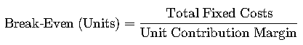
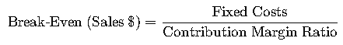

Query 1 Analysis - The Data
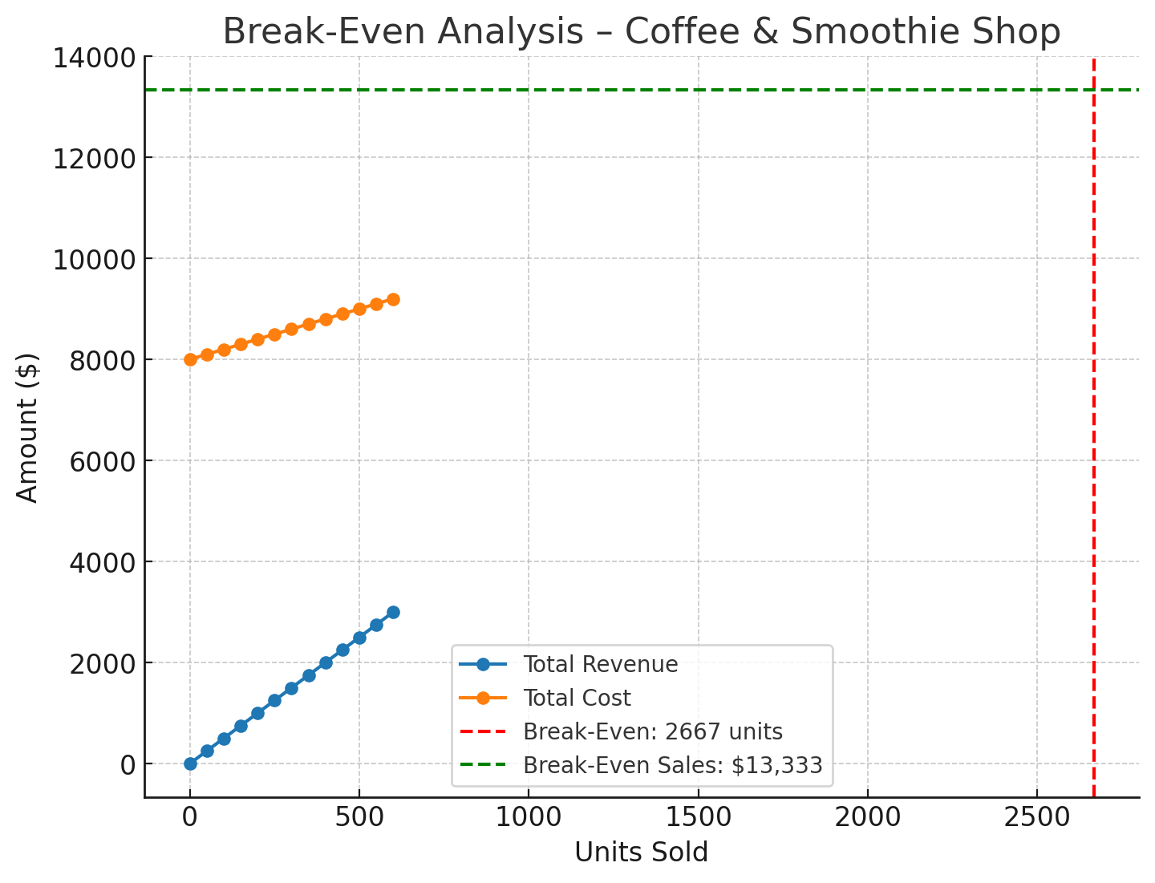
According to the above analysis which indicates that selling price per unit at $6.00, variable cost per unit at $2.50, and total fixed costs of $9,000 — the contribution margin per unit is $3.50 and this results in a break-even point of approximately 2,572 units, equal to $15,432 in sales revenue. However, it also illustrates that Selling Price per Unit is a $0.25 change can shift the break-even threshold by hundreds of units monthly. As per the variable costs in which coffee beans, tea leaves, fresh fruit, and packaging directly influence contribution margin; supplier negotiations or bulk purchasing can control these expenses (Silva, França & Neto, 2024). Based on the fixed costs which include the rent, utilities, insurance, and base wages remain constant regardless of sales, so increases in these directly raise the break-even level. It also includes the sales volume, which consistently exceeds 2,572 units per month, ensures the shop covers all expenses and begins generating profit (Senanayake et al., 2025). One of the major factors, contribution margin ratio is about 58.3%, this ratio indicates strong cost efficiency but is sensitive to ingredient price fluctuations.
According to the recent studies (U.S. Chamber of Commerce, 2024) highlight that small food and beverage businesses that conduct monthly break-even analysis adapt faster to market changes, particularly in managing seasonal demand and supplier cost volatility (Brunner et al., 2025). However, it is also important to understand that maintaining up-to-date cost tracking allows timely price adjustments, targeted promotions, and cost-saving measures, safeguarding profitability.
Query 2 – the Calculations
Selling Price per Unit = $6.00
Variable Cost per Unit = $2.50
Contribution Margin (CM) per Unit = $3.50
Total Fixed Costs = $9,000
Break-Even Point (in Units) = 2,572 units
Break-Even Point (in Dollars) = $15,432
Factors | Formula | Value
Contribution Margin per Unit | Selling Price − Variable Cost | $6.00 − $2.50 = $3.50
Break-Even Units | Fixed Costs ÷ CM per Unit | $9,000 ÷ $3.50 = 2,572 units
Break-Even Dollars | Break-Even Units × Selling Price | 2,572 × $6.00 = $15,432

It tends to analyse from the above table that the business must sell 2,572 units per month, generating $15,432 in revenue, to fully cover its fixed and variable costs before making a profit.
Query 3 – Fixed Cost Increase
Original Fixed Costs (per month) = $9,000
20% Increase
- New Fixed Costs: $9,000 × 1.20 = $10,800
Metric | Original | After 20% Increase
Fixed Costs ($) | $9,000 | $10,800
Break-Even Units | 2,572 | 3,086
Break-Even Sales ($) | $15,432 | $18,515

As per the analysis which indicates that the 20% rise in fixed costs—boosting monthly overhead from $9,000 to $10,800—raises the break-even threshold significantly. In accordance with the contribution margin unchanged at $3.50/unit, the shop now must sell 3,086 units per month (10,800 ÷ 3.50) or generate about $18,515 in revenue (3,086 units × $6.00) just to reach break-even. On the basis of that this means the business faces a higher sales burden before generating any profit, increasing risk during slower demand periods (Senanayake et al., 2025).
One of the major impacts includes the rent for small business clients in the U.S. jumped 11% year-over-year in July 2024, more than double the rise in residential rental costs (5.1%), putting added strain on margins. It also includes many businesses responding by raising prices, relocating, or renegotiating—none of which are guaranteed long-term solutions. It also tends to suggest that the U.S. utilities saw requests for rate increases balloon to $29 billion in the first half of 2025, nearly doubling compared to 2024 (Husemann, Kirste & Stumpf, 2024). Regions already under strain may face even larger jumps (Silva, França & Neto, 2024). It also comprises of consumer utility bills which rose 6% year-over-year by January 2025, substantially higher than the broader inflation rate (2.5%), underscoring rising operational costs (Senanayake et al., 2025).
In accordance with Australia, small businesses, especially cafés and restaurants, are confronting extreme energy prices and soaring overheads. As per the analysis, energy bills have doubled in recent years, leading to reduced staffing and operating hours. Based on the hospitality venues worldwide are increasingly closing due to surging rent and cost pressures—one Sydney restaurant is shuttering after five years due to unsustainable rent increases.
One of the major impact and factor includes that inflation may have stabilized, but fixed expense categories—such as commercial rent and utilities—remain on a steady upward trajectory, exacerbating financial risk for small businesses. It also includes the raising prices is a necessary countermeasure but risks alienating price-conscious consumers and reducing demand. As per the small businesses which are ultimately trimming staff, cutting hours, seeking more affordable locations, or exploring operating efficiencies, though these often come with trade-offs in service or capacity (Husemann, Kirste & Stumpf, 2024).
Query 4 – Wage Increase
According to the original Wage Component of Fixed Costs (Estimated): $3,000 (assumed portion of total fixed costs tied to wages)
10% Wage Increase:
- New Wage Costs = $3,000 × 1.10 = $3,300
- Revised Total Fixed Costs: Original = $9,000 + 10% wage uptick = $9,300

Factors | Original | After 10% Wage Increase
Fixed Costs ($) | $9,000 | $9,300
Break-Even Units | 2,572 | 2,657
Break-Even Sales ($) | $15,432 | $15,942

As per the 10% increase in wage-related fixed costs boosts the shop’s total monthly expenses from $9,000 to $9,300. It tends to be given a constant contribution margin of $3.50 per unit, the break-even point now rises slightly to 2,657 units, up from the original 2,572 units—an increase of 85 units. In accordance with the dollar terms, the shop needs to generate $15,942 in sales to break even, compared to the earlier $15,432 and this shift places added pressure on sales performance, requiring either higher volume or margin improvements to sustain profitability (Silva, França & Neto, 2024).
However, one of the major impacts is that the U.S. small business sector experienced a steady weekly wage growth of 2.74% as of July 2025, remaining below 3% for over a year, suggesting moderate downward pressure on labor costs (Pekkari et al., 2024). It also includes the Employment Cost Index, which reports private industry wages rose 3.5% over the past year, indicating sustainable wage inflation while benefits rose 3.4% (Husemann, Kirste & Stumpf, 2024). However, on the other hand, regarding Australia, a 3.5% minimum wage increase to AUD $24.95/hr hit the hospitality sector hard, prompting menu price hikes and shrinking margins due to rising labor and overhead costs (Pekkari et al., 2024). As per the California’s fast-food sector warns that further increases—up to $20/hr—could “cripple” operations: businesses are responding by raising prices (98%), reducing hours (89%), and 74% face heightened closure risks (Pekkari et al., 2024).
Query 5 – Variable Cost Increase
Original Variable Cost per Unit = $2.50
25% Increase in Most Expensive Variable Cost Component:
New Variable Cost per Unit = $2.50 × 1.25 = $3.125
Selling Price per Unit: $6.00 (unchanged)
Contribution Margin (CM) per Unit (New) = $6.00 – $3.125 = $2.875
Fixed Costs (Original) = $9,000
Break-Even Units (New) = $9,000 ÷ $2.875 = 3,130 units
Break-Even Sales (New): 3,130 × $6.00 ≈ $18,780

Factors | Original | After 25% Cost Increase
Variable Cost per Unit | $2.50 | $3.125
Contribution Margin per Unit | $3.50 | $2.875
Break-Even Units | 2,572 | 3,130
Break-Even Sales ($) | $15,432 | $18,780

As per the 25% increase in a key variable cost (e.g., premium ingredients) raises the per-unit cost to $3.125, shrinking the contribution margin to $2.875. Based on the monthly break-even volume jumps from 2,572 units to 3,130 units and required sales revenue increases from $15,432 to $18,780 and this heavier threshold intensifies financial strain, especially during demand fluctuations, and may squeeze profit margins unless offset by strategic countermeasures (Husemann, Kirste & Stumpf, 2024). However, another major factor includes the coffee commodity prices have surged dramatically, reaching $4.40 per pound in early 2025—up from under $1—driven by climate disruptions, flawed crop yields, and global supply chain volatility. It also includes the tariffs which are on imported goods that have led to supplier cost hikes of up to 30%, forcing many small businesses to raise retail prices or absorb margin losses (Pekkari et al., 2024). According to the small retail and hospitality businesses face profit margin compression as rising variable costs eat into already slim margins (Pekkari et al., 2024).
Conclusion
According to the above analysis, which conclude that this cost analysis highlights the critical influence of fixed costs, variable costs, and contribution margins on a small business’s financial health. It also tends to analyse that Break-even analysis provides a clear benchmark for the sales volume and revenue required to cover all expenses, enabling proactive adjustments in pricing, cost management, and operational strategy such as by monitoring these metrics and adapting to economic shifts, the business can maintain profitability and long-term sustainability even amid rising costs and market volatility.

References
Brunner, B., Aegerter, A. M., Johnston, V., Volken, T., Deforth, M., Sjøgaard, G., Elfering, A., Melloh, M., Barbero, M., Cornwall, J., Da Cruz Pereira, Y., Distler, O., Dratva, J., Dressel, H., Egli, T., Ernst, M. J., Etzer-Hofer, I., Falla, D., Gisler, M., . . . NEXpro Collaboration Group. (2025). Cost-utility and cost–benefit analysis of a multi-component intervention (NEXpro) for neck-related symptoms in swiss office workers. BMC Public Health, 25(1), 160-13. https://doi.org/10.1186/s12889-024-21103-6
Husemann, M., Kirste, A., & Stumpf, E. (2024). Analysis of cost-efficient urban air mobility systems: Optimization of operational and configurational fleet decisions. European Journal of Operational Research, 317(3), 678-695. https://doi.org/10.1016/j.ejor.2023.04.040
Pekkari, C., Lund, B., Davidson, T., Naimi-Akbar, A., Marcusson, A., & Weiner, C. K. (2024). Cost analysis of orthognathic surgery: Outpatient care versus inpatient care. International Journal of Oral and Maxillofacial Surgery, 53(10), 829-835. https://doi.org/10.1016/j.ijom.2024.02.005
Senanayake, S., Lieo, S. W. X., Latib, A. B., Kularatna, S., Graves, N., Kui, M. S. L., O’Regan, D. P., Chan, M. Y. Y., Hausenloy, D. J., Chin, C. W. L., & Le, T. (2025). Cost analysis of exercise cardiac magnetic resonance imaging in suspected dilated cardiomyopathy—a single-center experience. Journal of Cardiovascular Magnetic Resonance, 27(2), 101924. https://doi.org/10.1016/j.jocmr.2025.101924
Silva, C. d., França, M. T. A., & Neto, G. B. (2024). A cost analysis of machado-Joseph’s disease (MJD). PloS One, 19(9), e0307885. https://doi.org/10.1371/journal.pone.0307885

