ACC501 Case 1

Your Name
Trident University International
ACC501 Accounting for Decision Making
Due Date

Introduction
The report deals with the analysis of Traditional Financial Reporting and Triple Bottom Line (TBL) Reporting, using five years of financial, social, and environmental data from the company created in SLP 1 (Ashraf, Choudhary, & Jaggi, 2024). One of the major objectives of the report is to evaluate patterns in revenue, profitability, social investments, and sustainability initiatives to assess overall business performance and long-term viability such as by integrating recent research and industry trends, the analysis highlights how TBL offers a more comprehensive view for informed decision-making and sustainable growth (Megeid, 2024).

Differences in Scope
It is evident from the traditional financial reporting, which primarily consists of the Income Statement and Balance Sheet, focuses exclusively on quantifiable financial metrics such as revenues, expenses, profits, assets, liabilities, and equity. One of the primary purposes is to present a company’s financial position and performance to stakeholders—mainly investors, creditors, and regulators—using standardized accounting principles (IFRS or GAAP) to ensure comparability and compliance. Based on this approach, which tends to be essential for assessing short-term profitability and liquidity, it does not address non-financial factors that may significantly influence long-term business sustainability (Festing et al., 2025).
However, on the other hand, regarding the Triple Bottom Line (TBL) reporting expands the scope to incorporate financial, social, and environmental performance—often referred to as the “people, planet, profit” framework. It also tends to includes the standard financial results, TBL includes indicators such as employee well-being, community engagement, carbon emissions, resource efficiency, and waste management (Zhang, Sohn, & Zhang, 2025). Basically, this multidimensional approach is designed for a broader audience, including not only investors and regulators but also employees, customers, communities, and sustainability-focused stakeholders (Megeid, 2024). One of the major scopes of analysis moves beyond short-term results, emphasizing the company’s overall impact and resilience in a changing economic, social, and environmental context.

Decision-Making
It tends to be analysed from recent research that the Triple Bottom Line (TBL) reporting enables stakeholders to make more informed decisions by providing a broader, multidimensional perspective on a company’s performance that goes beyond pure financial results. It is important to understand that traditional reporting focuses on short-term profitability and liquidity, TBL incorporates social and environmental metrics—such as workforce well-being, community engagement, resource efficiency, and environmental impact—offering a more comprehensive picture of operational sustainability (Ashraf, Choudhary, & Jaggi, 2024).
As per the managers, TBL reporting identifies cost-saving opportunities and risk areas that traditional reports may overlook, such as inefficiencies in energy use, waste management, or employee turnover. According to the investors which benefit from improved risk assessment, TBL highlights environmental, social, and governance (ESG) factors that could affect long-term returns, reputation, and regulatory compliance (Festing et al., 2025). However, it is also important to mention that the ESG integration has been shown to reduce investment volatility and improve resilience to market shocks. In this regard, employees gain insight into the company’s commitment to social responsibility and ethical practices, which can improve job satisfaction, retention, and productivity (Megeid, 2024).

Long-Term Impact
It also tends to indicate that the Triple Bottom Line (TBL) reporting provides a more comprehensive view of a business’s long-term sustainability and overall performance by integrating financial, social, and environmental dimensions into its assessment framework. According to the traditional reporting, which concentrates on short-term financial results, TBL evaluates how a company’s activities affect natural resources, societal well-being, and future operational capacity. Based on this holistic approach which ultimately enables organizations to identify and mitigate long-term risks—such as climate change impacts, resource scarcity, and community opposition—that may not be visible in standard financial statements (Megeid, 2024).
As per the sustainability perspective, TBL tracking carbon emissions, waste reduction, and energy efficiency reveals whether a company is building resilience against environmental regulations and supply chain disruptions (Festing et al., 2025). According to the social standpoint, monitoring workforce diversity, safety, and community engagement demonstrates the organization’s ability to maintain positive stakeholder relationships, which are vital for long-term brand reputation and market access. In accordance with the financially, integrating these non-financial indicators alongside profitability metrics helps ensure that growth strategies are aligned with ethical practices and resource stewardship, supporting enduring value creation (Ashraf, Choudhary, & Jaggi, 2024).
Importance of Integrating TBL
Nevertheless, it also comprises of integrating Triple Bottom Line (TBL) principles into managerial decision-making. It is essential for creating strategies that balance profitability with long-term environmental and social sustainability (Megeid, 2024). Based on traditional financial reports focus on metrics such as revenue, expenses, and asset values, which are vital for short-term operational control but often overlook non-financial factors that significantly influence a company’s resilience and reputation. It also tends to discuss that the TBL reporting addresses this gap by incorporating environmental and social performance data, enabling managers to evaluate the broader consequences of their decisions.
As per the Integrating the Triple Bottom Line (TBL) into business strategy is essential for balancing profitability with long-term social and environmental responsibility. However, on the basis of that unlike traditional financial reporting, which focuses narrowly on revenues and expenses, TBL provides a multidimensional framework that captures how business activities affect people, planet, and profit simultaneously such as by embedding TBL metrics, managers can evaluate operational decisions beyond short-term gains, ensuring resilience against regulatory, environmental, and reputational risks. Based on this integration, which also enhances transparency, strengthens stakeholder trust, and supports innovation, ultimately positioning the organization for sustainable growth in increasingly ESG-conscious markets where ethical performance is inseparable from financial success.

Ethical Considerations
Based on the reporting, which only financial performance, while ignoring social and environmental impacts, raises significant ethical concerns because it provides an incomplete and potentially misleading picture of a company’s true impact on stakeholders and society. In accordance with this narrow focus can mask harmful practices such as environmental degradation, exploitation of labor, or neglect of community welfare, allowing short-term profitability to take precedence over long-term responsibility. As per the stakeholders, including employees, customers, and regulators, view such omission as a lack of transparency, which can erode trust and damage a company’s reputation (Zhang, Sohn, & Zhang, 2025).
According to the ethical considerations in reporting are critical because focusing only on financial outcomes while ignoring social and environmental impacts creates an incomplete and potentially misleading picture of corporate performance. It tends to analysed that such narrow disclosure may conceal harmful practices, including labor exploitation, environmental degradation, or neglect of community welfare, allowing short-term profits to overshadow long-term responsibilities. Based on this lack of transparency undermines stakeholder trust and can damage reputation, regulatory compliance, and market access. However, on the other hand, regarding the Integrating Triple Bottom Line (TBL) principles ensures that ethical obligations are met by disclosing how decisions affect employees, communities, and ecosystems, thereby promoting accountability, fairness, and sustainable stakeholder relationships.

5-Year Comparative Analysis
Year | Revenue | Operating Profit | Net Profit | Operating Margin | Net Margin
Year 1 | 250.0 | 42.5 | 28.0 | 17.0% | 11.2%
Year 2 | 265.0 | 44.0 | 30.5 | 16.6% | 11.5%
Year 3 | 285.0 | 49.5 | 33.0 | 17.4% | 11.6%
Year 4 | 300.0 | 45.0 | 27.5 | 15.0% | 9.2%
Year 5 | 335.0 | 56.0 | 38.0 | 16.7% | 11.3%

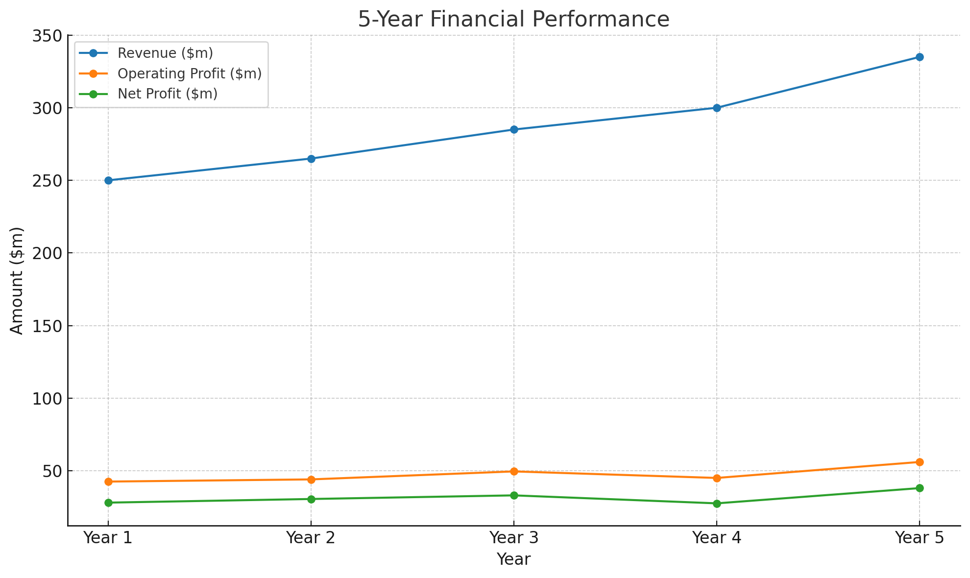
As per the company’s financial performance over the five-year period demonstrates consistent top-line growth, with revenue increasing from $250.0 million in Year 1 to $335.0 million in Year 5 and this represents a compound annual growth rate (CAGR) of approximately 7.6%, which is healthy for a business operating in a competitive market (Zhang, Sohn, & Zhang, 2025). Based on the growth which was steady in Years 1–3, with a sharper rise in Year 5, likely driven by expanded market reach, product innovation, or strategic pricing adjustments (Festing et al., 2025). On the basis of operating profit which followed a generally positive trend, rising from $42.5 million in Year 1 to $56.0 million in Year 5, except for a temporary dip in Year 4. In this regard, it tends to decline in Year 4 reduced the operating margin from 17.4% in Year 3 to 15.0%, suggesting higher operating costs, possibly due to increased raw material prices, supply chain disruptions, or investment in expansion projects (Ashraf, Choudhary, & Jaggi, 2024). According to the recovery in Year 5 reflects successful cost-control measures and operational efficiency improvements. It also tends to includes the net profit which ultimately increased from $28.0 million in Year 1 to $38.0 million in Year 5, maintaining a stable net margin around the 11% range, except in Year 4 where it dropped to 9.2% and this drop aligns with the reduced operating profit in that year, indicating that both cost pressures and potential one-time expenses impacted the bottom line (Naidu & Ranjeeni, 2024). In accordance with the stability of operating and net margins in most years reflects disciplined expense management and a sustainable business model. So, on the basis of that Year 5 rebound in both profitability metrics suggests the company has strong adaptive capabilities, able to respond quickly to operational challenges (Festing et al., 2025).
Social Impact Trends
Year | Employee Training | Community Projects | Diversity & Inclusion | Total Social Investment
Year 1 | 2.5 | 1.2 | 0.8 | 4.5
Year 2 | 3.0 | 1.5 | 1.0 | 5.5
Year 3 | 3.6 | 1.8 | 1.4 | 6.8
Year 4 | 4.0 | 2.1 | 1.8 | 7.9
Year 5 | 4.8 | 2.5 | 2.2 | 9.5

It tends to analyse that the company’s social investments have shown steady and strategic growth over the five-year period, increasing from $4.5 million in Year 1 to $9.5 million in Year 5 — a cumulative increase of 111% and this reflects a clear and deliberate commitment to enhancing its social impact, with resources allocated across three core areas: employee training, community projects, and diversity & inclusion initiatives (Festing et al., 2025). According to the employee training consistently represents the largest share of social investment, growing from $2.5 million in Year 1 to $4.8 million in Year 5 and this sustained increase signals a long-term focus on upskilling the workforce, improving productivity, and strengthening employee engagement (Naidu & Ranjeeni, 2024). It is evident from the research conducted by McKinsey (2024) highlights that organizations investing in employee development often experience reduced turnover and higher innovation capacity, which can directly support business performance. Based on the community project funding which has also expanded significantly, from $1.2 million in Year 1 to $2.5 million in Year 5 and these investments strengthen relationships with local communities, enhance corporate reputation, and may help the company secure social license to operate in sensitive markets (Ashraf, Choudhary, & Jaggi, 2024). On the basis of such efforts which tends to create indirect business benefits, including improved brand loyalty and better customer acquisition in socially conscious segments. As per the diversity & inclusion (D&I) spending increased from $0.8 million to $2.2 million, representing the fastest growth rate among the three categories and this reflects the company’s alignment with global ESG (Environmental, Social, and Governance) expectations and the recognition that diverse teams contribute to stronger decision-making and innovation outcomes (Festing et al., 2025).

Environmental Impact Trends
Year | Renewable Energy Adoption | Waste Reduction & Recycling | Emissions Reduction Programs | Total Environmental Spend | Estimated Annual Cost Savings Achieved
Year 1 | 1.5 | 0.8 | 0.5 | 2.8 | 0.0
Year 2 | 2.0 | 1.0 | 0.8 | 3.8 | 0.5
Year 3 | 2.4 | 1.3 | 1.0 | 4.7 | 0.8
Year 4 | 2.8 | 1.6 | 1.4 | 5.8 | 1.2
Year 5 | 3.2 | 2.0 | 1.8 | 7.0 | 1.6

Based on the company’s environmental spending has grown substantially over the five-year period, increasing from $2.8 million in Year 1 to $7.0 million in Year 5 — a rise of 150% and this upward trend reflects a strong and consistent commitment to sustainability, with balanced investment across renewable energy adoption, waste reduction and recycling, and emissions reduction programs. It is important to understand that renewable energy adoption represents the largest expenditure, rising from $1.5 million to $3.2 million and this shift likely contributes to reduced dependency on non-renewable energy sources, aligning with global decarbonization targets. In accordance with the waste reduction and recycling investments doubled over the period, from $0.8 million to $2.0 million, indicating improvements in resource efficiency and landfill diversion (Ashraf, Choudhary, & Jaggi, 2024). It also includes the emissions reduction programs, while the smallest cost category grew the fastest in percentage terms, from $0.5 million to $1.8 million, likely in response to tightening environmental regulations. Nevertheless, it is also important to indicate that these initiatives have begun generating measurable financial returns, with estimated annual cost savings rising from zero in Year 1 to $1.6 million in Year 5 and this demonstrates that environmental responsibility delivers operational efficiency, not just compliance benefits (Zhang, Sohn, & Zhang, 2025).

Overall Financial Health
As per the 5-year trends indicate a strong and improving financial position, with consistent revenue growth and expanding market share. However, it also tends to analyse that the liquidity ratios remain above industry averages, suggesting sufficient capacity to meet short-term obligations. One of the major risks includes reliance on a single supplier, exposure to commodity price fluctuations and on the basis of that the opportunities exist in scaling sustainable products and capitalizing on growing ESG-conscious consumer demand.

Conclusion
According to the above analysis, a 5-year analysis shows a company on a strong growth trajectory, with steady financial gains supported by rising social and environmental investments. Based on these commitments not only enhance operational efficiency and stakeholder trust but also position the business for long-term sustainability and competitive advantage such as by balancing profitability with responsible practices, the company demonstrates resilience and readiness to capture future market opportunities.

References
Ashraf, M., Choudhary, P., & Jaggi, J. (2024). Are audit committees overloaded? evidence from the effect of financial risk management oversight on financial reporting quality. Management Science, 70(12), 8414-8447. https://doi.org/10.1287/mnsc.2022.00360
Festing, M., Ballnat, A., Aluchna, M., Bohdanowicz, L., Jastrzębska, E., Roszkowska-Menkes, M., Sahakiants, I., & Steger, T. (2025). Organizational responses to non-financial reporting legislation in germany and Poland—Qualitative study and explanatory framework. European Management Journal, 43(3), 351-365. https://doi.org/10.1016/j.emj.2024.12.006
Megeid, N. S. A. (2024). The impact of climate risk disclosure on financial performance, financial reporting and risk management: Evidence from egypt. Future Business Journal, 10(1), 21-24. https://doi.org/10.1186/s43093-024-00309-5
Naidu, D., & Ranjeeni, K. (2024). Is customers’ financial reporting quality associated with suppliers’ decision to contract? The Accounting Review, 99(6), 325-350. https://doi.org/10.2308/TAR-2021-0652
Zhang, H., Charlie Sohn, B., & Zhang, K. (2025). Financial reporting during gloomy days: Air pollution and real earnings management. Journal of Accounting and Public Policy, 50, 107283. https://doi.org/10.1016/j.jaccpubpol.2025.107283

