Apple Inc. – Investment Analysis
Introduction
The report represents the Apple Inc. company, which tends to be one of the leading technology companies known for its innovation in consumer electronics, software, and online services. However, the company headquarters is in Cupertino, California. Apple designs, manufactures, and markets products such as the iPhone, iPad, Mac, Apple Watch, and various software like iOS, macOS, and iCloud. One of the major services of the company towards their customers is the App Store, Apple Music, and Apple TV+. The studies reveal that Apple’s critical ability to blend hardware, software, and services in a seamless ecosystem makes it fascinating to analyse from an investment perspective (Cai and Chen, 2024). The company is well known for its consistently delivered strong financial results and remains at the cutting edge of technological innovation, making it an attractive option for investors. The interesting fact that ultimately makes the company worth investing in is that its efforts toward sustainability and its ongoing venture into areas like augmented reality and health tech present long-term growth opportunities (Cai and Chen, 2024).
The major interest in investment arises from Apple’s ability to blend hardware, software, and services in a seamless ecosystem, which makes it fascinating to analyse from an investment perspective. It is evident from recent studies that the company consistently delivers strong financial results and remains at the cutting edge of technological innovation, making it an attractive option for investors (Macrotrends., 2025). However, other authentic investment websites also illustrate that Apple is a market leader in the technology sector, with a brand synonymous with quality, innovation, and premium pricing (Cai and Chen, 2024). The reason for success is that Apple’s products are designed with user experience at the forefront, which has earned the company a devoted consumer base.
Beta of Apple’s Stock
The beta of a company tends to be very critical to measure because it shows the stock’s volatility in relation to the broader market. According to the most recent data, Apple’s beta is about 1.1, indicating that stock tends to be 20% more volatile than the market overall.
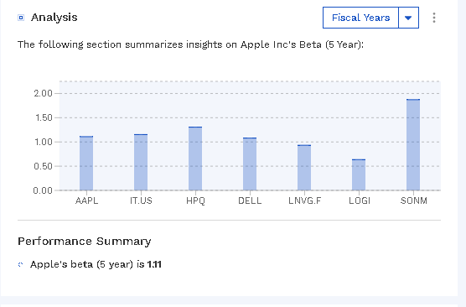
Figure 1: Performance summary (Macrotrends., 2025)
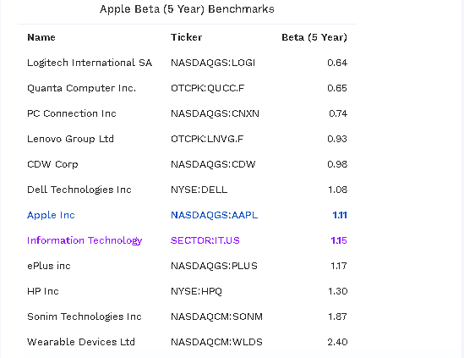
Figure 2: Apple beta analysis (Macrotrends., 2025)
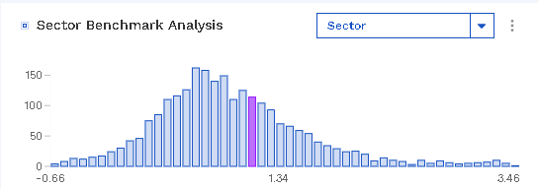
Figure 3: Stock benchmark analysis (Macrotrends., 2025)
The above figures critically analyse the distribution of beta for certain companies that operated in the IT sector. However, based on the stats which analyse that over 2510 companies had meaningful values in which average beta of 5 years ranges to 0.92 with the standard deviation of 0.66. Nevertheless, the research also discusses that Apple Inc., Beta 5 years score of 1.1 indicates the 67.2% percentile for certain sectors.
Based on the given circumstances, which show that Apple's beta score is about 1.2, the stock is considered to carry moderate risk (Solovyev Kirill, 2024). So, on the basis of the fact that it moves more than the market, its volatility is not extreme because a beta above 1 indicates higher risk, but also the potential for higher returns, making it suitable for investors with a tolerance for market fluctuations but who also seek growth (Solovyev Kirill, 2024).
Recent Stock Price Movements

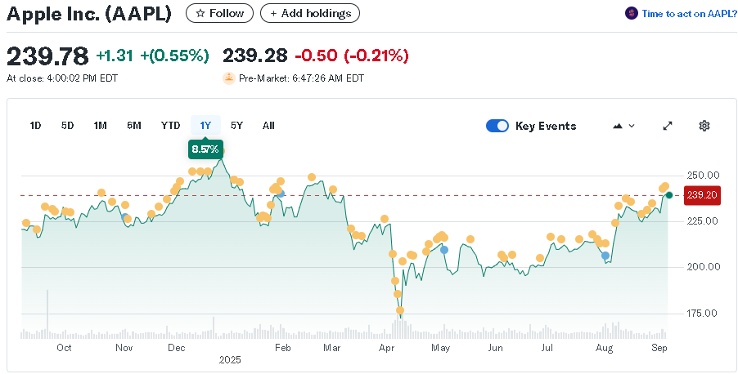
Figure 4: Apple analysis 1 year (Solovyev Kirill, 2024)

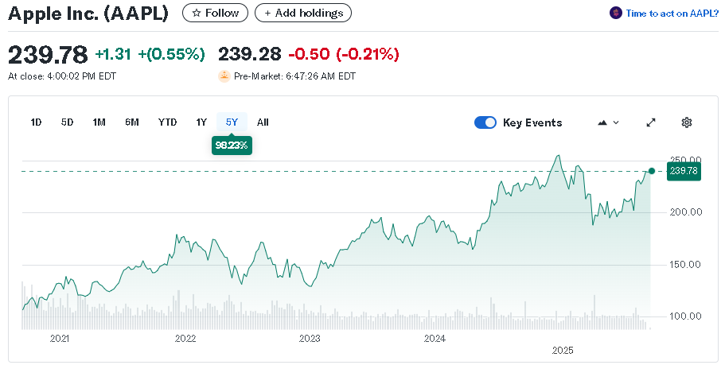
Figure 5: 5 years Apple analysis (Yahoo Finance, 2025b)
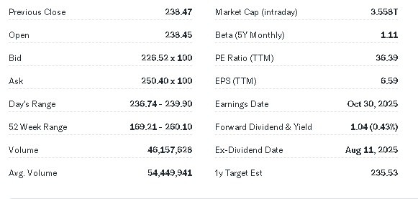
Figure 6: Factor analysis (Yahoo Finance, 2025b)
The above figures show the stock situation over the years. However, it describes that the highest price over the past year, Apple’s stock has reached a peak of $260.10 on December 26, 2024. On the other hand, the lowest price for Apple’s stock over the last year was $169.21. Nevertheless, it also comprises the past five years in which Apple has seen consistent growth, with its stock price climbing from around $55 in 2019 to about $170 - $180 in 2024. It can be identified that, despite the occasional drops and highs of the company's stocks during market corrections, Apple has maintained an upward trajectory, reflecting its strong fundamentals and market dominance (Solovyev Kirill, 2024). The insights of the company clearly suggest that the high points reflect investor confidence in Apple's business model and long-term growth potential. Based on these increases, which show that the company is well-positioned, fluctuations could also indicate periods of uncertainty in the market or broader tech sector (Yahoo Finance, 2025b). As per the lower points of the company, it also reflects broader market trends, like recessions or tech sector corrections, but they also show that Apple’s stock isn’t immune to market risks (Solovyev Kirill, 2024).
Comparison with Competitors
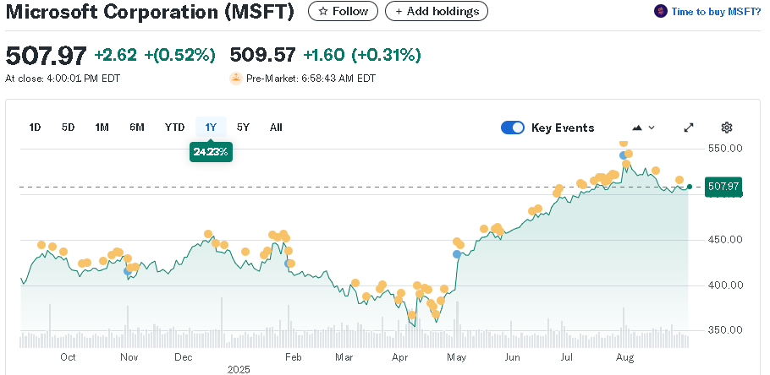
Figure 7: Microsoft analysis (Yahoo Finance, 2025c)

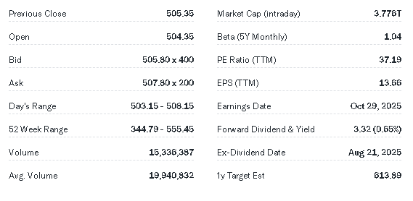
Figure 8: Factor analysis (Yahoo Finance, 2025c)
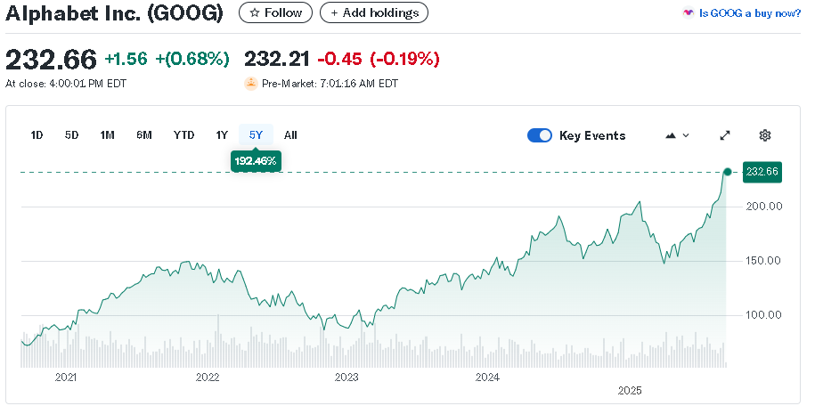
Figure 9: Alphabet analysis (Yahoo Finance, 2025a)

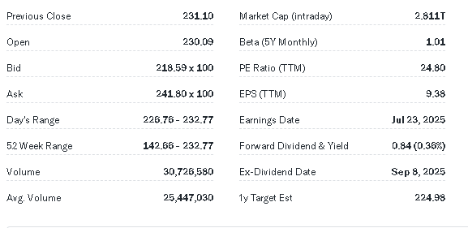
Figure 10: Factor analysis (Yahoo Finance, 2025a)

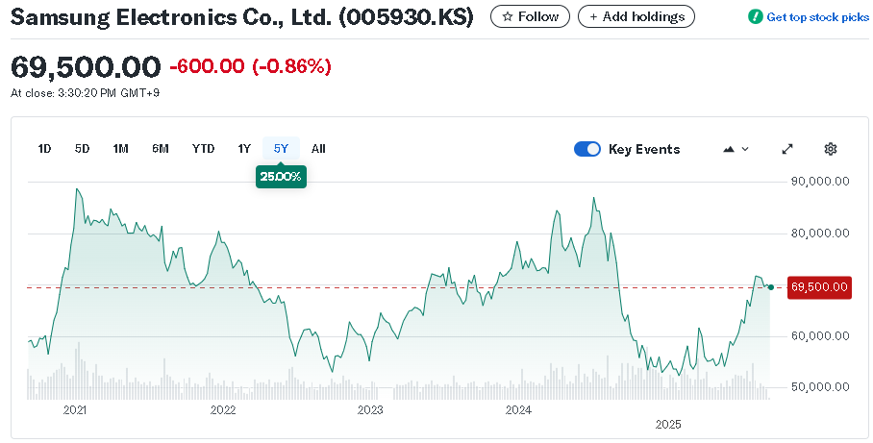
Figure 11: Samsung analysis (Yahoo Finance, 2025d)

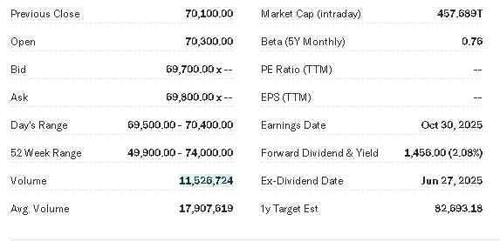
Figure 12: Analysis factors (Yahoo Finance, 2025d)
- Microsoft Corporation (MSFT) Beta = 1.04.
- Alphabet Inc. (GOOGL) Beta = 1.01.
- Samsung Electronics Co. (005930.KS) Beta = 0.75.
- Apple vs Microsoft
The above figure indicates that both have similar beta values, indicating comparable volatility. It also tends to discuss that Apple’s reliance on consumer electronics and services may introduce different risk factors compared to Microsoft's focus on cloud computing and enterprise solutions. However, as per the investing perspective, exposure to consumer-driven growth automatically prefers Apple, while those interested in enterprise and cloud computing might lean towards Microsoft.
- Apple vs Alphabet
In the analysis of both companies, Alphabet's slightly lower beta suggests it may be less volatile than Apple. However, on the other hand, regarding the Alphabet's diversification into areas like digital advertising and cloud services provides a different risk profile such as Alphabet offers a more diversified revenue stream, which could appeal to risk-averse investors.
- Apple vs Samsung
This tends to be one of the most competitive competitors of the market for Apple because Samsung's lower beta indicates it is less volatile than Apple but Samsung's diverse product range and exposure to the semiconductor market introduce different risk considerations. So, on the basis of that Samsung's lower volatility attracts investors because it shows brand strength and ecosystem which offers higher growth potential.
Conclusion
According to the above analysis which conclude that the Apple Inc. remains a compelling investment option for those seeking exposure to the technology sector. In accordance with a beta of 1.04, the stock carries moderate risk, reflecting its sensitivity to market movements. So, on the basis of that the company's consistent growth over the past five years, combined with its strong brand and innovative product offerings, positions it well for future success.

References
Cai, Q. and Chen, S. (2024). Analysis of the Influencing Factors of Marketing Strategy on Consumer Purchasing behaviour: A Case Study of Apple. SHS web of conferences, 188(188), pp.03005–03005.
Macrotrends.net. (2025). Apple - 45 Year Stock Price History | AAPL. [online] Available at: https://www.macrotrends.net/stocks/charts/AAPL/
Solovyev Kirill (2024). DEVELOPING SUSTAINABLE BUSINESS STRATEGIES IN CONDITIONS OF GLOBAL ECONOMIC UNCERTAINTIES. Холодная наука, [online] (4). Available at: https://cyberleninka.ru/article/n/developing-sustainable-business-strategies-in-conditions-of-global-economic-uncertainties.
Yahoo Finance (2025). Apple Inc. (AAPL) Valuation Measures & Financial Statistics. [online] Yahoo Finance. Available at: https://finance.yahoo.com/quote/AAPL/key-statistics/.
Yahoo Finance (2025a). Alphabet Inc. (GOOGL) Stock Price, News, Quote & History - Yahoo Finance. [online] finance.yahoo.com. Available at: https://finance.yahoo.com/quote/GOOGL/.
Yahoo Finance. (2025b). Microsoft Corporation (MSFT) Stock Price, News, Quote & History - Yahoo Finance. [online] Available at: https://finance.yahoo.com/quote/MSFT/.
Yahoo Finance. (2025d). Samsung Electronics Co., Ltd. (005930.KS) Stock Price, News, Quote & History - Yahoo Finance. [online] Available at: https://finance.yahoo.com/quote/005930.KS/.

