Assignment Name
Student Name
Date

Capital Budgeting and Cost of Capital

Overview of the Assignment
This paper will discuss the different capital budgeting and cost of capital estimates and decision-making procedures using fictitious business projects. Before discussing the projects' financial viability and strategic choices, important financial metrics involving Net Present Value (NPV), Payback Period, Weighted Average Cost of Capital (WACC) as well as Internal Rate of Return (IRR) will be computed for each issue being addressed (Advani, 2018).
Question 1:
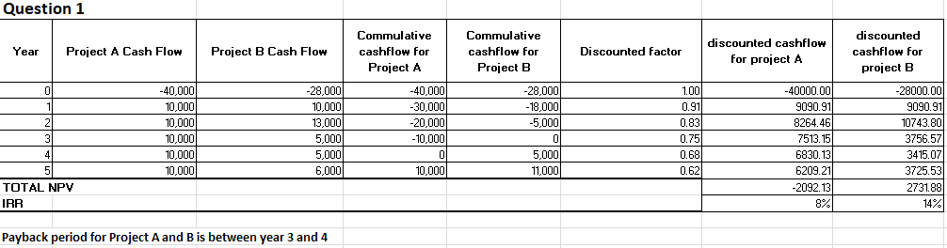
Some assumptions that are made to calculate the given financial metrics are; it is assumed that the discount rate to be used is 10% along with a requirement from management to invest in projects that payoff within a span of four years.
Criteria for Decision Making
Project A requires four years to recoup the investment, whereas Project B requires three years. Both projects meet this condition since management prefers to fund initiatives that yield results in less than four years. The fact that Project A's net present value ($-2092) is in negative which indicates a loss whereas Project B's ($2731) value suggests that it will add value to the company so Project B should be the ultimate choice. When it comes to IRR, Project B appears to offer a larger return on investment, as seen by its higher IRR (14 %) compared to Project A's (8 %). Project B should be chosen since it has a better NPV and IRR based on the three criteria (Fabozzi & Peterson Drake, 2021).
Question 2: A)- NPV calculations for both Souvenir Stand and Hot dog stand:
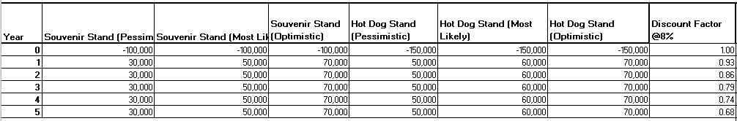
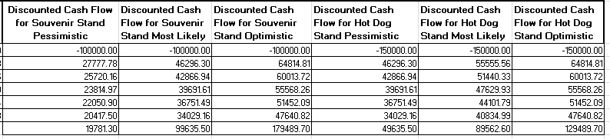

B)- Which one is better?

Souvenir Stand offers positive NPVs in all scenarios, with the largest return in the Optimistic scenario. In the pessimistic scenario, the Hot Dog Stand's NPVs are often higher than those of the souvenir stand, which is interesting. The Hot Dog Stand (Pessimistic) has a higher net present value (NPV) than the Souvenir Stand because of its $50,000 yearly cash flow, which is greater than the Souvenir Stand's $30,000 annual cash flow (Ross, Westerfield & Jaffe, 2023). Other than that, in the rest of the cases souvenir stand performed better than hot dog stand. Since the Souvenir Stand is profitable in the Pessimistic scenario and has larger NPVs in the “Most Likely” and “Optimistic” scenarios, it would typically be a better investment if the company anticipates a good or moderately good outcome (Harris & Thomas, 2021).

Question 3:
Brazilian Banana Farm Discount Rate

When choosing between buying a Brazilian banana farm and investing in corn farming equipment, one would typically anticipate that the Brazilian banana farm would need a larger discount rate. The reason is as follows:

- Significant country-specific risks, including political unpredictability, exchange rate volatility, and economic instability, are introduced by Brazil. The investment in banana farms is more unpredictable as a result of these considerations (Brealey, Myers & Allen, 2022).

- The Brazilian real's value could change in relation to the currency of our home land, which would increase the risk to our anticipated future earnings.

- It could be more difficult to predict the operational risks and expenses if we are not familiar with the Brazilian banana farming industry, which would add to the uncertainty.

Question 4 –
Calculations

- Cost of Equity using C A P M:
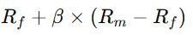
Here, Rf stands for the risk free rate (which is 2 % in current scenario)
𝛽 stands for beta that is 1.3
Rm​−Rf refers to the market risk premium that is 8% currently

Cost of Equity = 0.02 + 1.3 × 0.08
Cost of Equity = 0.02 + 0.104
Cost of Equity = 0.124 or 12.4 %

- Cost of equity
The cost of equity can be calculated using the dividend discount model (Damodaran, 2020).
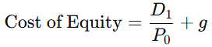
Here, D1 represents next years expected dividend ($ 2 \ times (1 + 0.07) = $ 2.14)
P0 represents the current price of stock which is $ 40
g represents growth rate of dividend which is 7%

So,
Cost of Equity = (2.14 / 40) + 0.07
Cost of Equity = 0.0535 + 0.07
Cost of Equity = 0.1235 or 12.35 %

- WACC

WACC will be calculated using the following formula:
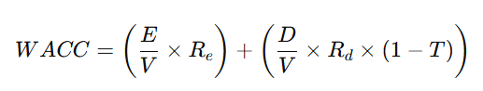
Here,
E = $ 400,000
V = $ 1,000,000
Re = 15%
D = $ 600,000
Rd = 6%
T = 25%
WACC = (400,000 / 1,000,000 × 0.15) + (600,000 / 1,000,000 × 0.06 × (1−0.25))
WACC = (0.4 × 0.15) + (0.6 × 0.06 × 0.75)
𝑊𝐴𝐶𝐶 = 0.06 + 0.027
WACC = 0.087 or 8.7 %

Question 5:

For the casino equipment project, we should not use the same WACC that we did for the dry cleaning company. Here's why:

Distinct Risk Profiles:

A steady, low-risk company with steady cash flows is dry cleaning. Due to market uncertainty, economic instability, and regulatory concerns, casinos are considered high-risk businesses. Regulations pertaining to gambling, legislative changes, and shifting consumer demand are all more likely to affect casinos.

Equity and Debt Costs:

A larger beta would probably translate into a higher cost of equity for the casino, representing heightened market risk. The casino's heightened risk would result in higher borrowing costs, which would raise the cost of debt.

Distinctions from Applying the Same WACC:

To reflect the increased risk, the WACC should be adjusted by raising the cost of debt and equity especially for the casino. The Risk-Adjusted Discount Rate (RADR) should be used by adjusting the discount rate to reflect the risk profile of the casino by accounting for variables such as economic volatility, legal risk, and market risk. There is a need to establish a distinctive WACC for the casino that takes into consideration its specific risk profile and financial structure. Also, we should use industry benchmarking to get the right WACC for this new endeavor by comparing it to other similar casino firms (Weston & Brigham, 2021).
The casino's WACC ought to be greater because it is a riskier enterprise than the dry cleaning company. It is required to make changes or create a new WACC calculation tailored to the casino project because the normal dry cleaning WACC calculation is unlikely to accurately reflect the potential hazards of the venture (Weston & Brigham, 2021).

References
Advani, R. (2018). The Wall Street MBA: Your personal crash course in corporate finance (3rd ed.). McGraw-Hill.
Brealey, R. A., Myers, S. C., & Allen, F. (2022). Principles of corporate finance (13th ed.). McGraw-Hill Education.
Damodaran, A. (2020). Applied corporate finance (5th ed.). Wiley.
Fabozzi, F. J., & Peterson Drake, P. (2021). Capital budgeting techniques in modern finance. Wiley.
Harris, F. H., & Thomas, C. R. (2021). Investment analysis and portfolio management (10th ed.). Cengage Learning.
Ross, S. A., Westerfield, R., & Jaffe, J. (2023). Corporate finance (13th ed.). McGraw-Hill Education.
Weston, J. F., & Brigham, E. F. (2021). Essentials of managerial finance (15th ed.). Cengage Learning.

