Company Overview
EcoSip is a local specialty coffee shop, which is located in Austin, Texas, and deals with organic coffee, artisanal tea, and baked goods sourced sustainably. The enterprise focuses on environmental sustainability, such as ethically sourced products and sustainable packaging, which are consistent with the increased popularity of green and people-oriented businesses in Austin. The target audience is mainly young professionals and university students who focus on being environmentally friendly, ethical in their drinking and eating choices, and who drink and eat high-quality and artisanal products. In making it a local venue and an eco-friendly brand, EcoSip aims to establish a distinction among the bigger chain cafes and will attract customers who appreciate authenticity, quality, and social responsibility. The cultural sensitivity in this strategic approach is also to provide products and services that appeal to the preferences and expectations of the diverse population in Austin, so that all customer interactions can be seen as inclusive and respectful of the diverse cultures of the people. Through this and the introduction of these values in its branding and marketing programs, the EcoSip develops a solid base of online and offline integrated marketing communications (IMC).

IMC Application
In order to reach its target market, EcoSip will use three marketing communications tools: one online and two traditional. The online medium will be the social media channels, which will be Instagram and Facebook, because these platforms are popular among the young professionals and university students in the city of Austin (Ahmed et al., 2019). Social media enables EcoSip to communicate directly with customers, present products in a visual manner, and propagate sustainable practices in a format that is interactive and shareable. By selecting posts, stories, and promotions carefully, the brand can also reaffirm itself as being a community-driven, ecologically friendly cafe, as well as publicize the events, new dishes, and seasonal offers (Ahmed et al., 2019). The strategy will make them engage and also be visible across the key audience.
The initial conventional media are community newspapers and lifestyle magazines, local print advertising. Print media will still be a reliable means of information in Austin and will be able to access a wider group of demographics, such as older professionals who might not be active social media users. Through visual advertisements with cultural sensitivity, whereby the emotional appeal focuses on the fact that, as a company, EcoSip aims at sustainability and sourcing locally, the brand can reinforce itself within the community and appeal to a wide range of customers (Dwi Nita Aryani et al., 2024).
The second conventional medium is outdoor advertising, namely, the use of strategically placed banners and posters in the areas of universities, coworking spaces, and locations with a high flow of people. Through outdoor advertising, potential customers will be exposed to their everyday surroundings, which will ensure the reinforcement of brand awareness and recognition (Ahmed et al., 2019). Inclusive imagery of different communities will be used in banners and posters, and will focus on the environmentally friendly and socially responsible approach of EcoSip. The strategy will make sure that, besides being evident, marketing communications should be appealing to the principles of cultural and social inclusivity, which will enhance brand loyalty and trust in the community (Rosário & Dias, 2025).
The combination of these three channels, which include social media, print advertisement, and outdoor marketing, will establish a coherent IMC strategy that is designed to meet the needs of the target market, competitive positioning, and brand mission of EcoSip. The channels chosen will be used to reach as many people as possible and engage, be diverse, and inclusive in the message and image, so that EcoSip attracts as many diverse people as possible to be socially conscious (Campbell et al., 2025).

IMC Campaign
In the case of the integrated marketing communications campaign of EcoSip, three distinct marketing tools have been created: one online and two traditional, which guarantee that the message remains the same across all the media, whilst focusing on diversity and inclusivity.
The initial marketing campaign would be an Instagram campaign that is aimed at attracting the attention of young professionals and university students. The posts are characterized by high-quality pictures of organic coffee and baked goods that EcoSip produces, and captions that emphasize the sustainability of the sourcing practices and the dedication of the company towards local communities (Ahmed et al., 2019; Rosário & Dias, 2025). The campaign also consists of user-generated content by various customers who demonstrate a variety of ages, ethnicities, and cultural backgrounds who consume the EcoSip products. This will not only enhance engagement but also strengthen the inclusive nature of the brand, where all groups of the audience would feel represented and valued. Narratives and interactive polls also entice customers to take part in decision-making on the menu, making them feel like they own it and are a part of the community (Rosário & Dias, 2025).
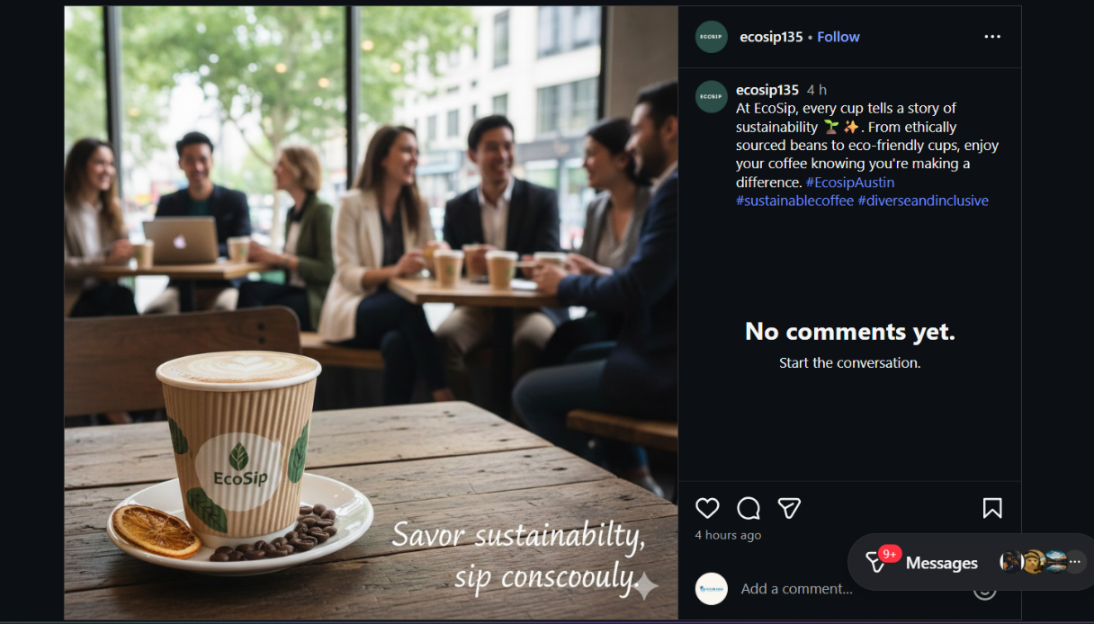
Link: https://www.instagram.com/p/DR-MjNhjY60/
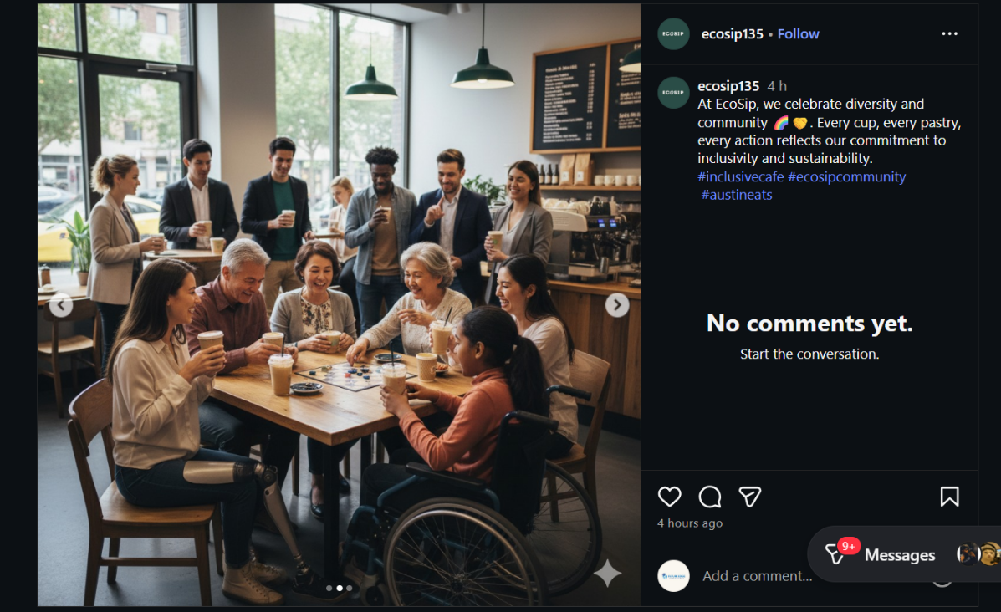
Link: https://www.instagram.com/p/DR-M4TCDf4Z/

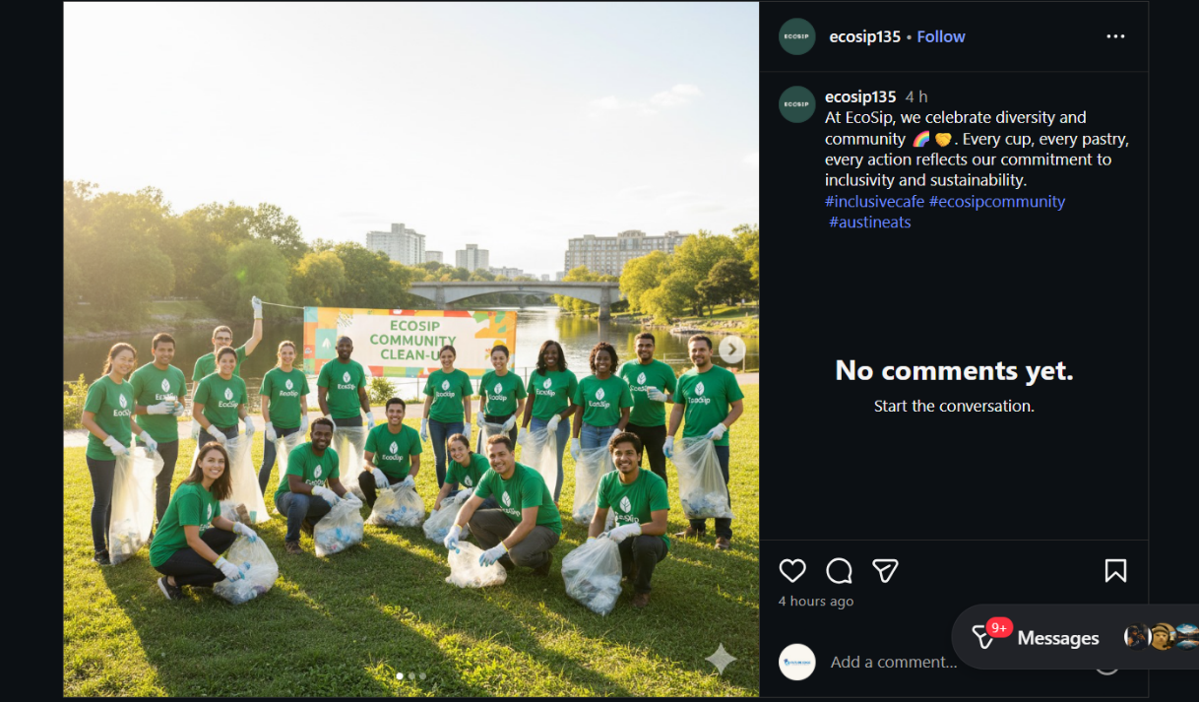
Link: https://www.instagram.com/p/DR-M4TCDf4Z/

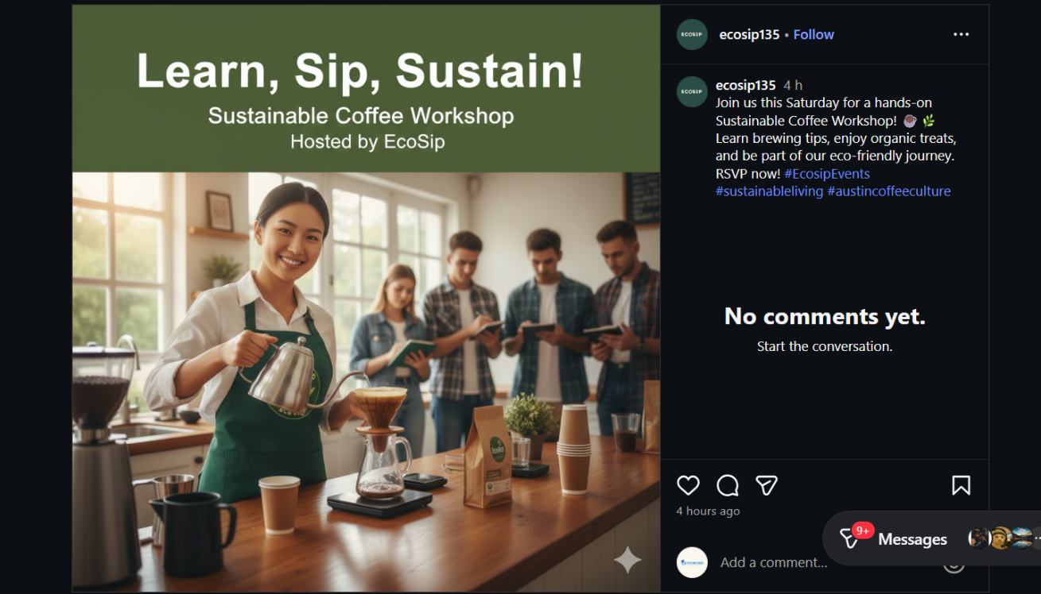
Link: https://www.instagram.com/p/DR-OByEjb44/
The second message is a print advertisement in the local magazine about the Austin lifestyle. The advertisement design is inclusive, using people of various cultural backgrounds taking EcoSip beverages, and the message is both quality and sustainable. The print advertisement exhibits the ability to understand the diverse background of the population in Austin by appealing to the students and the professionals who appreciate responsible consumption through culturally sensitive images and words (Alzu’bi et al., 2025). Another aspect of the ad, which mentions the eco-friendly activity of the cafe, biodegradable cups, locally produced products, etc., corresponds to the ethical concerns of the target audience. Print media offers physical presence, giving credibility and trust to the brand among the readers who might be so inclined to use traditional means of communication (Rosário & Dias, 2025).
The third medium of communication will be the outdoor poster campaign, which will be placed at strategic locations around the universities, coworking spaces, and high-traffic places. The graphic designs used in the posters are colorful and attractive to the eye as they represent how EcoSip is dedicated to sustainability, diversity, and inclusivity. Messaging focuses on a friendly consumer experience for all customers and on seasonal deals and neighborhood gatherings (Rosário & Dias, 2025). The posters contain QR codes to help guide the viewers to the EcoSip site and social media to close the gap between offline and online interaction. The integration enables potential customers to easily get more content, promotions, and interactive capabilities, which make the brand experience a seamless one. Having these three marketing communications in place, EcoSip will be able to have a uniform and all-encompassing brand message throughout the touch points. The online and offline mediums collaborate to raise awareness, support brand values, and initiate communication with different customer groups (Ahmed et al., 2019; Rosário & Dias, 2025). All the communication items demonstrate cultural awareness, social responsibility, and inclusivity, which are part of the mission of EcoSip to provide a community-oriented, eco-friendly cafe.

Analysis of Diversity & Inclusivity
The three marketing communications by EcoSip show that the inclusion and diversity principles are integrated intentionally. The Instagram campaign will utilize the images of people of different cultural, ethnic, and age groups using EcoSip products, which will guarantee that all potential customers will see themselves reflected in the message of the brand. Interactive polls and user-created content are also used in the campaign to encourage the participation of a diverse audience and make it more inclusive, as their preferences and contributions are appreciated (Rosário & Dias, 2025).
The print advertisement is also strengthening the aspect of inclusivity; the advertisement represents a multicultural group of customers, and the language used is culturally sensitive and friendly. Emphasizing sustainable activities and a wide range of visuals, the ad targets the needs of consumers, who are socially responsible regardless of their demographic segments, and provides a feeling of community and common values (Ahmed et al., 2019; Dwi Nita Aryani et al., 2024). On the same note, the outdoor poster campaign enables inclusive imagery to be placed strategically in the open areas where various groups of people gather to facilitate marketing to different groups of people.
QR codes to the online platforms connect the offline and online channels, and therefore, the brand becomes approachable and interactive to all audiences. In general, the marketing communications of EcoSip are effective in terms of using diversity and inclusivity by being culturally sensitive, visually depicting various identities, and engaging various audience segments (Campbell et al., 2025; Rosário & Dias, 2025). Such approaches promote brand loyalty, credibility, and social responsibility, which would be in line with ethical and community-oriented principles that the mission of EcoSip is based on.

Conclusion
EcoSip has a strong integrated marketing communications combining both online and conventional channels and focusing on diversity and inclusivity. Representing multiple cultures, interactivity, and encouragement of ethical behavior of business behavior make the brand compatible with its community-oriented image and reinforce the relationships with clients, guaranteeing future loyalty and adherence to the socially responsible mission.

Reference
Ahmed, R. R., Streimikiene, D., Berchtold, G., Vveinhardt, J., Channar, Z. A., & Soomro, R. H. (2019). Effectiveness of Online Digital Media Advertising as a Strategic Tool for Building Brand Sustainability: Evidence from FMCGs and Services Sectors of Pakistan. Sustainability, 11(12), 3436. https://www.mdpi.com/2071-1050/11/12/3436
Alzu’bi, R. M., Kontor, E., & Kovács, S. (2025). A qualitative study of using green marketing practices within Jordanian food companies: a content analysis approach. Discover Sustainability, 6, 430. https://doi.org/10.1007/s43621-025-01301-x
Campbell, C., Sands, S., McFerran, B., & Mavrommatis, A. (2025). Diversity representation in advertising. Journal of the Academy of Marketing Science, 53(2), 588–616. https://link.springer.com/article/10.1007/s11747-023-00994-8
Dwi Nita Aryani, N. W. C., Gan, K. H., Koh, T. W., Khor, M. H., & Lee, Y. C. (2024). Green Packaging as a Branding Strategy: How Eco-Friendly Materials Influence Brand Image and Customer Loyalty. International Journal of Tourism and Hospitality in Asia Pacific. https://ejournal.aibpmjournals.com/index.php/IJTHAP/article/view/4192
Rosário, A. T., & Dias, J. C. (2025). The Role of Digital Marketing in Shaping Sustainable Consumption: Insights from a Systematic Literature Review. Sustainability, 17(17), 7784. https://www.mdpi.com/2071-1050/17/17/7784

