One of the essential instruments to make small businesses become more visible and active is the use of social media hashtags. With the choice of relevant and trending hashtags, businesses can increase their scope to the audience that may not be their followers. To illustrate, application of hashtags like #SocialMediaMarketing or #SmallBusiness may assist niche businesses to reach wider audiences that would be searching on these topics. Besides that, trending hashtag research and a tiered approach, i.e. combination of more popular and niche ones, will guarantee businesses reach both high-volume and niche-specific feeds and allow them to be found in more user feeds in a platform such as Instagram. The small businesses can be able to compete with the big brands through this strategy of strategically targeting the communities that are more likely to be interested in their products.
As an illustration, a local coffee shop may create an Instagram post with a picture of their sustainably sourced coffee with hashtags like: #EcoFriendly, #LocalBusiness, #CoffeeLovers, #SustainableLiving. These hashtags are selected based on the mission of the brand, and they resonate with people who embrace ethical consumption. Hashtags that are location-based or niche-based enable the business to reach more of the potential customers, particularly in local communities or communities of interest, better than those who are followers of the business. Through tracking of the hashtags that attract interest, businesses will be able to adjust their social media plan as time progresses to help them increase their coverage and capture new consumers on a regular basis.
Link of 1st post: https://www.tiktok.com/@ecosiip135/photo/7580908866888617223
Screenshot of 1st post:

Link of 2nd post: https://www.instagram.com/p/DR8RXFZiMCm/
Screenshot of 2nd post:
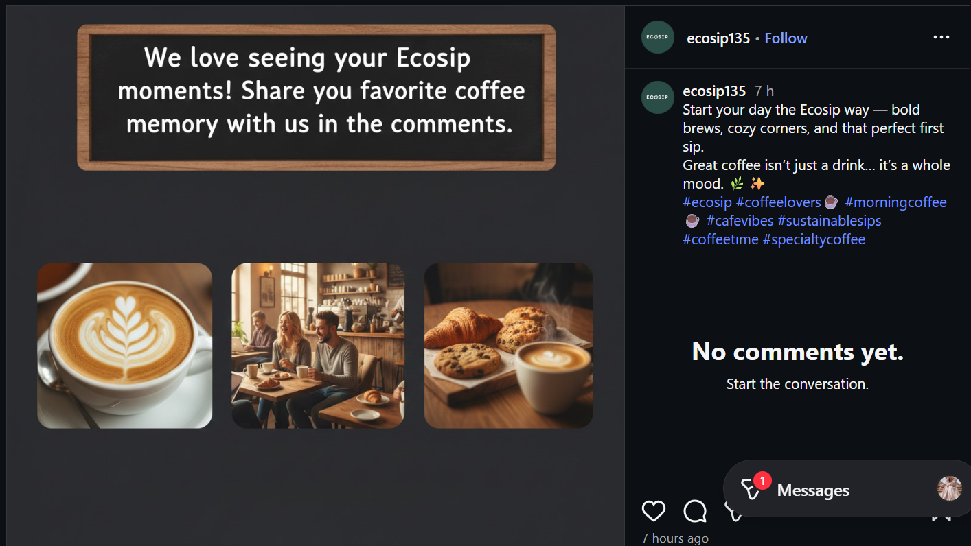

Reference
Wahid, N. A., Hussin, A., Ishak, M., & Aziz, N. N. A. (2022). The impact of social media adoption on business performance among homepreneurs: A preliminary study. International Journal of Academic Research in Business and Social Sciences, 12(10), 2958–2967. https://hrmars.com/ijarbss/article/view/15323/The-Impact-of-Social-Media-Adoption-on-Business-Performance-among-Homepreneurs-A-Preliminary-Study
La Rocca, G., & Boccia Artieri, G. (2022). Research using hashtags: A meta-synthesis. Frontiers in Sociology, 7, 1081603. https://pmc.ncbi.nlm.nih.gov/articles/PMC9733595/
Zhang, Y. (2019). Language in our time: An empirical analysis of hashtags. arXiv Preprint. https://arxiv.org/abs/1905.04590
Cantini, R., Marozzo, F., Orsino, A., Talia, D., & Trunfio, P. (2025). Dynamic hashtag recommendation in social media with trend shift detection and adaptation. arXiv Preprint. https://arxiv.org/abs/2504.00044

