The initial social media message is an appeal to the multicultural consumers who are not within the target profile of the company. According to research, over half of U.S. consumers do not believe that they are well represented in digital advertising, even though about 65 percent of them anticipate that brands should be involved in business communications that are diverse and inclusive. In order to occupy this void, the call-to-action post encourages a wide range of community members to interact with the brand by showing that they have common values of respect, visibility, and equal opportunity. This practice can be related to the suggestion that inclusive communication creates trust and long-term customer relationships (Clark & Hawley, 2024). The chosen social media tool, the Instagram platform, embraces very visual storytelling, which would allow brands to target multicultural audiences in a manner that is relatable and authentic in terms of messages (Bughao, 2022).
The second one has a more general message, which targets people with disabilities who can be another underrepresented group in mainstream marketing. The inclusive marketing approach focuses on the necessity of being authentic in the appearance of diversity and making sure that the message is built on the basis of real experience, not empty display. The post further supports the interest in the company to be accessible and belong by ensuring that everyone can equally receive the services and by acknowledging consumers to provide feedback on how the brand can serve them better. Instagram is a suitable platform due to its accessibility capabilities, alt-text, and screen-reader support, which make the platform more accessible to visually impaired users and, at the same time, open up the platform to a wider audience. The brand is aware of different consumer needs by channeling this to show that its communication is in line with the current trends of meaningful representation (McKinsey & Company, 2022).
Link of 1st post: https://www.tiktok.com/@ecosiip135/photo/7580908866888617223
Screenshot of 1st post:
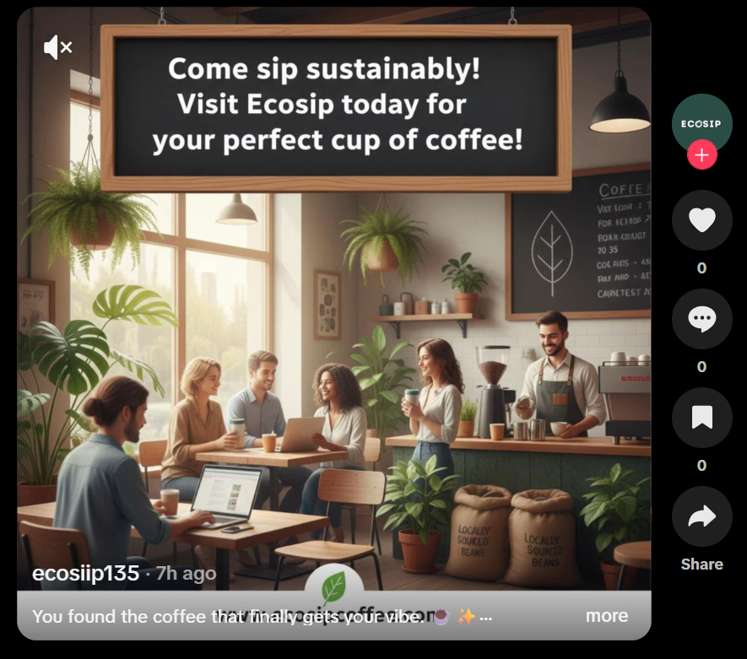
Link of 2nd post: https://www.tiktok.com/@ecosiip135/photo/7580907801736760583
Screenshot of 2nd post:
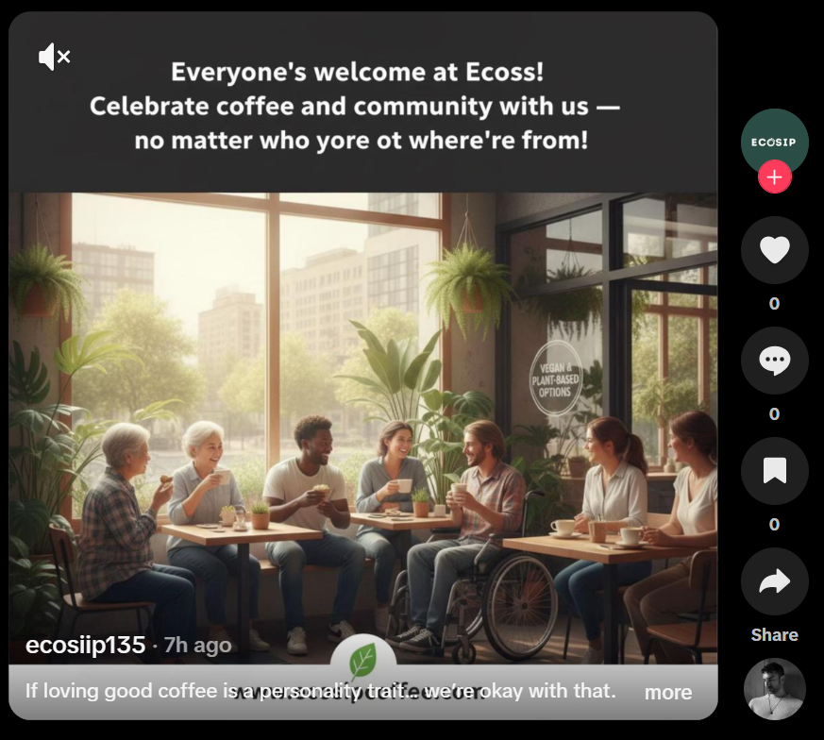

Reference
- Clark, S., & Hawley, M. (2024, April 19). Diversity, equity, inclusion: Are brands doing it right? 5 ways diversity and inclusion impact the customer experience. CMSWire. https://www.cmswire.com/customer-experience/5-ways-diversity-and-inclusion-impact-the-customer-experience/
- Meta & The Geena Davis Institute on Gender in Media. (2022). 65% of US consumers expect brands to promote diversity and inclusion in online advertising, but 53% do not feel fully represented. Ethical Marketing News. https://ethicalmarketingnews.com/65-of-us-consumers-expect-brands-to-promote-diversity-and-inclusion-in-online-advertising-but-53-do-not-feel-fully-represented
- Bughao, A. (2022, June 27). Inclusion doesn’t end with the creative — a diverse media plan is crucial, too. Campaign Asia-Pacific. https://www.campaignasia.com/article/inclusion-doesnt-end-with-the-creative-a-diverse-media-plan-is-crucial-too/478805
- Cox, C. (2022, February 4). 7 ways to create an inclusive marketing strategy. Hawksem. https://hawksem.com/blog/ways-to-create-inclusive-marketing-strategy/
- McKinsey & Company. (2022, February 8). The rise of the inclusive consumer. McKinsey & Company. https://www.mckinsey.com/industries/retail/our-insights/the-rise-of-the-inclusive-consumer
- Deci, E. L., & Ryan, R. M. (2021). Intrinsic motivation and self-determination in human behavior. Springer Science & Business Media. https://link.springer.com/book/10.1007/978-1-4899-2271-7

