Discussion Post: Selecting Messages for Social Media Channels
All of the posts made within the social media will assist EcoSip, a local specialty coffee store in Austin, Texas, to market our organic coffee, artisanal tea, and sustainable baked goods to our target consumers, who are young professionals and are aware of the environment. Instagram is our primary source, as it is the most visual one, and will allow EcoSip to show visually pleasing products and help our brand promote the concept of sustainability and ethical values. The former is a generic appeal to action, which will appeal to our major target demographic: Start your day with a cup of organic goodness! You are welcome to spend your time in EcoSip, the place where you can find ethically produced coffee and handcrafted delicacies that help to maintain your body and your community. Look at our menu: go by clicking on the site www.ecosip.com. This post makes you take action now and reminds people of the importance we are as our brand. The use of straightforward, simple language is as per the best practice of call-to-action messages that increase engagement and lead to conversion on social media. This strategy will be complemented by the image storytelling feature of Instagram to create a powerful platform that will reach our key market.
The second post will be written to a broader audience, not to our primary consumers, but to accessibility and community representation: anyone would be welcome to drink EcoSip! Slurp our gluten-free baked goods, non-discriminatory community environment, and organic coffees. EcoSip will accompany you in the office or when you are meeting your friends or having a conscious break. Find out more: (https://ecosip.ct.ws). This is an escape to the thoughtlessness of the needs of our diversified society, where we are caring about the needs of people not allowed to eat gluten-filled products, or with different lifestyles, we are sensitive to their needs. Not only do inclusive campaigns allow gaining a good brand image, but they also improve relations with underrepresented groups, which is critical in sustainable development. The visual quality of posting stories and posts on the Instagram platform will allow us to access these groups, and this will assist in supporting our wish to be diverse without compromising on access to our core customers.
Link of 1st post: https://www.instagram.com/p/DR8RlWWCEIx/
Screenshot of 1st post:
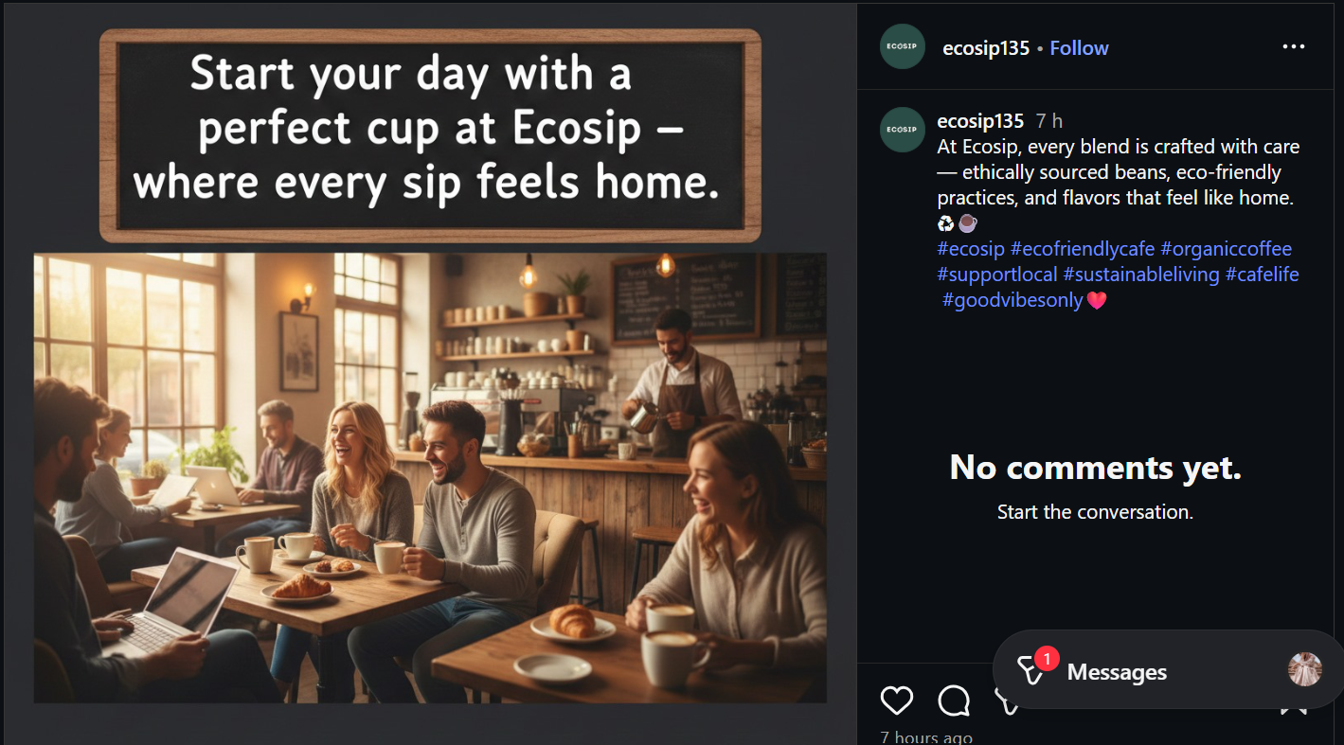
Link of 2nd post: https://www.instagram.com/p/DR8RXFZiMCm/
Screenshot of 2nd post:
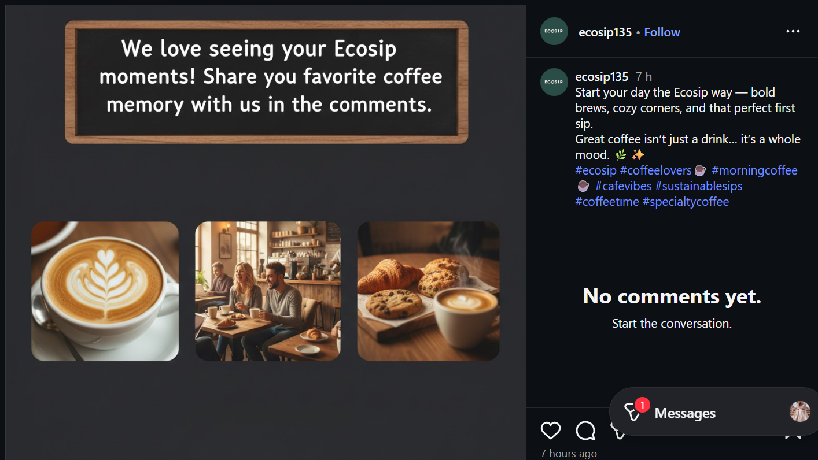
Reference
Walker-Ford, M. (2022, February 6). 9 Call to Action Best Practices to Improve Your Marketing Strategy. Social Media Today. https://www.socialmediatoday.com/news/9-call-to-action-best-practices-to-improve-your-marketing-strategy/618385/
Hootsuite. (n.d.). Create engaging and effective social media content. Hootsuite Help Center. Retrieved December 8, 2025, from https://help.hootsuite.com/s/article/social-strategy-create?language=en_US
Powell, J. I. (2022, March 14). How brands can build inclusive campaigns year-round. Sprout Social. https://sproutsocial.com/insights/inclusive-campaigns/
OptinMonster. (n.d.). How to create the perfect call-to-action (CTA). OptinMonster. Retrieved December 8, 2025, from https://optinmonster.com/university/guides/how-to-create-the-perfect-call-to-action-cheatsheet/

