Grant Clauser
Amazon’s Alexa-controlled Echo speaker, now in its second generation and with several derivative versions available, continues to expand its music, smart-home, and digital-assistant abilities. It’s first a wireless speaker, but capable of much more. Using nothing but the sound of your voice, you can play music, search the Web, create to-do and shopping lists, shop online, get instant weather reports, and control popular smart-home products—all while your smartphone stays in your pocket.
Share this review on Facebook
Share this review on Twitter
Save this review on Pocket
Share this review on Pinterest
Share this review with E-mail
Our pick
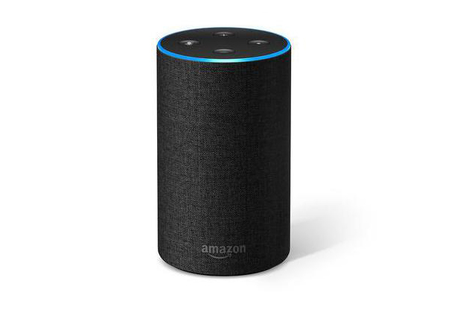
Amazon Echo (2nd Generation)
Our pick
Echo, always listening via Amazon’s Alexa voice service, lets you play music, order pizza, and get answers to questions, and can control popular smart-home devices and 1,000-plus other things.
$100 from Amazon
Alexa (named after the ancient library of Alexandria) is Amazon’s voice-control system. It lets you speak your wishes to an Echo smart speaker and see them fulfilled—at least simple ones, like dimming your lights or playing music tracks. This guide covers how it all works, what it’s capable of doing (and where it still falls short), privacy concerns you may have, and how to pick the right Echo for your home. (We also have separate guides to the best Alexa-compatible devices and how Echo compares to Google Home.)
What sets Alexa and Echo apart from first-generation voice assistants is responsiveness. There’s no activation button to press. Simply say the trigger word (either “Alexa,” “Echo,” “Amazon,” or “Computer”) followed by what you want to happen, and it will usually be done—as long as you’ve set up everything properly and are using the correct command. Once you get used to the quirks, using Alexa feels much more natural and responsive than speaking to a phone-based voice assistant like Apple’s Siri. As a result, you’ll likely find yourself using your phone less frequently when you’re at home.
Top of Form
Keep up with everything Wirecutter from your inbox
Wirecutter Weekly: New reviews and picks, sent weekly
Deals We Love: The best deals we can find, sent daily
Please choose a newsletter to subscribe to.
Sign up for Wirecutter’s Newsletter Subscribe
That wasn’t a valid email address. Please try again.
Feel free to opt out or contact us at any time.
Opt out or contact us at any time.
Bottom of Form
Thanks for subscribing!
You’ll be hearing from us soon.
Back to top
The research
Expand all
Who should get an Echo
How does Alexa work?
What can Alexa skills do?
Alexa’s limitations
Is your Echo spying on you?
Amazon Echo vs. Echo Dot vs. Echo Plus
What about non-Amazon Alexa speakers?
Extending Alexa with IFTTT
What to look forward to
Sources
Who should get an Echo
Let’s get this out of the way: Though the Echo is a decent speaker in its own right, if music streaming is all you’re after, you can get better sound with other speakers, like the Sonos One. The real reason to get an Echo right now is because you want the Alexa voice-control platform, which makes interacting with your speaker and other devices much easier. Voice control frees you from being constantly tethered to your smartphone. If you thought the transition from flipping light switches to pressing smartphone buttons was game-changing, then letting Alexa control your things will be even more satisfying.
Alexa is particularly useful for smart-home users because it lets you control your Alexa-compatible devices without having to take out your phone and launch an app. (Alexa does have an app, but that’s mostly for setup and configuration, or to add new abilities or to view to-do and shopping lists.) Most of the time, the Echo, Tap, and Dot let you access Alexa’s useful features without your having to interact with a screen at all (Echo Show and Spot include built-in screens). Without touching anything, you can walk into a quiet room and ask for music, or walk into a dark room and ask for lights.
Beyond asking for music, you can use Alexa to search Wikipedia (“Alexa, who was Guy Fawkes?”), make quick cooking conversions (“Alexa, how many pints are in a gallon?), help with math homework (“Alexa, what’s 9 x 48?”), or create a to-do list (“Alexa, add ‘make doctor’s appointment’ to my to-do list.”). A growing list of built-in capabilities and third-party skills means that your Alexa device keeps improving the longer you own it.
If you already have some Alexa-compatible devices or one of the three major smart-home hubs (SmartThings, Wink, and Insteon), adding an Echo can make accessing those devices more interesting and convenient.
Pull Quote
Without touching anything, you can walk into a quiet room and ask for music, or walk into a dark room and ask for lights.
However, Echo isn’t a comprehensive smart-home system. It won’t replace a smart-home hub for complex programmed automations, and it won’t always be the most practical means of interacting with your other devices. Rather, think of it as an additional interface for your smart home that provides functionality that an app on your phone can’t. As a result, you will probably come to rely on it more and more. The new Zigbee-enabled Echo Plus and Alexa’s new “routines” feature move the product closer to hub-level home automation, but it’s not there yet.
How does Alexa work?
Amazon built a natural-language processing system that is one of the easiest to interact with we’ve seen. If you ask a question or deliver a command, you usually don’t have to ask twice. Part of Alexa’s success is dependent on the several very sensitive microphones built into all Echo devices (a February 2017 update requires Tap owners to turn this feature on in the settings menu). Alexa is always listening and is quick to respond.
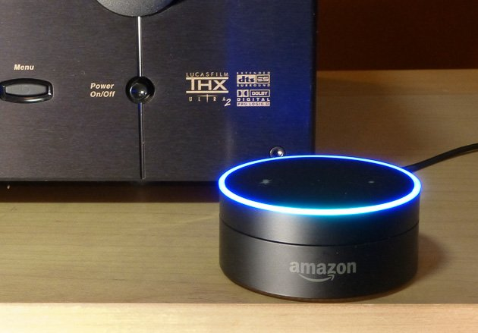
To use Dot with your home theater system, connect it via the 3.5-millimeter cable to your AV receiver. Photo: Grant Clauser
As noted earlier, Echo devices stream your voice to the cloud only when you ask it to do something (your requests also show up in the app, and you can delete them if you don’t want to leave a record). The default wake word is “Alexa,” but you can change that to “Echo,” “Amazon,” or “Computer.”
Once you say the magic word, the microphone takes everything you say next and beams it up to Amazon’s cloud computers for quick analysis. If it’s a question it can answer, such as, “Alexa, what’s the weather in Chicago today?” an answer comes forth from the speaker in a female, slightly computery voice. If it’s music you want, Alexa will search through the Amazon Music catalog or Amazon Prime Music for the artist or genre you requested. (An Amazon Prime account is required for access to Prime Music.) It can also play TuneIn Internet radio stations, music from Pandora (free or subscriber accounts), Spotify (only subscriber accounts), and iHeartRadio (subscription required). If it’s a request for a joke, be prepared to groan. If it’s a request to turn off a light or adjust the thermostat, your light will turn off and your temperature will adjust—but only if you’ve asked correctly and have properly integrated that ability into the system.
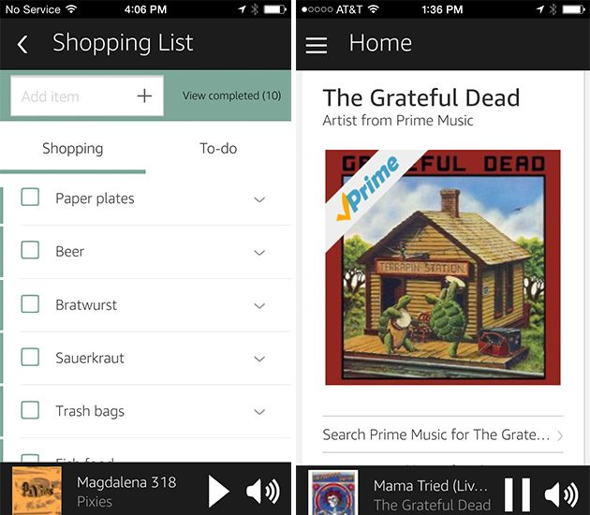
Getting Echo to play music or add things to a shopping list is as easy as asking Alexa.
It’s those smart-home talents that have many people excited about Echo. One of the key characteristics of a smart device is that it should make common daily tasks easier. Sure, turning off your lights or adjusting your thermostat with an app on your iPhone is neat, but it’s simply moving the switch from your wall to your phone. Completing the same task by speaking your command while your phone sits dormant in your pocket is even easier. Echo and Alexa are for smart-home users who think even launching an app is too tedious.
Echo has a growing list of products it can integrate with directly, and that list includes the most popular smart-home products on the market, which we cover in a separate guide. The Echo Plus, with built-in Zigbee, adds about a hundred more Zigbee-compatible products to that list. The list of products Alexa can natively work with is also supplemented by something Amazon calls “skills” and third-party integration applications like IFTTT, Yonomi, and Muzzley. (More on those in the IFTTT section.) Amazon actively welcomes more integration partners, and its API is available to any company that wants to pull up a chair.
Pull Quote
Voice shopping is available only to Prime members, and only Prime-eligible products can be purchased this way.
The easiest integrations are with the products Alexa can work with directly, and those can be found in the smart-home section of the app’s menu. Partner systems include Philips Hue lights, the Lutron Caséta lighting system, Belkin Wemo switches, Nest thermostats (second- and third-generation models), Ecobee thermostats, the Sensi thermostat, the TP-Link Kasa outlet switch, and LIFX smart bulbs, plus Insteon, Wink, and SmartThings hubs. Integrating one of the hubs essentially makes Echo able to control most things connected to those hubs, and thereby makes the list of things it can control significantly larger.
Initially, you were limited to one action per voice command, but now you can string activities to be activated by a single command using either grouping or routines. For example, you can group smart lights together by room or area, then turn off that area with one command (“Turn off the kitchen”). Routines are custom-named activities you can program that can combine smart devices (such as lights) with other tasks like playing your morning news briefing. For instance, you could create a routine called “good morning” that when triggered, would turn on your bedroom and kitchen lights and play the news in the bathroom. Routines can also be scheduled to activate automatically at a certain time, so your good morning routine could turn on the lights for you every day at 6 am without you having to do anything else. Unfortunately, music tracks or playlists are not currently supported by routines.
You can also use the entire family of Amazon Echo speakers as a home intercom system. If you have multiple Echos throughout your home, you can initiate walkie-talkie–style chats between them with a voice command. You’ll have to set this up first, by giving each of your devices names and the enabling the “drop-in” feature. You can also ask your Echo to make free phone calls to any phone simply by saying, “Alexa, call xxx-xxx-xxxx.” If you have one of the video-enabled Echo models (Show or Spot), you can make video calls, at no additional charge.
If you’re an Android device owner, as of 2018 you can also use Alexa to text (as long as it’s not a group text). We haven’t tested this feature yet, but we’ll update this guide when we do.
Another smart feature of Echo and Alexa, and one that’s close to Amazon’s heart, is voice-controlled shopping. Voice shopping is available only to Prime members, and only Prime-eligible products can be purchased this way. There are some restrictions beyond that, too. For instance, you can’t order clothing, shoes, watches, or jewelry by voice. To buy something, you ask Alexa to order your item. It will search for it and tell you the price and ask you to confirm with a four-digit security code (that you would have already configured in the app) that prevents children and strangers from making unauthorized purchases. The purchase is charged to your default payment method. Often Amazon offers special deals exclusive to voice purchasers. You can learn about those by asking “Alexa, what are today’s deals?”
What can Alexa skills do?
What’s a skill? In the Echo-Alexa world, a skill is like an app. It’s a little program you can add to your Echo to enable a new ability. At the time of this writing there were more than 25,000 skills in the skill menu of the Alexa app, with more launching every week. In early April, Amazon released the Alexa Skill Kit to the public, making it easy for anyone with basic programming chops to create skills and add them to Alexa. Once you add a skill to your Alexa account, it will work with all the Alexa devices in your home. You don’t need to add the skill to each device separately.
Like apps for phones, there are a lot of throwaway skills, but there are plenty of useful ones as well. The first that any smart-home enthusiast will want to add is the IFTTT skill. IFTTT (it stands for “If This Then That”) is a website and app that lets you link different devices and services in the cloud with what the app calls recipes (read more about this).
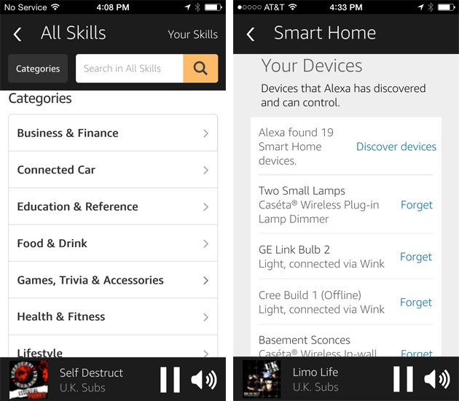
You’ll interact with the Echo app to manage Alexa’s skills and connected devices.
Some skills let you purchase things or services outside of Amazon. For instance, there’s skills for Uber and Lyft to order rides, a Domino’s Pizza skill for ordering a large pie with extra pepperoni, a skill for ordering flowers from 1-800-FLOWERS, and more.
Users can find skills for a variety of hobbies and interests. There’s a tide guide for surfers, homework helper skills, recipe skills, traffic report skills, plus lots of skills for individual smart-home devices, such as the SkyBell doorbell camera and the Scout smart-home security system.
Among the less practical, but possibly fun, skills are DrinkBoy (for finding drink recipes), Cricket Facts (for facts about, well, cricket), Daily Affirmation (to make you feel better about life’s great struggle), unicorn trivia, and at least two skills to deliver “yo mama” jokes. There’s no limit to the number of skills you can add to your account, but sorting through them on the app, and remembering the voice commands to make them work, can be difficult if you have several.
Alexa’s limitations
Alexa can do a lot of things, but sometimes in practice, things might not work exactly how you would expect them to. For example, you can create a shopping list by telling Alexa to add firecrackers or beer to your list, but you must add each item separately. That is, instead of saying “Alexa, add firecrackers and beer to my shopping list,” you have to say “Alexa, add firecrackers to my shopping list. Alexa, add beer to my shopping list.” The process can get annoying if you’re creating a large shopping list, especially for other people in the room. Further, though Alexa nicely creates a shopping list in its app (that you can access when you’re in the grocery store), you need to use an IFTTT recipe to create a version of the list for sharing or printing.
And although one of the favorite uses of Echo is to ask random questions, Alexa isn’t Google. The system knows a lot, but what it can’t answer outweighs what it can. If your primary use for a smart speaker is to answer factual questions, we recommend the Google Home instead.
Owners of multiple Alexa devices, such as myself, have run into problems as a result of the limited number of wake words. Again, you can change the Echo’s wake word, but you can use only “Alexa,” “Amazon,” “Echo,” or “Computer.” The far-field microphones on the original Echo and Dot are so sensitive that if I were to address the Dot in my basement theater, and have the basement door open, the Echo in the kitchen would likely respond as well. Owners can change the wake word for each Alexa device, but it gets confusing to remember which one responds to “Alexa” and which one responds to “Echo.” Amazon somewhat resolved this with the introduction of its new Echo Spatial Perception technology, which activates voice commands from one Echo device—the one closest to you—regardless of how many devices are in the room.
Pull Quote
You can change the Echo’s wake word, but you can use only “Alexa,” “Amazon,” “Echo,” or “Computer.”
In addition to wake-word confusion, sometimes Alexa can’t hear your request due to background noise or because it’s playing music too loudly. However, the second-generation Echo is much better at hearing through music than the original Echo. The new Echo can hear and understand voice commands even with music playing at a moderately high volume.
Is your Echo spying on you?
Like any website or browser, Alexa collects information about how users interact with it. Amazon likens that to how websites use cookies to collect info on your browsing. It knows what music you listen to, what you put on your shopping list, and what smart-home products you have connected to your system, all based on what you told it to do. Presumably, that information is used to market more products and services to you, yet, in my experience, using Alexa on a daily basis hasn’t resulted in more direct marketing from Amazon, or at least the connection between my Alexa commands and what I’ve seen browsing hasn’t been as obvious as, say, the stalking capabilities built into Chrome or any other Web browser.
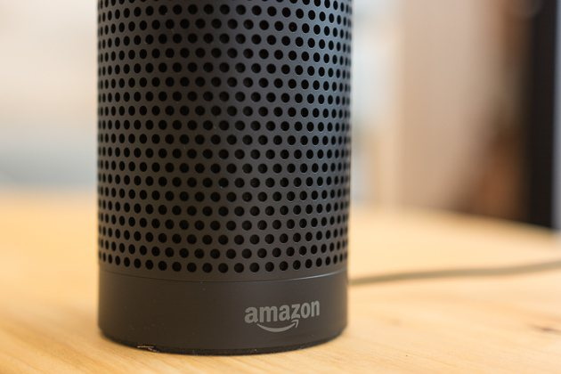
Echo’s always-on microphones are listening to everything you say. Should you worry? Photo: Michael Hession
Alexa can also facilitate communication with third-party services, including the aforementioned Uber and Domino’s, and Capital One’s online banking services. Amazon doesn’t actually get access to the transactions taking place, however. In the case of Capital One, the bank says the system is fully encrypted, and the Alexa skill includes a user-created passcode to prevent unauthorized access. Still, some people may worry that trusting your life savings to a cloud-enabled voice assistant may be taking too big of a risk.
The fact is that your Echo or Dot is always listening to you. This is and isn’t as creepy as it sounds. Though it’s true that the device hears everything you say within range of its very good far-field microphones, it’s listening for its wake word. Once it hears that, everything in the next few seconds after is perceived to be a command or request and sent up to Amazon’s cloud computers where the correct response or action is triggered. You know Echo is paying attention because the circular blue light turns on when it hears its name. Echo is like your dog: It’s always listening, but it understands only “cookie,” “walk,” or “Buddy.” Everything else goes right over its head.
Pull Quote
Echo is like your dog: It’s always listening, but it understands only “cookie,” “walk,” or “Buddy.” Everything else goes right over its head.
This is no different from Apple’s Siri and some of Samsung’s smart TVs that by default listen for key phrases (“Hey, Siri” or “Hi, TV”) said near them to allow for searches or voice control of things like volume and channel. Again, the Alexa devices kick into gear only when they hear their name (they also record a “fraction of a second of audio before the wake word,” according to Amazon’s Alexa FAQ page). That said, when Alexa hears a command and sends those words up to the cloud, Amazon has just learned something about you. Maybe the company only learned that you like The Police, or fart jokes, or need to put broccoli on your shopping list. If you said, “Alexa, where should I bury the body?” you’re not going to have the police show up at your door (I know because I’ve tried it).
Is it important that Amazon is collecting this information? That’s up to you to decide. Your computer is tracking everything you do online through cookies. Google knows everything you’ve ever searched for. Primarily, Amazon wants to sell you stuff. Lots of stuff. So when you use a workout skill with your Echo, don’t be surprised if Amazon sends you an email promoting yoga pants (this hasn’t happened to me yet). When you add mechanical pencils to your Alexa shopping list, Amazon may well use that to recommend lead refills or erasers.
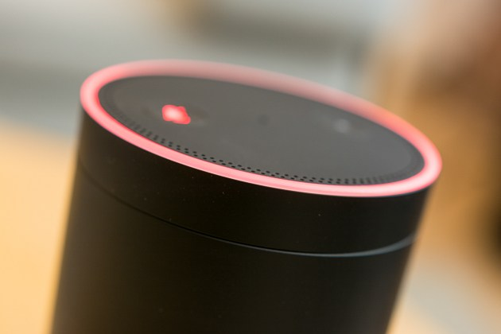
Pressing the microphone button on top of the Echo or Dot disables Alexa’s listening capability and also turns the LED ring red. Photo: Michael Hession
Pull Quote
If you said, “Alexa, where should I bury the body?” you’re not going to have the police show up at your door (I know because I’ve tried it).
Both the always-listening aspect and the data-collection tendencies raise privacy concerns. Should you tell guests that a computing device is listening to their conversations (similarly, with a security camera, do you tell your guests they’re being videotaped)? Amazon doesn’t discriminate among users. Anyone within range can use it, including children (looking in the history section of the app I learned that my kids were trying to get Echo to tell them dirty jokes). Everything you say to Alexa is noted in the app and can be deleted. Amazon says that once you delete it, it’s gone forever, even from its servers, and doing that may degrade the product’s performance. Amazon’s complete privacy policy in regard to Alexa can be found here.
So, in general use you’re not likely to be risking more than you are with other connected services. But if you are planning to discuss any national security secrets and don’t want to open yourself to Alexa’s snooping capabilities, press the mute button on the top to disable the microphone.
Amazon Echo vs. Echo Dot vs. Echo Plus
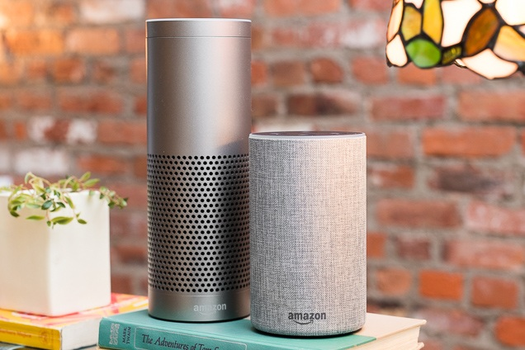
Photo: Michael Hession
Our pick
Amazon Echo (2nd Generation)
Our pick
Echo, always listening via Amazon’s Alexa voice service, lets you play music, order pizza, and get answers to questions, and can control popular smart-home devices and 1,000-plus other things.
$100 from Amazon
All Amazon Alexa devices offer essentially the same Alexa functions, but they differ in enough ways that you can’t simply substitute one for the other, or go with the cheapest.
If you want music without hooking up any additional speakers, the second-generation Echo offers the complete range of functions, minus the screen features of the Show and Spot. As a speaker, it’s good for kitchens, offices, dens, bedrooms, and other places where convenience and size (it’s about the size of a Foster’s beer can) is more important than audio performance. The speaker is designed for 360-degree dispersion, so placing it in the middle of the room will give you sound in all four corners.
If you’re a discerning listener, you might find the Echo wanting as a speaker. Its bass is a bit foggy, and details can get lost, though the second-gen Echo sounds a little more detailed than the original. You can also pair the Echo with your smartphone via Bluetooth for playback of your stored tunes or any music service Alexa doesn’t support, but you can’t pair it with another speaker as you can the Dot.
The main Echo, and all other Echo devices, can be used as a multiroom audio system similar to Sonos. You can create groups with multiple Echos and play the same music on all of them at once. Unfortunately, you can’t make two Echos work together as a stereo pair.
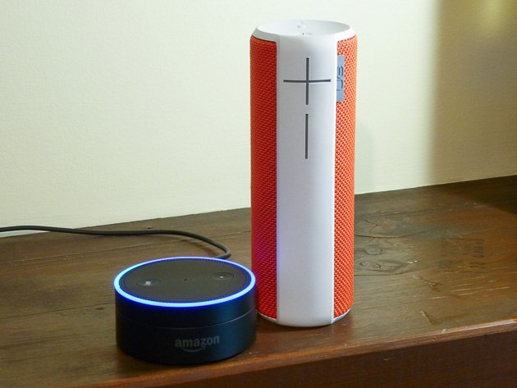
The Dot can wirelessly connect with a Bluetooth speaker, such as the UE Boom 2. Photo: Grant Clauser
Also great
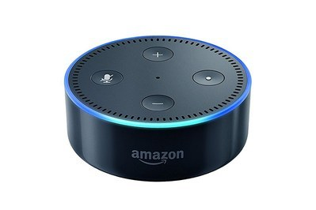
Amazon Echo Dot
The affordable Echo
This mini Echo does all the same tricks that the full-size model does, but the built-in speaker is too quiet for listening to music. However, it’s easy to connect it to a Bluetooth speaker or an aux input.
$50* from Amazon
$140 from Amazon
Buy from Amazon
Buy from Amazon
*At the time of publishing, the price was $30.
For a lot less than the full-size Echo, and with the ability to connect wirelessly to your choice of speaker or sound system, the Echo Dot 2 is a smart option. The original Dot sold out almost as soon as it launched, but the new Dot 2 began shipping in October 2016. The Dot 2 is only about 1½ inches high and includes volume buttons instead of the turnable knob of the Echo (and the original Dot). Amazon also covers the newer Dot in a glossy black or white finish rather than the flat black of the Echo and the first Dot. A special “Kids Edition” is available as well, with a protective rubber case in red, blue, or green. It includes a two-year warranty for physical damage, along with a one-year subscription to Amazon’s FreeTime Unlimited service for kids content and additional parental controls, all for $30 more than the standard Echo Dot.
In this smaller package, the Dot gives you all the Alexa control and search features, and it includes a speaker that’s good for hearing the Dot’s voice and alarms or listening to talk radio, but it isn’t nice enough for enjoying music. For music, you connect the Dot to any Bluetooth speaker or use a 3.5-millimeter stereo jack for a wired audio connection. You can plug that into a powered speaker or an audio receiver.
I hooked up my Dot to my home theater receiver so that I could hear music from a 1,000-watt system (the Dot is technically stereo, but with an AV receiver you can output it through all your speakers). The downside of that arrangement is that you must have the connected speaker or sound system turned on to be able to hear the Dot’s voice responses. For example, in my home theater system, the receiver has to be on and set to the Dot’s input for me to hear it say “Okay” when I ask it to lower the room lights. That doesn’t sound like a big deal until you discover that you don’t know whether the Dot received your command unless you see the resulting action. If it didn’t hear you correctly, the only way you’ll know is that you’re sitting on the sofa for 20 minutes and the lights still haven’t changed.
Also great
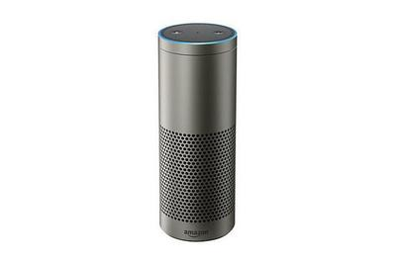
Echo Plus
The smarter Echo
This Echo lets you skip the smart-home setup when connecting a select group of Zigbee devices.
Buy from Amazon
*At the time of publishing, the price was $120.
If smart-home control dominates your list of reasons for wanting an Echo, the Plus might be your best choice. It’s bigger than the current generation Echo and looks identical to the original (except it’s also available in silver). Its main difference from the standard Echo is the inclusion of Zigbee, a popular wireless system for controlling smart-home devices and that can be found in many smart-home hubs. Building Zigbee into an Echo means you can connect Zigbee accessories, including some smart bulbs, outlet plugs, and door locks without any additional hub.
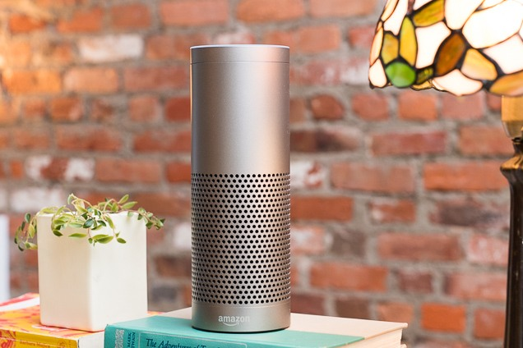
The Echo Plus can work directly with many Zigbee smart devices, including Philips Hue and some Schlage smart locks. Photo: Michael Hession
I tried out an Echo Plus with a Samsung SmartThings Zigbee plug, a Philips Hue light strip and a Philips Hue bulb. Normally, Hue systems require the Hue bridge, but that’s not needed with the Echo Plus. The Plus found and added the Zigbee devices with a simple “Alexa, find my devices” command, then let me add them to groups and routines. Echo’s app doesn’t let you control the devices with as much precision as a smart hub app; for instance, you can’t adjust a Hue bulb’s color with the Alexa app, but you can adjust the color with your voice.
Echo Plus doesn’t work with all Zigbee devices. Amazon has a curated list of things that it has approved and knows will work as promised.
Using the Plus rather than a smart-home hub might save you a little money and a little setup complication, but most people with basic smart-home needs will probably be just fine with the standard cheaper Echo or even a Dot.
Also great
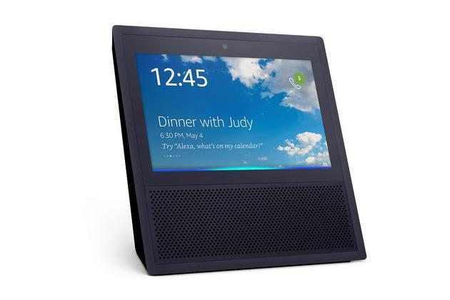
Echo Show
The Show me Echo
Here’s the Echo with all the Alexa smarts, on-screen lyrics and the ability to video chat with other Echo Shows—probably best to buy a pair and give one as a gift.
$130* from Amazon
You save $100 (43%)
*At the time of publishing, the price was $180.
The Echo Show may appeal to people who like the idea of video chatting with friends or relatives, but who don’t like using a phone’s small screen for it. The Show’s built-in 7-inch display makes it look like an old Mitsubishi rear-projection TV for a dollhouse. In addition to the display screen, there’s a small camera you can use for taking selfies, but the camera’s primary purpose is for free video chats. The display also works with a few Wi-Fi security cameras and Amazon’s new Cloud Cam. A few skills, notably Allrecipes, are optimized for the show, and it will display song lyrics from some Amazon music tracks.
The video chat feature works well, though the angle of the device means you have to stand a few feet away from it to get your head in the picture, so it won’t work well if you’re sitting in front of it at a desk. Both video and sound came through clearly when I used it to call The New York Times’s (parent company of Wirecutter) Brian X. Chen. We could hear and see each other very well.
The display doesn’t improve standard Alexa interactions. When not actively using the Show, the screen displays random news headlines, but you can’t customize them to fit your interests. The few skills optimized for the screen can still be awkward to use.
Get Show only if you really have a good use for video chats, and then get two, because they’re cheaper when you buy a pair.
Also great
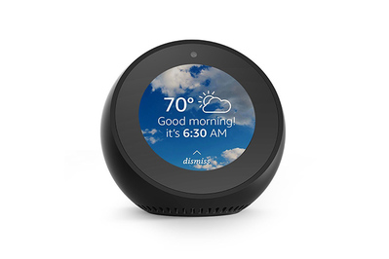
Echo Spot
The best clock radio Echo
This smaller, rounder version of the Echo Show sounds decent and is good for video calls.
$130 from Amazon
Buy from Amazon
Like the Echo Show, the Echo Spot’s defining features are a built-in camera and an LCD screen that can display a clock, song lyrics, or videos or allow video chats with other Spots, Shows, or the Alexa smartphone app. The Spot is about the size of a softball, and the screen is only 2.5 inches wide, making it perfect for a bedside clock (it includes six clock faces), but too small to watch anything longer than a film trailer.
Video chats with the Spot look sharp and sound clear, thanks to both the far-field microphones and the 1.2-inch speaker. The camera can also be used for quick selfies, which get saved in your Amazon Cloud account and can be used as your clock background, if you like the idea of being a clock face.
As a music device, the Spot plays louder and sounds better than the Echo Dot, but it’s still only clock-radio quality. If you want better sound you can connect it to a Bluetooth speaker wirelessly or another music system via the line-out connection.
As with the Show, the Spot can display weather conditions, news alerts, album art, and song lyrics. It will also show Alexa’s daily deals if you ask it to. The small screen makes it harder to read text from a distance compared with the Show, but it’s fine from a couple feet away. The bright display can be set to automatically dim at night so it won’t keep you awake in your bedroom.
If you’re bothered about the potential privacy risks of the camera, you can turn it off in the settings, but then you’d need to turn it back on when you want to make a video call. Another quirk, which Spot shares will other Alexa devices, is that it comes with the drop-in feature turned on by default. This allows anyone on your Alexa contact list to speak to, hear, and see you without you having to answer the call. If this sounds creepy, turn it off during setup, or say “Alexa, open settings” to turn off the feature.
Also great
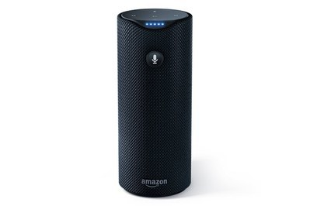
Amazon Tap
Best for taking Alexa with you
The Tap’s built-in battery lets you take Alexa voice control to the backyard or other places outside the home, though the audio performance is worse.
Buy from Amazon
Buy from Amazon
INR 14,726.00 from Amazon
*At the time of publishing, the price was $80.
The Tap is for people who want to take Alexa into the backyard, primarily those who’ve already made the investment in an Echo (or otherwise use Alexa within the home). Smaller than the Echo, the Tap includes a speaker capable of decently reproducing music, a rechargeable battery, and a charging base. Keep the Tap charging in a convenient place near the back door so every time you want to sit on your lounge chair you can grab it on the way out. As long as your Wi-Fi signal is strong enough to pass through your wall, the Tap can tap into its music abilities for all the neighbors to hear. The Tap didn’t originally sport the always-on microphone for receiving voice commands that the Echo and Dot have, but Amazon recently enabled a hands-free mode with a firmware update. If you don’t enable that feature, you need to press a microphone button prior to giving a command, similar to pressing the home button on an iPhone to call Siri to attention (if you don’t have “Hey Siri” enabled on your iPhone). This little inconvenience is meant to make the Tap’s battery last longer. It also makes it unsuitable as your main Alexa interface.
Pull Quote
The Tap didn’t originally sport the always-on microphone for receiving voice commands that the Echo and Dot have, but Amazon recently enabled a hands-free mode with a firmware update.
Both the Echo and the Dot (though not the Tap) devices can be extended with the addition of an Alexa Voice Remote. The remote, as you can guess, is a little handheld remote with a microphone built in. Let’s say you have an Echo in the kitchen, but want to be able to shut off your Hue and LIFX lights from the bedroom. Rather than purchasing another Echo for the bedroom, you can get a Voice Remote. It also includes volume control for the speaker it’s synced with, but because Alexa doesn’t support multiroom audio, it can’t turn down multiple Echo speakers.
There’s one last Amazon Alexa product that most people forget about: the Fire TV. The Voice Remote for Amazon’s media streamers includes a microphone for voice searches of Amazon content, but you can also use the remote to access Alexa, whether to search programming, control smart-home devices, or, perhaps, to order an Echo Dot. If you’re considering media streamers, we much prefer the Roku Streaming Stick+ (the Fire’s interface feels unfinished and privileges Amazon content), but it’s an interesting option if you do prefer Amazon Prime video or music and want to experiment with Alexa.
What about non-Amazon Alexa speakers?
There’s a field of third-party Alexa-enabled speakers, and though a few are junk, some may be better choices than their Amazon cousins, depending on your needs. However, you may sacrifice some features. First, all non-Amazon Alexa speakers will require two apps. The Amazon Alexa app, and the speaker’s own branded app. That’s a small inconvenience, but does add a little bit to the setup process. On the other hand, the speaker’s app may offer features, such as EQ settings, that the Amazon app doesn’t. No third-party speaker uses Amazon’s ESP technology, which cuts down on instances of the wrong speaker responding to your voice prompt. This can be an issue if you have several Alexa speakers in the house and you haven’t changed the wake word for any of them. Some third-party speakers won’t work with all the music services supported by Echo, such as Pandora or Spotify, but they’ll all work with Amazon Music, and most are also Bluetooth speakers, so you can stream directly from your phone. The third-party speakers don’t always allow you to set them up in a multiroom system. You also may not be able to use Amazon’s drop-in or phone calling features.
The Sonos One looks and sounds like the Sonos Play:1 speaker, but includes microphones and Alexa support built in. It sounds better than any of the Amazon Echo speakers, but also costs twice as much as an Echo. It also supports most major streaming services, and according to Sonos will be compatible with Google Assistant later this year. The Sonos Beam is a soundbar with Alexa. We haven’t reviewed the Beam yet, but will include that speaker in a future update.
The Ultimate Ears Megablast (and the smaller Blast) are essentially the company’s outdoor waterproof Megaboom and Boom Bluetooth speakers, but now with microphones and Alexa. Both claim an IP67 rating against water, so getting splashed by the pool or a rain shower isn’t going to kill them, and they run for about 12 hours on their rechargeable batteries. Both sound very good, with the Megablast being louder and putting out more bass. The microphones aren’t nearly as sensitive as the latest-generation Echo speaker, so you may find yourself reaching for the microphone button frequently when the speaker can’t hear you through the music. They don’t come with the convenient charging base like the Amazon Echo Tap (they include only a charging cord), but you can purchase one separately.
The Pioneer Elite F4 works with both Alexa and DTS Play Fi—a multiroom speaker platform similar to Sonos. The F4 is larger than the Echo, and sounds much better—closer in quality to the Sonos One, but it requires you to use two apps (DTS and Pioneer) in addition to the Alexa app, just to set it up, and we had frequent connection problems. If you want an indoor speaker that sounds better than Echo, we suggest the Sonos One.
The Fabriq Chorus is about the size of the second-generation Echo, and costs the same as the Echo, but is portable like the Tap and includes a charging cradle so you don’t need to plug it in. It sounds pretty good for its size—about the same as the Tap but not nearly as good as the two portable Ultimate Ears speakers. It looks nicer than the Tap and comes in a variety of fabric patterns and colors. Unfortunately it has no IPX rating for outdoor use, so if you take it outside, don’t expose it to rain. The battery is good for only about six hours.
Extending Alexa with IFTTT
IFTTT, Muzzley, and Yonomi are services that connect your stuff in the cloud. Imagine that your Nest, WeMo switch, and Hue light all have virtual Cat5 cords drifting around in the Internet ether. Those cloud services are like a matrix switch that all your things can plug into, and Alexa is the voice that those connections answer to. With these services you can create automation routines and make disparate products work together with Alexa that otherwise wouldn’t.
To make these integrations, you’ll first need to create an account with the service. IFTTT is the most popular, though both Yonomi and Muzzley do a few things IFTTT can’t. For example, one Yonomi integration allows some Alexa control over Sonos speakers.
Once you’ve configured your accounts, you’ll need to add the service to your Alexa device (the method differs slightly with each service), then through Alexa, log into the accounts of the devices you want to connect (again, this method varies) and authorize access by the service. You then need to link up the devices in routines (IFTTT calls these “recipes”) or create new ones.
These services are useful for enabling actions that Alexa can’t do natively, but they’re not perfect. For one thing, each service requires a unique action phrase that tells Alexa what to do. For example, IFTTT uses “Trigger” and Yonomi uses “Turn on.” If you want Alexa to turn on your home theater using IFTTT and a linked-up Logitech Harmony Elite remote, you have to say “Alexa, Trigger turn on home theater.”
Another limitation is that a cloud recipe can’t trigger an action from your Alexa device. You can use Alexa to enable a recipe, but, you can’t, for example, have Echo play “Rock Around the Clock” as part of an IFTTT wake-up recipe.
Because a command like the one above may need to access multiple cloud accounts at once, there’s sometimes a delay of tens of seconds, and sometimes the commands just don’t work. Also, if you’ve configured a lot of IFTTT recipes, it’s easy to forget the exact phrase that works, so user mistakes are common.
What to look forward to
With Amazon trying to build on Alexa’s smart-home capabilities, and working to make it easier for companies to create compatible devices, you can expect many more companies to announce their Alexa integration. We’d love to see some items work better with Alexa, like smart TVs, smart appliances, and more smart garage-door controllers like the Chamberlain MyQ (Alexa currently works with Garageio). You can integrate some of those devices via IFTTT, Yonomi, or a smart-home hub, but native control is faster and more reliable, and it requires a less awkward use of activation phrases.
Another thing that would be great is the ability to take advantage of the Echo’s Bluetooth connection for use as a speakerphone, although you can already use it to make VoIP calls for free. Alexa now has calling and texting capabilities, but we haven’t tried the texting feature (which is compatible only with Android, and does not support group messaging) for ourselves. We’ll update this guide with our thoughts when we get a chance to test it out.
You can also expect to find Alexa itself built into more non-Amazon devices. That’s right—Amazon offers the Alexa Voice Service developer program to allow manufacturers to build their own Alexa devices. If you’re techie enough, you can build Alexa into your own Raspberry Pi computer. One manufacturer, Invoxia, built Alexa into its Triby Internet speaker. That (currently) $200 device hangs magnetically onto a refrigerator, lets you make speakerphone calls via a Bluetooth connection, and can even display digital scribbles on a small screen. Imagine an Alexa soundbar or home theater receiver or TV or car. Those are all possibilities.
Sources
Dale Higgs, A complete list of all available Alexa Skills, GitHub
Alexa and Alexa Device FAQs, Amazon
Amazon Echo users, Facebook Group
Rory Carroll, Goodbye privacy, hello ‘Alexa’: Amazon Echo, the home robot who hears it all, The Guardian, November 21, 2015
Brian Heater, Amazon Echo VP Mike George talks Alexa security and simplifying search, TechCrunch, May 10, 2016
Hayley Tsukayama, How closely is Amazon’s Echo listening?, The Washington Post, November 11, 2014
Comments are disabled
We respect your privacy. Comments are disabled because they require cookies and you’ve opted out of cookies for this site. You can change your cookie preferences to enable comments.
You can also send us a note or a tweet, or find us on Facebook.

