CE 458 SPRING 2018

Prepare a 6 page report, (4 pages of text, including references, and two of images) on the Globalnaya navigatsionnaya sputnikovaya sistema, or "Global Navigation Satellite System" GLONASS (ГЛОНАСС). Report on the following components of this Satellite Constellation Network:

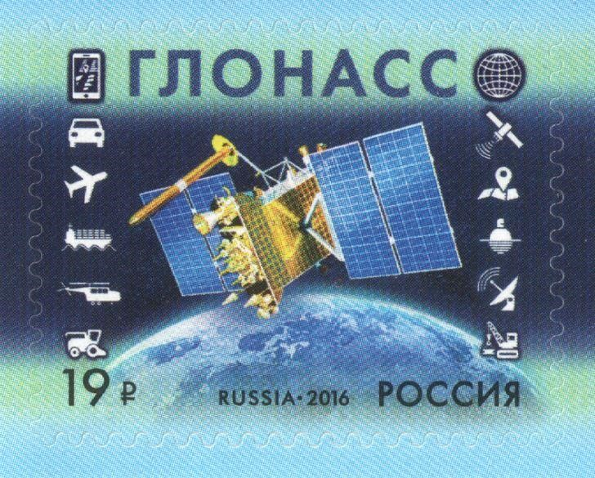

- HISTORY OF GLONASS DEVELOPMENT. Report on why the Russian Federation and predecessor government of the Soviet Union chose to develop their own Navigation Satellite constellation and when. Talk about the key developments of GLONASS, including the period of time when the system almost fell apart.

- SIGNALS. Describe the details of the signals/codes that the GLONASS system utilizes. Describe any new codes/signals which will be placed in new Satellites. Describe the signals which make GLONASS interoperable with GPS receivers in the US and other countries, such as the European GALILEO constellation. Is there special coding to identify the GLONASS satellite and its signal in a codeless wave based solution?

- ACCURACY: Describe the accuracies for GLONASS code based solutions and wave based solutions. Can you get a positional solution by only using GLONASS satellites and signals? Or is GPS required as the primary satellite constellation using GLONASS to enhance the robustmensss of the position solution.
CE 458 SPRING 2018

- SPACE SEGMENT: Describe the GLONASS satellite constellation presently in orbit and planned for launch through 2019; how many are in orbit. Describe each satellite type, which signals each carries, its lifespan, the orbital plane of the satellites and how they differ from the GPS orbital planes and heights in orbit.

- GROUND SEGMENT: Describe any master control station operated by the Russian Federal Space Agency (ROSCOSMOS) and where it is located. How do signals and corrections get processed and where do they get sent to? How many ground control upload and tracking stations are in the GLONASS network and where are they located (find a picture to insert into your report)?

- USER SEGMENT: How are the GLONASS signal products used in receivers sold in the civilian market in the US? What hardware changes needed to be made to GPS receivers and antennas to accommodate the needed signals coming from GLONASS satellites? Were some of the signals already interoperable?

- REVIEW of GLONASS website: Visit the GLONASS website called “Information & Analysis Center for Positioning, Navigation and Timing”. Describe three elements of this website that provided you with good information about the GLONASS satellite system, which you did not know previously.

Please submit your paper as a WORD compatible document by Saturday, March 31, 2018, midnight. Font Height 12, normal spacing is required. Reference your work with parentheses and provide a list of references at the end, including all internet sources. Internet addresses should be accompanied by a little explanation of what was there. If there are valuable references found please place a comment in the reference list.

