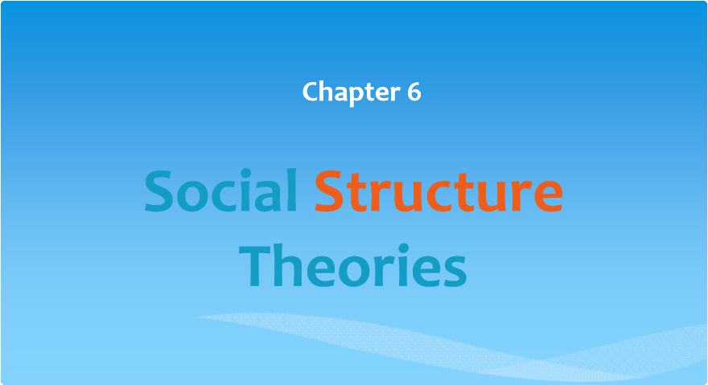
Copyright © 2013 by Nelson Education Limited
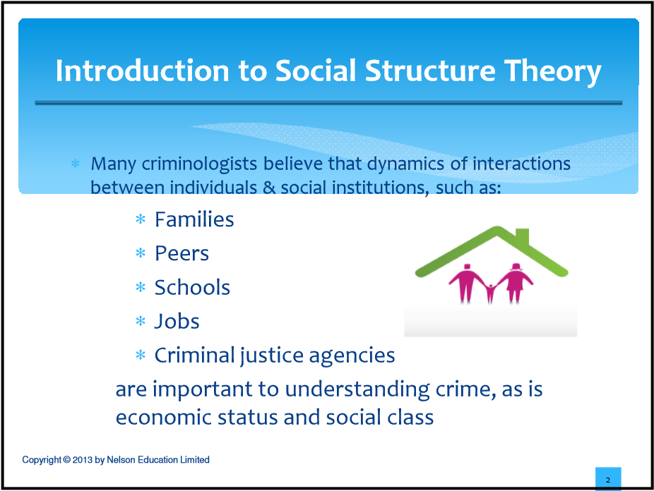
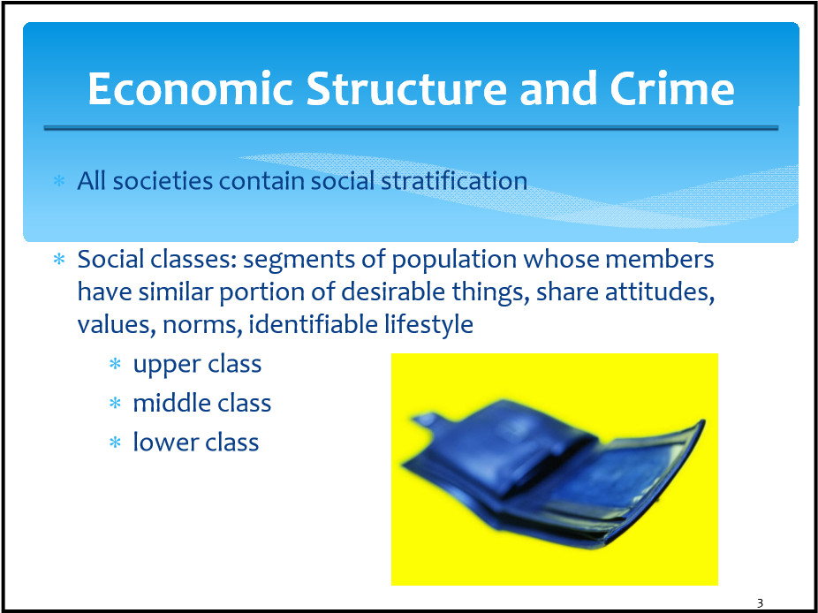

Children and Poverty
∗ 1 in 10 children in Canada live in poverty (2007)

∗ Association between family poverty and children’s health, achievement, behaviour impairments
∗ Timing of poverty is relevant
∗ most severe impact if in early childhood
∗ Suffer from various social and physical ills
∗ Described as an “epidemic”
∗ poverty destroys inner workings of a poor neighbourhood ∗ Rates vary by race and ethnicity
Copyright © 2013 by Nelson Education Limited
4
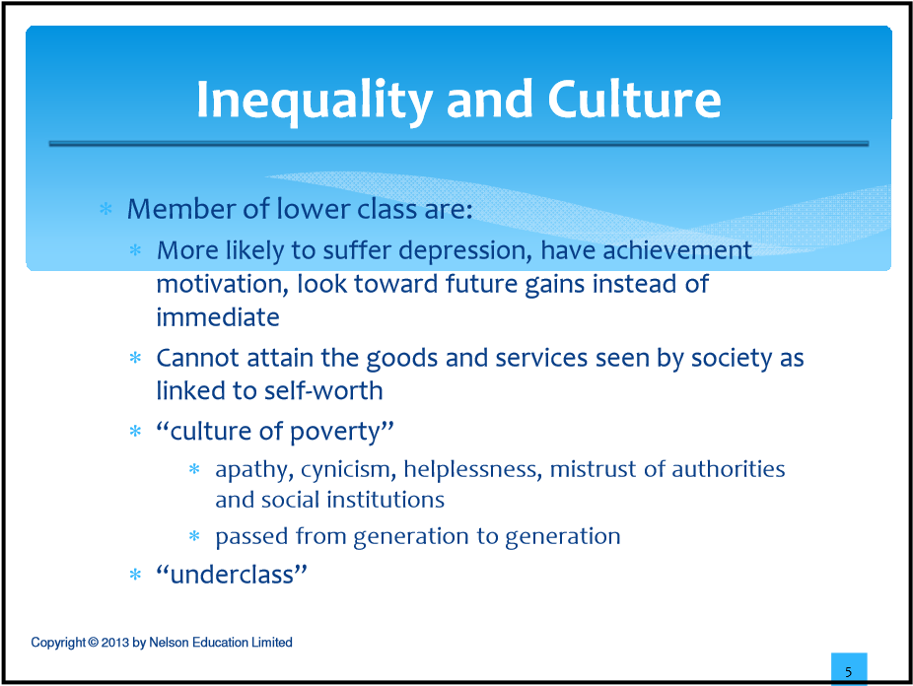
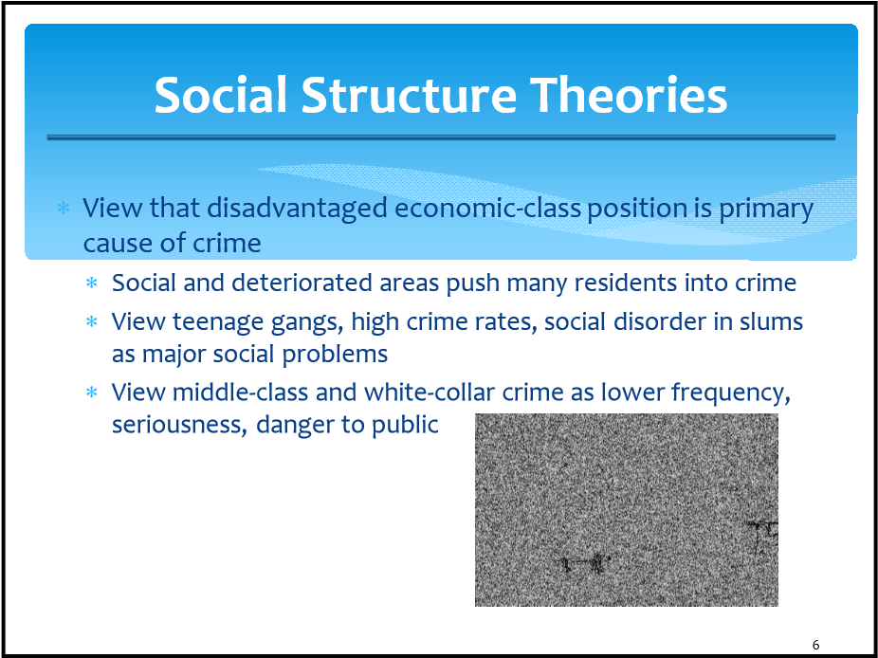

Social Disorganization Theory
characteristics
∗ Crime rates are higher in areas which are highly transient, mixed-use, changing
∗ Localities cannot provide necessary services
∗ High unemployment, single-parent families, families on welfare ∗ Residents try to leave these area ASAP
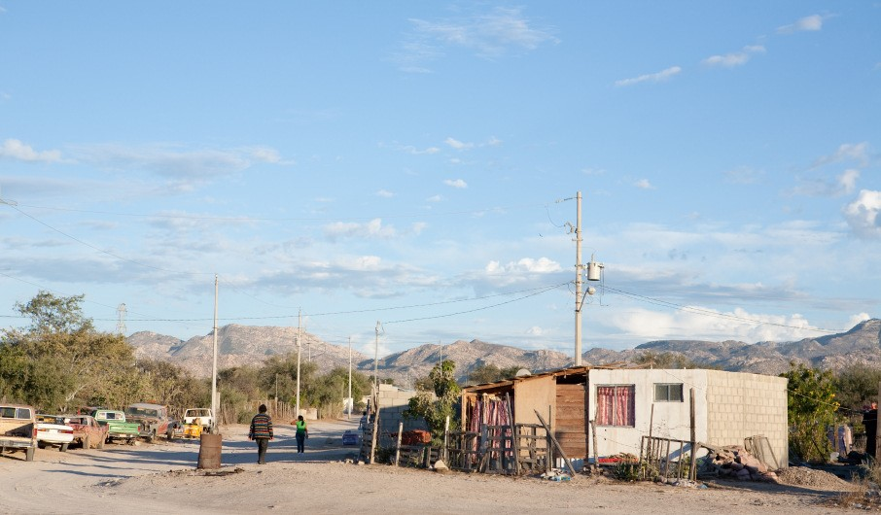
Copyright © 2013 by Nelson Education Limited
7
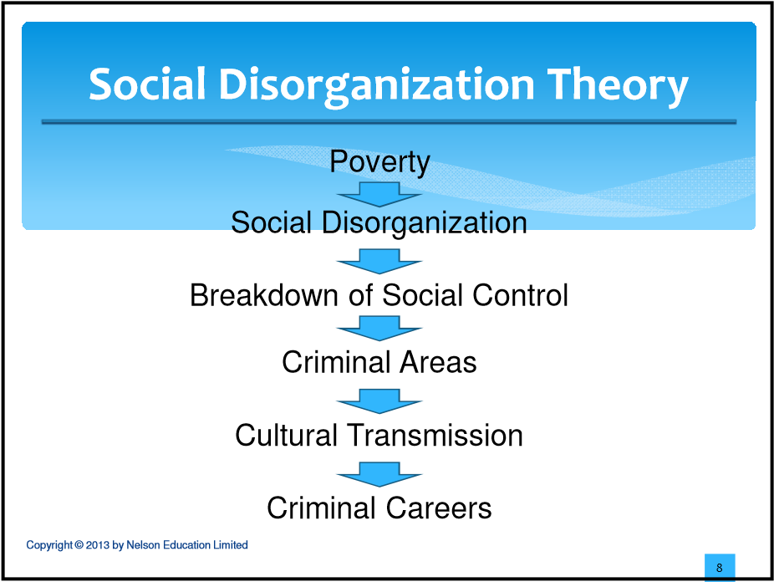

Social Disorganization Theory
Shaw and McKay
∗ Linked life in transitional slums to inclination to crime
∗ Transitional neighbourhoods
∗ Concentric zones
∗ Chicago divided into nine concentric zones, each with stable, significant differences in crime rates

∗ Highest crime: transitional inner-city zones with high number of foreign-born citizens
∗ Lowest crime: zones far from city centre
∗ multiple cultures, diverse values co-exist
∗ deviant lifestyle is financially successful
∗ formation of gangs
9
Social Ecology School: Community
Disorganization

∗ This view emphasizes association between community deterioration and economic decline with criminality
∗ Crime rates, need for police services associated with deterioration of community
∗ Disorder, poverty, alienation, disassociation, fear of crime
∗ Holds true in rural areas as well
∗ When many houses/apartments become deserted, they become a ‘magnet’ for crime
∗ Houses/apartments in poor repair become location of highest violence rates and gun crime
Copyright © 2013 by Nelson Education Limited
10
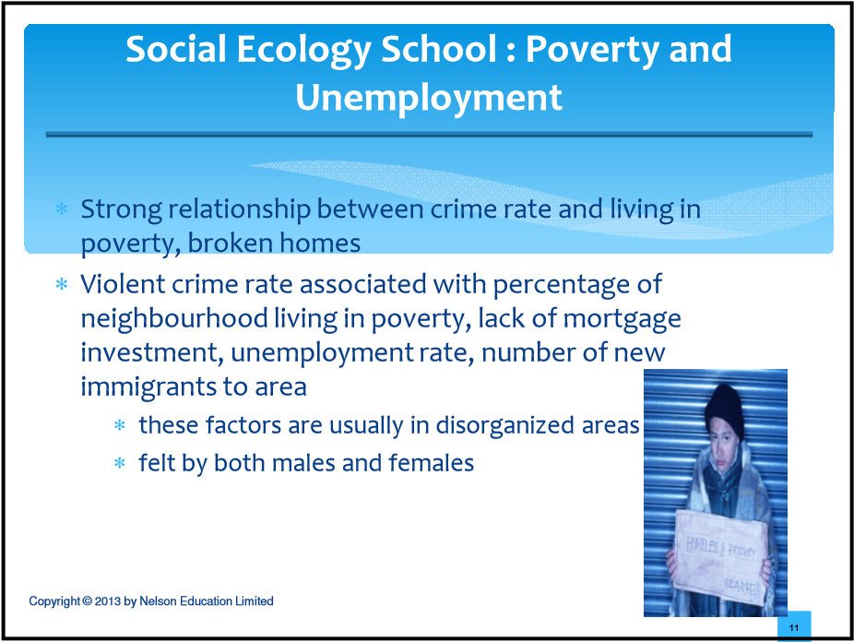
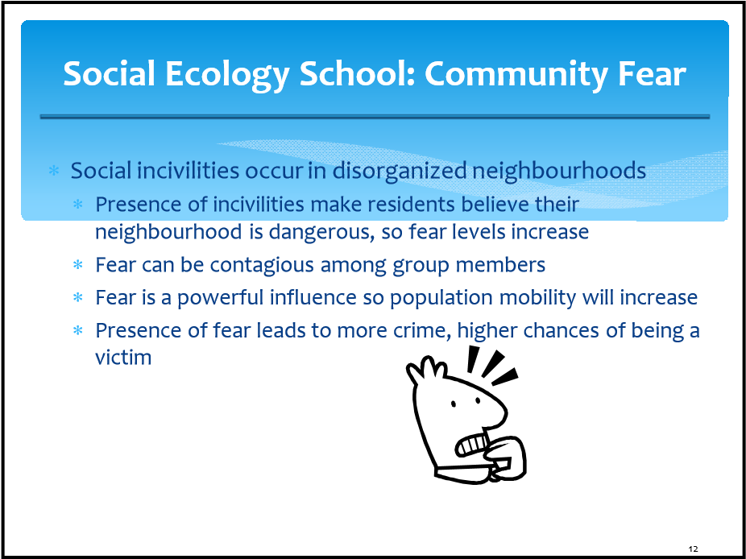
Social Ecology School: Community Change

∗ If rapid structural changes to racial, economic composition of community then greatest crime rate change
∗ Even disorganized areas acquire new identifying features
∗ As areas deteriorate, residents move out to safer neighbourhoods
∗ If can’t leave, face increased risk of victimization ∗ Minorities often can’t leave area easily
Copyright © 2013 by Nelson Education Limited
13
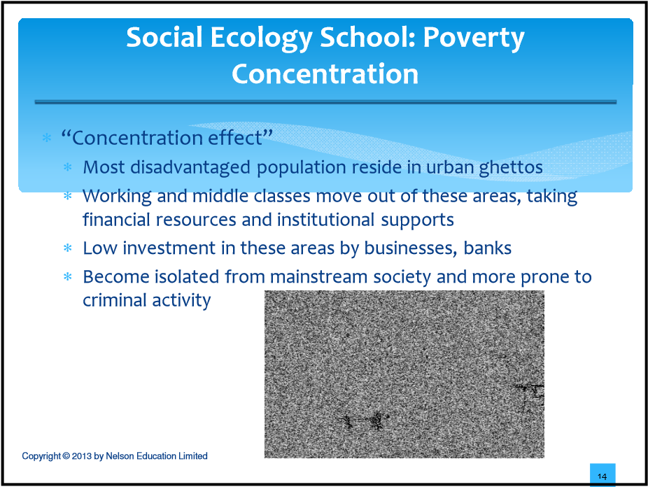
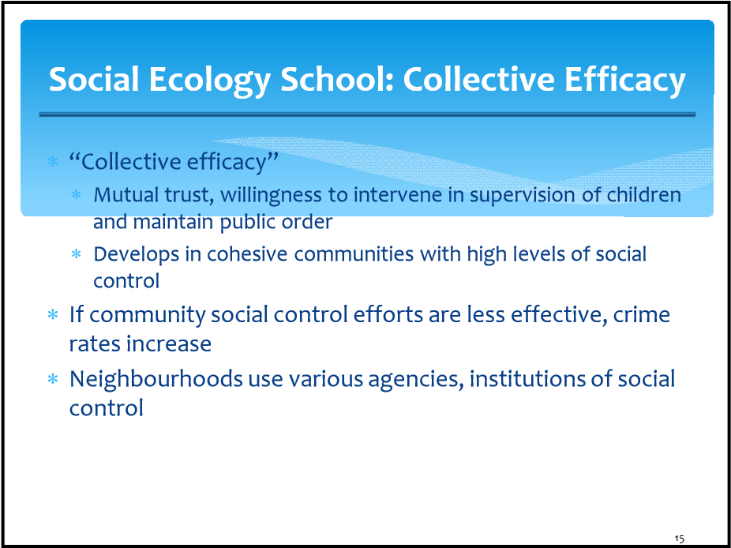
Social Ecology School: Collective Efficacy
control
∗ Policing in low-crime, stable areas can have resources, motivation to respond vigorously to crime
∗ Community leaders may have enough influence to get funding for additional law enforcement
∗ In disorganized areas, police have less resources and are less motivated 
Copyright © 2013 by Nelson Education Limited
16
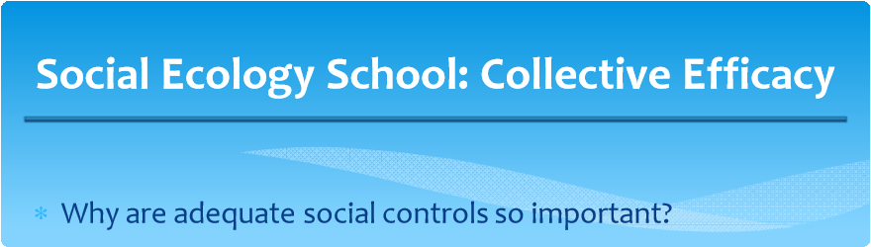
∗ Children will be less likely to become involved with deviant peers, problem behaviours
∗ Ineffective schools and religious institutions
∗ Limited access to external funding, protection
Copyright © 2013 by Nelson Education Limited 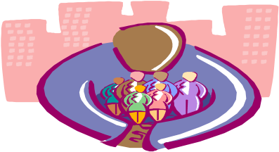
17
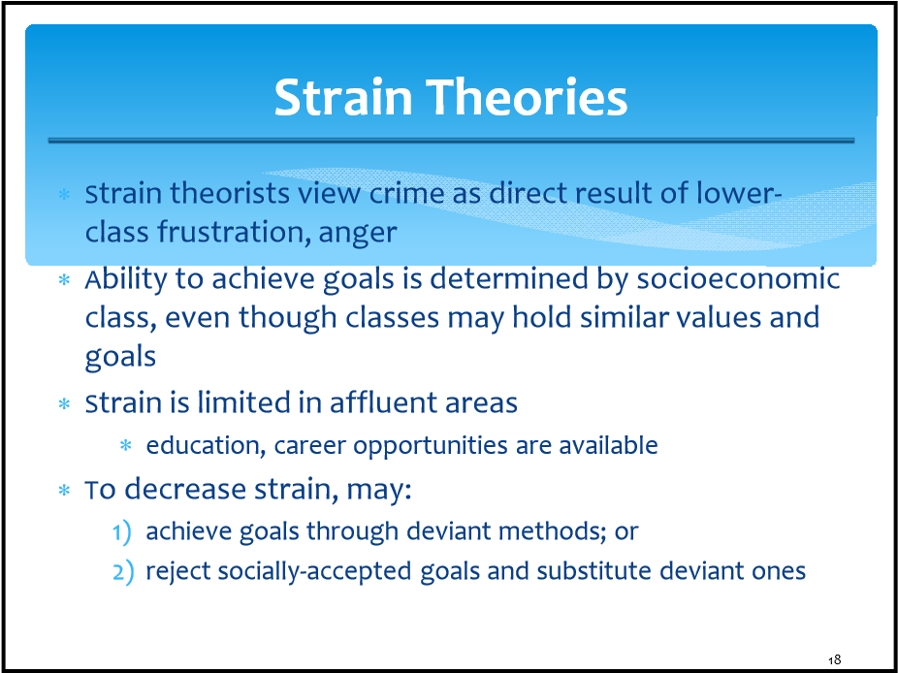

Theory of Anomie
∗ Anomie: lack of norms and clear social standards

∗ 2 elements of culture interact to create potentially anomic conditions:
- culturally defined goals; and
- socially-approved means of obtaining them
∗ Legitimate means to acquire wealth are different across classes and status lines
∗ If little education, money then more difficult to legally acquire wealth
∗ If goals cannot be met legally, resulting strain produces anomie and may turn to criminal solutions instead
Copyright © 2013 by Nelson Education Limited
19
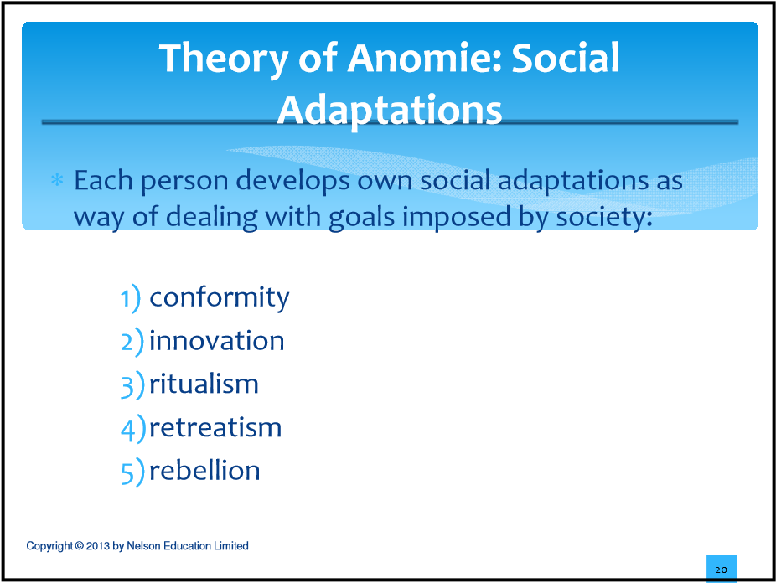
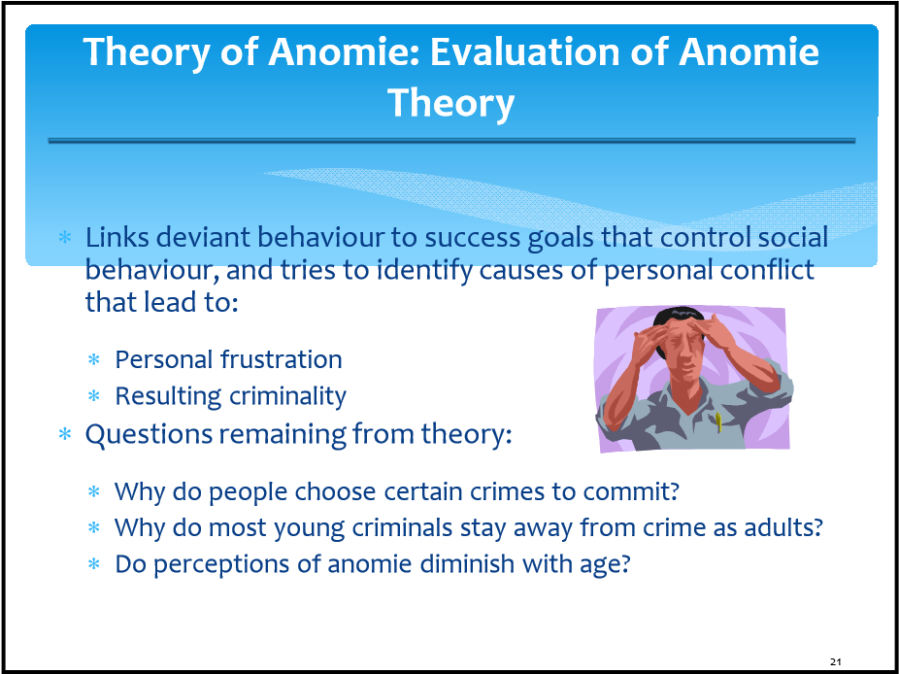

Institutional Anomie Theory

∗ This is an updating of anomie theory
∗ The success goal is pervasive in North American culture
∗ The “American Dream”
∗ Anomic conditions are created because desire to succeed drives people apart, weakens sense of community, places focus singularly on material wealth

Copyright © 2013 by Nelson Education Limited
22
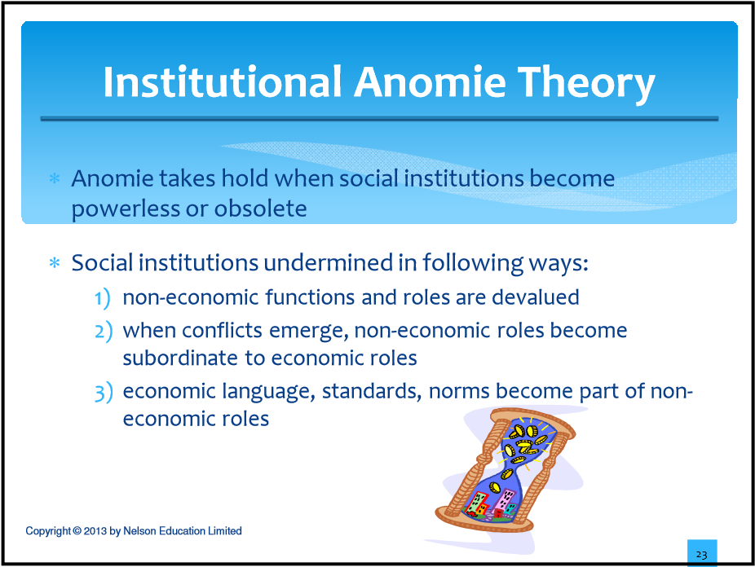
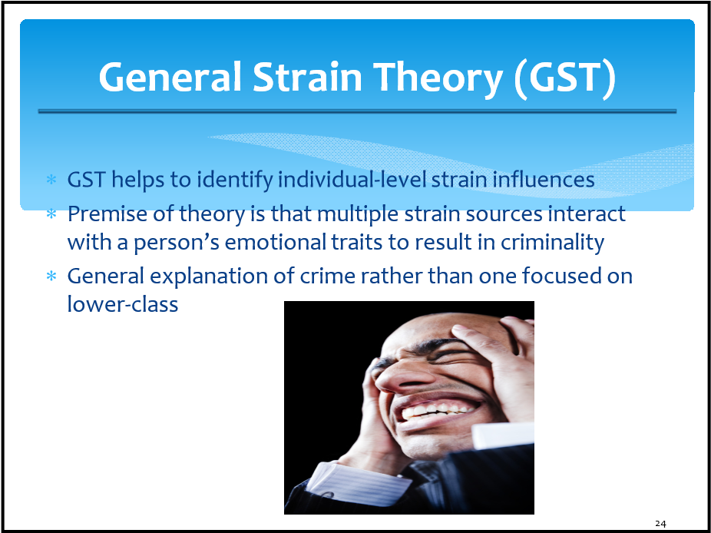
General Strain Theory (GST): Multiple Sources of Strain


∗ Negative affective states produced by variety of strain sources:
- not achieving positively-valued goals
- disjunction of expectations and achievements
- loss of positive stimuli
- presence of negative stimuli
Copyright © 2013 by Nelson Education Limited
25
General Strain Theory (GST):
Coping with Strain
∗ Not everyone who experiences strain turns to criminality
∗ Some cope well with the anger and frustration

∗ May rationalize frustrating circumstances (e.g. “I didn’t want that job anyway”)
∗ May seek behavioural solutions (e.g. running away, physical exercise, drug abuse)
∗ Some people do not cope well with strain
∗ May have traits that make them more sensitive
∗ Explosive temper, low adversity tolerance
∗ Poor problem-solving ∗ Particularly emotional
Copyright © 2013 by Nelson Education Limited
26
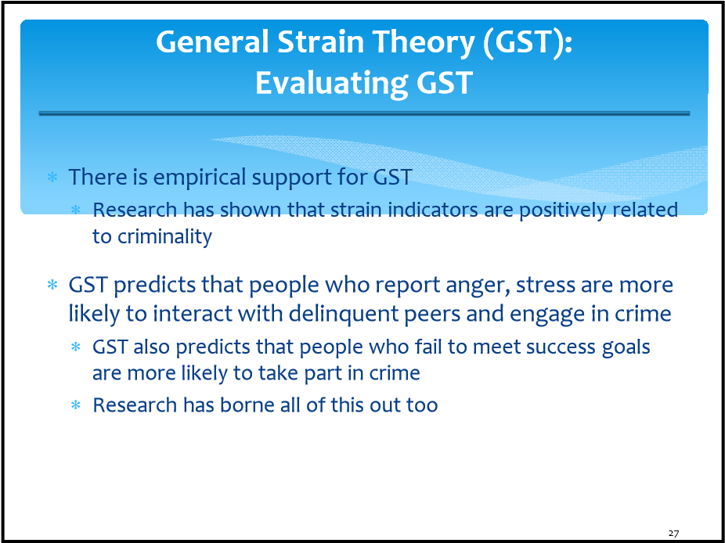

Cultural Deviance Theory
3rd branch of social structure theory

∗ Combines effects of social disorganization and strain
∗ Lifestyle is draining, frustrating for those in deteriorated neighbourhoods in social isolation, economic deprivation
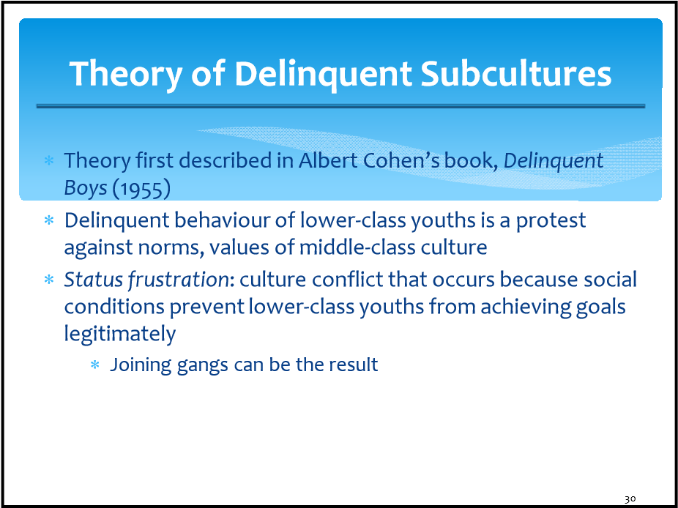
∗ Independent subculture is created
∗ Lower-class subculture stresses excitement, toughness, taking risks, street smarts, immediate gratification (this is different from middle-class subculture) 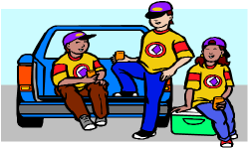
Copyright © 2013 by Nelson Education Limited
28

Theory of Delinquent Subcultures: Middle-Class Measuring Rods

Lower-class children do not have ability to impress authority figures (who are usually members of the middle-class)
∗ Standards by which authority figures evaluate lower-class children and often prejudge them negatively
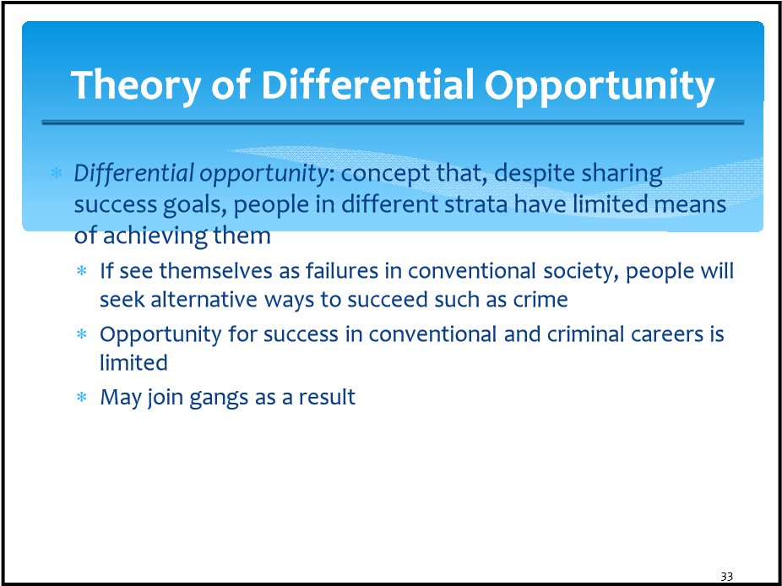
∗ Negative evaluations (e.g. school) often result and become part of child’s permanent file, preventing future advancement

Copyright © 2013 by Nelson Education Limited
31
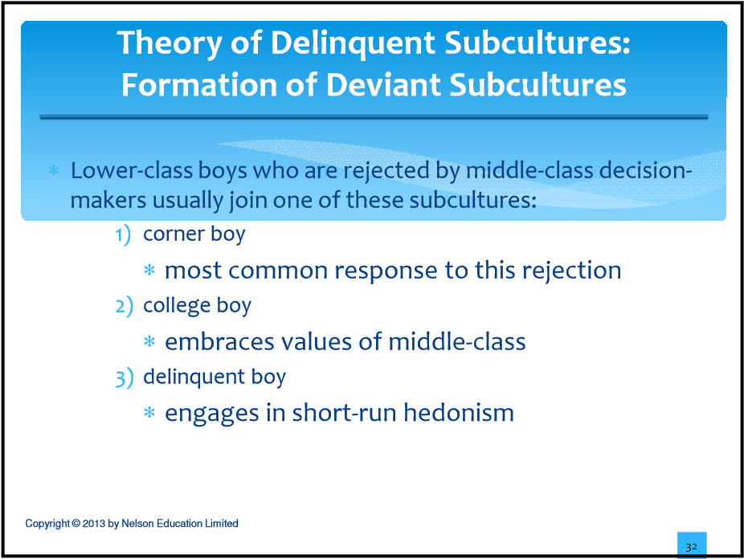
Theory of Differential Opportunity
type of gang:
- Criminal gangs
∗ are in stable neighbourhoods with environment for successful criminal enterprise
- Conflict gangs
∗ develop in communities having no legitimate or illegitimate opportunities
- Retreatist gangs
∗ contain “double failures”
Copyright © 2013 by Nelson Education Limited
34

Social Policy
∗ Social structure theory has greatly influenced social policy

∗ View that alternatives to criminal behaviour can give inner-city youth a chance to share in rewards of conventional society
∗ Giving financial aid to those who are indigent
∗ Social structure theory has greatly influenced social policy
∗ Efforts to improve community structure in high-crime neighbourhoods
∗ Programs initiated, such as:
∗ Head Start
∗ Neighbourhood Legal Services
∗ Breakfast clubs for school-age children
∗ After-school homework, recreation programs
Copyright © 2013 by Nelson Education Limited
35

